DESIGN + TECHNICAL DIRECTION

CRUSADER

NO REMORSE
  - Third-Person Shooter / Tech Demo
UNREAL ENGINE 5.8 • GASP + LYRA • GAMEPLAY FIRST
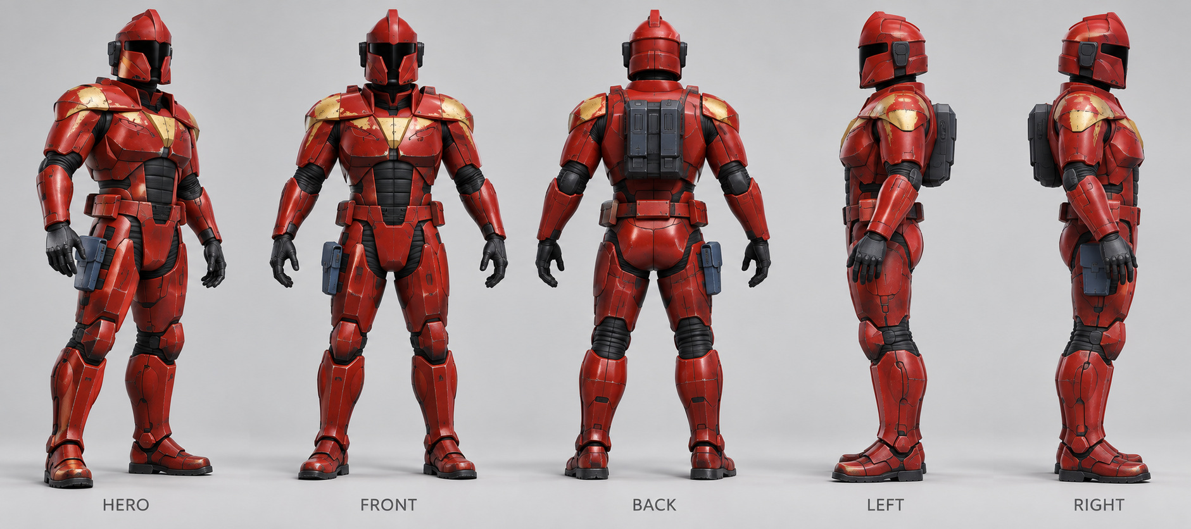
Free camera. Shoulder aiming. Reactive interiors.
Prove the GASP–Lyra shooter before importing custom models.
CONFIRMED PERSPECTIVE
A third-person shooter throughout. Earlier isometric level mockups are environment art references only, not the gameplay camera or final room layout.

Prepared for Kristian Delay
Version 1.1 • 06 October 2026
Internal concept and implementation plan. No official affiliation, remaster authorization, playable build or benchmark result is asserted. The included images are visual references, not shipped assets.

READING MAP

Contents
Use sections 11–14 to establish the starter project. Sections 02–10 specify the playable behavior. The landscape atlas preserves the mockups at a modeler-friendly size.
01 Project charter | 3
02 Third-person camera and game feel | 4
03 Controls and locomotion | 5
04 Shooting and Rifle-01 | 6
05 Health, energy and feedback | 7
06 Enemy behavior and encounters | 8
07 Annex 01 / third-person mission | 9
08 Destruction, alarms and power | 10
09 Interactions and checkpoint state | 11
10 Interface, sound and accessibility | 12
11 Technical foundation and version lock | 13
12 Merge architecture / ownership | 14
13 Integration workflow and first gate | 15
14 Animation and custom-model pipeline | 16
15 Environment kit / third-person overrides | 17
16 Performance and validation | 18
17 Milestones, risks and completion | 19
18 Sources and provenance | 20
Reference atlas / 15 chat mockups | 21
Legacy screenshots / visual lineage | 36
Implementation priority: version lock → merged mannequin baseline → playable graybox → custom-model swap → measured demo candidate.
The words “proposed,” “target” and “verified” are intentional. Public documentation confirms the source frameworks; only local tests can validate this specific integration.

GAME DESIGN / 01

01 Project charter
Build a compact, replayable third-person shooter tech demo for a Crusader: No Remorse remaster concept. An agile red-armored protagonist fights through a reactive industrial security annex, manipulates facility systems, recovers data and escapes. Prove control, shooting and interaction before finished art.
The original premise identifies the player as a Silencer who turns against the World Economic Consortium and joins the Resistance. Use that framing lightly: Annex 01 is a new scenario, not a reconstruction of a named original mission. [S11]
Decision | Status / definition
Gameplay perspective | User requirement: third-person shooter. Free camera and over-the-shoulder aiming; no isometric gameplay mode.
Engine and foundation | User requirement: Unreal Engine 5.8 with GASP merged into Lyra as the baseline.
Player and art order | User requirement: the supplied red-and-gold character is the player. Import custom models only after the merged baseline works.
Platform / session | Proposed: offline Windows PC, single-player; keyboard/mouse and controller. Multiplayer is not a demo requirement.
Playable scope | One 8–12 minute mission, one rifle, three enemy tuning roles, one vault type, doors, alarms, limited destruction and two checkpoints.
Existing mockups | Character/prop appearance and environment language only. Isometric level images do not specify the gameplay camera or final room dimensions.

The promise of the slice
The player can aim precisely from either shoulder, move around cover, break a tactical obstacle, disable security and finish without developer coaching. Preserve the industrial identity and forceful action while rebuilding the experience around third-person controls.

Outside this demo
No full campaign, hub, multiplayer, crafting, RPG progression, vehicles, dialogue trees, procedural world, cover-snapping system, boss fight or production-scale dismemberment. No second firearm is required. Civilian/official actors and minor dressing are optional.
STATUS AND SCOPE
This is an illustrated design and implementation plan, not a delivered Unreal project, tested merge or authorized commercial remaster. Tuning and dimensions are proposals. Third-person perspective, the red player, UE 5.8 and the baseline-before-models order are confirmed user requirements.

GAME DESIGN / 02

02 Third-person camera and game feel

Gameplay pillars
Immediate control: animation follows player intent. Precise shooting: the reticle, rifle muzzle and damage result agree. Reactive interiors: selected cover and security equipment change the fight. Resourceful movement: reposition, reload, exploit the room, then commit to an objective.

Primary camera: free-orbit, over the shoulder
Mouse movement and the right stick control camera yaw/pitch in a fully modeled room. Use a right-shoulder view by default, with manual left/right shoulder switching. The character remains visible during focused aim; there is no first-person zoom, fixed overhead angle, cursor-directed aiming or isometric gameplay mode.
Camera property | Starting target for graybox
Follow / aim distance | 300 cm behind the pivot in locomotion; 220 cm while aiming.
Pivot / lateral offset | Approximately 155 cm above the floor; 60 cm shoulder offset, signed by shoulder side.
Field of view | 85° horizontal follow FOV at 16:9; 70° while aiming. Expose FOV and separate aim sensitivity.
Rotation / transitions | 360° yaw; about 70° downward and 60° upward look. Aim/shoulder blends start near 0.2 s; tune for comfort.

Camera obstruction and shoulder switching
Sweep the camera probe against walls, ceilings, door frames and large cover; retract the boom and recover smoothly. Add hysteresis to avoid corner jitter. Fade only the player mesh when unavoidably too close. Do not hide room walls, remove ceilings or disable gameplay collision to make the camera fit.
Shoulder switching changes the camera offset, not weapon handedness or bullet origin. Keep the intended aim point stable through the blend when unobstructed. When either the boom or muzzle is blocked, clamp the view and show obstruction rather than inventing a clear shot. A left camera does not imply left-handed reload animation.

Feel and comfort
A typical beat is: enter behind a desk, aim at a guard, fire, dodge a burst, destroy marked cover, reload while relocating, then disable the alarm. Preserve camera control through ordinary movement and interactions. Keep shake subtle and optional; no heavy motion blur, forced recentering or cinematic camera takeover is needed.
REFERENCE BOUNDARY
The earlier isometric level images are art studies only. Reuse their architecture, colors, props and room functions—not their cutaway view or screen composition. The third-person camera must pass collision and aiming tests before art import.

GAME DESIGN / 03

03 Controls and locomotion
All actions must be rebindable. These are proposed defaults for a third-person shooter; looking rotates the camera and aiming uses its center reticle, not an on-screen world cursor.
Action | Keyboard / mouse | Controller
Move / camera look | WASD / mouse movement | Left stick / right stick
Fire / shoulder aim | LMB / hold RMB | RT / hold LT
Reload / interact | R / E | X / A
Dodge / crouch | Space / C | B / right-stick click
Sprint | Hold Left Shift | Left-stick click; toggle option
Contextual vault | V | LB
Switch camera shoulder | Q | Y
Use medkit / battery | F / G | D-pad up / down
Pause / settings | Esc | Menu

Movement and facing
Start at 360 cm/s jog, 650 cm/s sprint, 240 cm/s aimed strafe and 180 cm/s crouch. Movement uses camera yaw projected onto the ground. Normalize diagonals and preserve analog speed. Free locomotion faces travel; aiming or firing turns the body toward the view and uses directional strafing. A turn-in-place response prevents unlimited torso twist.
Dodge starts at 220 cm travel over 0.55 s, with a 0.8 s cooldown from action start. Sweep the capsule and stop at blockers. No invulnerability frames, stamina meter or shield-energy cost is proposed for basic movement. Camera rotation remains available during the dodge.

Action arbitration
Aim/fire ends sprint. Reload permits movement but blocks firing. Dodge/vault cancels reload using section 04’s commit rule. These full-body actions suppress firing, aim and item use until recovery; restore prior camera offsets cleanly. A 100 ms input buffer may queue one valid action. Pause/death clears held actions and transient locks.

Cover and traversal scope
Use free positioning, crouch, shoulder switching and vaulting—not a sticky cover attachment or blind-fire system. Permit one explicit vault over authored 60–110 cm obstacles up to 100 cm deep. Validate approach, top, landing capsule and swept path before commitment. Reject blocked landings. No free climbing, wall running or unrestricted jumping is required; sample jump/fall states remain in the integration gym.

GAME DESIGN / 04

04 Shooting and Rifle-01
ART-02 defines the main rifle appearance. Prove it first with an existing Lyra weapon mesh; swap the visual actor after M1 without changing equipment or damage ownership. Rifle-01 is a prototype name, not an assertion of the original weapon’s exact rules.
Parameter | Initial prototype target
Fire model | Automatic hitscan; 8 shots/second; cosmetic tracer and muzzle flash.
Damage / magazine | 24 body damage; optional 1.5× head multiplier; 30 rounds loaded.
Ammunition | Start 30 loaded + 90 reserve. Reserve cap 180; standard pickup +30.
Accuracy / range | Cone half-angle: hip 1.5°, aim 0.35°; movement adds up to 0.7°. Trace cap 80 m.
Reload | 1.8 s duration; one authoritative ammunition transfer at 1.25 s.

Reticle targeting, muzzle-origin damage
Trace from the center of the current third-person camera into the world to establish aim intent. Use the first targetable blocker; if nothing is hit, use the ray endpoint at maximum range. Support vertical aiming at every valid pitch. Do not use a ground plane, world cursor, automatic torso snap or a top-down stick-aim scheme.
Validate the path from the character/weapon base to the muzzle so an embedded barrel cannot fire from beyond a wall. Then trace from the muzzle toward the aim point, with weapon spread. The nearest blocker wins. Handle targets too close or behind the muzzle conservatively: obstruct/lower the weapon rather than reverse-fire. Camera visibility alone never permits damage through cover.
Display a blocked-muzzle cue whenever the camera sees past a corner but the rifle cannot. The same checks apply on either shoulder, crouched, during camera retraction and near ceilings. Apply camera recoil once; weapon animation adds cosmetic kick, not a second aim rotation. Optional controller slowdown is limited to visible targets and never overrides collision.

Authority and reload cancellation
One firing ability validates cadence/state, spends one round and creates one shot ID and damage result. Notifies may drive sounds or effects, not a second hit/ammunition transaction. Releasing fire, pausing or dying stops queued shots.
Cancel reload before 1.25 s: no transfer. Cancel after transfer: retain the new ammo state and never commit again. Ammo survives equip/unequip in item state; equipped visual actors are disposable. Lyra distinguishes inventory and equipment lifetimes; preserve that separation. [S07]
REQUIRED CLOSE-RANGE TEST
A target visible over a low desk or around a pillar must still be blocked when the muzzle is behind that obstacle. Test both shoulders, all aim pitches and the replacement rifle’s longer barrel.

GAME DESIGN / 05

05 Health, energy and feedback

Small, explicit resource model
Use Health = 100 and Shield Energy = 75 at mission start. There is no passive health or shield regeneration in this slice. Shield energy is a defensive resource only; sprint, dodge and basic interactions do not spend it. This is prototype tuning, not a reproduction of the original game’s exact damage mathematics.
For incoming damage D: absorbed damage = min(current Energy, 0.60 × D); subtract that amount from Energy, and apply the remainder to Health. Example: a 20-damage hit with enough energy spends 12 Energy and removes 8 Health. When energy is empty, the full hit reaches Health. Cosmetic sparks, blood or shield flare do not modify this calculation.
Resource / action | Rule
Medkit | Restores up to 50 Health after a 1.2 s use action; maximum carry 3.
Battery | Restores up to 40 Shield Energy after a 1.0 s use action; maximum carry 3.
Starting supplies | One medkit and one battery, plus placed supply caches.
Use interruption | Taking damage, dodging, vaulting or dying cancels use before completion. Spend the item only on successful completion.
Full resource | Do not consume an item at full Health/Energy. Explain with a brief UI cue.
Death | Disable attacks and interaction, end active abilities, play a readable death response and offer checkpoint restart.

Combat feedback that communicates state
Shield absorption produces a brief blue-white impact; armor hits produce metal response; unshielded character damage uses restrained blood impact and a directional damage indicator. Low health receives a stable icon and audio cue rather than continuous screen obstruction. Shield depletion has a distinct sound and icon. Keep optional damage numbers off by default.
Enemies react to meaningful hits without permanent stagger-lock. A short hit-reaction cooldown prevents every bullet from restarting the same animation. Death removes combat authority immediately; ragdoll and debris are presentation, not a prerequisite for ending an enemy’s firing ability.

Violence and readability
The intended tone is forceful, industrial action. Include localized impact effects, short-lived blood decals, wrecked props and a compact ragdoll response. Provide a reduced-blood setting. Elaborate dismemberment, persistent fluid simulation and detailed civilian harm systems are not needed to validate the demo. Friendly and neutral actors grant no kill or loot rewards.
RESET CONTRACT
Restart restores a defined checkpoint snapshot, including Health, Energy, inventory, enemies, objective flags and facility state. Never keep yesterday’s PlayerState effects or duplicate spawned equipment when the pawn is recreated.

GAME DESIGN / 06

06 Enemy behavior and encounters
Use one shared humanoid combat framework with data-driven roles. The black-trooper and patrol-officer models are presentation variants added later; colored mannequins are sufficient for every AI acceptance test.
Role | Starting tuning | Behavior
Patrol officer | 80 Health; 8 damage/shot | Short 3-shot bursts, wider spread, slower reaction. Investigates noise and uses nearby cover.
Rifle trooper | 120 Health; 10 damage/shot | Maintains a useful distance, fires 3-shot bursts, relocates when its cover is destroyed.
Heavy variant | 180 Health; 12 damage/shot | Slower advance, 4-shot bursts, longer readable preparation. Reuses black-trooper mesh initially.

Behavior state model
Patrol → suspicious → investigate → engage → search → return; death overrides every state. Use a Behavior Tree with shared blackboard data and perception inputs. Give each role different tuning, not a different decision architecture. Existing Lyra bots are useful plumbing, but this patrol/search/room-security behavior is project work, not an assumed drop-in sample feature.
Sight requires unobstructed checks against gameplay collision. Hearing receives explicit shot, explosion and interaction stimuli. After losing sight, track the last known position; do not track the player through opaque walls. Use an initial 0.35–0.7 s reaction delay by role and a visible weapon-raise cue. Alerts share the last reported location, not perfect continuous knowledge.

Encounter budget
Place eight hostiles across the slice: two at the checkpoint; four in the security bay; two around the office/return lane. Only the active encounter wakes by default. An alarm can add one two-unit reinforcement group, once per mission snapshot. Cap awake combat AI at eight and simultaneous firing permissions at three in normal play; use four shooters only in the stress scenario.
Use authored cover points and small relocation choices rather than a sophisticated cover solver. A destroyed cover point becomes invalid immediately. Keep a retreat route and use directional audio/indicators for off-screen threats. Enemies may shoot from outside the view when their own line of sight is valid; the camera frustum is not an invulnerability rule. Reinforcements use a visible entrance or marked deployment point with at least 1.5 s of audiovisual warning, never materialize on the player.

Optional noncombatants
A civilian and senior official may idle, startle, flee and shelter. Neither is an escort objective or a required kill. They must not block the only doorway or hold the only copy of the mission data. Their omission is a permitted scope reduction.

GAME DESIGN / 07

07 Annex 01 / third-person mission
Objective: recover an archive, disable containment, then extract from the red pad. Target 8–12 minutes for a first successful run; measure during graybox rather than adding padding. This new scenario adapts the facility’s room functions to third-person sightlines.
Beat | Player experience / proof
1. Checkpoint entry | Start in a service vestibule. Teach look, aim, shoulder swap and interact; two patrol enemies provide the first fight.
2. Security bay | Reveal the field/pad through the entry doorway at character height. Four hostiles, two movement lanes, low cover and a marked hazard test repositioning.
3. Archive office | Approach via the main lane or a short side route. Two guards defend the office. Recover data; an optional cache rewards investigation.
4. Security control | Use the junction or its designated weak point. Drop containment and silence the pending reinforcement request; retain emergency illumination.
5. Return and extract | Revisit the changed bay. With data and containment resolved, hold interact on the pad for 2 s, then show results/replay.

Geometry for the new perspective
Graybox starting envelopes: checkpoint about 10 × 10 m, security bay 18 × 16 m and office 10 × 8 m, linked by 3–4 m clear combat lanes. Begin with 3.6 m ceilings, full walls and an office doorway sized for the shoulder camera. Provide two routes around the bay’s central obstruction and a 60–110 cm vaultable flank. These are proposed spaces, not measurements from the artwork.
Validate reveals from both shoulders at standing and crouched height. No top-down room readability or hidden roof is assumed. Keep the field recognizable from the doorway, reserve door pockets, and expose a safe reload position before each advance. The large pressure door is a reinforcement entrance, not a second extraction objective.

Progression and checkpoints
DataRecovered and ContainmentDisabled can be completed in either order; both are required to extract. The pad states ARCHIVE REQUIRED or DISABLE CONTAINMENT as appropriate. Checkpoint A is the entry. Checkpoint B commits after data recovery and a safe out-of-combat office state; defer it until safe. Restart Mission returns to A.
NO SOFT LOCKS
A broken archive screen exposes a salvage interaction; the security junction has a reachable manual override. No civilian kill, alarm countdown or displaced decorative prop is required to finish. End-to-end graybox completion takes priority over copying the concept’s floor plan.

GAME DESIGN / 08

08 Destruction, alarms and power

Destruction is a gameplay feature, not a blanket promise
Support three deliberate response classes. Small breakables—lamps, screen glass and loose dressing—change visual/audio state. Tactical cover—selected crate and desk variants—changes a firing or movement lane. Marked hazardous props create a telegraphed local blast. Structural room walls, floors and critical navigation boundaries stay intact.
Each object uses an explicit state sequence: Intact → Damaged → Destroyed. Update gameplay collision and cover availability once when the authoritative state changes. Use authored ruined meshes for the default path; allow a bounded fractured-mesh effect where it adds value. Debris is cosmetic, pooled where practical and nonblocking after its short active phase. Do not rely on random fragments to keep a doorway accessible.

Prototype hazardous prop
Use a fictional marked service canister with a visible 0.8 s warning before a 4 m-radius blast, up to 70 damage with distance falloff and line-of-sight obstruction. It may damage the player and enemies. Each prop detonates once; queued chain reactions have unique event IDs and a maximum depth of three. These are gameplay parameters, not physical specifications for a real device.

Alarm state is independent from enemy awareness
Alarm states: Quiet, Active, Silenced. A confirmed guard report or designated security trigger activates it. If it remains active for 10 s, it requests one two-unit reinforcement group. Silencing it stops that pending request; already spawned enemies do not disappear or forget the player. Snapshot and restore ReinforcementUsed, the pending request and spawned actor IDs together; restoring an earlier checkpoint may replay that earlier event once, but cannot duplicate its units or rewards.

Two simple power domains
Security circuit: supplies the containment controller and report transmitter. Disabling it drops the field and silences further reinforcement requests. Essential circuit: supports the archive, manual door controls, emergency lamps and extraction pad. Essential equipment stays usable after the security shutdown. Do not simulate a general electrical network.
Alarm lamps communicate the alarm state rather than their mesh’s destruction. Breaking a warning light alone does not silence the alarm. Shutting down containment removes its gameplay barrier and beam effects together; an invisible or dark beam is never the authoritative control. The red pad remains available for extraction on the essential circuit.
ROOM REACTION TARGET
One encounter must be finishable through both direct rifle fire and a meaningful environment-assisted approach. The alternative cannot be purely cosmetic: it must remove cover, alter a lane, disable a defense or interrupt reinforcements.

GAME DESIGN / 09

09 Interactions and checkpoint state

One interaction contract
A proposed CR interactable interface returns display text, enabled state, disabled reason, hold duration and an execute request. The controller selects a candidate near the camera’s center within 180 cm of the character and a clear reach trace; do not select through walls or behind the player. Use a deterministic priority for mission controls, doors, supplies and optional dressing. The UI reports what the action will do before it executes.
Instant interactions handle pickups and ordinary door requests. Archive recovery takes 1.5 s, the manual security override 1.0 s and extraction 2.0 s. Holding interact allows camera look; looking away from the selected control or leaving reach cancels it. Damage or leaving reach cancels mission interactions before completion; committed state changes are idempotent so repeat requests cannot duplicate rewards or complete the mission twice.

Door behavior
Door states are Closed, Opening, Open and Closing, with a separate Locked flag. A blocking sweep or overlap check stops and reopens a closing door. A required door has a manual recovery path when its decorative panel is damaged. Do not animate leaves through normal solid posts or walls. Audio, lamps, collision and navigation state follow the same door-state owner.

Snapshot contents
State category | Save / restore rule
Player | Transform at a safe checkpoint; Health, Energy, supplies, reserve/magazine ammo and selected equipment.
Mission | DataRecovered, ContainmentDisabled, completion flag and stable objective IDs.
Facility | Alarm state, ReinforcementUsed, power domain state and interactable/door states.
Actors | Stable spawn IDs for alive/dead enemies and picked-up or destroyed gameplay props.
Presentation | Rebuild authored damaged states. Do not serialize an uncontrolled cloud of physics debris.

Restore in a controlled order: suspend combat/input → reset dynamic actors and world state → spawn/possess player → initialize ability state → restore inventory/equipment and camera shoulder/FOV preferences → restore enemies and navigation → resume. Resolve identifiers through save-safe IDs, not transient actor pointers. Version the save payload and reject an incompatible development save with a clean restart option.

Scope of persistence
Provide one local Continue slot and Restart Mission. Save only at the two authored checkpoint conditions; no mid-burst arbitrary save is required. File write failures must not crash the run. A missing save starts A, and a damaged save provides a readable reset message.

GAME DESIGN / 10

10 Interface, sound and accessibility

Third-person HUD
Use a stable screen-center reticle in hip fire and shoulder aim, not a floor cursor. Put Health/Shield Energy and medkit/battery counts at lower left; weapon, magazine and reserve at lower right; objective at upper left. Show alarm/reinforcement status only when relevant. Interaction text sits near the reticle or a consistent lower-center anchor.
Distinguish valid aim, blocked muzzle and non-damageable surfaces. Show hit confirmation only after resolved damage. A camera that can see around a corner does not guarantee a shot. Directional damage indicators and spatial audio communicate threats outside the player’s current view without revealing enemies through walls.

The painted HUD is not an interface asset
ART-07/08 contain an earlier concept HUD and isometric framing; neither is the third-person specification. Build real widgets with input-specific prompts. Reuse Lyra’s modular UI/settings foundation where useful, replacing arena scores and match state with mission data. The proposed HUD layout is custom work. [S03]

Audio and forceful combat
Differentiate rifle reports, occluded shots, reload handling, material impacts, shield depletion, footsteps and door motors. Nearby threats outrank debris and ambience in the mix. Reinforcement entrances have a clear warning; alarm loops must not mask incoming fire. Limit repeated barks and simultaneous debris sounds.
Use low-intensity exploration and combat music states with a brief completion sting. Placeholder audio must have recorded permissions; original game audio is not assumed available for reuse. No adaptive music framework, extended voice cast or cinematic dialogue is required.

Accessibility and comfort
Support rebinding, correct device glyphs, separate look/aim sensitivity, pitch inversion, stick dead zones, aim/sprint hold-or-toggle, adjustable FOV, UI scaling and subtitles for speech. Expose shake, motion blur, flashes, blood and controller assistance settings. Pair important color cues with icons, shapes or wording.
Keep shoulder switching predictable and remember the preference. Menus pause offline combat, release held firing input and restore control cleanly. Camera collision and reticle behavior must remain correct across supported FOV/aspect settings. Avoid automatic recentering while the user is looking deliberately.
FIRST-TIME USABILITY TEST
Without coaching, a tester can orbit the camera, swap shoulder, aim vertically, reload, use cover, disable the alarm and understand an unavailable extraction prompt. Record confusion before decorating the interface.

GAME DESIGN / 11

11 Technical foundation and version lock
Use Lyra as the host project and integrate selected Game Animation Sample Project systems into it. Do not build two competing game frameworks inside one content folder. GASP is an animation-focused sample with simple gameplay examples, not a complete combat and mission framework. [S03, S04]
Dependency | Verified basis / project decision
Unreal Engine | Epic has released 5.8. The latest patch verified here is 5.8.3, announced 22 September 2026. Proposed baseline: 5.8.3, frozen after smoke tests. [S01, S02]
Lyra | Official documentation covers modular Experiences, abilities, weapons and UI. Obtain the engine-compatible sample and record its actual download/build identifiers. [S03, S08]
GASP | Official sample supports capsule-driven locomotion and traversal examples. Record the installed snapshot, plugins, skeletons, schemas and databases before migration. [S04, S12]
Merged project | Not supplied or validated. Compatibility must be demonstrated locally in M1; sample documentation is not proof of a working merge.

Manifest required before integration
Record engine version and build/changelist, host platform/toolchain, Lyra snapshot, GASP snapshot, enabled plugin names/versions, project revision and smoke-test results. Keep pristine sample projects alongside the working branch for comparison. Do not silently accept a sample version intended for another engine release. Epic’s upgrade guidance explicitly calls for matching sample comparison and manual code/data fixes where needed. [S08]

Use the relevant engine features
Pose Search/Motion Matching and the sample’s required Chooser/warping dependencies are candidates for the locomotion integration, subject to the manifest audit. The animation output selects from prepared data rather than generating missing weapon animations. [S09] Keep the map small and conventional. Profile the lighting configuration before adopting additional rendering features.
5.8’s release includes both production-ready and experimental features. For this indoor slice, a working Lumen-based profile and conventional skeletal-mesh pipeline are sufficient starting points; evaluate newer lighting options only against the chosen machine. Terrain, large crowds and open-world authoring are not baseline dependencies. [S01]
GASP IS NOT GAS
GASP means Game Animation Sample Project. GAS means Gameplay Ability System, which Lyra uses for gameplay actions. The names are similar; the responsibilities are different. This document uses them consistently. [S04, S05]

GAME DESIGN / 12

12 Merge architecture / ownership
The following is a proposed architecture. CR-prefixed assets and components are names to create, not files claimed to already exist.
Concern | Single owner / integration rule
Experience and spawn | Lyra Experience + CR PawnData. Preserve pawn-extension and hero initialization rather than bypassing them.
Abilities and attributes | Lyra Ability System path. PlayerState retains the ASC; pawn lifecycle explicitly initializes and removes pawn-specific grants. [S05]
Movement and collision | One Lyra-compatible CharacterMovement/capsule path. GASP reads movement state; do not add a second movement component or a competing Mover authority.
Input and camera | One Enhanced Input path and Lyra-compatible third-person camera stack: follow, aim, shoulder offset and collision. Mouse/right stick drive look; disable duplicate GASP camera/input ownership.
Animation | One final Animation Blueprint output: integrated locomotion, weapon layers and controlled full-body action overrides.
Inventory and weapon | Lyra inventory/equipment flow. Ammunition belongs to persistent item state; the equipped actor carries presentation. [S07]
Mission and facility | New CR objective, checkpoint, interactable, alarm and power components.
Damage and effects | One resolved damage path. Gameplay state drives UI/VFX, never the reverse.

Bridge movement intent to animation
Create a compact CR animation-state snapshot: velocity, acceleration, desired move direction, aim yaw/pitch, stance, gait, grounded state, weapon stance and action tags. Gather gameplay references on the game thread and expose safe values to animation evaluation. Lyra’s animation documentation describes thread-safe update patterns and Property Access; do not read arbitrary actors from a worker-thread pose update. [S06]
Keep the source locomotion trajectory consistent with the actual movement settings. Use one selected turn-in-place/root-offset strategy; applying the GASP and Lyra rotations together creates competing corrections. Visual mesh offset must not move the damage capsule or silently alter muzzle authority.

Ability and action contract
Proposed CR abilities: Fire, Reload, Aim, Dodge, Vault, UseMedkit, UseBattery and Interact. Shoulder switching is camera state, not a second movement/weapon system. Shared state tags include Dead, Reloading, Dodging, Traversing and Interacting. Use one centralized cancel/block map. Each action defines start, commit, cancel, recovery and cleanup; every exit path removes its transient tags and movement overrides.

GAME DESIGN / 13

13 Integration workflow and first gate
Step | Work / exit evidence
0. Reproducible source | Open and run pristine Lyra and GASP independently on the chosen 5.8 patch. Package Lyra to Win64 before modifying it; archive the manifest.
1. CR Experience | Create an offline CR test Experience, pawn data and input configuration. Spawn one mannequin and one sample weapon without requiring online login or an arena match.
2. Dependency migration | Migrate GASP animation assets with their dependencies. Audit plugins, skeleton references, Choosers, schemas, databases, curves and root-motion settings. Do not copy project settings wholesale.
3. Skeleton and locomotion | Choose one canonical mannequin skeleton. Retarget/rebuild the imported locomotion databases as necessary; test starts, stops, turns, strafe and crouch coverage.
4. Combat composition | Reconnect weapon pose, aim, recoil, reload and hand IK. Resolve montage slots and root-offset ownership. Fire while moving; do not leave the sample pawn as a separate gameplay character.
5. Camera and actions | Integrate free-look shoulder aim, shoulder swap, camera retraction, muzzle obstruction, dodge and one vault. Verify clean ability cancellation and equipment cleanup after death.
6. Cook and regression | Cook required assets, package Win64, test from a clean local user profile and replay the integration gym. Commit the working baseline before custom art import.

M1 acceptance: a merged baseline, not just a compiling project
The same Lyra-owned pawn must visibly use the integrated locomotion during normal play, aim and shoot with the sample weapon, reload without duplication, take damage, die/restart and perform the approved vault. Both input methods must support orbit, vertical aim and shoulder swap, with collision-safe camera retraction. No conflicting input contexts, second camera owner, second ASC or unhandled missing animation assets may remain.
Complete ten consecutive start/restart cycles and a ten-minute packaged soak without crashes, stuck action tags, lost input, duplicate equipment or missing cooked databases. Record video and logs from the packaged build. A pristine sample remaining playable elsewhere in the repository does not satisfy the merged-pawn requirement.
HARD ART GATE
No custom character, rifle or environment model is imported into the working demo until M1 passes; complete M2 graybox before the full environment art pass. Artists may prepare reference blockouts outside the project, but model delivery cannot be used to hide a broken integration. If armed motion coverage is incomplete, document a temporary Lyra combat-locomotion branch while GASP handles free locomotion; do not claim full motion-matched armed coverage.

GAME DESIGN / 14

14 Animation and custom-model pipeline

Resolve the skeleton once
Default proposal: keep the Lyra baseline’s mannequin-compatible skeleton as the runtime contract. Audit the actual Lyra and GASP skeleton assets, including root, virtual bones, IK chains, curves and weapon references; similar names or compatible proportions do not make them identical. Use IK retargeting deliberately and rebuild Pose Search data for the chosen skeleton. [S09, S10]
Runtime retargeting is acceptable for an early comparison, but the first custom-character delivery should have a documented, repeatable import/retarget path. Do not leave a hidden duplicate character evaluating an entire animation graph without profiling its cost and recording why it is needed.

One composed pose
The proposed graph separates motion-matched locomotion from the weapon upper-body layer, then applies aim/recoil and controlled hand/foot corrections. Full-body dodge/vault actions temporarily override that composition. Preserve Lyra’s useful linked-layer approach, but adapt its interfaces to the new main graph rather than expecting an Animation Blueprint swap to merge everything. [S06]
Weapon posture, vertical aim, crouched strafe, reloads and armored dodges may need authored animation; the GASP locomotion set does not prove those clips exist. Preserve decisive starts, body lean, weight transfer and clean foot plants without making input feel heavy. Do not solve missing motion by extreme playback-speed changes or excessive limb warping.

Custom asset import order after M1
1. Import the red character and validate the full action matrix. 2. Attach the supplied rifle using the existing equipment behavior. 3. Import the black trooper and patrol officer onto the agreed humanoid pipeline. 4. Replace architecture and gameplay props without changing their established collision envelope. 5. Add optional civilian, official and decorative props only when the mission is already stable.

Modeler handoff
Target approximately 185 cm standing height for the player as a proposed scale; confirm against the gameplay capsule. Supply skinned mesh, skeleton/retarget notes, materials, collision/physics asset and source files. Keep the red silhouette readable at shoulder-camera distance; the back, backpack, helmet rear and forearms now dominate the view and need close-range texture quality. Test shoulder plates, backpack, thigh pouch, fingers and rifle grips during extreme poses. Make weapon muzzle, grip and magazine references explicit.
Use the agreed FBX/export preset, apply transforms deliberately and validate physical size in Unreal with a known measurement object. Unreal scene targets are centimeters, Z-up. Appearance sheets define shape and material intent, not exact measurements or perfectly matching rear geometry. No new Animation Blueprint is accepted solely because a static A-pose looks correct.

GAME DESIGN / 15

15 Environment kit / third-person overrides
Reuse the seven modular boards: 45 labeled asset groups, not exactly 45 final meshes. The earlier guide’s proposed snap grid and appearance remain useful; its isometric cutaway instructions do not apply to this game. These third-person fit rules supersede conflicting room/clearance assumptions. [A-SPEC, pp. 1–3]
Element | Proposed third-person modeling contract
Retained grid / shell | 100 cm planning grid; typical 200 cm bays; 5 cm local offsets. 170/70 cm infill, 20 cm wall thickness, 30 × 30 cm posts.
Height / ceilings | Start at 360 cm clear ceiling height: adapt the 294 cm shell + 6 cm cap with a 60 cm upper extension and matching post variant. Add real ceiling panels.
Floor / routes | Retain 200 × 200 × 10 cm floor tiles, top Z=0. Keep 300–400 cm clear combat lanes after cover placement.
Door adaptation | Large opening remains 320 × 260 cm. Proposed office TPS variant: 220 × 260 cm clear within a 300 cm bay. Original 120 cm door is secondary/service access only.
Cover / field | Tune low cover to 90–110 cm; check crouched muzzle and vault fit. Retain the field’s proposed 360 cm footprint; effects and blocking volume stay separate.

New work beyond the boards
Create ceiling panels, upper-wall/post extenders, widened office frame/leaf, end caps and ruined-cover variants; they are needed production assets, not already supplied mockups. For the 220 cm opening, initially reserve about 230 cm leaf travel and 235 cm clear side pocket. Check the complete swept envelope before committing the frame or adjacent walls.

Appearance stays swappable
Gameplay actors own state, collision and interactions; meshes/materials provide appearance. Art swaps cannot silently change cover height, reach or navigation. Model full visible rooms. Use camera retraction—not render-only wall removal—to solve close quarters. Keep lights, signs and conduits attached to intact geometry.

Proposed project organization
A CRDemo Game Feature plugin holds the custom Experience, abilities, camera modes, UI, AI and mission content. Use separate integration-gym, combat-gym, annex-graybox and final-annex maps. Keep source sample assets identifiable and record dependencies.
Proposed names: EXP_CR_Annex, DA_CR_Pawn, DA_CR_Rifle01, DA_CR_EnemyRole, DA_CR_Destructible, DA_CR_Camera, ABP_CR_Locomotion and SG_CR_Checkpoint. These are names to create, not existing API promises. Validate cooking and primary-asset references.

GAME DESIGN / 16

16 Performance and validation

Performance target—not a measured result
Choose and record one real reference PC during M0, including CPU, GPU, RAM, driver and graphics settings. Baseline target: 1080p output at 60 fps, no frame generation; evaluate 1440p only after baseline success. Lock internal rendering resolution/scalability when comparing builds. Do not substitute the editor’s empty-map frame rate for a packaged combat test.
For a warmed, repeatable 120 s worst-case encounter, target p95 frame time ≤16.7 ms and p99 ≤25 ms, excluding explicit loads. Working diagnostic ceilings: Game Thread ≤4 ms, Render Thread ≤4 ms and GPU ≤12 ms. These overlap in the pipeline and are not summed as a single budget. Investigate recurring stalls above 50 ms; capture cold-start and warmed results separately.

Stress scene
Eight awake AI, four active firing permissions, two simultaneous hazardous-prop events, the security-field effect, door motion and a limited debris pool. Start with no more than 80 active cosmetic fragments and four simulated ragdolls; settle or remove them on a time budget. These caps are tunable limits, not engine guarantees.
Test family | Required observation
Controls / movement | Both inputs: orbit/vertical aim, shoulder swap, eight-direction strafe, reversals, crouch, blocked dodge and rejected vault landing.
Combat integrity | No corner/over-cover camera-origin hits, embedded-muzzle exploits, duplicate damage or ammo, including during shoulder swaps.
State cleanup | Ten death/restart cycles; no persistent action lock, doubled ability grants, missing input or extra weapons.
Mission robustness | Data/security in either order; broken terminal fallback; alarm before/after shutdown; required doors never permanently block progress.
Presentation / performance | Camera cannot cross walls/ceilings; test both shoulders, FOV changes and doorways. HUD legible at 1080p; recorded packaged profile meets targets or identifies blockers.

Log shot IDs, target resolution, applied damage, ammo transactions, action transitions, alarm requests, objective commits and checkpoint restores in development builds. Ship without diagnostic overlays by default. Keep a reproducible input/encounter script and compare before/after traces when an art asset or animation database changes.

GAME DESIGN / 17

17 Milestones, risks and completion
Milestone | Exit condition / deliverable
M0 · Version lock | Pristine samples run; engine/sample/plugin manifest recorded; unmodified Lyra packages on the chosen 5.8 patch.
M1 · Merged baseline | One Lyra-owned mannequin uses integrated GASP locomotion plus shoulder-camera shooting, vertical aim, shoulder swap, dodge/vault and clean restart. Packaged tests pass; custom-art gate opens.
M2 · Gameplay graybox | Complete Annex 01 with AI, destruction, alarms, interactions and checkpoints. Full walls/ceilings and third-person camera/muzzle clearance validated before the environment art pass.
M3 · Reference art swap | Red player and rifle first; enemies and modular environment next. Back/shoulder detail, rifle grip and camera obstruction pass the same tests.
M4 · Demo candidate | Uncoached usability, packaged performance capture, stability soak, complete/replay flow and known issues. No unsupported claims in presentation.

Highest risks and mitigations
Merge complexity: keep one Lyra-owned pawn, movement path, ASC and camera stack. Armed animation gaps: audit coverage, then record a temporary hybrid rather than claiming missing animations exist. Third-person parallax: test reticle-to-muzzle obstruction at corners, low cover and both shoulders. Art fit: widen/extend modules only through reviewed collision envelopes. Destruction scope: use authored state changes and bounded cosmetic fragments.

Scope cuts in order
Remove optional NPCs, minor dressing, elaborate cloth and a second destruction treatment before compromising camera correctness, rifle feel, action cancellation, mission reset or one meaningful environment-assisted encounter. Do not expand the weapon roster until Rifle-01 passes its complete test matrix.

Decision register for M0/M1
Third-person gameplay is confirmed, not an open camera question. Confirm the proposed offline Windows target; record actual Lyra/GASP snapshots and reference hardware; choose the canonical skeleton; tune shoulder framing and action coverage; review branding/distribution. Timings, numbers and geometry targets become validated only through milestone evidence.
DEFINITION OF DONE
A packaged third-person shooter launches without a developer, supports both input methods, presents the red player, completes the mission, demonstrates reactive interiors and restarts reliably. Deliver revision, dependency manifest, controls, test results, performance capture and known issues—not only an editor video.

GAME DESIGN / 18

18 Sources and provenance
External technical references were checked on 06 October 2026. Citations support framework/release facts, not the untested project-specific design or tuning. URLs are embedded in the linked titles below.
[S01] Epic Games — Unreal Engine 5.8 is now available
Release availability and feature maturity. Published 23 June 2026.
[S02] Epic Games — 5.8.3 Hotfix Released
Official hotfix announcement, 22 September 2026. Latest patch verified for this document.
[S03] Epic Games — Lyra Sample Game
Modular sample architecture, shooter systems and Experiences.
[S04] Epic Games — Game Animation Sample Project
Animation-focused sample, capsule-driven locomotion, traversal examples and migration.
[S05] Epic Games — Abilities in Lyra
Ability System ownership, pawn initialization and ability sets.
[S06] Epic Games — Animation in Lyra
Linked layers, upper/lower-body blending and thread-safe animation data.
[S07] Epic Games — Lyra Inventory and Equipment
Inventory lifetime, equipped actors, ammunition state and granted abilities.
[S08] Epic Games — Upgrading the Lyra Starter Game
Version-matched sample comparison and manual code/data upgrade checks.
[S09] Epic Games — Motion Matching
Pose Search schemas, databases and trajectory-driven pose selection.
[S10] Epic Games — IK Rig Animation Retargeting
Retargeting framework used for the proposed custom-character pipeline.
[S11] Electronic Arts — Crusader: No Remorse
Original premise: the Silencer, World Economic Consortium and Resistance.
[S12] Epic Games / Fab — Game Animation Sample
Official distribution listing; not proof that a particular downloaded snapshot has been tested.
[A-SPEC] Government_Facility_Modular_Reference_Guide.pdf, prior conversation handoff, v1.0 dated 5 October 2026. Pages 1–3 supply the original proposed snap grid and assembly rules. Section 15 supersedes camera and room-clearance assumptions for third-person play.
Image provenance: ART-01–ART-15 are the supplied or previously generated mockups in this conversation. They are embedded in the following atlas and included at original resolution in the design pack. The three legacy screenshots were supplied by the user and are included for visual comparison only.
Branding / permissions: this document establishes no license, ownership transfer or endorsement. Record source permissions and obtain the appropriate review before external distribution. Do not assume original game models, audio, logos or cinematics are available for reuse merely because they appear in a reference.

REFERENCE ATLAS / CHARACTER

ART-01 The playable Crusader
The red-and-gold character supplied in this chat is the main playable character. Preserve the crested helmet, dark recessed visor, rounded shoulder armor and strong red silhouette.
Import after M1. Prioritize the helmet rear, backpack, shoulders and weapon-side arm because the third-person camera views them continuously. Validate crouch, strafing, vertical aim, dodge and vault with the same gameplay capsule. The sheet is an appearance reference, not a guaranteed measured orthographic drawing.

REFERENCE ATLAS / WEAPON

ART-02 Rifle-01 / player weapon
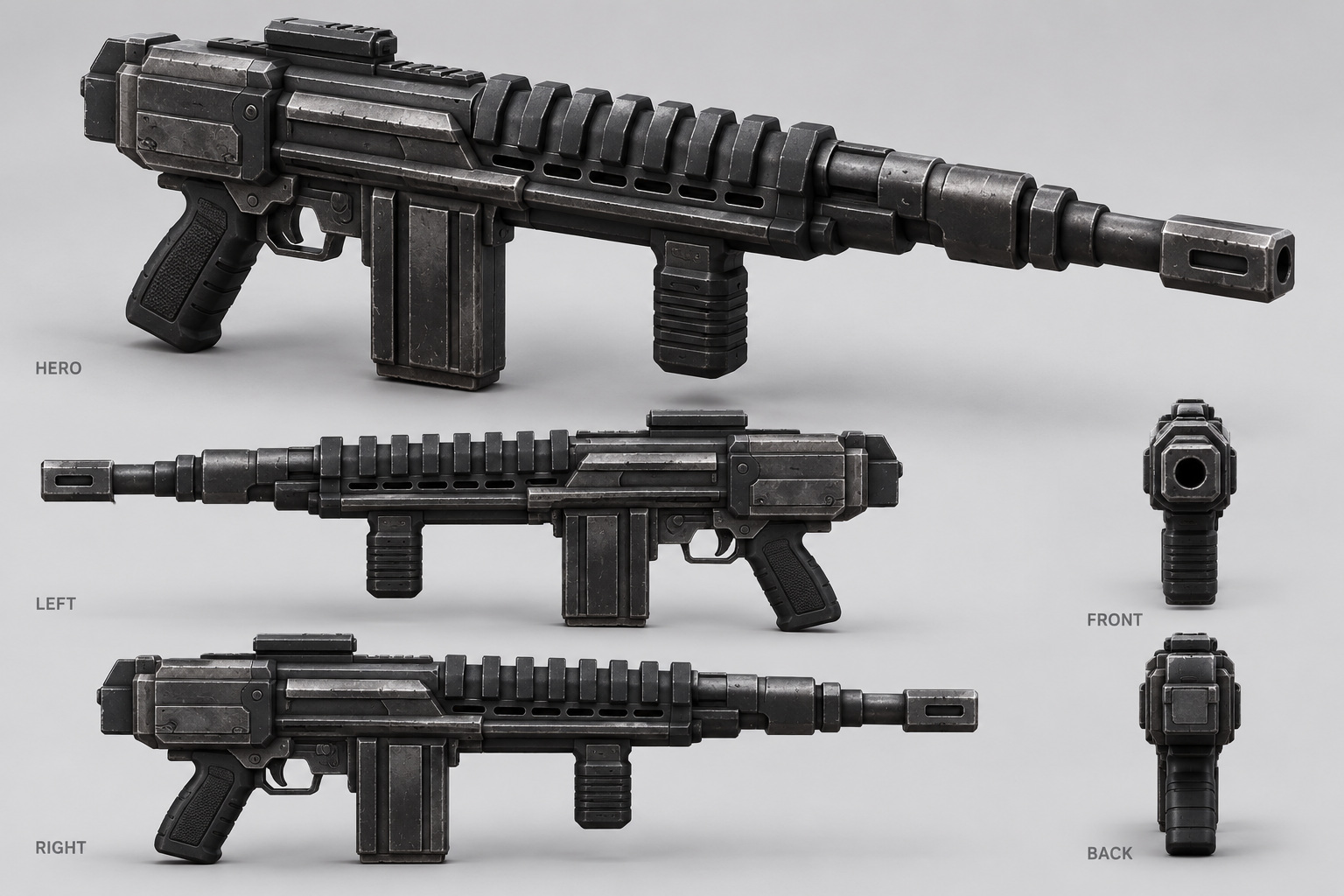
Use this dark, ribbed science-fiction rifle as the player weapon appearance. Rifle-01 is a prototype identifier, not a claim about the original game’s exact weapon name or ballistics.
Keep the receiver, ribbed shroud, barrel and compact silhouette. Author a muzzle socket, right-hand attachment, left-hand grip reference and detachable magazine for reload presentation. Hidden surfaces and small cross-view differences require a modeler’s resolution. Gameplay is specified in section 04.

REFERENCE ATLAS / ENEMY

ART-03 Black armored trooper
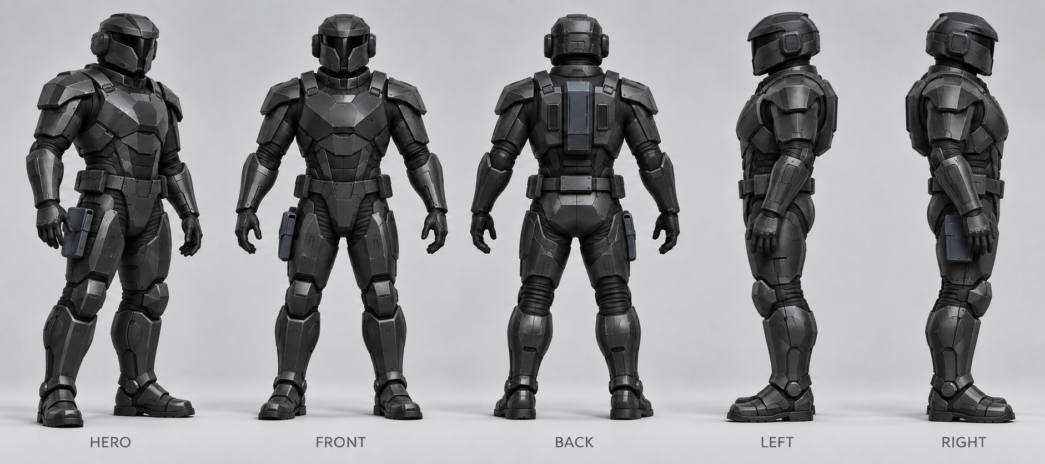
The black trooper supplies the primary armored-enemy silhouette. Its helmet and angular plates should remain distinct from the red player character.
One base model can serve rifle-trooper and heavy tuning variants during the demo. Use equipment, posture and clear UI cues to distinguish roles rather than color alone. Do not commission an additional heavy model as a baseline dependency.

REFERENCE ATLAS / ENEMY

ART-04 Government patrol officer
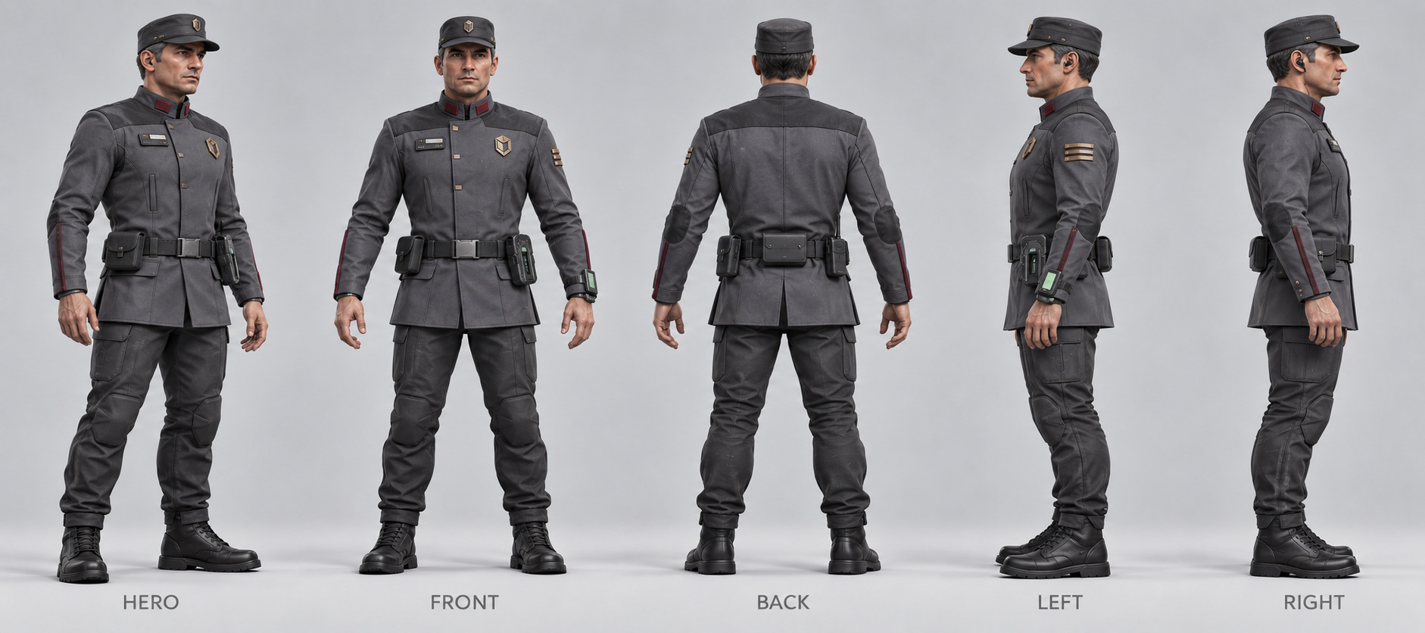
The cloth-uniform patrol officer is the lighter security archetype: service cap, exposed face, compact equipment and restrained institutional markings.
Use the same gameplay rifle with a temporary attachment setup until a separate sidearm is deliberately scoped. The wrist terminal and inspection tools are optional cosmetic props. Facial performance and bespoke dialogue are not required for the tech demo.

REFERENCE ATLAS / OPTIONAL NPC

ART-05 Civilian reference
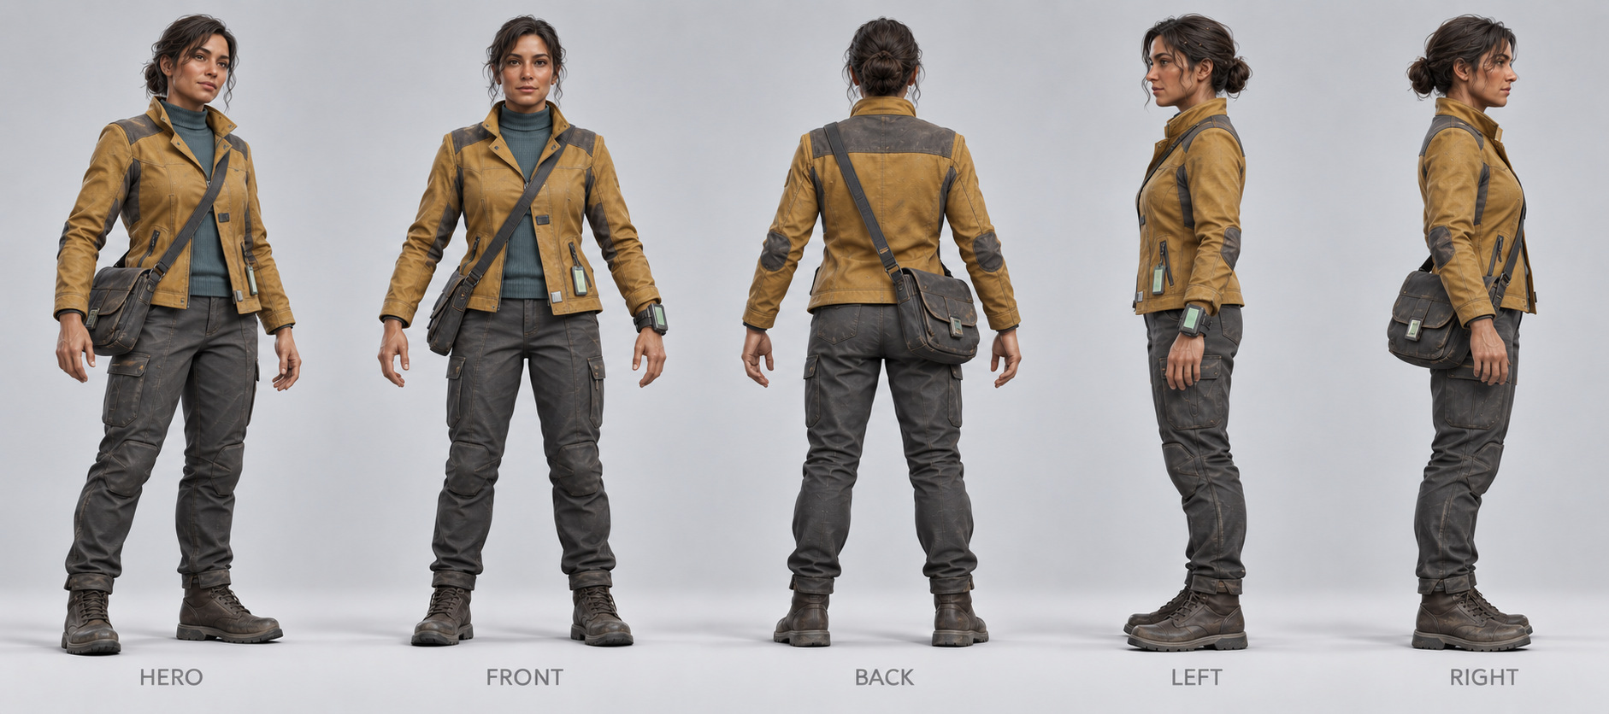
The civilian’s ochre jacket, work trousers and shoulder bag add contrast to the facility’s armored and uniformed occupants.
Optional for the final presentation pass, not required to prove combat. Behavior is limited to idle, startle, flee and take shelter. A civilian is never a required target, a resource dispenser or a condition for mission success.

REFERENCE ATLAS / OPTIONAL NPC

ART-06 Senior official reference
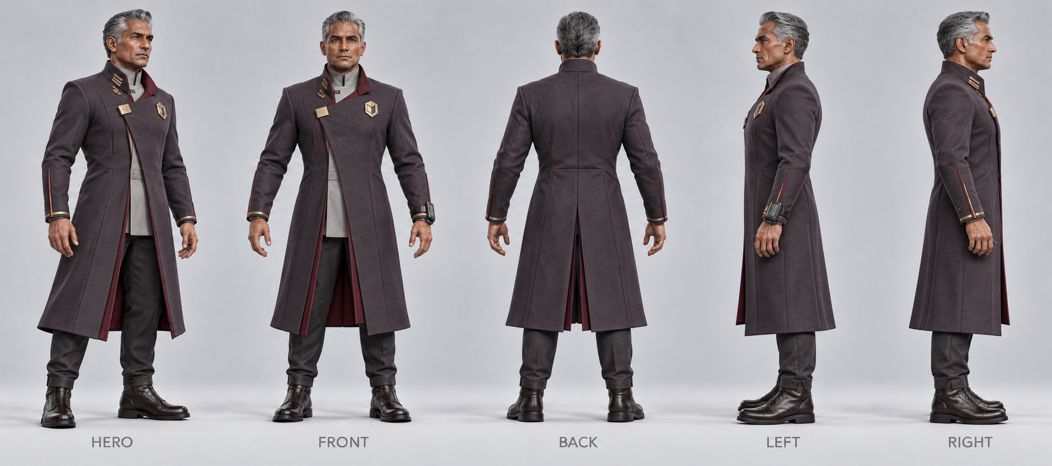
The silver-haired official and long charcoal-plum coat provide an administrative silhouette for the office. This is a proposed visual adaptation, not a named canonical character.
Optional set dressing with idle and shelter behavior. Recovering the objective must not depend on killing or escorting this character. Keep the coat rig simple; elaborate cloth simulation is outside the integration baseline.

REFERENCE ATLAS / LEVEL LOOK DEVELOPMENT

ART-07 Facility / occupied art study
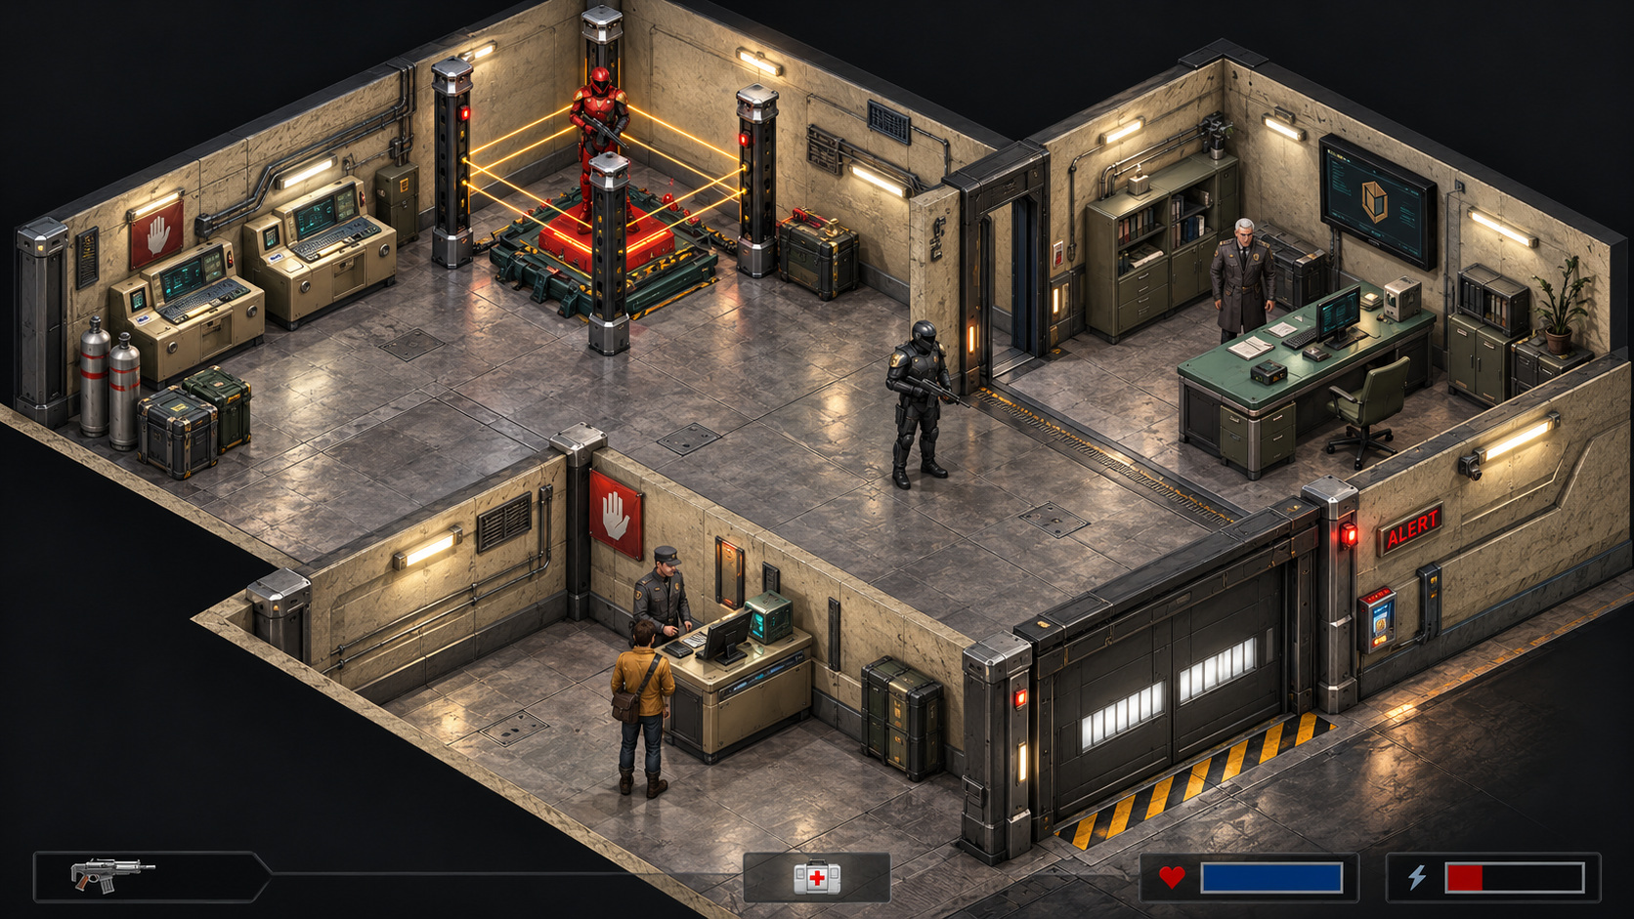
ISOMETRIC ART STUDY — NOT THE GAMEPLAY CAMERA. Reuse the industrial palette, room functions and character designs; play takes place in a rebuilt, fully enclosed third-person environment.
Character placement and the painted HUD are concept composition only. Rebuild entrances, cover spacing, ceilings and sightlines for free orbit and shoulder aiming. Section 07 defines the encounter; sections 02 and 15 override this image’s camera and geometry assumptions.

REFERENCE ATLAS / LEVEL LOOK DEVELOPMENT

ART-08 Facility / empty art study
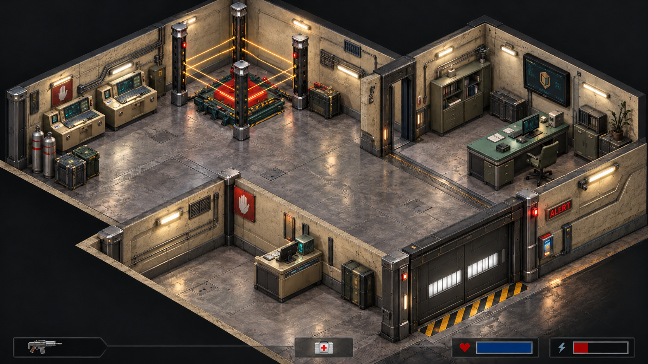
ISOMETRIC ART STUDY — NOT THE GAMEPLAY CAMERA. The cream walls, pressure doors, green furniture and four-post amber field define environment art direction only.
Create complete walls and ceilings; the black void and cutaway are not in-game presentation. Verify both camera shoulders, muzzle clearance and playable cover. The embedded HUD is not a UI asset. Widen/extend the kit as specified in section 15.

REFERENCE ATLAS / MODULAR KIT / A01–A07

ART-09 Architecture kit
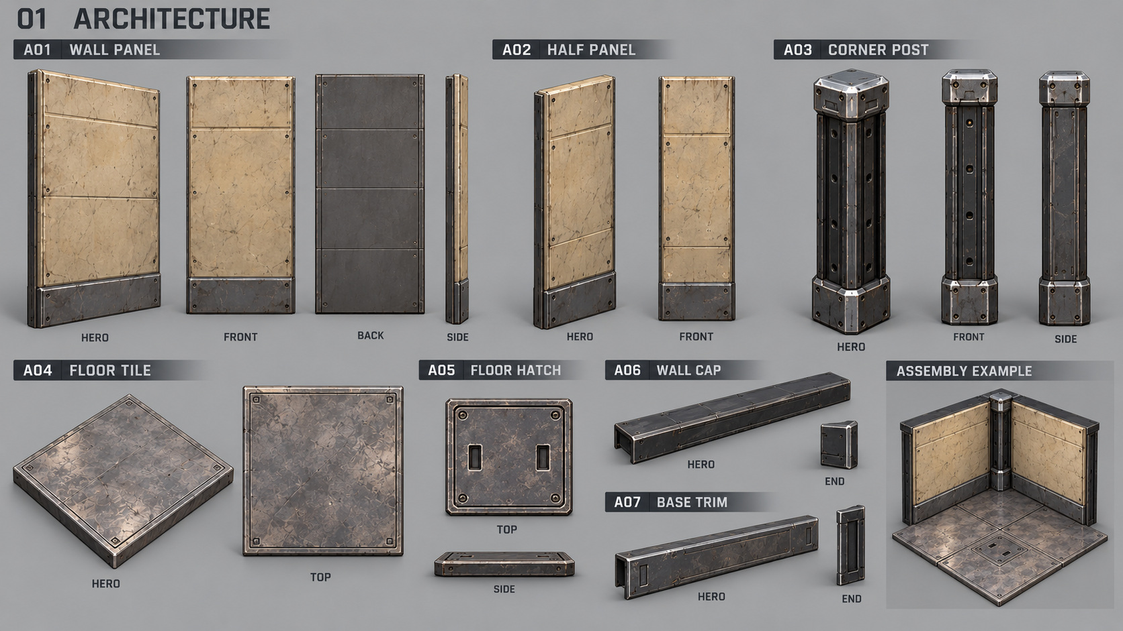
Seven visual groups: full wall shell, half shell, corner post, floor tile, hatch, top cap and base trim.
Retain the proposed modular footprint. Add upper-wall/post extensions and ceiling panels for the 360 cm third-person height target. Avoid duplicate posts and overlapping hatch surfaces. The dark back is a service-side option; occupied rooms need complete visible finishes.

REFERENCE ATLAS / MODULAR KIT / D01–D07

ART-10 Doors and portals
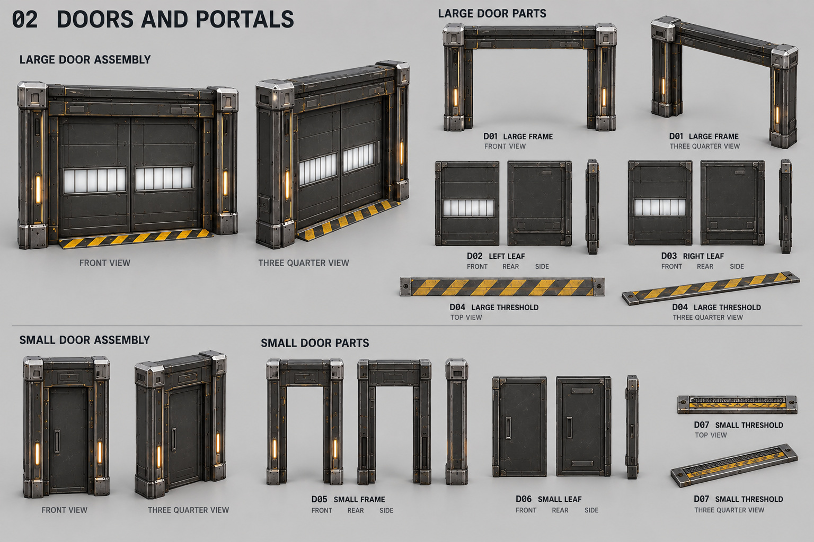
Seven groups separate static frames, moving leaves and flush thresholds for the large double door and smaller office door.
Door leaves, frames and thresholds stay separate. Block out full swept travel/pockets. The original narrow office door is an art reference; the primary office entrance uses the wider TPS variant in section 15. Test camera retraction without letting the camera, muzzle or player pass through solid jambs.

REFERENCE ATLAS / MODULAR KIT / C01–C05

ART-11 Consoles and displays
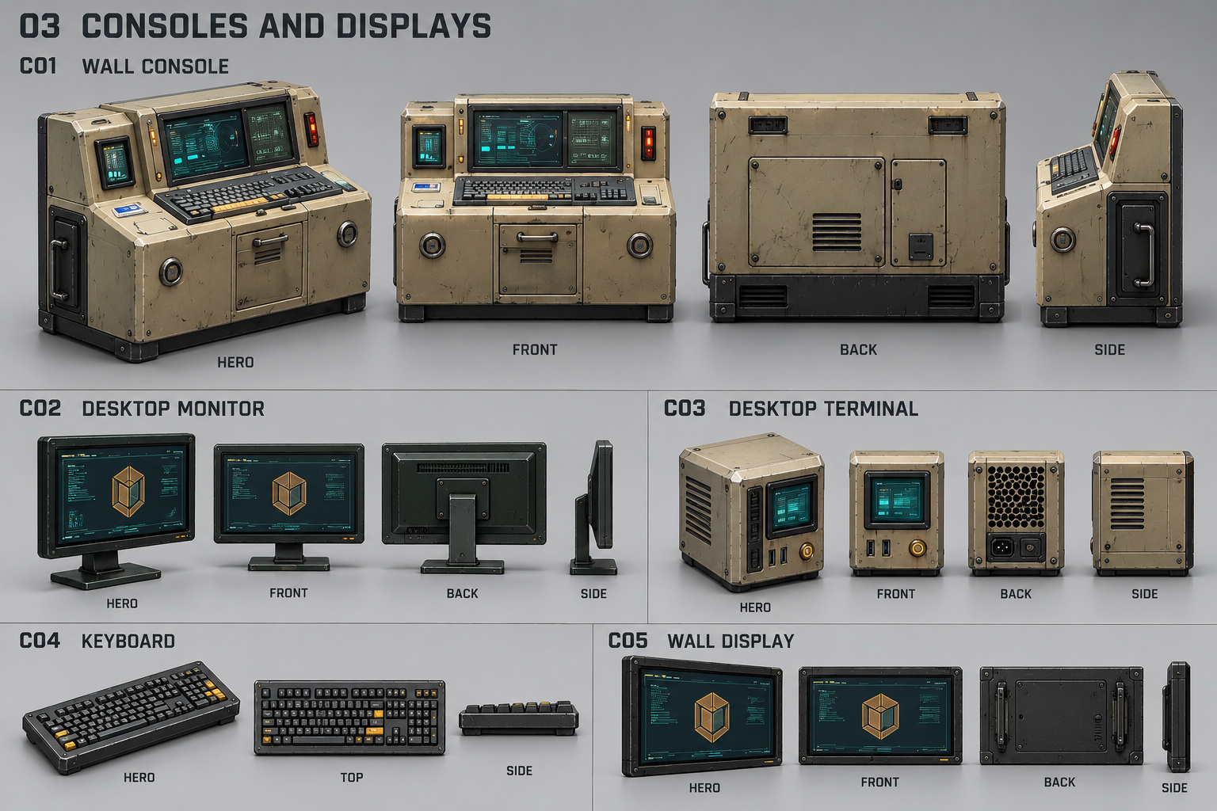
Wall console, desktop monitor, box terminal, keyboard and wall display remain separate reusable props.
Create material-driven idle, active, damaged and disabled screen states. A mission-critical console has a protected functional base or salvage fallback. Do not make progression depend on a fragile decorative monitor mesh.

REFERENCE ATLAS / MODULAR KIT / F01–F06

ART-12 Furniture and storage
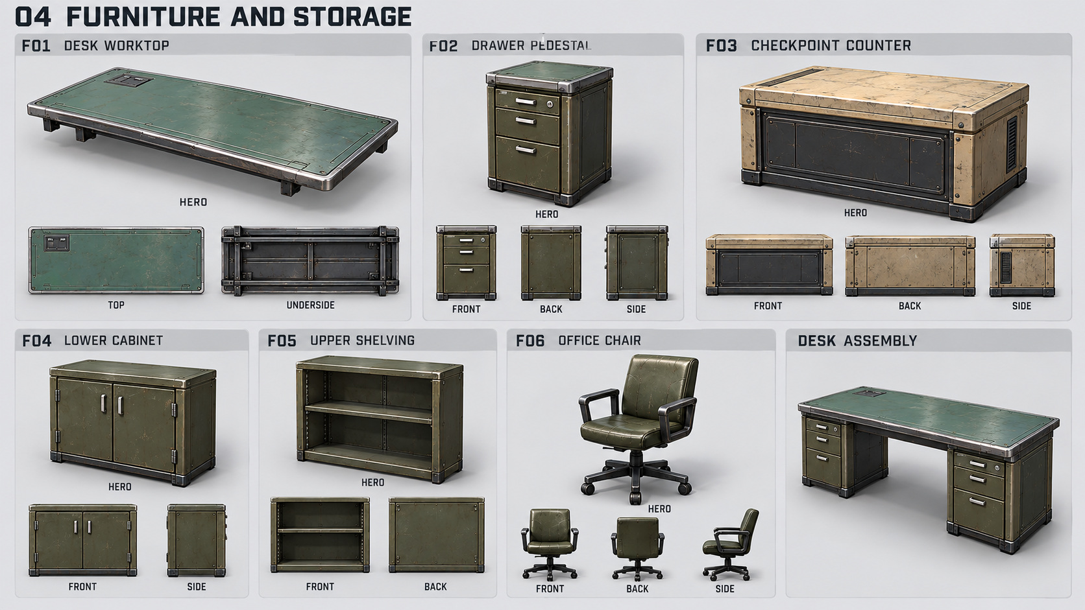
Desk top, drawer pedestal, checkpoint counter, lower cabinet, shelving and office chair form a reusable office kit.
One worktop plus two pedestals forms the desk. Separate appearance from cover collision. Prototype low cover at 90–110 cm, with a useful ruined state; check crouched camera and muzzle clearance from both sides. Preserve the widened office doorway and 3–4 m movement lanes.

REFERENCE ATLAS / MODULAR KIT / E01–E04

ART-13 Security-field assembly
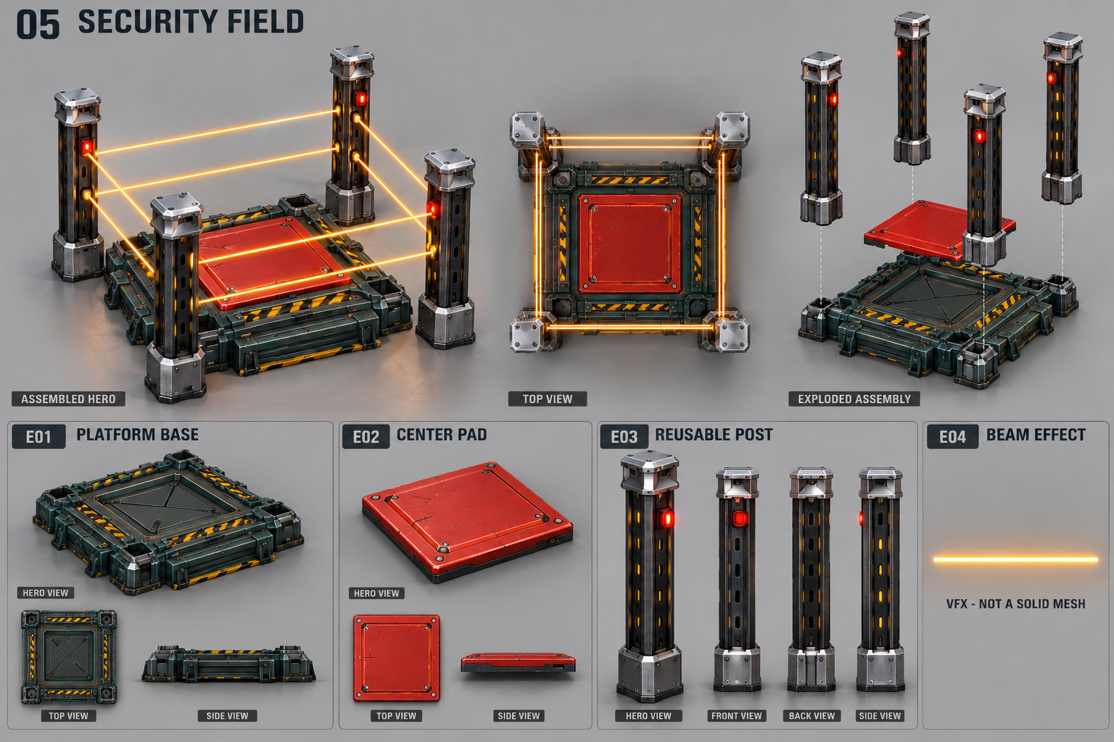
One base, one red center pad, four instances of one post, and a separate beam effect form the landmark assembly.
Beams are effects, not the gameplay barrier. Author an independently controlled collision volume. Use two square perimeter loops with eight side spans and no diagonals. The assembly’s in-demo role is a security-controlled extraction pad; after shutdown, containment beams go dark while the pad can remain powered.

REFERENCE ATLAS / MODULAR KIT / U01–U10

ART-14 Wall utilities
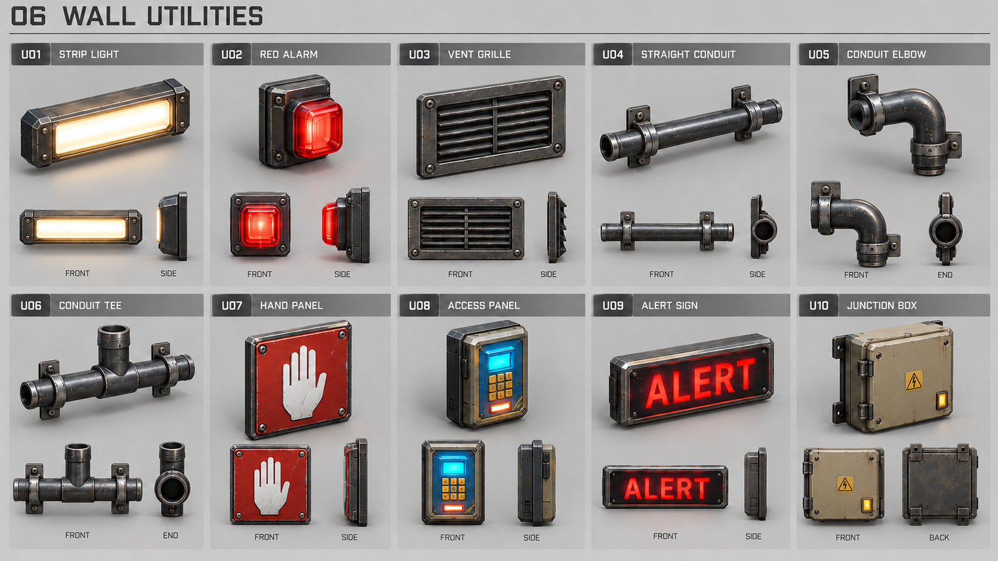
Lights, alarm, vent, conduit pieces, hand panel, access panel, ALERT sign and junction box supply modular wall dressing.
Use the corrected conduit end labels. Only designated alarm/access/junction units need gameplay interactions. Attach fixtures to full room geometry; no isometric cutaway groups are needed. Place interaction screens near character eye height and readable from shoulder view.

REFERENCE ATLAS / MODULAR KIT / P01–P06

ART-15 Containers and office dressing
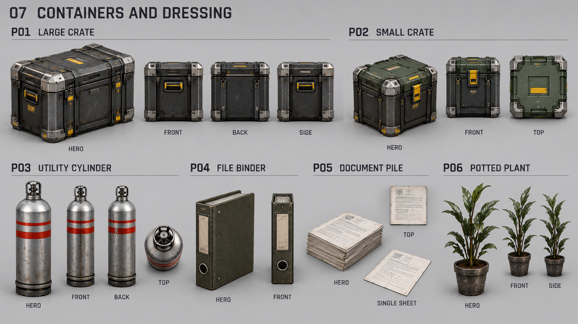
Large crate, small crate, service cylinder, binder, paper pile and potted plant provide cover and everyday scale.
Use crates for deliberate third-person cover and readable lane changes. Ordinary service cylinders are nonhazardous; a fictional hazardous variant needs distinct warnings and telegraphing. Cosmetic papers, leaves and fragments are nonblocking. Optional dressing never delays M1 or M2.

VISUAL LINEAGE / USER-SUPPLIED SCREENSHOTS

Legacy rooms / reference only
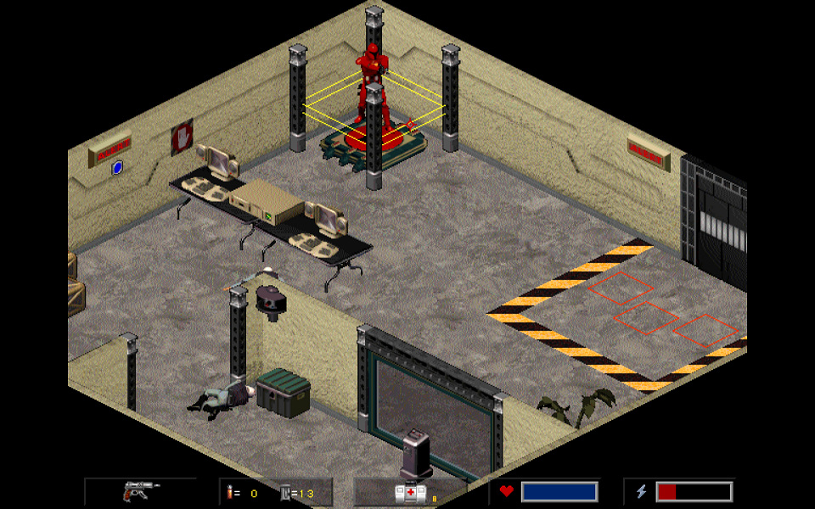 | 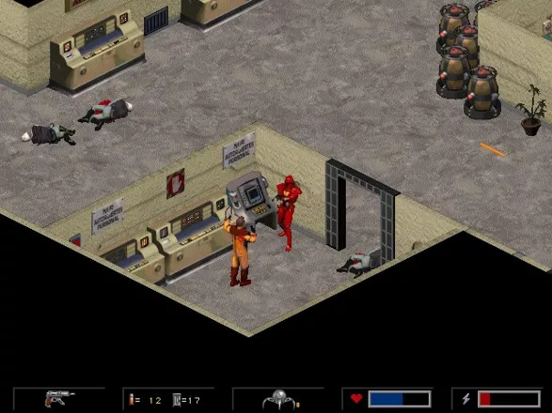
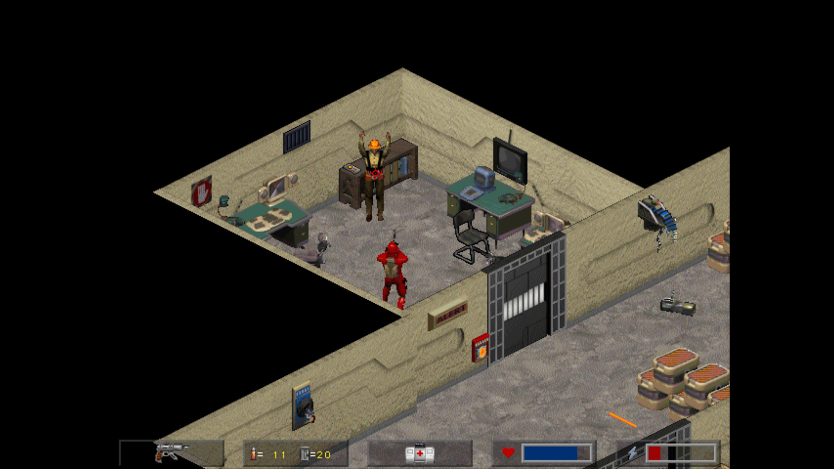
Retain heavy doors, everyday office props and strong industrial contrast—not the original camera. Rebuild the rooms for free-look third-person shooting, full-height geometry and shoulder-camera clearance. Do not treat pixels as measured dimensions.
Legacy imagery is source reference only. The new concept sheets are visual proposals; the document’s gameplay rules and verified engine sources govern the implementation.

