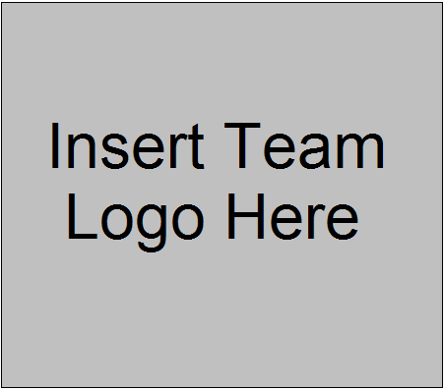

Technical Design Document
Game Name Here

Justin Gallo  Phone: #407-679-0100 ext. 1672  E-mail: jgallo@fullsail.com  Jason Hinders  Phone: #407-679-0100 ext. 1684  E-mail: jhinders@fullsail.com  Mike Lebo  Phone: #407-679-0100 ext. 1684  E-mail: mlebo@fullsail.com | Don Smith  Phone: #407-679-0100 ext 1694  E-mail: dsmith@fullsail.com  Brian Dammen  Phone: #407-679-0100 ext 1694  E-mail: bdammen@fullsail.com  Marcus Barker  Phone: #407-679-0100 ext 1694  E-mail: mbarker@fullsail.com

(This page intentionally left blank)

That means delete these lines

Table of Contents

Overview 1
Coding Standards 2
Naming Standards 2
Prefix Convention 2
Structures 2
Classes 3
Relevant Function Names 3
Macros and Constants 3
Summary of Naming Convention 3
Commenting 4
Data Alignment 4
Coding Guidelines 5
Development Environment 6
Timing Specifications 7
System Feature Breakdown 10
FX Manager 10
Game Feature Breakdown 12
Spellcasting Manager 12
System Architecture 8
Milestone Deliverables 14
Appendix A 15
Memory Map 15
Integration Plan 16
Testing Plans 17
Appendix B 18
Game Folder Hierarchy 18

Overview
This is where you state the overall purpose for this document, how the team plans to use it, and how you foresee it helping you in the production of your game. You can go over the overall layout of the doc, how things are organized and where to look for certain things.
This is where you can also briefly touch on any overall philosophies on the group as far as coding, tech design, game planning, etc. goes. Any future uses you might have for the tech that you are planning here could also be listed as this kind of thing will affect how you design your systems.

Coding Standards

Keep in mind that all of these are just examples. You might not use all of them, there maybe other sections that you do use, and you may use totally different standards than those in the example. Use whatever works best for your group and what everyone in the group can agree on.
Also keep in mind that the examples are meant to be just guidelines to get you going, and don’t represent the amount of information or effort that should be put forth for each section.

Naming Standards
What are the purposes of naming standards? What are the group philosophies on it?
You can list any naming standards you decide on as a group. They can include, but aren’t limited to, variable prefixing, structures, functions, classes

Prefix Convention
Are you going to have a variable prefix convention? Will it be some subset of Hungarian notation or some other method? Don’t just mention the method. The best way to go about it is to talk about the method, and then list ALL the prefixes the group will use.

Structures
Will the team require any naming convention or layout for the structures? Remember possible employers might read this; ANSII standard code specs for structures might be better as opposed to the visual assist variation of the standard.

Classes
Any naming conventions or layout for the class? You could work a template class layout into this section as well.

Relevant Function Names
How will you name functions? Do they have to have some sort of prefix? How readable must they be? Any size limit?

Macros and Constants
Are C-style macros allowed? What kind of things can they be used for? How must they be formatted? Where should they be declared?
How will constants be handled? Will you use #define or const variables? Where should they be declared?

Summary of Naming Convention

Summarize

Commenting
What commenting standards will you apply as a group? What formatting for file headers? Function headers? Is there a difference in commenting in .h and .cpp files? How much commenting will be enforced throughout code? What sort of things need more comments? Address comment noise. Do you have any commenting keywords to be used for various purposes?

Data Alignment
Are you going to enforce data alignment? How will it be done? What order will things need to be put in? What should be avoided?

Coding Guidelines

List anything here that you want your team to abide by when coding. This can be absolutely anything that you’ve decided to make uniform across all your code. For examples:

- Singleton classes must contain both an Initialize() and Shutdown() functions

Go into more detail with any guidelines you put in so that there aren’t any questions as to how things must be done.

Development Environment
This section is for detailing out the tools that your team plans on using. Compiler, editors, 3D modeling tools, shader creation tools, etc. List and describe all the programs you will be using to assist you in the development of your game(also include the version of these applications). This includes any 3rd party libraries you will use in your game (Novodex, NetZ, OpenAL, etc.)

Timing Specifications
This section is for laying out the planned timing of your game. How many frames per second will the game run? Things to think of would be how often will the main game be rendered? How often will the HUD be rendered? How often will pathfinding be updated? How long will be spent on processing input or collision? Also talk about any threading you will be doing. What processes will be running in which threads and what interaction is required between them.

System Architecture

Description: This should be the overall purpose of the system (i.e. to run a game). You want to specifically address goals from the Design Doc and show how your system is designed to achieve these goals.
E.g. - To allow for multiple levels while keeping memory to a minimum we plan to load levels from a file created by our level editing tool, and unload them as soon as they are no longer needed. (We should then see the described functionality both here in the context model and later in that specific module’s “Module Break Down” section.)

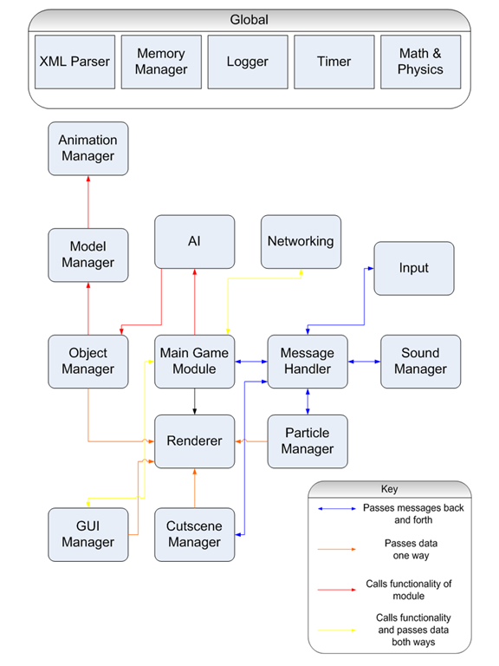
Context Model Description: Following the Context Model should be a brief description noting all relationships shown in the diagram. Any tools that appear outside of the software boundary should be noted as such. Any 3rd party software that is incorporated into your system should also be discussed here, as far as how it will be used and what kind of interactions with the rest of the system there will be. A key should be included showing what each different type of relationship entails.

System Feature Breakdown

The system feature breakdown is the mid-level design to actual implementation of low-level engine components. Each subsystem defined should include a description of what the module does; any dependencies required for the system to work as intended; all features and subcomponents of the module; the risks associated with creating the module; and the expected time of completion for the system. In addition, any special information and examples needed to use the system should be documented here as well. An example of this would be the ‘Effect Script Example’ in the FX Manager example listed below. Ideally, modules should be laid out in the same order that they will be implemented (i.e. the FX Manager module would come after the module breakdowns for Timer, LUA Script Loader, Sound, etc. It would come before the Cut-scene breakdown). The system description for the ‘FX Manager’ should be considerably larger than the one provided in the example. Any applicable third-party software contained within the module should be described in the system breakdown (i.e. if FMOD is used in the Sound Manager then it should covered in the Sound Manager Description). Some modules may be inter-dependent on each other and it is a judgment call as to which would go first in the doc.

FX Manager
This module is responsible for controlling all of the audio/visual effects in the game. It will create compositions of the various effect pieces and will coordinate between all the components such as: shader effects, particle effects, sound effects, animations, etc. It will internally deal with the timing issues in one central location required to ensure effects run smoothly. Effects will be stored and read-in from LUA script.

Dependencies
- Access to the following: (FX Manager can not be written until the following modules are completed)
  - Timer
  - LUA Script Loader
  - Sound Manager
  - Particle Manager
  - Animation Manager
- Accessed by the following:
  - Cut-scene manager
  - Main Game Engine

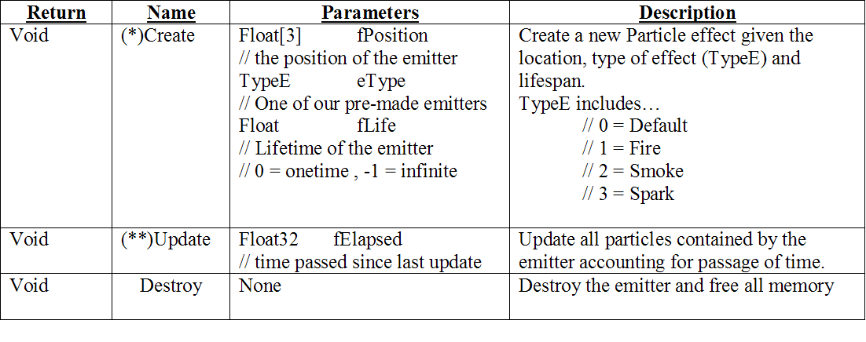

Features
- Allows the combination of multiple systems into one controllable Effect Object and the management and replication of these objects-known as Effect Instances, in the game world.
- Effect Object
  - Maintains information about how to manipulate the subsystems to produce one combined effect.
- Effect Instance
  - Keeps track of state-based information for unique instances of Effect Objects in the game world (timing, position, etc.)

Effect Script Example

// Our Fire Effect
EFFECT fire {
Duration(2.0);
Sound(effect_fire_crackling, 0.0, 1.0);
Emitter(particle_fire, 0.0, 0.5);
Emitter(particle_smoke, 0.25, 1.0);
Shader(heat_wave, 0.0, 1.0);
};
// One instance of our Fire
INSTANCE fire_1 {
Effect(fire);
Position(0.0, 1.0, 0.0);
};

Associated Risks
Risk: | Affected Resource: | P | C | RF
LUA integration with C++ code may not get completed because of library incompatibility | Mike Lebo | .5 | .3 | .65
 | Response or avoidance:
Support Lua library building with examples from LuaWiki

If not done by FF2
Use simple text parsing to read in effect files
If not done by alpha
Hardcore effects in C++ function calls

Note: The same rules apply as the Gantt chart no estimate and cannot be longer then 3-5 days (depending on the team’s EP) and every task has to be at least 1 day.
Time to Complete Estimate
- Research 1 day
- Implementation 2 days
  - Effect pieces integration 1 day
  - Timing Issues 1 day
- Testing 1 day
- Integration 1 day

Module Author(s)
- Mike Lebo

Game Feature Breakdown

The system feature breakdown is the high-level design to actual implementation of game specific technology. These are the modules that create the actual gameplay. Each subsystem defined should include a description of what the module does; any dependencies required for the system to work as intended; all features and subcomponents of the module; the risks associated with creating the module; and the expected time of completion for the system. In addition, specific algorithms used in the module should be laid out, as well as descriptions of specific uses of the module. (i.e. listing out each type of spell effect and its components) Ideally, modules should be laid out in the same order that they will be implemented (i.e. the Spellcasting Manager module would come after the module breakdowns for Player, FX Manager, etc. It would come before the Main Game module). Some modules may be inter-dependent on each other and it is a judgment call as to which would go first in the doc.

Spellcasting Manager
This module is responsible for controlling all of the spells and their effects that will exist in the game. It will take care of determining whether the player has enough energy to cast the desired spell, the effect associated with the spell, and any responding actions. This will allow the players to not have to contain any information about spellcasting aside from energy points and a list of which spells they can currently cast. The HUD will access the spellcasting manager to determine what graphical representations to use for each spell on the interface.
The available spells within the game will be fireball, ice bolt, heal, invincibility and immobility.

Dependencies
- Access to the following: (Spellcasting Manager can not be written until the following modules are completed)
  - Player
  - FX Manager
  - Projectile Manager
- Accessed by the following:
  - HUD
  - Main Game Module
  - Collision Module

Algorithms
- Spell Resistance
  - val = yourLevel(atk_rating) / oppLevel(def_rating);
if (1 <= val)
hit(val(spell_dmg))
else
resistSpell()

Spell Composition (All spells should be here)
- Fireball
  - Energy Check (15 Energy)
    - If enough energy, lower energy by 15
  - Fireball_Casting_Effect (using FX Manager)
    - Casting Animation
    - Casting Sound Effect
    - Motion_Blur Shader
    - Fire_ball_cast Particle Effect
    - Fire_ball_cast Sound Effect
  - Fire_ball_projectile_Effect (using FX Manager)
    - fire_ball Particle Effect,
    - Fire_ball model,
    - Fire_crackling Sound Effect)
  - On Hit:
    - Spell Resistance Check
      - Update HUD if entity hit is a player
      - Update health by determined amount from spell resistance algorithm
    - Fireball_Hit_Effect (using FX Manager)
      - Spell_Damage Animation
      - Fire_ball_splash_damage Particle Effect
      - Fire_ball_collision Sound Effect
    - AOE damage check (5 feet)

Note: This example has no risk section. If no risk can be quantified, if risks are tasks, or any of the normal options that disqualify risks, then omit that section from the doc. The same applies to any section; instead of writing N/A or nothing for any section, just omit that section of the document. If there is a risk, then the risk section would be added here.

Module Complete
Note: This module was already complete, so there is no need to show how long the author had worked on this. Make sure if the module is complete, it is still reflected in the Gantt chart as a milestone at the start of the project.

Module Author(s)
- Marcus Barker

Milestone Deliverables
This section is for laying out what portions of the tech will be completed for each milestone that is laid out. It also serves as a way to see in what order tech will be worked on and when it will be available in the main build. Once these are laid out it will help you in the development of your schedule. At minimum you must break it down for Proof of Concept, Feature Fragment #1, Feature Fragment #2, Alpha, and Beta (must match Gantt chart). Make sure your milestone deliverables match the criteria for the milestone.

Appendix A

Memory Map

This section details how you are going to utilize your memory (RAM). Once you’ve determined how much memory your program is going to use, it can usually be helpful to break it up into various sections that will be used for specific purposes. I.e. A certain chunk for level data, a chunk for character data, a chunk for dynamic memory usage, etc. This will help ensure that you don’t exceed your specified memory use, and will force you to better manage your memory. (Note: Level information could be broken further into model geometry, textures, other information such as spawns, powerups, etc.)
If the application is dumping information to the video card or any other media, include additional memory maps for each media the application will store and or use memory.

Total memory footprint here (128MB)

2 Meg for Executable
32 Meg for Level information
……
……
……

Integration Plan

This section is for documenting how you plan to handle the difficult task of integration. It should cover such things as who is responsible for integration, what method of source controls software you’re going to use, and when integrations are done. It’s also necessary to cover what makes any module or file a candidate to be integrated. Discuss what kind of testing needs to be completed, what acceptable amount of bugs there are, what happens if an integrated module breaks something, and when a full rollback would take place. It is also necessary to discuss how the team will know a rollback is needed.
When it comes to the source control software, discuss whether multiple file check-out is allowed, how many files can be checked out by one person at a time, a certain time things must be checked in by, etc. Basically, lay out the guidelines for the source control server to make sure there are no questions by anyone on the team

Testing Plans

This section is for documenting how you plan to handle the testing phase of the project. Detail who is going to be in charge of maintaining the bug database for your team, how individual bugs will be assigned to team members, how often the bug database will be updated, and when the bugs will be worked on.
List anything that you plan to do in addition to the testing that will be done by the Gaming Project Studio staff and listed in the studio bug database. If you have outside testing planned, internal dev team testing, or anything else, list it here. Who is the QA lead? How, exactly, are bugs assigned to group members? When and who will the check the database and when will the database get updated? When will the bugs get worked on (also reflected in the Gantt)?
Include a sample bug report. Don’t forget to define bug priorities (i.e. medium – does not crash game, high – crashed game, etc.)

Appendix B

Game Folder Hierarchy

This section is for laying out the directory structure for your project. Organizing your source files, scripts and assets will make everything easier to find once you start getting a large number of each as you work on your game. It helps to organize everything and keep things separated.
