If you get the bellow error:

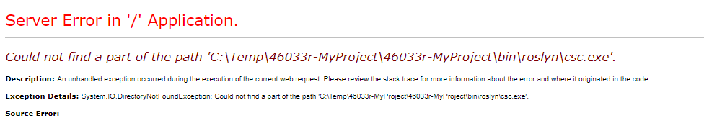

Go to the project web.config and add the below before the very last line.

<appSettings>

<add key="ValidationSettings:UnobtrusiveValidationMode" value="None" />

</appSettings>

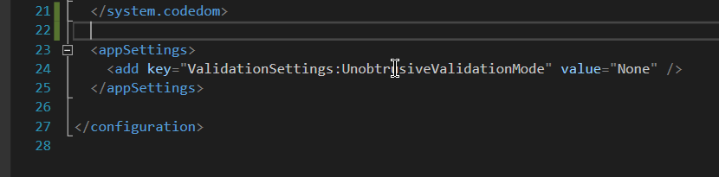

Copy the Database1.mdf into you App Data folder in Visual Studio in order the login functionality to work.

