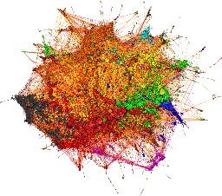

Graph Convolutional Layer

Graph Convolutional Layer

In features: 128 Out features: 64

In features: 64 Out features: 32

Graph Convolutional Layer

Features: 128

Input Graph Data

Output

In features: 16 Out features: 4

In features: 32 Out features: 16

Linear Layer

ReLU

ReLU

ReLU