TBMI26 – Computer Assignment Reports  
Boosting

Deadline – March 15 2019

Author/-s:

In order to pass the assignment you will need to answer the following questions and upload the document to LISAM. You will also need to upload all code in .m-file format. If you meet the deadline we correct the report within one week after the deadline. Otherwise we give no guarantees when we have time.

1. **Plot how the classification accuracy on training data and test data depend on the number of weak classifier (in the same plot). Be sure to include the number of training data (non-faces + faces) and the number of Haar-Features.**

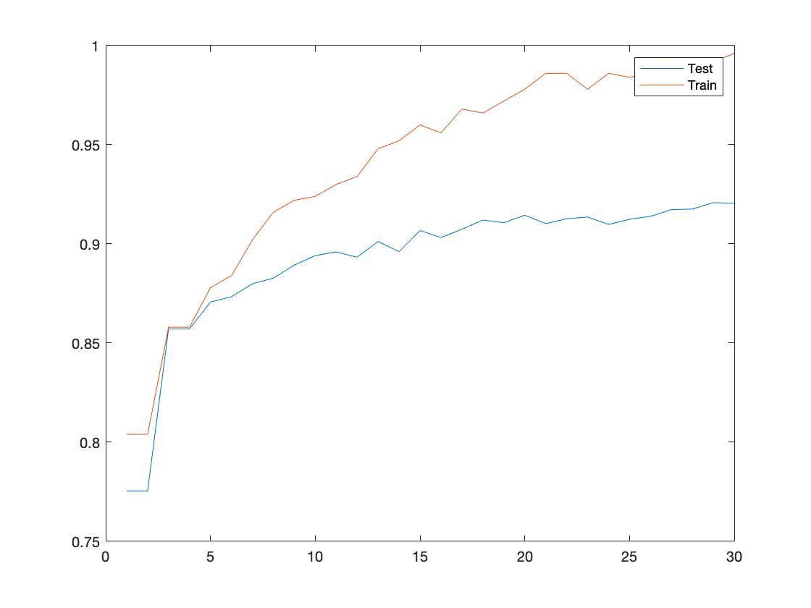

Training data: 500 images

Haar-features: 100.

1. **How many weak classifiers did you chose before testing the data?**

30.

1. **How many weak classifiers did you use for final strong classifier? Why?**

In the code we choose 30 because it was most accurate, but one could also choose a value around 15 which will give an accuracy of 0.9. After this the graph evens out so the gain in accuracy is not significantly better with more weak classifiers.

1. **What is the accuracy on the test data after applying the optimized strong classifier?**

92.45%.

1. **Plot some of the misclassified faces and non-faces that seem hard to classify correctly.**

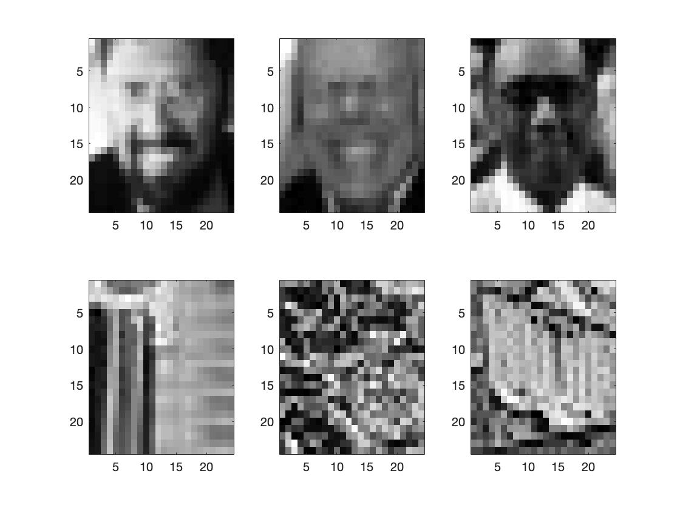

1. **Defend your results. Are they reasonable?**

Yes, most of the images were correctly classified. The faces above have very even color distribution, so if a haar-feature is applied on these faces there is not much difference in the images. While in the images of no faces above, there is a lot of different patterns, which might mislead the classifier.

1. **Can we expect perfect results?**

We don’t think so, since there is always an element of uncertainty because the haar-features are randomized and can match with the wrong patterns. Also, if the plot of the accuracy given the number of weak classifiers is extended with a lot of classifiers, the graph plans out on around 93-94%. This suggests that we cannot except perfect results.