ATTACKS (SHELBY)
- No_attack PSNR=41.645 dB (D: NC=1.000, BER=0.000) (U: NC=0.999, BER=0.001)
- JPEG_Q70 PSNR=38.594 dB (D: NC=1.000, BER=0.000) (U: NC=0.783, BER=0.336)
- Gaussian_noise_10 PSNR=28.286 dB (D: NC=0.876, BER=0.203) (U: NC=0.852, BER=0.240)
- Rotation_20deg PSNR=14.094 dB (D: NC=0.706, BER=0.446) (U: NC=0.667, BER=0.490)
- Rotation2_20deg PSNR=26.689 dB (D: NC=0.800, BER=0.321) (U: NC=0.931, BER=0.116)
- Resize_0.5 PSNR=35.915 dB (D: NC=0.869, BER=0.216) (U: NC=0.662, BER=0.493)
- Median_3x3 PSNR=38.461 dB (D: NC=0.833, BER=0.269) (U: NC=0.641, BER=0.518)
- Blur_1.0 PSNR=37.345 dB (D: NC=0.833, BER=0.271) (U: NC=0.959, BER=0.069)
- SaltPepper_0.01 PSNR=24.008 dB (D: NC=0.922, BER=0.131) (U: NC=0.976, BER=0.041)
- Cropping_25pct PSNR=22.604 dB (D: NC=0.932, BER=0.132) (U: NC=0.999, BER=0.001)
- Brightness_20pct PSNR=27.124 dB (D: NC=0.734, BER=0.407) (U: NC=0.999, BER=0.001)
- Gamma_0.9 PSNR=32.033 dB (D: NC=0.788, BER=0.331) (U: NC=0.999, BER=0.002)
- RowCol_Blanking PSNR=22.735 dB (D: NC=0.706, BER=0.443) (U: NC=0.899, BER=0.166)
- RowCol_Copying PSNR=39.677 dB (D: NC=0.983, BER=0.029) (U: NC=0.983, BER=0.029)
- Bitplane_LSB PSNR=40.650 dB (D: NC=0.999, BER=0.001) (U: NC=0.949, BER=0.087)
Under every row of pictures from left to right: Attacked watermarked image, Extracted watermarks from D matrix, Extracted watermarks from U matrix.
No attack
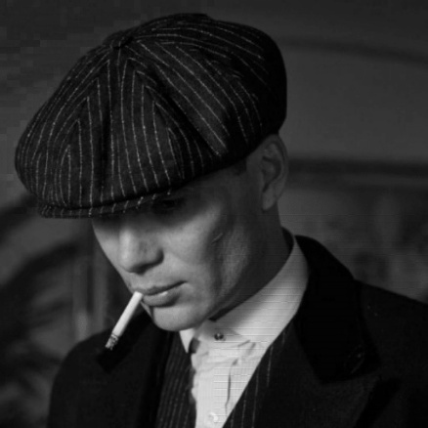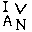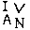

JPEG Q70
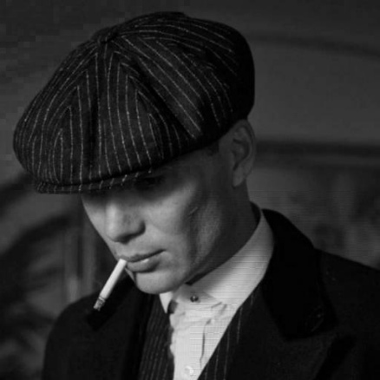

Gaussian noise 10
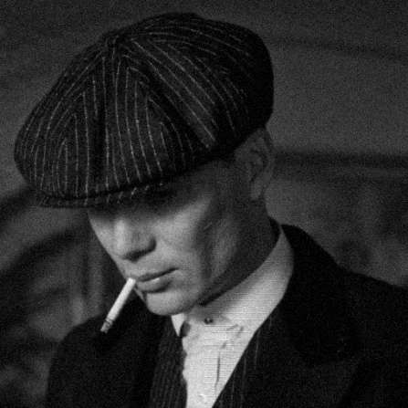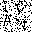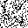

Rotation 20°
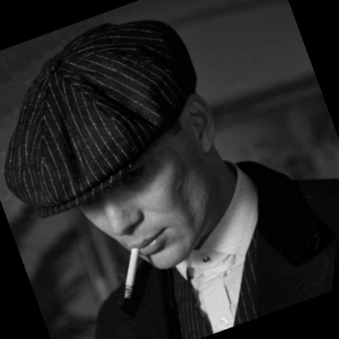

Rotation2 20°
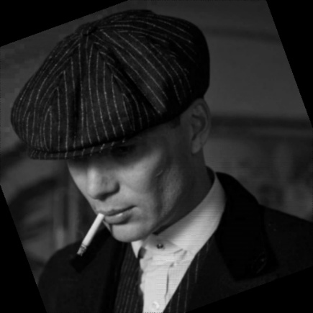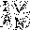

Resize 0.5
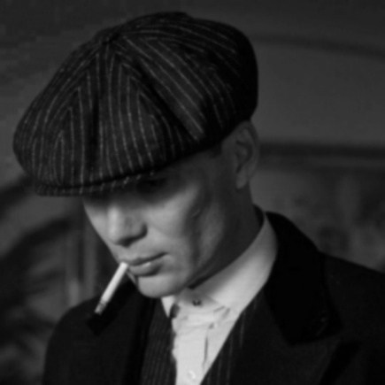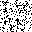

Median 3x3
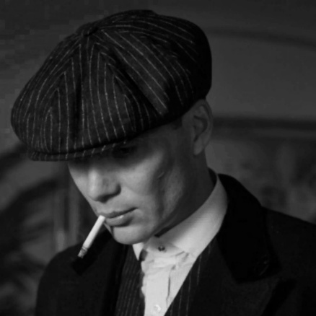

Blur
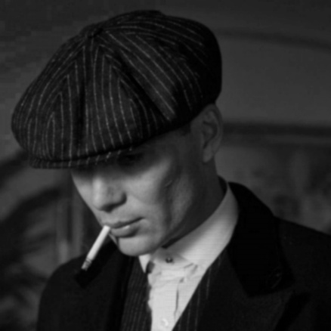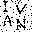

Salt and Pepper
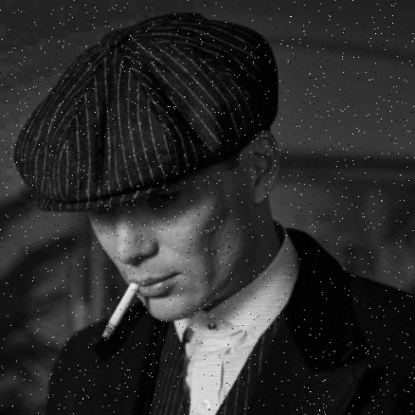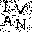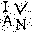

Cropping 25%
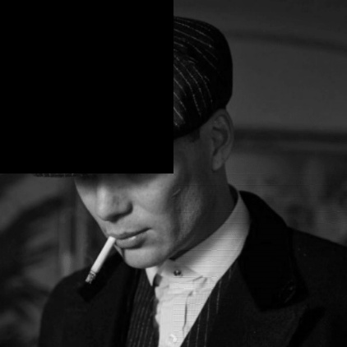

Brightness 20%
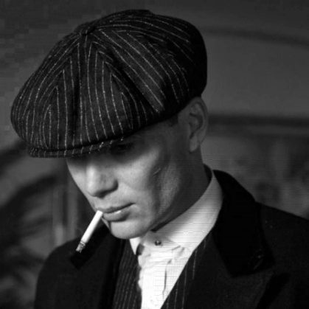

Gamma Correction (gamma=0.9)
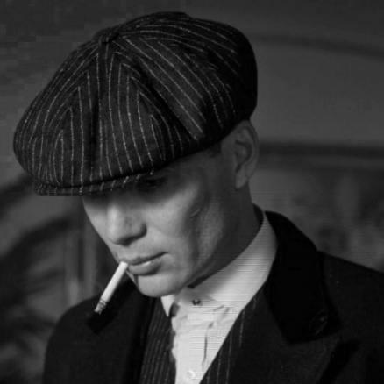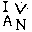

Row Column Blanking
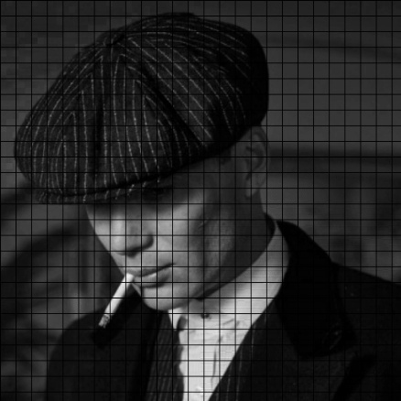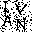

Row Column Copying
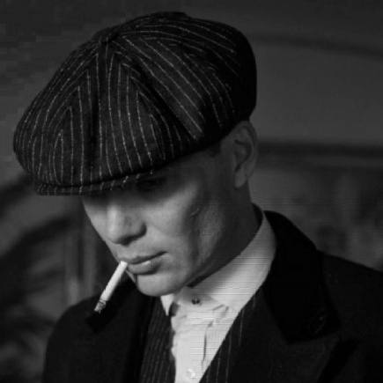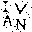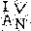

Bit Plane Removal (LSB)
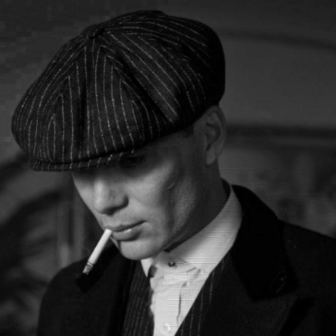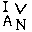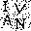

ATTACKS (LENA)

No_attack PSNR=39.270 dB (D: NC=1.000, BER=0.000) (U: NC=1.000, BER=0.000)

JPEG_Q70 PSNR=38.481 dB (D: NC=1.000, BER=0.000) (U: NC=0.998, BER=0.004)

Gaussian_noise_10 PSNR=27.774 dB (D: NC=0.858, BER=0.231) (U: NC=0.988, BER=0.021)

Rotation_20deg PSNR=12.215 dB (D: NC=0.728, BER=0.418) (U: NC=0.710, BER=0.441)

Rotation2_20deg PSNR=16.800 dB (D: NC=0.917, BER=0.143) (U: NC=0.989, BER=0.019)

Resize_0.5 PSNR=36.944 dB (D: NC=0.984, BER=0.028) (U: NC=0.798, BER=0.318)

Median_3x3 PSNR=40.929 dB (D: NC=0.994, BER=0.010) (U: NC=0.674, BER=0.482)

Blur_1.0 PSNR=38.513 dB (D: NC=0.979, BER=0.037) (U: NC=0.957, BER=0.073)

SaltPepper_0.01 PSNR=25.179 dB (D: NC=0.818, BER=0.290) (U: NC=0.982, BER=0.031)

Cropping_25pct PSNR=13.385 dB (D: NC=0.932, BER=0.132) (U: NC=1.000, BER=0.000)

Brightness_20pct PSNR=21.291 dB (D: NC=0.691, BER=0.459) (U: NC=1.000, BER=0.000)

Gamma_0.9 PSNR=29.955 dB (D: NC=0.994, BER=0.010) (U: NC=1.000, BER=0.000)

RowCol_Blanking PSNR=17.024 dB (D: NC=0.843, BER=0.253) (U: NC=0.900, BER=0.165)

RowCol_Copying PSNR=37.775 dB (D: NC=0.993, BER=0.012) (U: NC=0.993, BER=0.012)

Bitplane_LSB PSNR=38.709 dB (D: NC=0.992, BER=0.014) (U: NC=1.000, BER=0.000)

No attack
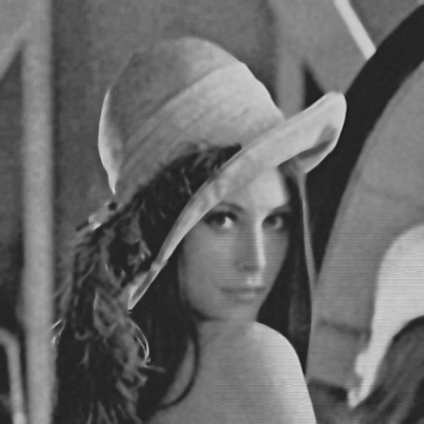

JPEG Q70
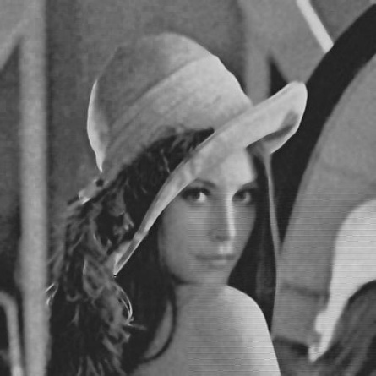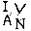

Gaussian noise 10
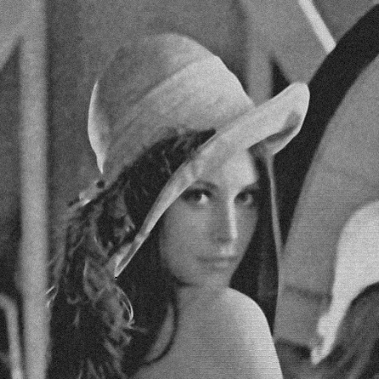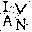

Rotation 20°
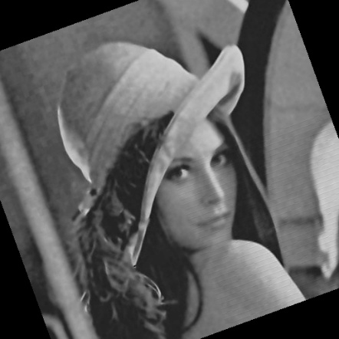

Rotation2 20°
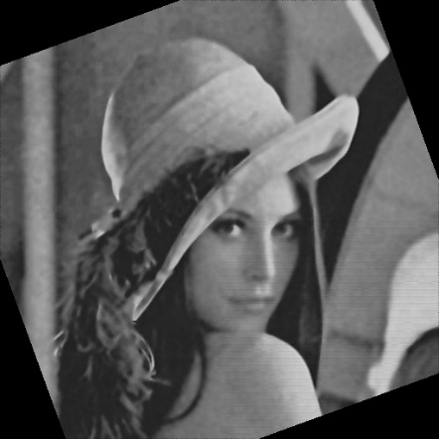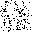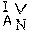

Resize 0.5
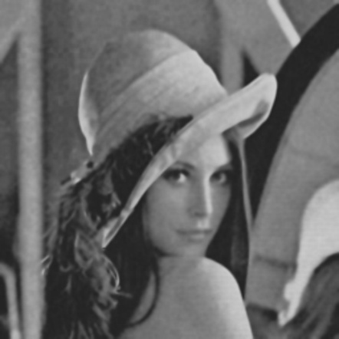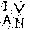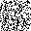

Median 3x3
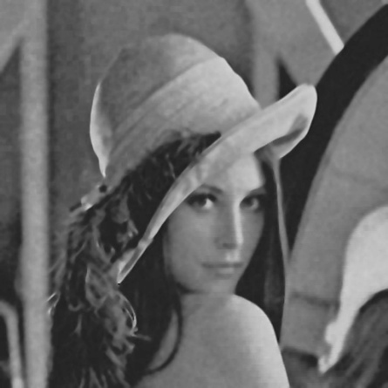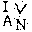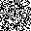

Blur
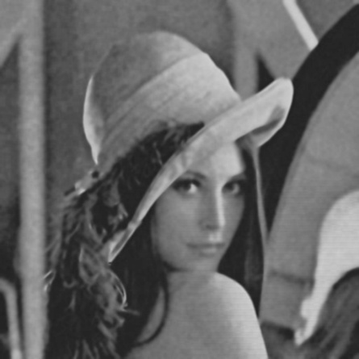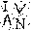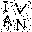

Salt and Pepper
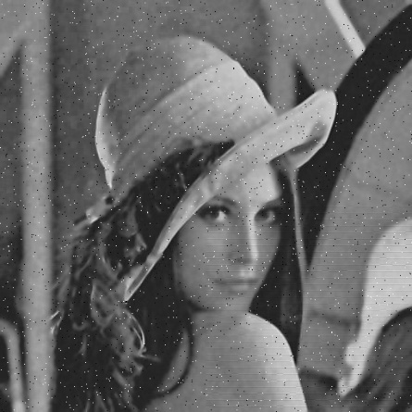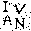

Cropping 25%
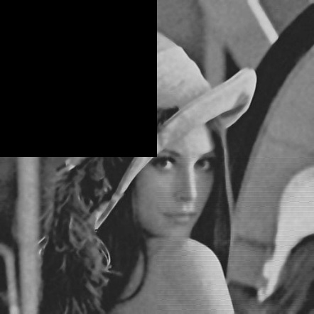

Brightness 20%
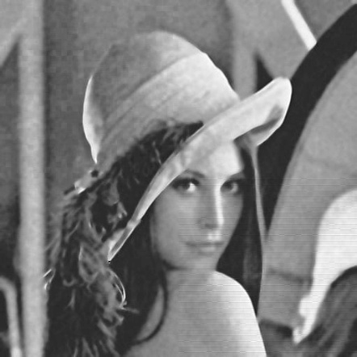

Gamma Correction (gamma=0.9)
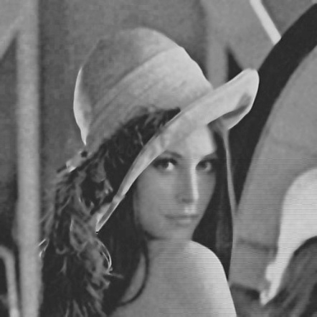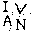

Row Column Blanking
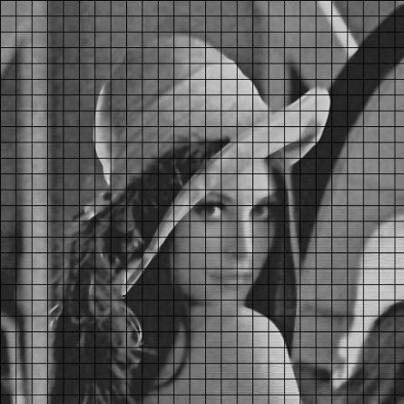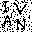

Row Column Copying
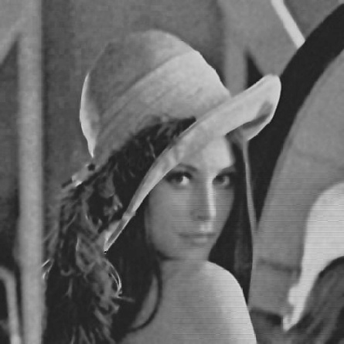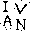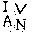

Bit Plane Removal (LSB)
