Kristie Desiree Ly

**<http://ngx.sfsu.edu/~kly5/loginpagewithsql.php>**

**(1) 4 tables created.**

* Table eggs with animalid (primary key), eggtype, price, sellprice
  + This table has information about the eggs, such as animalid (what type of animal it hatches into), eggtype (the name of the egg ‘dragonEgg’ etc), price to buy it for, and price to sell it for
* Table animals with fields animalid (foreign key), goldperhour, lifespan
  + This table has animalid (referencing eggs table), how much gold it lays per hour, and how long the animal can live
* Table userinfo userid (primary key), username, password, gold
  + Userid is auto incremented, username and password saved from the login form, gold amount
* Table useranimals with userid(foreign key), mouse, snake, rabbit, rooster, pig, rabbit etc
  + For my game, there are 12 types of animals that can be won. This useranimals table has userid and the number of each mouse, snake, rabbit, etc they have

**(2)** [**http://ngx.sfsu.edu/~kly5/loginpagewithsql.php**](http://ngx.sfsu.edu/~kly5/loginpagewithsql.php) **~I can’t figure out how to connect to the SQL database through NGX server so it only functions on local host.**

**A. Login page**

User can login with username and password. It validates so neither can be blank.

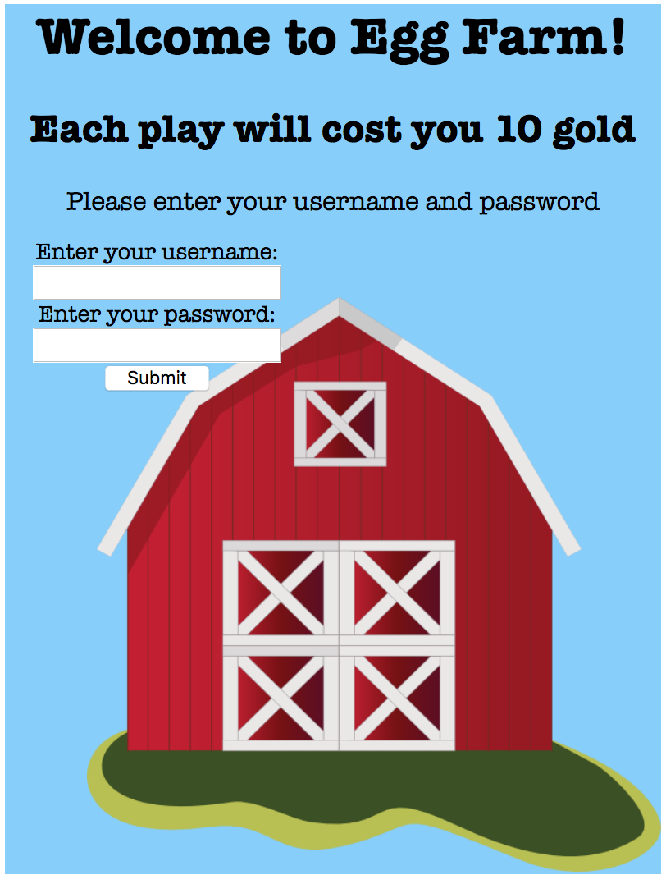

**B. Navigation page**

It welcomes the user and displays their gold amount. If username is registered for the first time, they are granted with 150 gold.

User can choose to go to one: the egg store page, their farm, or the top scoreboard

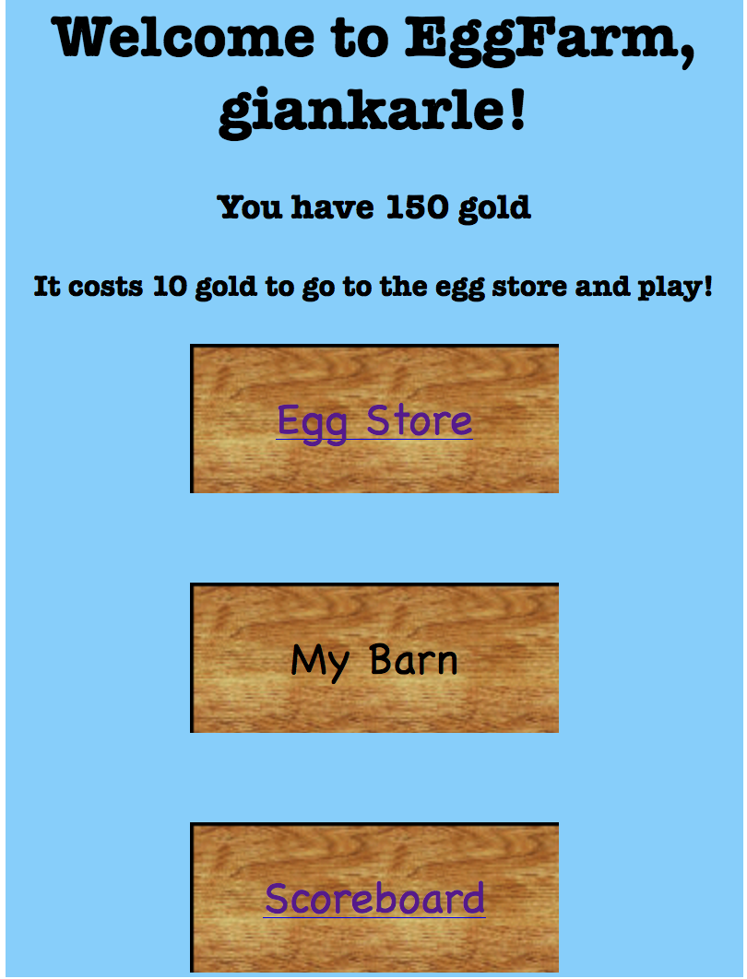

**C. Eggstore**

Since each gameplay costs 10 gold, the gold decrements by 10 by the time the user arrives at this page.

Gold amount that the user has is displayed at the top.

The eggs are priced differently; each egg will hatch only into one type of animal.

User can click to select an egg; it will glow.

They can buy only one egg by clicking the buy button (it disappears after they buy). They must have enough gold.

They click “next” to get transferred to the next page.

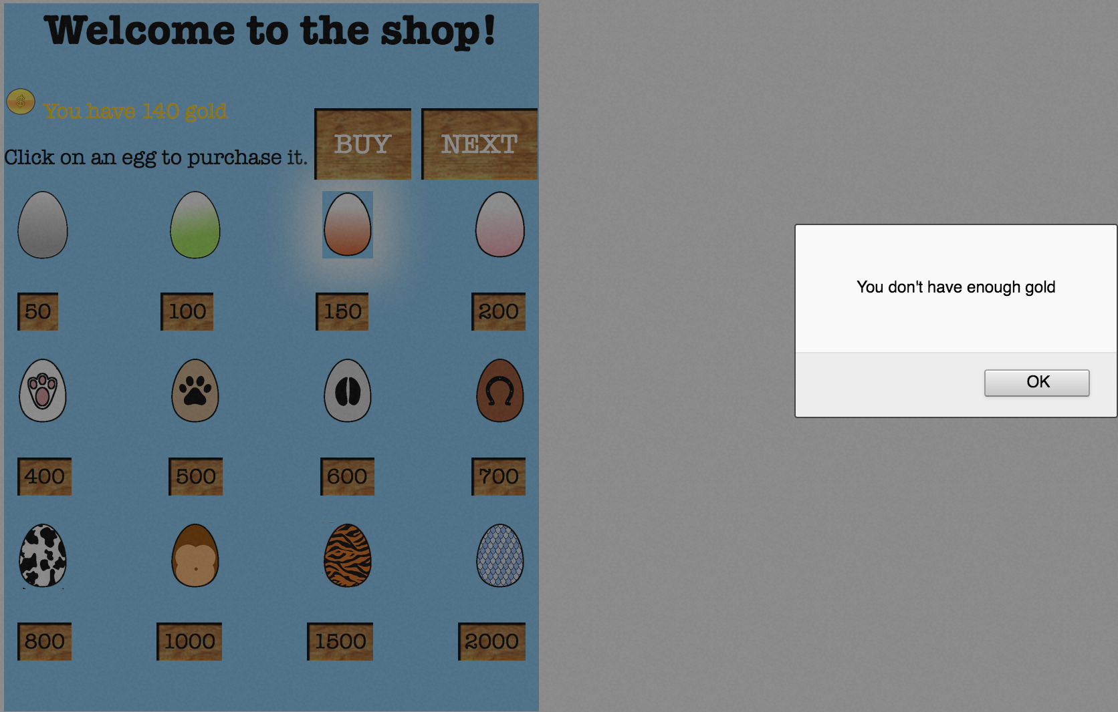

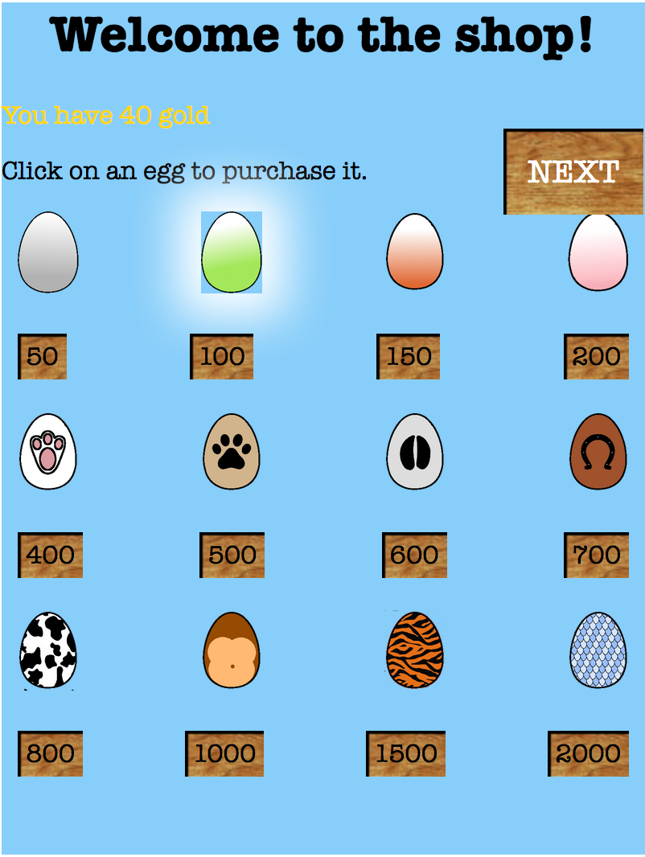

**D. Egg game play page**

The user has 60 seconds to hatch the egg; timer doesn’t start counting down until “Start” press

The user needs to click the egg until it hatches within the time limit.

The cheaper eggs need less clicks to hatch; range is from 40 to 350 clicks necessary.

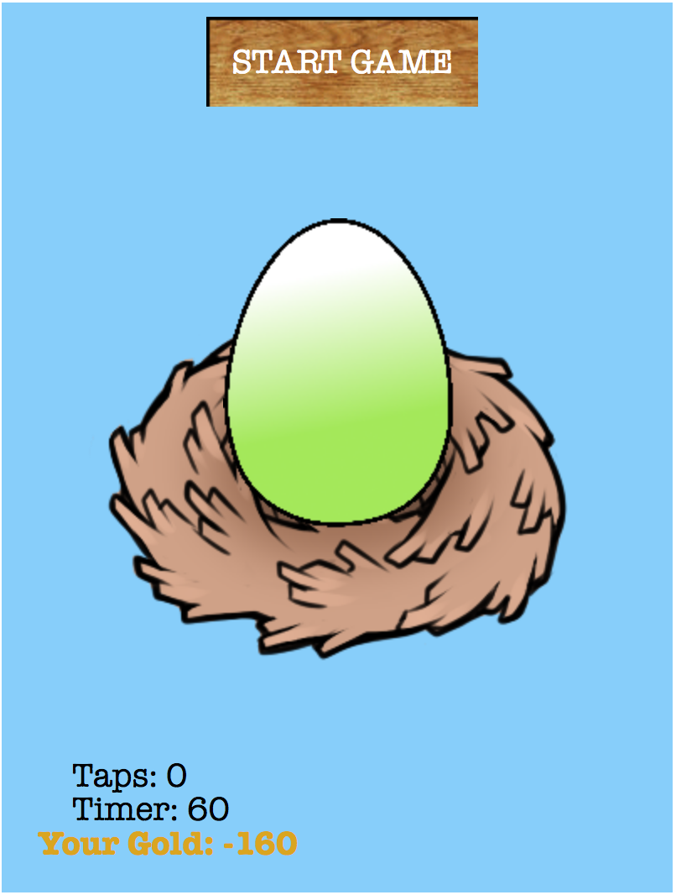

If the user runs out of time, they get a “Game over” message. A button pops up to return to navigation page.

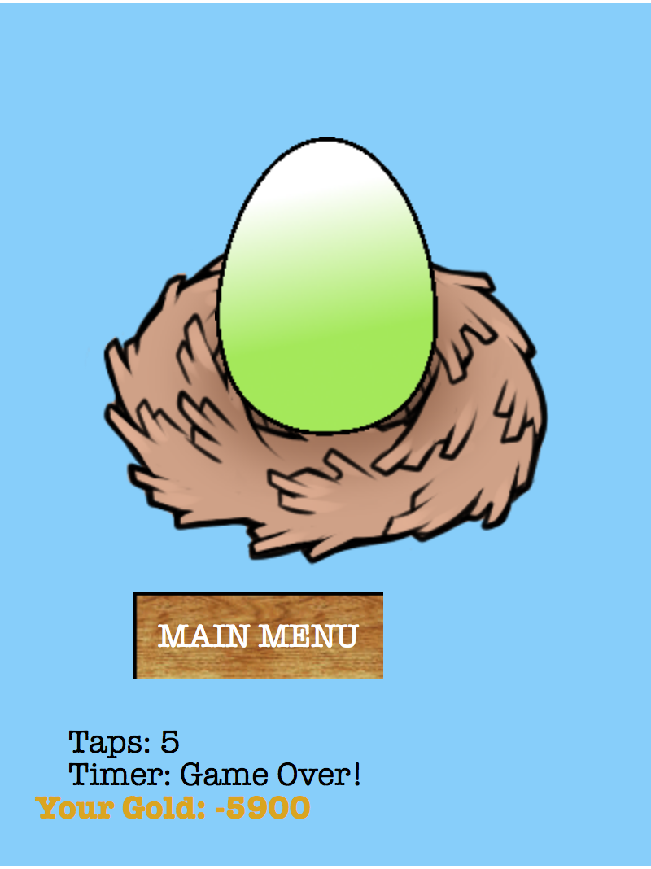

If the user successfully hatches an animal, two buttons appear. They can click a button to “Keep” or “Sell”

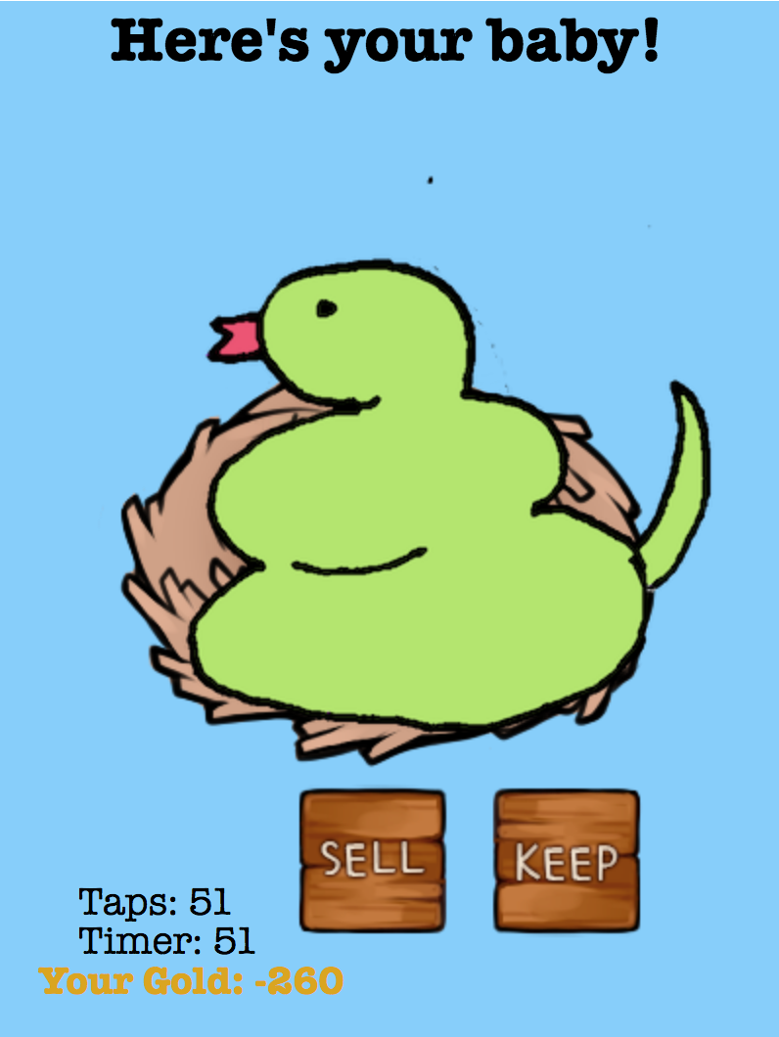

If “keep” is selected, user is redirected to the keep page, and the number of that animal in the barn is incremented.

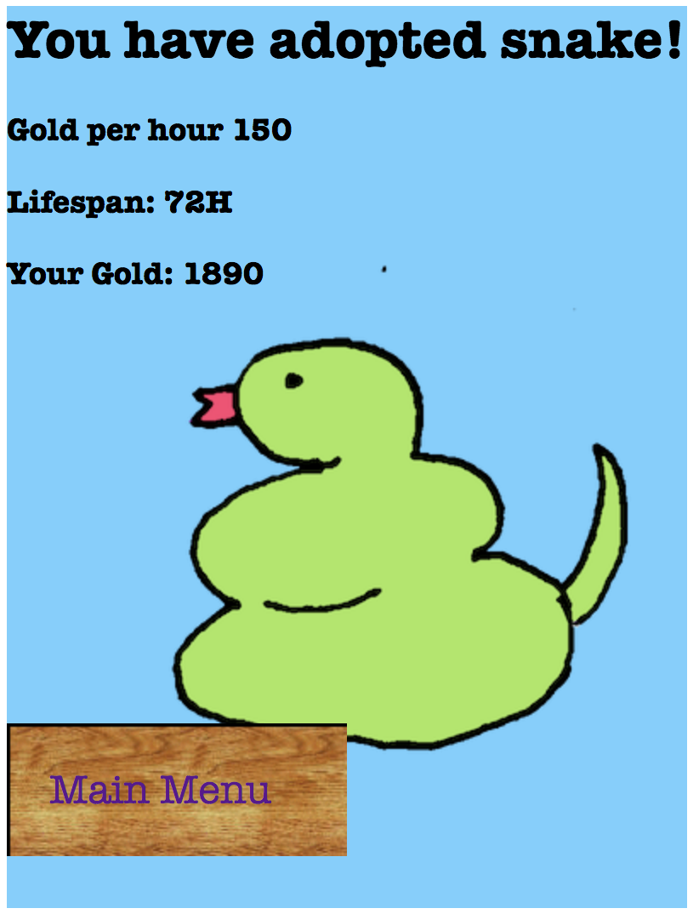

If “sell” is selected, user is redirected to sale page and their gold amount is incremented

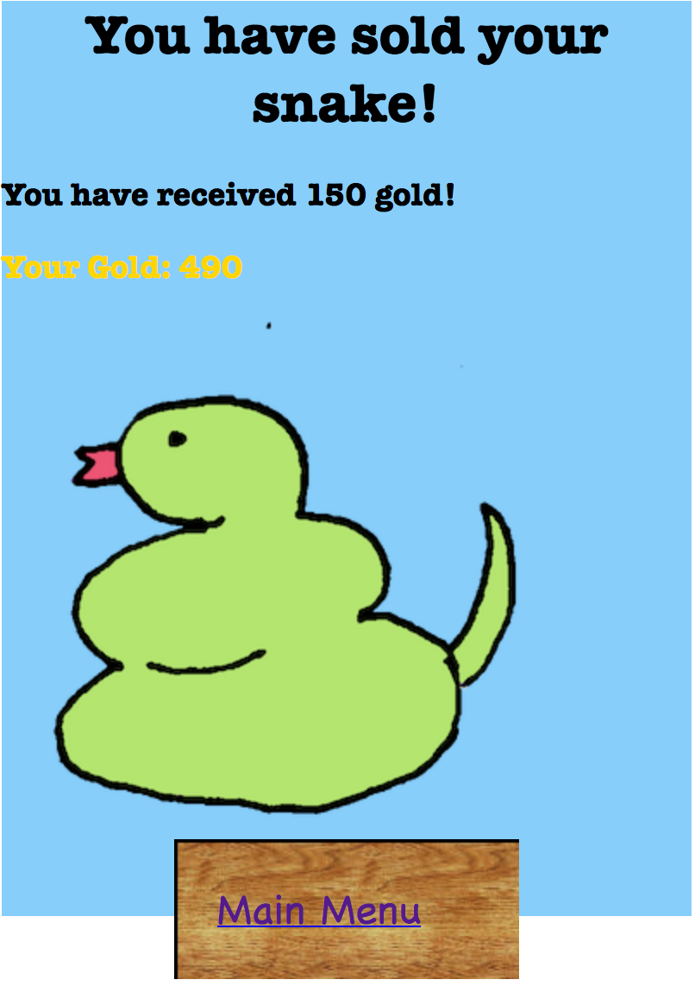

**E. Top scores page shows users and their scores**

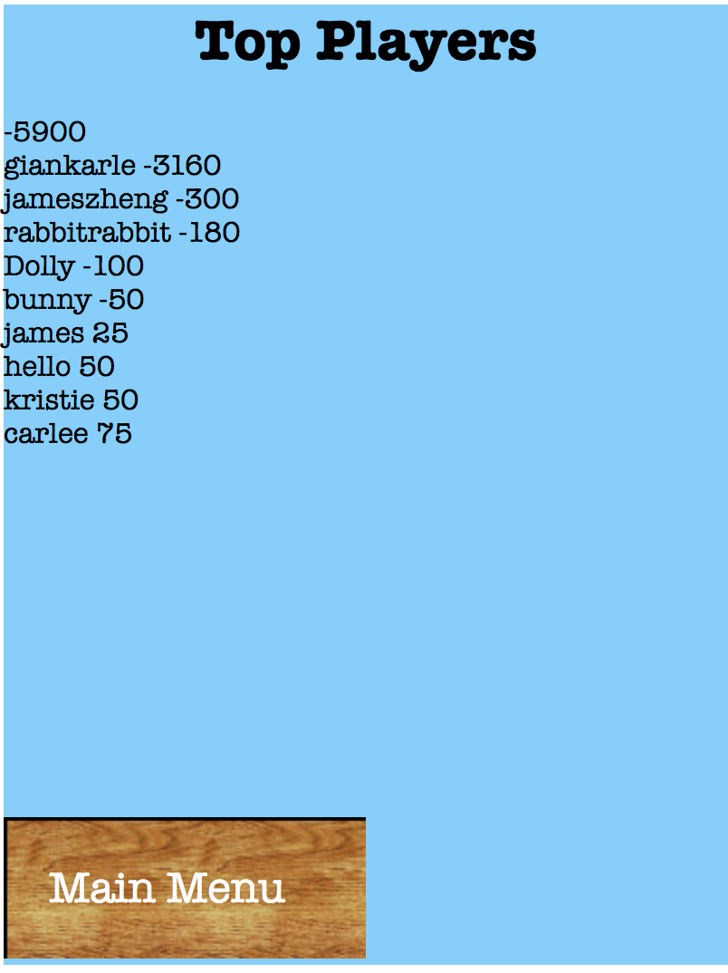

Other notes:

If user’s gold amount drops below 50, it will automatically be reset to 100 to make sure the user is able to keep playing.