Assignment_3_k_el

Kristine Eliosidze

5/28/2021

# task 1

Read the data from the assignment3.csv file in a data frame named “dataset”.

getwd()

## [1] "/Users/kristi/Desktop/Kristi/R"

dataset <- read.csv("assigment3.csv")  
df <- data.frame(dataset)

# task 2

Show the first lines of dataset using the “head” function. In the text comment on how many columns the dataset has, and what class is each column (numeric? character?).

head(df)

## propensity group score  
## 1 high control 0.40119617  
## 2 high experiment 0.25167464  
## 3 high control 0.04282297  
## 4 high control 0.26698565  
## 5 low experiment 0.31220096  
## 6 low control 0.11961722

str(dataset)

## 'data.frame': 1000 obs. of 3 variables:  
## $ propensity: chr "high" "high" "high" "high" ...  
## $ group : chr "control" "experiment" "control" "control" ...  
## $ score : num 0.4012 0.2517 0.0428 0.267 0.3122 ...

it has 3 columns, by using str function 2 of them is character and 1 - numeric.

# task 3

Use ggplot2 for creating boxplot showing the difference in score according to group. In the text, comment on whether the drug given to the experiment group seems to be effective or not.

library(ggplot2)  
  
ggplot(data = dataset, mapping = aes(x=score, y=group)) +   
geom_boxplot()

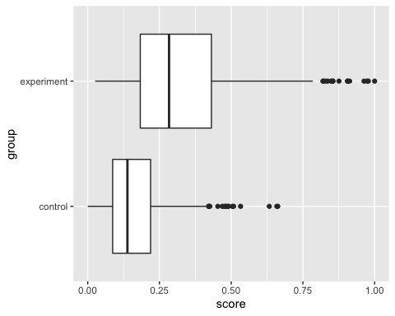

there is higher scores in the experiment group and in the control group - lower, so it must be effective for drug given group.

# task 4

Create the same plot as in point 3), this time coloring the boxes according to propensity (hint: use the “fill” argument in the “aes” function). Is there any difference in score between control mice with high propensity and experiment mice with low propensity? Please comment in the text.

library(ggplot2)  
  
ggplot(data = dataset, mapping = aes(x=score, y=group, fill=propensity)) +   
 geom_boxplot()

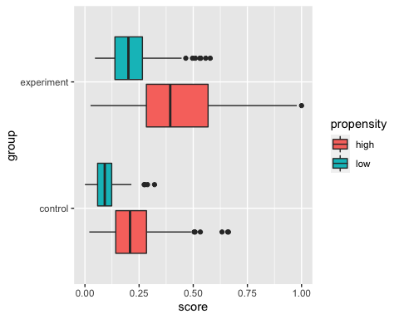 boxes of control with high propensity and experiment group with low propensity is almost the same, so it shows, that drug treatment is effective.

# task 5

Knit the RMarkdown both as an html and as a Word file

Files are attached.