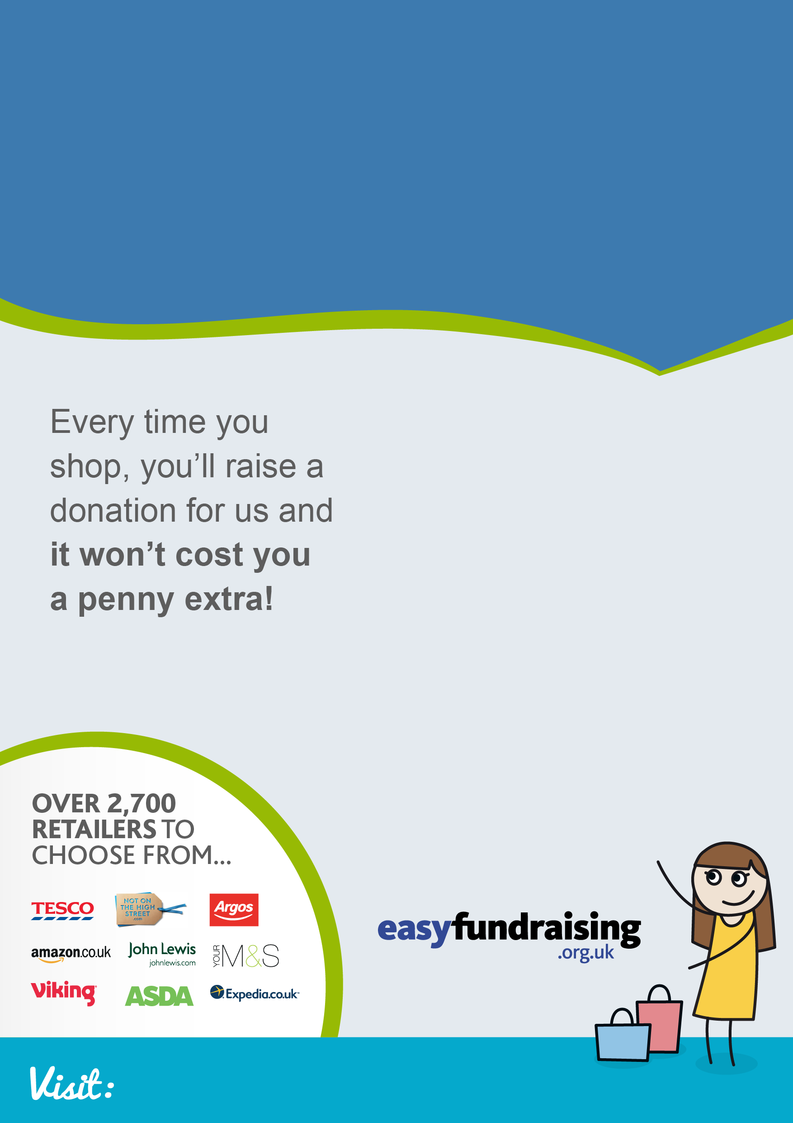

With every purchase you make you’ll raise a donation from the retailer. Your donations are then transferred to **CAUSE NAME**

**3. Earn donations**

When you shop online, visit easyfundraising first, click through to the retailer and shop as normal. Everything costs exactly the same

Got to **www.easyfundraising.org.uk/your-cause-name** and follow the simple steps to sign up.

**2. Hit the shops**

**1. Sign up to easyfundraising**

easyfundraising.org.uk/Your-Cause-Name

Help **Your Cause Name** raise FREE funds when you shop online!