Report

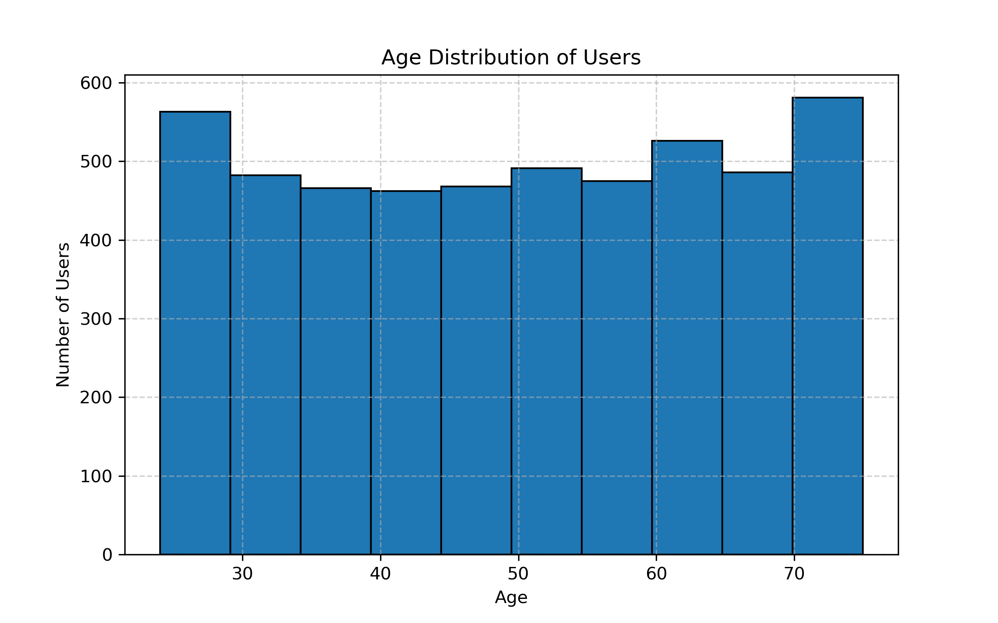
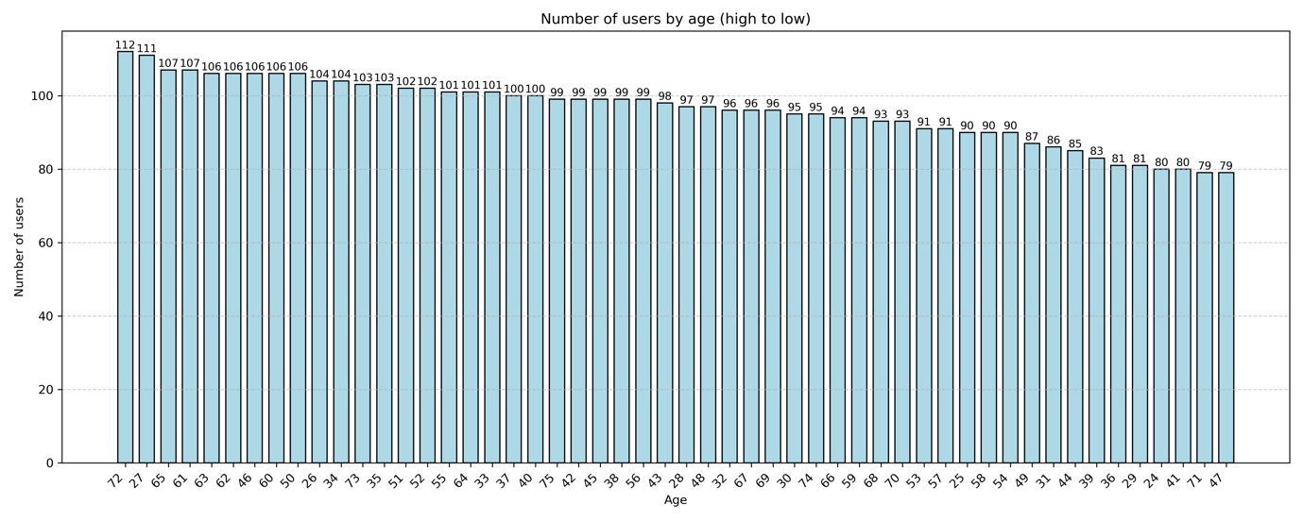
Observation
The age distribution of customers is relatively even, with no significant peaks.
Customers represent a wide range of age groups, from 24 to 72 years old.
The difference between the most and least common ages is relatively small, indicating that customers of all age groups are well represented and that the store appeals to a broad, diverse audience without a pronounced age bias.

