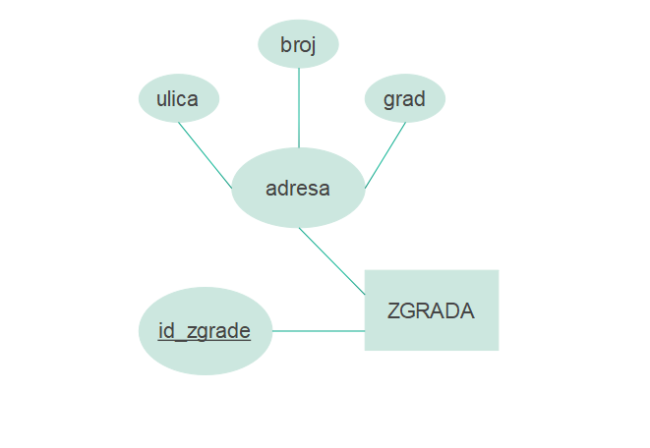

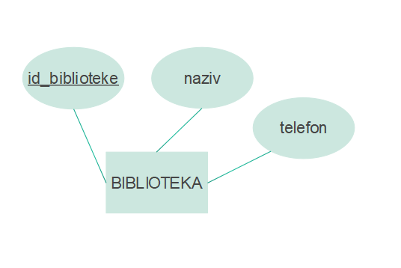

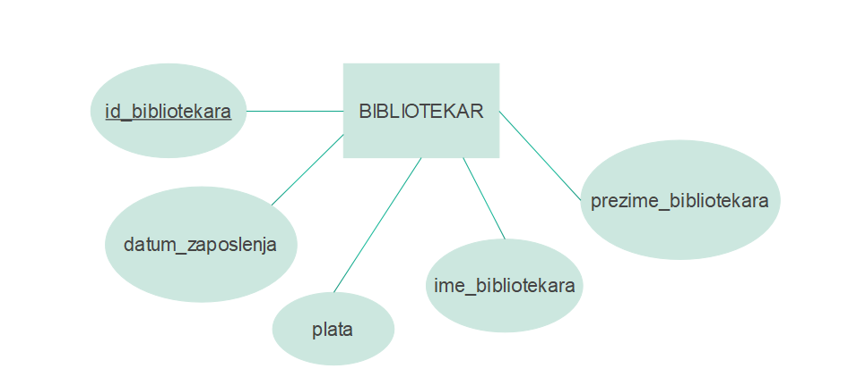

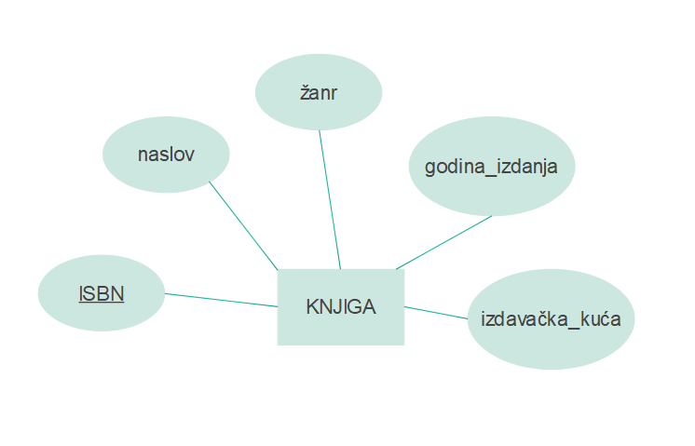

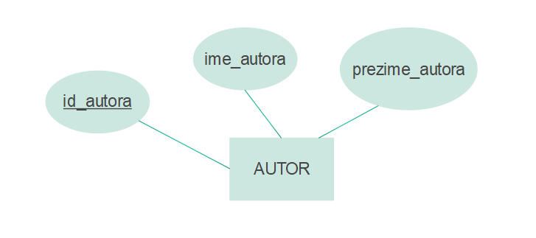

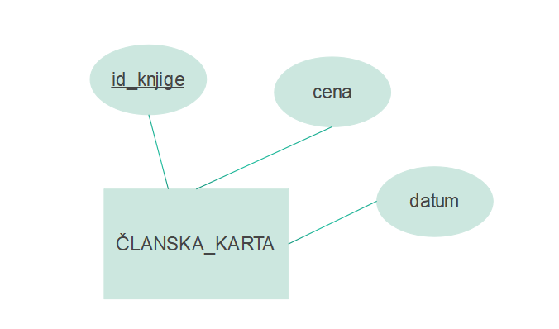

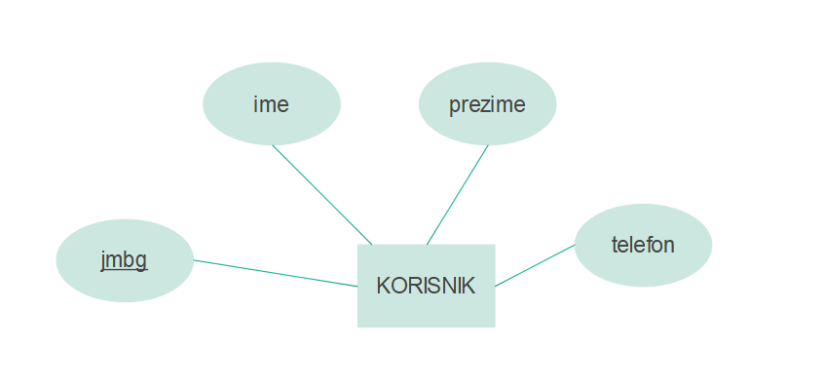

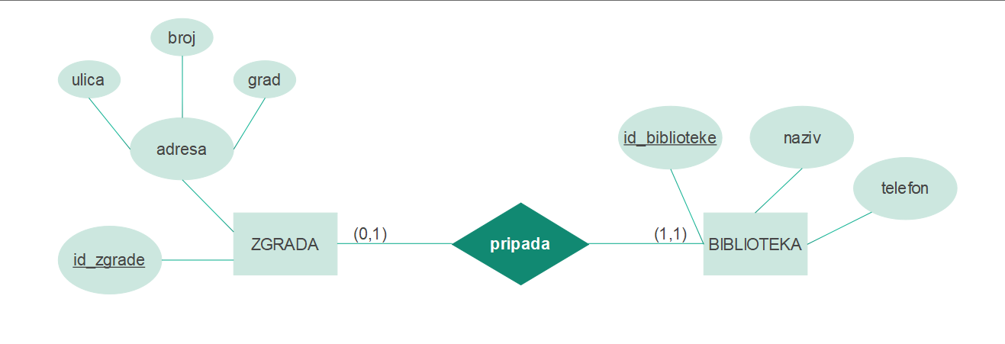

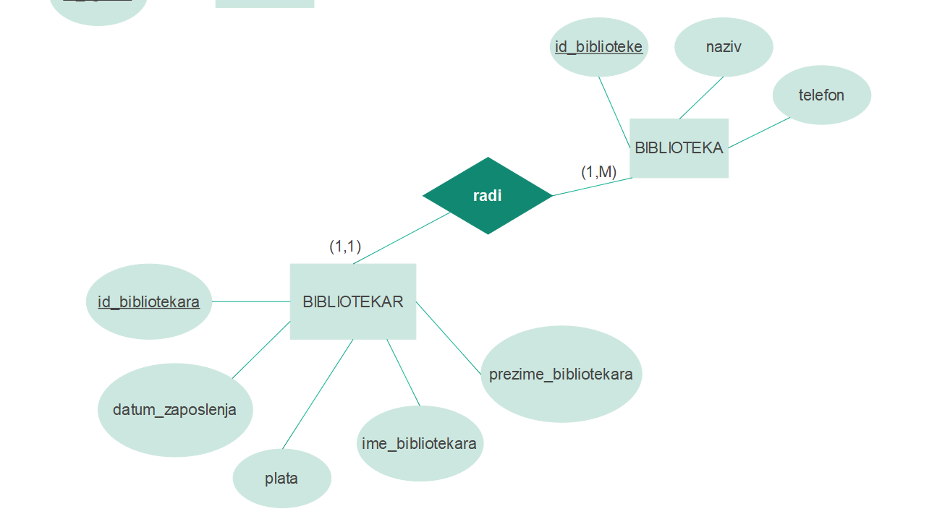

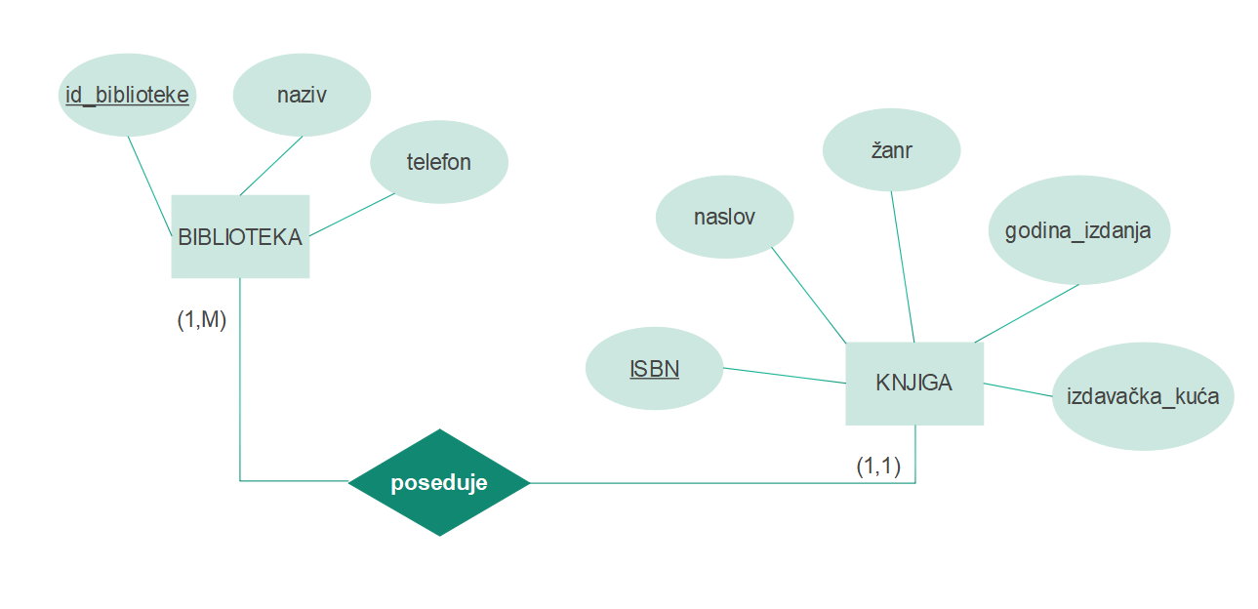

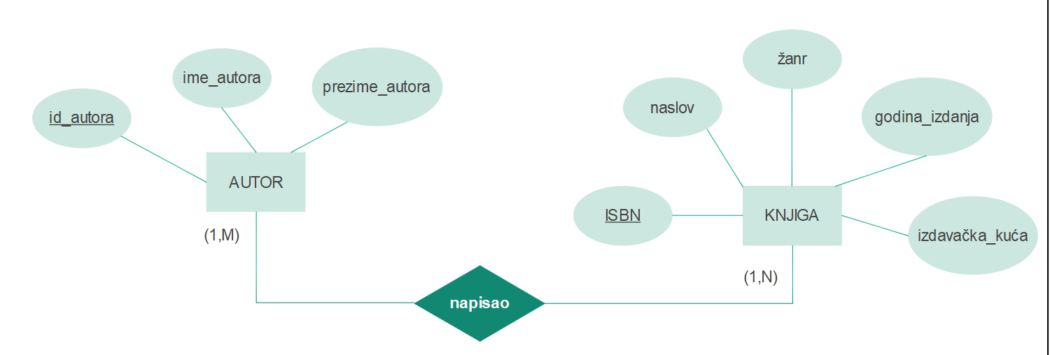

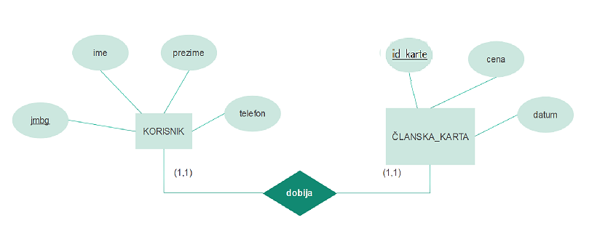

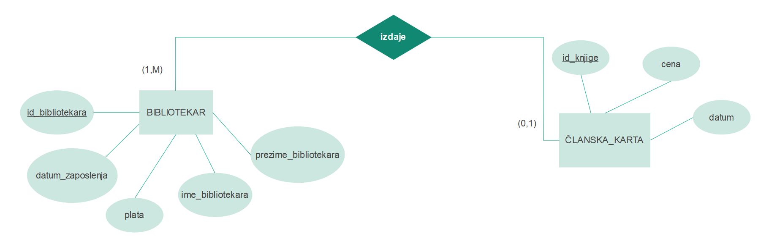

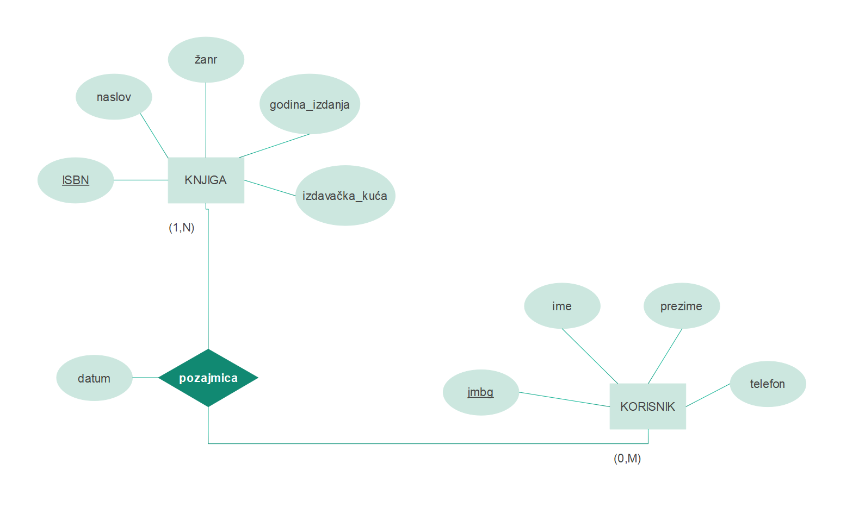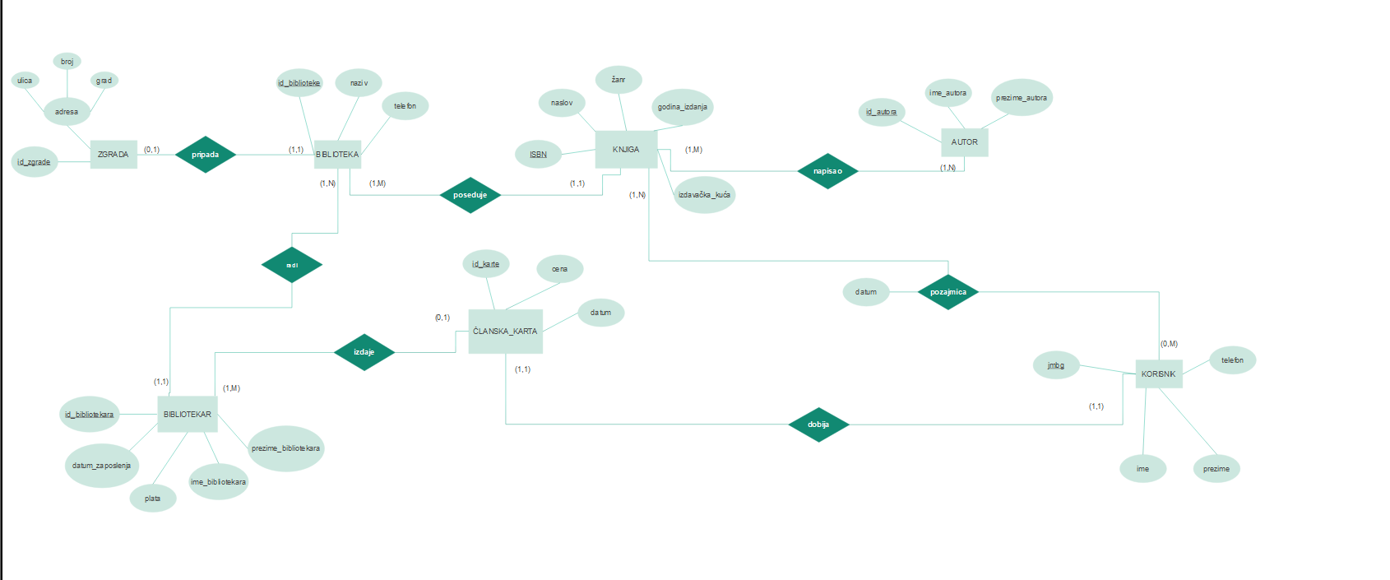

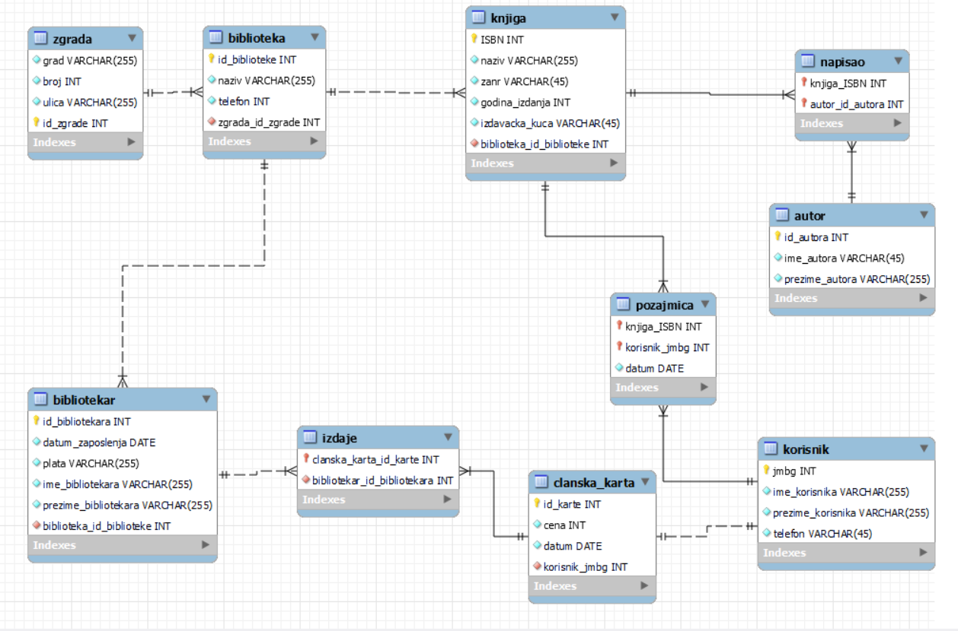

-- MySQL Script generated by MySQL Workbench

-- Sun Jun 5 18:22:35 2022

-- Model: New Model Version: 1.0

-- MySQL Workbench Forward Engineering

SET @OLD_UNIQUE_CHECKS=@@UNIQUE_CHECKS, UNIQUE_CHECKS=0;

SET @OLD_FOREIGN_KEY_CHECKS=@@FOREIGN_KEY_CHECKS, FOREIGN_KEY_CHECKS=0;

SET @OLD_SQL_MODE=@@SQL_MODE, SQL_MODE='ONLY_FULL_GROUP_BY,STRICT_TRANS_TABLES,NO_ZERO_IN_DATE,NO_ZERO_DATE,ERROR_FOR_DIVISION_BY_ZERO,NO_ENGINE_SUBSTITUTION';

-- -----------------------------------------------------

-- Schema biblioteka

-- -----------------------------------------------------

DROP SCHEMA IF EXISTS `biblioteka` ;

-- -----------------------------------------------------

-- Schema biblioteka

-- -----------------------------------------------------

CREATE SCHEMA IF NOT EXISTS `biblioteka` DEFAULT CHARACTER SET utf8 ;

-- -----------------------------------------------------

-- Schema test

-- -----------------------------------------------------

USE `biblioteka` ;

-- -----------------------------------------------------

-- Table `biblioteka`.`zgrada`

-- -----------------------------------------------------

DROP TABLE IF EXISTS `biblioteka`.`zgrada` ;

CREATE TABLE IF NOT EXISTS `biblioteka`.`zgrada` (

`grad` VARCHAR(255) NULL,

`broj` INT NULL,

`ulica` VARCHAR(255) NULL,

`id_zgrade` INT NOT NULL,

PRIMARY KEY (`id_zgrade`))

ENGINE = InnoDB;

-- -----------------------------------------------------

-- Table `biblioteka`.`biblioteka`

-- -----------------------------------------------------

DROP TABLE IF EXISTS `biblioteka`.`biblioteka` ;

CREATE TABLE IF NOT EXISTS `biblioteka`.`biblioteka` (

`id_biblioteke` INT NOT NULL,

`naziv` VARCHAR(255) NOT NULL,

`telefon` INT NULL,

`zgrada_id_zgrade` INT NOT NULL,

PRIMARY KEY (`id_biblioteke`),

INDEX `fk_biblioteka_zgrada_idx` (`zgrada_id_zgrade` ASC) VISIBLE,

CONSTRAINT `fk_biblioteka_zgrada`

FOREIGN KEY (`zgrada_id_zgrade`)

REFERENCES `biblioteka`.`zgrada` (`id_zgrade`)

ON DELETE NO ACTION

ON UPDATE NO ACTION)

ENGINE = InnoDB;

-- -----------------------------------------------------

-- Table `biblioteka`.`bibliotekar`

-- -----------------------------------------------------

DROP TABLE IF EXISTS `biblioteka`.`bibliotekar` ;

CREATE TABLE IF NOT EXISTS `biblioteka`.`bibliotekar` (

`id_bibliotekara` INT NOT NULL,

`datum_zaposlenja` DATE NULL,

`plata` VARCHAR(255) NULL,

`ime_bibliotekara` VARCHAR(255) NULL,

`prezime_bibliotekara` VARCHAR(255) NULL,

`biblioteka_id_biblioteke` INT NOT NULL,

PRIMARY KEY (`id_bibliotekara`),

INDEX `fk_bibliotekar_biblioteka1_idx` (`biblioteka_id_biblioteke` ASC) VISIBLE,

CONSTRAINT `fk_bibliotekar_biblioteka1`

FOREIGN KEY (`biblioteka_id_biblioteke`)

REFERENCES `biblioteka`.`biblioteka` (`id_biblioteke`)

ON DELETE NO ACTION

ON UPDATE NO ACTION)

ENGINE = InnoDB;

-- -----------------------------------------------------

-- Table `biblioteka`.`knjiga`

-- -----------------------------------------------------

DROP TABLE IF EXISTS `biblioteka`.`knjiga` ;

CREATE TABLE IF NOT EXISTS `biblioteka`.`knjiga` (

`ISBN` INT NOT NULL,

`naziv` VARCHAR(255) NULL,

`zanr` VARCHAR(45) NULL,

`godina_izdanja` INT NULL,

`izdavacka_kuca` VARCHAR(45) NULL,

`biblioteka_id_biblioteke` INT NOT NULL,

PRIMARY KEY (`ISBN`),

INDEX `fk_knjiga_biblioteka1_idx` (`biblioteka_id_biblioteke` ASC) VISIBLE,

CONSTRAINT `fk_knjiga_biblioteka1`

FOREIGN KEY (`biblioteka_id_biblioteke`)

REFERENCES `biblioteka`.`biblioteka` (`id_biblioteke`)

ON DELETE NO ACTION

ON UPDATE NO ACTION)

ENGINE = InnoDB;

-- -----------------------------------------------------

-- Table `biblioteka`.`autor`

-- -----------------------------------------------------

DROP TABLE IF EXISTS `biblioteka`.`autor` ;

CREATE TABLE IF NOT EXISTS `biblioteka`.`autor` (

`id_autora` INT NOT NULL,

`ime_autora` VARCHAR(45) NULL,

`prezime_autora` VARCHAR(255) NULL,

PRIMARY KEY (`id_autora`))

ENGINE = InnoDB;

-- -----------------------------------------------------

-- Table `biblioteka`.`korisnik`

-- -----------------------------------------------------

DROP TABLE IF EXISTS `biblioteka`.`korisnik` ;

CREATE TABLE IF NOT EXISTS `biblioteka`.`korisnik` (

`jmbg` INT NOT NULL,

`ime_korisnika` VARCHAR(255) NULL,

`prezime_korisnika` VARCHAR(255) NULL,

`telefon` VARCHAR(45) NULL,

PRIMARY KEY (`jmbg`))

ENGINE = InnoDB;

-- -----------------------------------------------------

-- Table `biblioteka`.`clanska_karta`

-- -----------------------------------------------------

DROP TABLE IF EXISTS `biblioteka`.`clanska_karta` ;

CREATE TABLE IF NOT EXISTS `biblioteka`.`clanska_karta` (

`id_karte` INT NOT NULL,

`cena` INT NULL,

`datum` DATE NULL,

`korisnik_jmbg` INT NOT NULL,

PRIMARY KEY (`id_karte`),

INDEX `fk_clanska_karta_korisnik1_idx` (`korisnik_jmbg` ASC) VISIBLE,

CONSTRAINT `fk_clanska_karta_korisnik1`

FOREIGN KEY (`korisnik_jmbg`)

REFERENCES `biblioteka`.`korisnik` (`jmbg`)

ON DELETE NO ACTION

ON UPDATE NO ACTION)

ENGINE = InnoDB;

-- -----------------------------------------------------

-- Table `biblioteka`.`napisao`

-- -----------------------------------------------------

DROP TABLE IF EXISTS `biblioteka`.`napisao` ;

CREATE TABLE IF NOT EXISTS `biblioteka`.`napisao` (

`knjiga_ISBN` INT NOT NULL,

`autor_id_autora` INT NOT NULL,

PRIMARY KEY (`knjiga_ISBN`, `autor_id_autora`),

INDEX `fk_knjiga_has_autor_autor1_idx` (`autor_id_autora` ASC) VISIBLE,

INDEX `fk_knjiga_has_autor_knjiga1_idx` (`knjiga_ISBN` ASC) VISIBLE,

CONSTRAINT `fk_knjiga_has_autor_knjiga1`

FOREIGN KEY (`knjiga_ISBN`)

REFERENCES `biblioteka`.`knjiga` (`ISBN`)

ON DELETE NO ACTION

ON UPDATE NO ACTION,

CONSTRAINT `fk_knjiga_has_autor_autor1`

FOREIGN KEY (`autor_id_autora`)

REFERENCES `biblioteka`.`autor` (`id_autora`)

ON DELETE NO ACTION

ON UPDATE NO ACTION)

ENGINE = InnoDB;

-- -----------------------------------------------------

-- Table `biblioteka`.`pozajmica`

-- -----------------------------------------------------

DROP TABLE IF EXISTS `biblioteka`.`pozajmica` ;

CREATE TABLE IF NOT EXISTS `biblioteka`.`pozajmica` (

`knjiga_ISBN` INT NOT NULL,

`korisnik_jmbg` INT NOT NULL,

PRIMARY KEY (`knjiga_ISBN`, `korisnik_jmbg`),

INDEX `fk_knjiga_has_korisnik_korisnik1_idx` (`korisnik_jmbg` ASC) VISIBLE,

INDEX `fk_knjiga_has_korisnik_knjiga1_idx` (`knjiga_ISBN` ASC) VISIBLE,

CONSTRAINT `fk_knjiga_has_korisnik_knjiga1`

FOREIGN KEY (`knjiga_ISBN`)

REFERENCES `biblioteka`.`knjiga` (`ISBN`)

ON DELETE NO ACTION

ON UPDATE NO ACTION,

CONSTRAINT `fk_knjiga_has_korisnik_korisnik1`

FOREIGN KEY (`korisnik_jmbg`)

REFERENCES `biblioteka`.`korisnik` (`jmbg`)

ON DELETE NO ACTION

ON UPDATE NO ACTION)

ENGINE = InnoDB;

-- -----------------------------------------------------

-- Table `biblioteka`.`izdaje`

-- -----------------------------------------------------

DROP TABLE IF EXISTS `biblioteka`.`izdaje` ;

CREATE TABLE IF NOT EXISTS `biblioteka`.`izdaje` (

`clanska_karta_id_karte` INT NOT NULL,

`bibliotekar_id_bibliotekara` INT NOT NULL,

INDEX `fk_clanska_karta_has_bibliotekar_clanska_karta1_idx` (`clanska_karta_id_karte` ASC) VISIBLE,

INDEX `fk_izdaje_bibliotekar1_idx` (`bibliotekar_id_bibliotekara` ASC) VISIBLE,

PRIMARY KEY (`clanska_karta_id_karte`),

CONSTRAINT `fk_clanska_karta_has_bibliotekar_clanska_karta1`

FOREIGN KEY (`clanska_karta_id_karte`)

REFERENCES `biblioteka`.`clanska_karta` (`id_karte`)

ON DELETE NO ACTION

ON UPDATE NO ACTION,

CONSTRAINT `fk_izdaje_bibliotekar1`

FOREIGN KEY (`bibliotekar_id_bibliotekara`)

REFERENCES `biblioteka`.`bibliotekar` (`id_bibliotekara`)

ON DELETE NO ACTION

ON UPDATE NO ACTION)

ENGINE = InnoDB;

SET SQL_MODE=@OLD_SQL_MODE;

SET FOREIGN_KEY_CHECKS=@OLD_FOREIGN_KEY_CHECKS;

SET UNIQUE_CHECKS=@OLD_UNIQUE_CHECKS;