The Fractal Structure of Treelines in High Mountains

Bálint Kovács, Kristóf Kássa, Najeed Muhammad

Institute of Mathematics, Faculty of Natural Sciences, Budapest University of Technology and Economics

Project advisor: Dr. Beáta Oborny, Associate Professor

Department of Plant Systematics, Ecology and Theoretical Biology, Faculty of Science, Eötvös Loránd University

ABSTRACT The occurrence of tree species in high mountains usually ends abruptly at some elevation. This is the treeline. The appearance of treeline structures in such areas is a topic of interest to ecologists and climate scientists. These treeline structures exhibit a characteristic mainland-island structure, where the tree cover is continuous at lower elevations (‘mainland’) and fragmented at higher ones (‘islands’). Theoretical predictions from percolation theory using simulation-based results obtained by studying two widely known types of models (the static Uniform/Gradient Random Map model and the dynamic Uniform/Gradient Contact Process model) suggest that the hull of the ‘mainland’ should be a fractal with dimension 7/4. This research project aims to test this hypothesis using satellite images of treelines and to develop simulation software that appropriately presents the gradient models as well.

INDEX TERMS Treeline structure, percolation theory, fractal, gradient contact process

1. INTRODUCTION

The occurrence of tree species in high mountains usually ends abruptly at some elevation. This is the treeline. The appearance of treeline structures in such areas is a topic of interest to ecologists and climate scientists. These treeline structures exhibit a characteristic mainland-island structure, where the tree cover is continuous at lower elevations (‘mainland’) and fragmented at higher ones (‘islands’). Theoretical predictions from percolation theory using simulation-based results obtained by studying two widely known types of models (the static Uniform/Gradient Random Map model and the dynamic Uniform/Gradient Contact Process model) suggest that the hull of the ‘mainland’ should be a fractal with dimension . This research project aims to test this hypothesis using satellite images of treelines and to develop simulation software that appropriately presents the gradient models as well.

1. RELATED WORK

Several studies have investigated the transition from connected to fragmented vegetation across environmental gradients and scaling laws in ecotone geometry [1]. Recent research has also suggested that percolation theory predicts some universal features in range margins across environmental gradients [3]. However, there is a lack of research that uses satellite images to analyse the fractal structure of treelines and its implications for species border delineation and climate change detection. Additionally, the existing simulation software of this population model in finite space does not capture environmental gradients

1. METHOD
   1. General description

Satellite images of treelines will be obtained from publicly available datasets after careful consideration and thorough discussion with a cartographer specialist. A custom algorithm based on the existing literature in the field was implemented to calculate the fractal dimension of the treeline structures. The potential limitations of the data and methods is being cautiously addressed. Additionally, simulation software was developed (involving visualization of population dynamics models in finite space, implementation of algorithms for detecting the so-called ‘giant component’ of the population, and for the delineation of its ‘hull’) that captures some environmental gradients and appropriately presents gradient models. The results of the simulation software will be compared with those obtained from real-life ecological data.

The so-called finite-size effect in analysing tree species distribution on a bounded square lattice refers to the influence of the lattice's limited size on observed spatial patterns and population dynamics. It introduces boundary effects that can alter colonization patterns and spatial interactions. As a common attempt to address it, toroidal boundary conditions are employed to mitigate these effects and simulate an infinite lattice. Understanding the finite size effect is vital for the accurate interpretation of results.

To be able to effectively test our hypothesis and to maintain the possibility of extending this research topic in the future we have decided to use the following methodology:

* Programming language: Python (desktop application);
* Build a compact, yet easily extendible framework for the research topic;
* Using our Python program and multiple process variables we test the hypothesis.

1. DESCRIPTION OF THE IMPLEMENTATION
   1. Software design

Our Python program provides a graphical interface for simulating and visualizing the dynamics of various treeline fractal models. It primarily leverages the PySide6 library for creating the GUI and pyqtgraph for data visualization.

The simulation strategies, imported from the simulation package, include:

* Gradient Contact Process
* Homogeneous Contact Process
* Gradient Random Map
* Image Treeline

Our grid-based simulation tool is designed to model and visualize different strategies of property spread, such as diseases or ideas, in a population. It includes multiple classes that each handle different parts of the simulation:

SimulationStrategy: This abstract base class outlines the basic structure for a simulation strategy. It provides a template for the simulation algorithm and maintains important state information, including the grid size, colonization and extinction probabilities, occupied cells, and neighbouring cells.

HomogeneousContactProcessSimulationStrategy: A subclass of SimulationStrategy that simulates a homogeneous contact process. In this strategy, every cell in the grid has the same probabilities of colonization and extinction, regardless of its position.

GradientContactProcessSimulationStrategy: Another subclass of SimulationStrategy. This strategy introduces a gradient in the colonization and extinction probabilities based on the cell's position on the grid. The chance of a cell becoming occupied increases, while the chance of becoming unoccupied decreases, as we move across the grid.

The ImageTreelineSimulationStrategy class in the context of this simulation software is dedicated to handling real-world treeline data represented by image files. Instead of using abstract mathematical models or algorithms, it bases its simulation on actual visual data, opening new possibilities for more realistic and tangible simulations.

The ImageTreelineSimulationStrategy class provides an interface between raw image data and the simulation grid, transforming real-world visual information into a form suitable for the simulation process.

MainWindow: This class creates the graphical user interface for the simulation. It contains functions to start and stop the simulation, update the grid display, and adjust the simulation parameters. It is in charge of creating the Graphical User Interface (GUI) that allows the users to interact with the simulation program.

Grid Display Area: A large central area where the grid is displayed. Each cell of the grid may be colour-coded based on whether it is occupied or not, providing a visual representation of the current state of the simulation.

Simulation Control Buttons: Buttons to start, pause, stop, and reset the simulation. This allows the user to control the flow of the simulation.

Settings/Parameters Panel: A section where users can adjust various simulation parameters such as grid size, colonization probability (), and extinction probability ().

Data Visualization Tools: There are options for plotting the results of the simulation over time, for example, a line graph showing the number of occupied cells over time.

Overall, our software provides an interactive and flexible tool to study the spread of properties across a grid-based population using different stochastic process models. It's capable of creating visually interesting simulations that can provide insights into how these processes work under various conditions.

* 1. Simulation of the Popularization Models

The analysis of tree species distribution on a bounded square lattice provides valuable insights into ecosystem dynamics, biodiversity patterns, and conservation strategies.

* + 1. Homogeneous Random Map

For the sake of clarity, we begin with describing the simplest possible model, the Homogeneous Random Map model, which is not implemented in our project, but contributes to a more thorough understanding of the more complex models implemented.

The homogeneous random map model assumes that the distribution of tree species is random and uniform, without specific spatial patterns or dependencies. To apply this model, we consider a square lattice with rows and columns   
(), representing the discrete sampling units within the study area. Each lattice point corresponds to a sampling unit where a tree species can be observed or recorded.

The model begins by randomly assigning 1% of the lattice cells as occupied (seeded with tree species).

At each Monte Carlo step of the model, random lattice cells are selected uniformly, one after the other, and their status is updated based only on the colonization and extinction rates. If the selected cell is already occupied, it has a probability  
 to become unoccupied (extinct), representing the extinction rate. On the other hand, if the cell is unoccupied, it has a probability   
 to become occupied (colonized), representing the colonization rate.

By iteratively updating the lattice cells according to these colonization and extinction rates, the model captures the dynamics of tree species distribution, considering both the expansion and contraction of occupied cells over time.

The resulting distribution of tree species on the bounded square lattice provides insights into the spatial patterns and population dynamics of the tree species under investigation. Statistical analysis can be performed on the simulated data to study aspects such as species richness, clustering, or the effects of different colonization and extinction rates on the observed patterns.

It is important to acknowledge that the homogeneous random map model on a bounded square lattice has its limitations. While it provides a rather simplified representation of tree species distribution, it offers a starting point for understanding the impact of colonization and extinction processes on the spatial patterns of tree species on the lattice. For a comprehensive analysis of tree species spatial patterns, to account for additional factors and complexities, more advanced models incorporating factors like environmental gradients or species interactions may be considered.

In conclusion, the homogeneous random map model with colonization and extinction rates on a bounded square lattice enables the study of tree species distribution dynamics. By considering the probabilities of colonization and extinction at each step, the model provides insights into the expansion and contraction of tree species populations and contributes to the understanding of spatial patterns and ecological processes involved in tree species distribution.

* + 1. Homogeneous Contact Process

In this project, we utilize the homogeneous contact process model with toroidal boundary conditions to study the spatial distribution of tree species on a bounded square lattice. The homogeneous contact process model extends the previous model by incorporating the colonization probability based on the number of occupied neighbouring cells, while toroidal boundary conditions address the finite size effect associated with the bounded lattice.

To begin, we randomly assign 1% of the lattice cells as occupied, representing the initial presence of tree species. At each Monte Carlo step of the model, random lattice cells are uniformly selected, one after the other, for updating. If the selected cell is already occupied, it has a probability  
 to become unoccupied (extinct), representing the extinction rate. However, if the cell is unoccupied, the colonization occurs with a probability of , where is the colonization rate and is the number of occupied neighbouring cells (in general, we consider two sells neighbours if they share an edge; more on the boundaries in the next paragraph). This colonization probability accounts for a factor of species interaction, namely the influence of neighbouring occupied cells on the colonization process. This is a special case of the idea of considering two occupied sites connected and hence belonging to the same vegetation patch if and only if the species can move from one site to the other without stepping on a vacant site in between. Various step lengths were tested in [1], our approach is clearly the step length of .

To tackle the finite-size effect and create an environment that mimics an infinite lattice, we employ toroidal boundary conditions. By applying toroidal boundary conditions, the lattice wraps around at the edges, creating a torus-like shape. This means that cells on opposite edges are considered neighbours, effectively connecting the lattice, and removing the boundary effects. The toroidal approach allows the colonization and interaction processes to occur seamlessly across the lattice as if it were infinitely extended.

By incorporating the toroidal boundary conditions, the homogeneous contact process model captures the spatial interactions, clustering tendencies, and colonization dynamics of tree species on the bounded square lattice. This approach helps minimize biases caused by the finite size of the lattice and facilitates the exploration of tree species distribution patterns that would be observed in an infinitely extended lattice.

Statistical analysis can be conducted on the simulated data to investigate various aspects of tree species distribution, such as species richness, spatial clustering, and correlations between colonization rates and the surrounding occupied cells. The results obtained from the model with toroidal boundary conditions provide valuable insights into the spatial patterns and population dynamics of tree species within the bounded square lattice.

However, it's important to acknowledge that while the toroidal approach mitigates finite-size effects, it may introduce wrapping interactions and altered edge effects. The appropriateness of toroidal boundary conditions should be carefully considered in the specific context and results should be validated accordingly.

In conclusion, the homogeneous contact process model with toroidal boundary conditions offers a mathematical framework for analysing tree species distribution on a bounded square lattice while addressing the finite size effect. This approach improves the realism of the tree species distribution analysis and allows for a more accurate representation of their spatial patterns within the bounded square lattice.

* + 1. Gradient Random Map

We also employ the gradient random map model to study the spatial distribution of tree species on a bounded square lattice, considering the influence of an environmental (spatial) gradient, e.g. altitude, on colonization and extinction dynamics.

The gradient random map model extends the previous homogeneous random map model by incorporating gradient-dependent colonization and extinction probabilities. In this model, the probability of colonization, denoted as , and the probability of extinction, denoted as , become functions of the gradient variable , which represents a continuous spatial variation.

To begin, we again randomly assign 1% of the lattice cells as occupied, representing the initial presence of tree species. At each Monte Carlo step of the model, random lattice cells are uniformly selected, one after the other, for updating. The updating process takes into account the gradient-dependent colonization and extinction probabilities. If the selected cell is already occupied, it will go extinct with a probability of . If the cell is unoccupied, the colonization occurs with a probability of , where and represent the colonization and extinction rate influenced by the gradient variable . The colonization probability is higher in areas with more favourable environmental conditions. Similarly, the extinction probability is higher in areas with less favourable environmental conditions.

By incorporating gradient-dependent colonization and extinction probabilities, the gradient random map model captures the spatial dynamics of tree species in response to environmental variations. It allows for the exploration of how species colonization and persistence are influenced by the gradient variable , providing insights into the relationship between environmental gradients and tree species distribution patterns.

In our simulations, we studied the dynamics of the model with the functions and , and being constants. However, it is important to note that the gradient random map model assumes a continuous gradient variable and functions and that appropriately capture the underlying ecological processes. These functions should be carefully selected and validated based on ecological knowledge and data availability.

* + 1. Gradient Contact Process

Finally, we utilize the gradient contact process model with a tube-like boundary to study the spatial distribution of tree species on a bounded square lattice, incorporating gradient-dependent colonization and extinction probabilities.

The gradient contact process model extends the homogeneous contact process by incorporating gradient-dependent colonization and extinction probabilities. In this model, the probability of extinction, denoted as , and the probability of colonization, denoted as , also become functions of the gradient variable , which represents a continuous spatial variation.

To initiate the model, as usual, we randomly assign 1% of the lattice cells as occupied, representing the initial presence of tree species. At each Monte Carlo step, random lattice cells are uniformly selected, one by one, for updating, considering the gradient-dependent colonization and extinction probabilities.

If the cell is unoccupied, the colonization occurs with a probability of , where represents the colonization rate influenced by the gradient variable , and is the number of occupied neighbouring cells. The colonization probability considers both the suitability of the local environment, as indicated by the gradient value at that location, and the presence of neighbouring occupied cells.

On the other hand, if the selected cell is already occupied, it has a probability of to become unoccupied, reflecting the extinction rate influenced by the gradient variable . The extinction probability varies based on the gradient value at that location, considering the suitability of the local environment.

To tackle the finite-size effect associated with the bounded lattice, instead of the traditional toroidal boundary, we implement a tube-like boundary approach. Instead of connecting the opposite edges, we duplicate the last and first columns on the vertical edges, creating a tube-like structure. This boundary setup allows colonization, extinction, and spatial interactions to occur seamlessly within the lattice, mimicking an infinitely extended environment and minimizing the finite-size effects.

By incorporating gradient-dependent colonization and extinction probabilities and utilizing the tube-like boundary conditions, the gradient contact process model captures the spatial dynamics of tree species in response to environmental gradients within the bounded square lattice. It enables the investigation of how the gradient variable influences colonization patterns, extinction probabilities, and resulting tree species distribution.

In our simulations, we studied the dynamics of the model with the functions and , and being constants. However, it is again crucial to note that the gradient contact process model assumes appropriate functions and that accurately represent the underlying ecological processes. These functions should be attentively selected and validated based on ecological knowledge and available data.

* 1. Detection of the Giant Component

As already mentioned before, we consider two occupied sites connected and hence belonging to the same vegetation patch if and only if the species can move from one site to the other without stepping on a vacant site in between. Various step lengths can be studied, but in this project, we focus on the step length of 1.

We want to determine which sites are connected and hence belong to the same patch (i.e. percolation cluster). The largest patch is usually the one that connects the highest number of sites (cells) in the region of a low density to the region of a higher density. If the gradient points along the horizontal -direction from sparse to full vegetation cover, this patch will span from the bottom to the top of the lattice, a property that can be used later in delineating the hull. The probability of two distinct large patches in the densest region is negligible [1] in a sufficiently large lattice. Therefore, we call the largest patch the “connected patch”, or “giant component”. All the other patches we call “fragments”.

There are two (and eventually a lot more) algorithms that can be used to detect the giant component, which we will describe here.

The detection can be made using the Hoshen-Kopelman algorithm which is a simple and efficient algorithm for labelling clusters on a grid, where the grid is a regular network of cells, with the cells being either occupied or unoccupied. This algorithm is based on a well-known union-finding algorithm. In this algorithm, we scan through a grid looking for occupied cells and labelling them with cluster labels. The scanning process is called a raster scan. The algorithm begins with scanning the grid cell by cell and checking whether the cell is occupied or not. If the cell is occupied, then it must be labelled with a cluster label. This cluster label is assigned based on the neighbours of that cell. (For this we are going to use Union-Find Algorithm which is explained in the next paragraph.) If the cell doesn’t have any occupied neighbours, then a new label is assigned to the cell.

The Union-Find algorithm is a simple method for computing equivalence classes. Calling the function returns whether items and are members of the same equivalence class. Because equivalence relations are transitive, all the items equivalent to are equivalent to all the items equivalent to . Thus, for any item , there is a set of items which are all equivalent to (called the equivalence class). A second function returns a representative member of the equivalence class to which belongs.

During the raster scan of the grid, whenever an occupied cell is encountered, neighbouring cells are scanned to check whether any of them have already been scanned. If we find already scanned neighbours, the operation is performed, to specify that these neighbouring cells are in fact members of the same equivalence class. Then the operation is performed to find a representative member of that equivalence class with which the current cell will be labelled. On the other hand, if the current cell has no neighbours, it is assigned a new, previously unused, label. The entire grid is processed in this way.

The other algorithm, which is actually used in our project, is the well-known DFS algorithm, where we consider the cells of the lattice as the vertices of a graph, the neighbouring cells being connected in the graph with an edge. The components of the population will be the connected components of this graph.

Finally, the giant component will be the component with the highest number of members.

* 1. Delineation of the Hull

Finally, we want to delineate the so-called hull of the giant component, which, following [1], we define as the set of the farthest points a species can reach without experiencing habitat fragmentation (i.e. without having to step on a vacant site).

The determination of the hull edge of the giant component of the population is an important aspect of studying spatial patterns and boundaries. One approach to determining this edge is through a biased walk algorithm.

The biased walk algorithm typically incorporates a bias towards the unexplored region of the connected component. This bias ensures that the walker explores the boundary region more extensively, providing information about the hull edge.

During the biased walk, the walker traverses the connected component by moving from one occupied cell to another. At each step, the walker assesses the neighbouring cells and selects the next cell to visit based on specific rules. These rules might include favouring unvisited cells or cells with fewer neighbours within the connected component.

As the walker progresses through the biased walk, it continuously updates the hull edge by recording the trees visited along the boundary region. This process allows the determination of the outermost trees that define the hull edge of the largest connected component.

Once the biased walk algorithm is completed, the recorded boundary sites can be used to reconstruct and visualize the hull edge of the giant component. This information contributes to the understanding of the spatial extent, shape, and connectivity of the tree population.

The determination of the hull edge of the largest connected component using a biased walk algorithm is a valuable tool for analysing tree population patterns and boundaries. It provides insights into the structure and spatial dynamics of the population, facilitating further investigations into ecological processes, habitat fragmentation, and landscape connectivity.

In our implementation, the hull is represented as a Boolean matrix with the same dimensions as the grid, with 'True' values for cells that are part of the hull and 'False' otherwise. Our method starts by finding the lowest and leftmost cell in the cluster. From there, it starts walking along the edge of the cluster by moving from each edge cell to the next adjacent edge cell. The edge cells are marked as part of the hull in the hull matrix.

After walking the entire edge of the cluster, the algorithm finally calculates two different types of fractal dimensions – the box-counting and correlation fractal dimensions.

* 1. Approximation of Fractal Dimension

Fractal dimension is a mathematical measurement that quantifies the complexity and self-similarity of a geometric object or pattern. It provides a way to characterize the irregularity and intricacy of structures that do not have a simple integer dimension, such as fractals.

In the context of calculating the fractal dimension of the delineated hull of a tree population, the fractal dimension serves as a metric to describe the complexity and roughness of the hull's boundary. It provides a numerical value that reflects the degree of self-similarity and the space-filling properties of the hull.

To calculate the fractal dimension of the hull, various methods can be employed, depending on the nature of the data and the desired level of detail.

* + 1. Box Counting

The box-counting method serves as one of the mathematical techniques for estimating the fractal dimension of the hull. This method involves partitioning the hull into a grid of non-overlapping squares, known as boxes, of varying sizes and determining the number of boxes needed to cover the hull.

Let represent the minimum number of boxes of size needed to cover the hull. The box-counting dimension, denoted as , is then obtained by examining the scaling relationship between the size of the boxes and the corresponding count.

To apply the box-counting method, a range of box sizes is selected, typically spanning multiple scales. Beginning with the smallest box size, the hull is covered with boxes, and the count of intersecting boxes is meticulously recorded. The box size is subsequently increased, and the counting procedure is repeated. This iterative process continues until the largest box size is reached.

To estimate the fractal dimension using the box-counting method, a logarithmic plot is constructed. The logarithm of the box size is plotted along the -axis, while the logarithm of the box count is plotted along the -axis. If the hull exhibits fractal properties, the resulting plot should exhibit a linear relationship.

By performing a linear regression analysis on the data points, a line of best fit is obtained, allowing the determination of the slope. This slope represents an estimate of the box-counting dimension. More precisely, this can be expressed as

The box-counting dimension provides a quantitative measure of the complexity and self-similarity inherent in the delineated hull of the tree population. A higher fractal dimension indicates a greater level of intricacy and irregularity within the hull, while a lower dimension suggests a more regular and smoother structure.

By employing the box-counting method in the context of the delineated hull, we can gain valuable insights into the geometric properties and spatial organization of the tree population. This mathematical approach allows for a rigorous examination of the fractal nature of the hull, providing a means to quantify and characterize its intricate patterns and scaling behaviour.

* + 1. Correlation Dimension

This method focuses on measuring the degree of correlation or similarity between points at varying distances within the hull.

To apply the correlation dimension method, a series of distance thresholds is selected, encompassing a range of scales. To calculate the so-called correlation integral, a distance threshold (denoted as ) is chosen. This threshold defines the maximum distance within which point pairs are considered for analysis. For each point in the dataset, the number of other points located within the specified distance threshold is counted. This count represents the correlation integral at that distance threshold. It can be expressed as

In this equation, represents the number of points in the data set, represents the distance between points and , while is the Heaviside function (the value of which is for non-negative input and otherwise).

The correlation integral provides a measure of the correlation or similarity between points within the dataset at a specific distance threshold. It quantifies the number of point pairs that are closer to each other than the chosen threshold.

Subsequently, the correlation integral is plotted against the corresponding distance threshold on a logarithmic scale. If the hull exhibits fractal characteristics, the resulting plot will manifest a power-law relationship, wherein the correlation integral scales with the distance threshold raised to a power.

The estimation of the correlation dimension involves analysing the slope of this power-law relationship. Mathematically, the correlation dimension can be expressed as

The correlation dimension method offers a valuable mathematical approach for approximating the fractal dimension. It serves as a powerful tool for quantitative analysis, allowing us to investigate and quantify the fractal characteristics of the delineated hull, thereby enhancing the understanding of spatial patterns, connectivity, and ecological dynamics within the tree population.

* 1. Analysing real-life ecological data

The extraction of meaningful data from map images plays a crucial role in the image processing pipeline for tree population analysis. One pivotal aspect involves determining the regions within the image that are occupied, indicating the presence of tree species. To achieve this, a well-established approach employed in nature imagery involves analysing the green colour channel, given that vegetation typically exhibits a distinct green coloration. By focusing on this channel, we can leverage the inherent properties of green vegetation to discern its presence in the image.

In this method, the intensity of the green colour within each pixel is evaluated and compared to a predefined threshold value. This threshold serves as a discriminative criterion for distinguishing between areas that correspond to tree presence and those that do not. By comparing the intensity values against this threshold, a Boolean matrix can be generated, providing a spatial representation indicating the occupancy status of each pixel or cell in the image.

By employing this technique, meaningful information regarding tree occupancy can be effectively extracted from map images. This initial step lays the foundation for subsequent analyses, enabling the investigation of various ecological characteristics and processes associated with tree populations. Such analyses may include assessing tree density, spatial distribution patterns, component detection, hull delineation and fractal analysis, thereby enhancing our understanding of forest ecosystems and contributing to informed decision-making for sustainable land management and biodiversity conservation efforts.

1. EXPERIMENTS

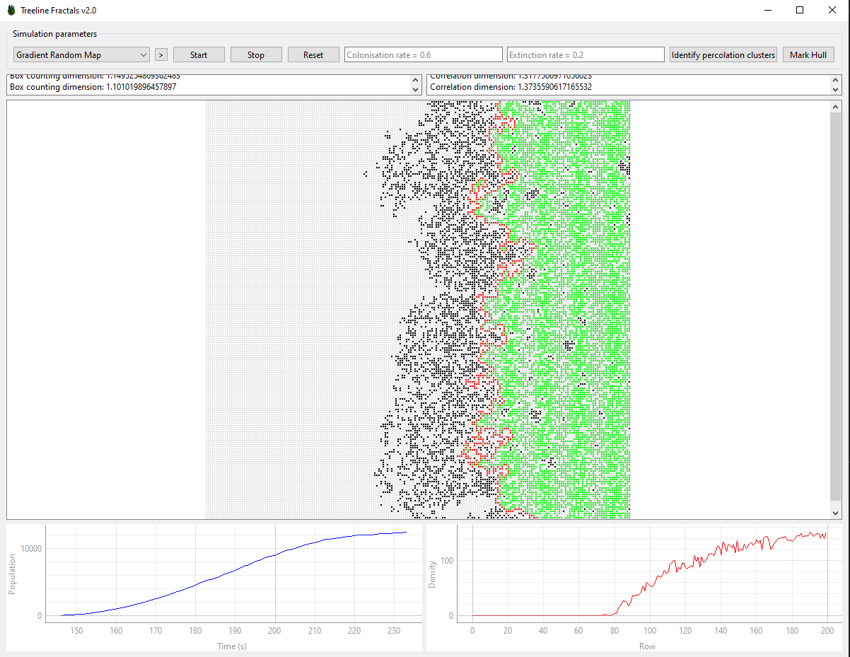

GUI of the simulation program.

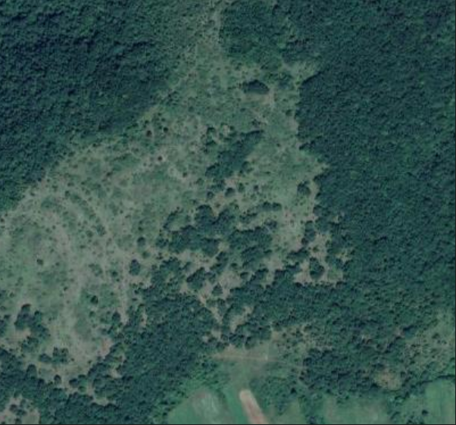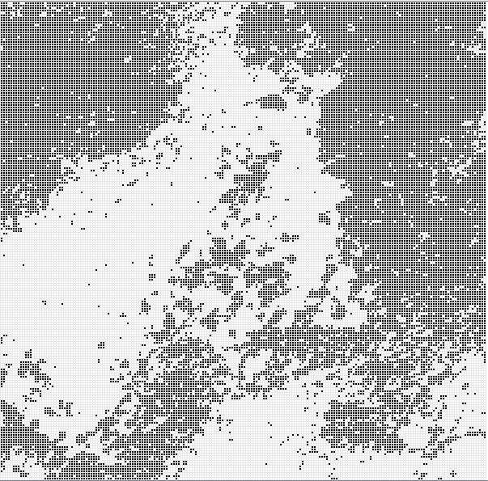

Sample satellite image and its processed version loaded into the grid.

1. EVALUATION AND VISUALIZATION OF RESULTS
   1. Result analysis

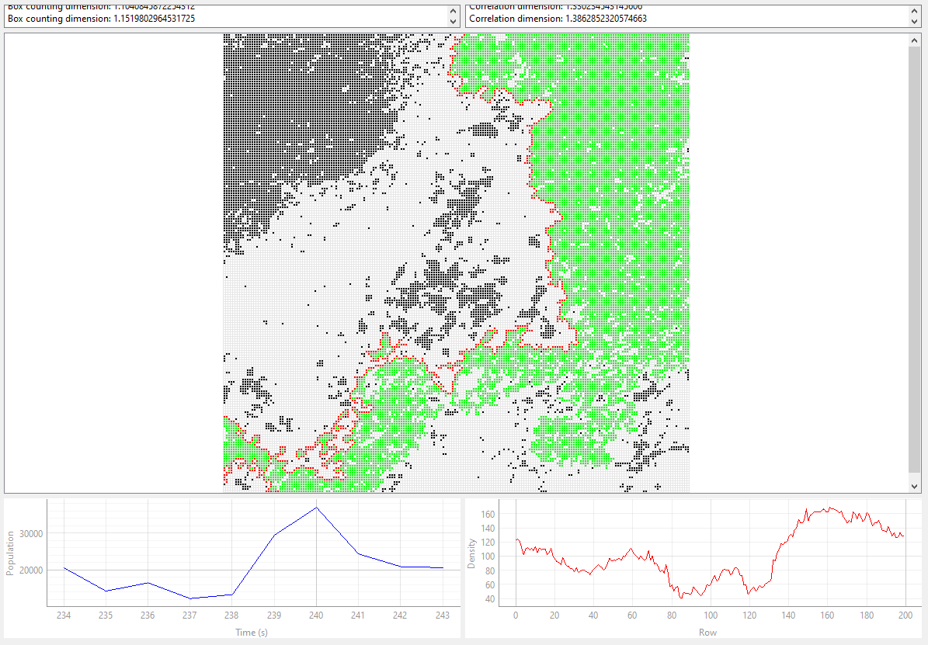

Existing functions applied on the given pre-processed image.

1. CONCLUSION AND DISCUSSION

We have developed robust simulation software and analysed real satellite images. The results, however, presented a different picture than what was initially proposed. In our analysis, we found that the box counting and correlation fractal dimension, whether calculated from our simulation software or derived from real satellite images, consistently fell between the ranges of and . Importantly, this result held true regardless of the resolution of the grid used in the analysis, demonstrating the robustness of our findings. Our results also indicated that the correlation fractal dimension consistently exceeded the box-counting dimension.

These values, which are noticeably lower than the anticipated dimension, suggest that the phenomenon underlying the structure of treelines may not be fully captured by the existing theoretical models. The discrepancy underscores the complexity of real-world systems and highlights the need for the continued evolution of our theoretical frameworks.

In light of these findings, we believe that further research is warranted. A more comprehensive analysis should be undertaken to uncover the causal factors leading to the observed fractal dimension. Investigating these factors may provide valuable insights into the dynamics of treeline structures and their responses to ecological variables and climate change.

To support open science and foster further research in this area, we have made our simulation software code publicly accessible on GitHub. The code can be examined and built upon by interested researchers [7].

REFERENCES

1. M. T. Gastner, B. Oborny, D. K. Zimmermann, G. Pruessner, *Transition from Connected to Fragmented Vegetation across an Environmental Gradient: Scaling Laws in Ecotone Geometry*, The American Naturalist, 174 (1), 2009, Chicago, Illinois, USA  
   <https://doi.org/10.1086/599292>
2. B. Oborny, *Scaling Laws in the Fine-Scale Structure of Range Margins*, Mathematics, 6 (12), p. 315, 2018  
   <https://doi.org/10.3390/math6120315>
3. R. Juhász, B. Oborny, *Percolation theory suggests some general features in range margins across environmental gradients*, 2019  
   <https://arxiv.org/abs/1909.00585>
4. J. M. Keller, R. M. Crownover, R. Y. Chen, *Characteristics of Natural Scenes Related to the Fractal Dimension*, IEEE Transactions on Pattern Analysis and Machine Intelligence, vol. PAMI-9, no. 5, pp. 621-627, 1987, Manhattan, New York, USA  
   <https://ieeexplore.ieee.org/abstract/document/4767956>
5. J. Theiler, *Estimating fractal dimension*, Journal of the Optical Society of America, 7 (6), pp. 1055-1073, 1990, Washington, DC, USA  
   <https://opg.optica.org/josaa/abstract.cfm?URI=josaa-7-6-1055>
6. G. P. Decoster, D. W. Mitchell, *The efficacy of the correlation dimension technique in detecting determinism in small samples*, Journal of Statistical Computation and Simulation, 39 (4), pp. 221-229, 1991, Abingdon-on-Thames, United Kingdom  
   <https://doi.org/10.1080/00949659108811357>
7. Our Simulation Software. (2023). GitHub repository, Available at: [<https://github.com/kristofkassa/project_lab_treeline>].