The Fractal Structure of Treelines in High Mountains

Bálint Kovács, Kristóf Kássa

Institute of Mathematics, Faculty of Natural Sciences, Budapest University of Technology and Economics

Project advisor: Dr. Beáta Oborny, Associate Professor

Department of Plant Systematics, Ecology and Theoretical Biology, Faculty of Science, Eötvös Loránd University

ABSTRACT The occurrence of tree species in high mountains usually ends abruptly at some elevation. This is the treeline. The appearance of treeline structures in such areas is a topic of interest to ecologists and climate scientists. These treeline structures exhibit a characteristic mainland-island structure, where the tree cover is continuous at lower elevations (‘mainland’) and fragmented at higher ones (‘islands’). Theoretical predictions from percolation theory using simulation-based results obtained by studying two widely known types of models (the static Uniform/Gradient Random Map model and the dynamic Uniform/Gradient Contact Process model) suggest that the hull of the ‘mainland’ should be a fractal with dimension 7/4. This research project aims to test this hypothesis and to develop simulation software that appropriately presents the gradient models as well.

INDEX TERMS Treeline structure, percolation theory, fractal analysis, gradient contact process

1. INTRODUCTION

The occurrence of tree species in high mountains usually ends abruptly at a certain level of elevation. This is the *treeline*. The appearance of treeline structures in such areas is a topic of interest to ecologists and climate scientists. These treeline structures exhibit a characteristic mainland-island structure, where the tree cover is continuous at lower elevations (‘mainland’) and fragmented at higher ones (‘islands’). Theoretical considerations from percolation theory obtained by studying two widely known types of models (the static Uniform/Gradient Random Map model and the dynamic Uniform/Gradient Contact Process model) suggest that the hull of the ‘mainland’ should be a stochastic fractal with dimension . This research project aims to test this hypothesis and to develop simulation software that appropriately presents the gradient models as well.

1. RELATED WORK

Several studies have investigated the transition from connected to fragmented vegetation across environmental gradients and scaling laws in ecotone geometry **(Gastner, Oborny, Zimmermann, & Pruessner, 2009)**. Recent research has also suggested that percolation theory predicts some universal features in range margins across environmental gradients **(Juhász & Oborny, 2020)**. However, there is a lack of research that uses satellite images to analyse the fractal structure of treelines and its implications for species border delineation and climate change detection. Additionally, the existing simulation software of this population model in finite space does not capture environmental gradients

1. METHOD
   1. General description

The so-called finite-size effect in analysing tree species distribution on a bounded square lattice refers to the influence of the lattice's limited size on observed spatial patterns and population dynamics. It introduces boundary effects that can alter colonization patterns and spatial interactions. As a common attempt to address it, toroidal and cylindrical boundary conditions were employed to mitigate these effects and simulate an infinite lattice. Understanding the finite size effect is vital for the accurate interpretation of results.

To be able to effectively test our hypothesis and to maintain the possibility of extending this research topic in the future we have decided to use the following methodology:

* Programming language: Python (desktop application);
* Build a compact, yet easily extendible framework for the research topic;
* Using our Python program and multiple process variables we test the hypothesis with increasing lattice size.

1. DESCRIPTION OF THE IMPLEMENTATION
   1. Software design

Our Python program provides a graphical interface for simulating and visualizing the dynamics of various treeline fractal models. It primarily leverages the PySide6 library for creating the GUI and pyqtgraph for data visualization.

The simulation strategies, imported from the simulation package, include:

* Gradient Contact Process
* Homogeneous Contact Process
* Gradient Random Map
* Image Treeline

Our grid-based simulation tool is designed to model and visualize different strategies of property spread, such as diseases or ideas, in a population. It includes multiple classes that each handle different parts of the simulation:

SimulationStrategy: This abstract base class outlines the basic structure for a simulation strategy. It provides a template for the simulation algorithm and maintains important state information, including the grid size, colonization and extinction probabilities, occupied cells, and neighbouring cells.

HomogeneousContactProcessSimulationStrategy: A subclass of SimulationStrategy that simulates a homogeneous contact process. In this strategy, every cell in the grid has the same probabilities of colonization and extinction, regardless of its position.

GradientContactProcessSimulationStrategy: Another subclass of SimulationStrategy. This strategy introduces a gradient in the colonization and extinction probabilities based on the cell's position on the grid. The chance of a cell becoming occupied increases, while the chance of becoming unoccupied decreases, as we move across the grid.

The ImageTreelineSimulationStrategy class in the context of this simulation software is dedicated to handling real-world treeline data represented by image files. Instead of using abstract mathematical models or algorithms, it bases its simulation on actual visual data, opening new possibilities for more realistic and tangible simulations.

The ImageTreelineSimulationStrategy class provides an interface between raw image data and the simulation grid, transforming real-world visual information into a form suitable for the simulation process.

MainWindow: This class creates the graphical user interface for the simulation. It contains functions to start and stop the simulation, update the grid display, and adjust the simulation parameters. It is in charge of creating the Graphical User Interface (GUI) that allows the users to interact with the simulation program.

Grid Display Area: A large central area where the grid is displayed. Each cell of the grid may be colour-coded based on whether it is occupied or not, providing a visual representation of the current state of the simulation.

Simulation Control Buttons: Buttons to start, pause, stop, and reset the simulation. This allows the user to control the flow of the simulation.

Settings/Parameters Panel: A section where users can adjust various simulation parameters such as grid size, colonization probability (), and extinction probability ().

Data Visualization Tools: There are options for plotting the results of the simulation over time, for example, a line graph showing the number of occupied cells over time.

Overall, our software provides an interactive and flexible tool to study the spread of properties across a grid-based population using different stochastic process models. It's capable of creating visually interesting simulations that can provide insights into how these processes work under various conditions.

* 1. Simulation of the Popularization Models

The analysis of tree species distribution on a bounded square lattice provides valuable insights into ecosystem dynamics, biodiversity patterns, and conservation strategies.

* + 1. Homogeneous Random Map

For the sake of clarity, we begin with describing the simplest possible model, the Homogeneous Random Map model, which is not implemented in our project, but contributes to a more thorough understanding of the more complex models implemented.

The homogeneous random map model assumes that the distribution of tree species is random and uniform, without specific spatial patterns or dependencies. To apply this model, we consider a square lattice with rows and columns   
(), representing the discrete sampling units within the study area. Each lattice point corresponds to a sampling unit where a tree species can be observed or recorded.

The model begins by randomly assigning 1% of the lattice cells as occupied (seeded with tree species).

At each Monte Carlo step of the model, random lattice cells are selected uniformly, one after the other, and their status is updated based only on the colonization and extinction rates. If the selected cell is already occupied, it has a probability  
 to become unoccupied (extinct), representing the extinction rate. On the other hand, if the cell is unoccupied, it has a probability   
 to become occupied (colonized), representing the colonization rate.

By iteratively updating the lattice cells according to these colonization and extinction rates, the model captures the dynamics of tree species distribution, considering both the expansion and contraction of occupied cells over time.

* + 1. Homogeneous Contact Process

In this project, we simulate the homogeneous contact process model with toroidal boundary conditions to study the spatial distribution of tree species on a bounded square lattice. The homogeneous contact process model extends the previous model by incorporating the colonization probability based on the number of occupied neighbouring cells, while toroidal boundary conditions address the finite size effect associated with the bounded lattice.

To begin, we randomly assign 1% of the lattice cells as occupied, representing the initial presence of tree species. At each Monte Carlo step of the model, random lattice cells are uniformly selected, one after the other, for updating. If the selected cell is already occupied, it has a probability  
 to become unoccupied (extinct), representing the extinction rate. However, if the cell is unoccupied, the colonization occurs with a probability of , where is the colonization rate and is the number of occupied neighbouring cells (in general, we consider two sells neighbours if they share an edge). This colonization probability accounts for a factor of species interaction, namely the influence of neighbouring occupied cells on the colonization process. This is a special case of the idea of considering two occupied sites connected and hence belonging to the same vegetation patch if and only if the species can move from one site to the other without stepping on a vacant site in between. Various step lengths were tested in (Gastner, Oborny, Zimmermann, & Pruessner, 2009), our approach is clearly the step length of .

To tackle the finite-size effect and create an environment that mimics an infinite lattice, we employ toroidal boundary conditions. By applying toroidal boundary conditions, the lattice wraps around at the edges, creating a torus-like shape. The toroidal approach allows the colonization and interaction processes to occur seamlessly across the lattice as if it were infinitely extended.

* + 1. Gradient Random Map

We also employ the gradient random map model to study the spatial distribution of tree species on a bounded square lattice, considering the influence of an environmental (spatial) gradient, e.g. altitude, on colonization and extinction dynamics.

The gradient random map model extends the previous homogeneous random map model by incorporating gradient-dependent colonization and extinction probabilities. In this model, the probability of a cell becoming occupied, denoted as , becomes a function of the gradient variable , which represents a continuous spatial variation.

The GRM model only consists of one step after which it already attains the steady-state. In this single step, we try to occupy (colonize) each cell of the lattice with the species. Occupation (colonization) happens independently, with probability , where is the gradient value of the cell in question.

By incorporating gradient-dependent colonization probabilities, the gradient random map model captures the spatial dynamics of tree species in response to environmental variations. It allows for the exploration of how species colonization and persistence are influenced by the gradient variable , providing insights into the relationship between environmental gradients and tree species distribution patterns.

In our simulations, we studied the dynamics of the model with the assumption that at the lowest inspected altitude, the probability of a cell being occupied is 0.8, while at the highest inspected altitude, the same probability is 0.4, and the function is set to be the linear function connecting these two points. This way, in the middle altitude (), the probability of a cell being occupied is approximately 0.6, near the theoretical critical percolation threshold of , where the population density is expected to be the highest (Mertens, 2022).

* + 1. Gradient Contact Process

Finally, we utilize the gradient contact process model with a tube-like, cylindrical boundary conditions to study the spatial distribution of tree species on a bounded square lattice, incorporating gradient-dependent colonization and extinction probabilities.

The gradient contact process model extends the homogeneous contact process by incorporating gradient-dependent colonization and extinction probabilities. In this model, the probability of extinction, denoted as , and the probability of colonization, denoted as , also become functions of the gradient variable , which represents a continuous spatial variation.

To initiate the model, as usual, we randomly assign 1% of the lattice cells as occupied, representing the initial presence of tree species. At each Monte Carlo step, random lattice cells are uniformly selected, one by one, for updating, considering the gradient-dependent colonization and extinction probabilities.

If the cell is unoccupied, the colonization occurs with a probability of , where represents the colonization rate influenced by the gradient variable , and is the number of occupied neighbouring cells. The colonization probability considers both the suitability of the local environment, as indicated by the gradient value at that location, and the presence of neighbouring occupied cells.

On the other hand, if the selected cell is already occupied, it has a probability of to become unoccupied, reflecting the extinction rate influenced by the gradient variable . The extinction probability varies based on the gradient value at that location, considering the suitability of the local environment.

To tackle the finite-size effect associated with the bounded lattice, instead of the traditional toroidal boundary, we implement a cylindrical boundary approach. Instead of connecting the opposite edges, we duplicate the last and first columns on the vertical edges, creating a tube-like structure. This boundary setup allows colonization, extinction, and spatial interactions to occur seamlessly within the lattice, mimicking an infinitely extended environment and minimizing the finite-size effects.

In our simulations, we studied used the colonization rate (function) linear in , while extinction rate constant in . However, it is crucial to note that the gradient contact process model assumes appropriate functions and that accurately represent the underlying ecological processes. These functions should be attentively selected and validated based on ecological knowledge and available data.

* 1. Detection of the Giant Component

As already mentioned before, we consider two occupied sites connected and hence belonging to the same vegetation patch if and only if the species can move from one site to the other without stepping on a vacant site in between. Various step lengths can be studied, but in this project, we focus on the step length of 1.

We want to determine which sites are connected and hence belong to the same patch (i.e. percolation cluster). The largest patch is usually the one that connects the highest number of sites (cells) in the region of a low density to the region of a higher density. If the gradient points along the horizontal -direction from sparse to full vegetation cover, this patch will span from the bottom to the top of the lattice, a property that can be used later in delineating the hull. The probability of two distinct large patches in the densest region is negligible (Gastner, Oborny, Zimmermann, & Pruessner, 2009) in a sufficiently large lattice. Therefore, we call the largest patch the “connected patch”, or “giant component”. All the other patches we call “fragments”.

There are two (and eventually a lot more) algorithms that can be used to detect the giant component, which we will describe here.

The detection can be made using the Hoshen-Kopelman algorithm, based on the well-known union-finding algorithm, which is a simple and efficient algorithm for labelling clusters on a grid, where the grid is a regular network of cells, with the cells being either occupied or unoccupied.

The other possible algorithm, is the well-known DFS algorithm, where we consider the cells of the lattice as the vertices of a graph, the neighbouring cells being connected in the graph with an edge. The components of the population will be the connected components of this graph. Finally, the giant component will be the component with the highest number of members.

* 1. Delineation of the Hull

We want to delineate the so-called hull of the giant component, which, following (Gastner, Oborny, Zimmermann, & Pruessner, 2009), we defined as the set of the farthest points a species can reach without experiencing habitat fragmentation (i.e. without having to step on a vacant site).

The determination of the hull edge of the giant component of the population is an important aspect of studying spatial patterns and boundaries. The approach employed in our project to determine this edge is a biased walk algorithm, as described in (Gastner, Oborny, Zimmermann, & Pruessner, 2009)

The biased walk algorithm prioritizes exploring the unexplored region within the connected component, emphasizing the boundary area. Moving between occupied cells, the walker selects the next cell based on rules favoring unvisited or less-connected cells. The walker updates the hull edge by recording visited trees along the boundary, helping determine the outermost trees defining the hull edge. After completion, the recorded boundary sites reconstruct and visualize the hull edge, aiding understanding of the tree population's spatial extent, shape, and connectivity.

* 1. Approximation of Fractal Dimension

Fractal dimension quantifies the complexity and self-similarity of geometric objects or patterns. It characterizes irregular and intricate structures, like fractals, which lack a simple integer dimension. When applied to the delineated hull of a tree population, fractal dimension becomes a metric describing the complexity and roughness of the hull's boundary. It offers a numerical value reflecting the degree of self-similarity and space-filling properties of the hull. Different methods can be used to calculate the fractal dimension based on the nature of the data and the desired level of detail.

* + 1. Box Counting

The box-counting method serves as one of the mathematical techniques for estimating the fractal dimension of the hull. This method involves partitioning the hull into a grid of non-overlapping squares, known as boxes, of varying sizes and determining the number of boxes needed to cover the hull.

Let represent the minimum number of boxes of size needed to cover the hull. The box-counting dimension, denoted as , is then obtained by examining the scaling relationship between the size of the boxes and the corresponding count.

The box-counting method selects various box sizes, covering the hull with non-overlapping boxes. Counts are recorded, and a logarithmic plot with box size on the -axis and count on the -axis estimates the fractal dimension. A linear plot suggests fractal properties in the hull.

By performing a linear regression analysis on the data points, a line of best fit is obtained, allowing the determination of the slope. This slope represents an estimate of the box-counting dimension. More precisely, this can be expressed as

The box-counting dimension provides a quantitative measure of the complexity and self-similarity inherent in the delineated hull of the tree population. A higher fractal dimension indicates a greater level of intricacy and irregularity within the hull, while a lower dimension suggests a more regular and smoother structure.

* + 1. Correlation Dimension

This method focuses on measuring the degree of correlation or similarity between points at varying distances within the hull.

To apply the correlation dimension method, a series of distance thresholds is selected, encompassing a range of scales. To calculate the so-called correlation integral, a distance threshold (denoted as ) is chosen. This threshold defines the maximum distance within which point pairs are considered for analysis. For each point in the dataset, the number of other points located within the specified distance threshold is counted. This count represents the correlation integral at that distance threshold. It can be expressed as

In this equation, represents the number of points in the data set, represents the distance between points and , while is the Heaviside function (the value of which is for non-negative input and otherwise).

Subsequently, the correlation integral is plotted against the corresponding distance threshold on a logarithmic scale. If the hull exhibits fractal characteristics, the resulting plot will manifest a power-law relationship, wherein the correlation integral scales with the distance threshold raised to a power.

The estimation of the correlation dimension involves analysing the slope of this power-law relationship. Mathematically, the correlation dimension can be expressed as

* + 1. Ruler Method

The ruler method, a fundamental technique in fractal analysis, serves as a powerful tool for quantifying the intricate self-similarities within geometric structures, such as the hull edge. This method meticulously examines the structural complexity across multiple scales by measuring the length of the hull edge using various ruler sizes.

In the application of the ruler method, a diverse set of ruler sizes is meticulously chosen, spanning a range of scales that capture the intricacies of the hull's features. For each specific ruler size, the process involves determining the number of rulers required to traverse the entire hull while maintaining a step-size equal to the chosen ruler size. These counts, representing the effective coverage of the structure at each scale, are recorded.

The subsequent step involves the creation of a logarithmic plot, where the recorded counts are graphed against the corresponding ruler sizes. To extract valuable insights regarding the fractal characteristics of the hull, linear regression is applied to approximate the slope of the line fitted to these data points. This slope, derived from the logarithmic plot, serves as a key indicator for estimating the fractal dimension of the hull.

Mathematically, the fractal dimension derived using this method can be expressed as

where is the recorded ruler count for ruler size .

In our case, we can also make use of the biased walk created at hull delineation: starting from the top-leftmost point of the hull, we examine distances from this initial point along the path of the walk through the hull. Among the points that are at a distance equal to the ruler length, we consistently choose the one that is positioned earlier along the traversal (left-turning walk), and always consider only the points that are ahead in the traversal, i.e., located after our initial point. This process ensures that, at each step, the ruler is aligned with the point that appears first along the left-turning walk, allowing for a systematic examination of distances along the hull.

Due to divisibility issues, there could emerge a case when the remaining part of the hull is smaller then the ruler’s size. In such cases, let us take the distance between the last regularly visited point and the starting point, and divide this by the ruler length. We will add this fraction to the cumulative count of (whole) rulers used so far.

* + 1. Average Distance (Equipaced Polygon) Method

Our last implemented method for fractal analysis is the Equipaced Polygon method (Batty & Longley, 1994). This method has the advantage of being easily carried out in both computer simulations and measurements in the field. (Gastner, Oborny, Zimmermann, & Pruessner, 2009)

Let us denote the cells in the left-turning biased walk used in the hull delineation as , where is the total number of steps in the walk. Next, we repeatedly skip intermediate steps and consider between two end points, namely

for any integer . Here, is the largest integer such that . If , the last few steps in the walk are ignored. We then calculate the average,

The method can be generalized for geometrical objects other than straight lines. (Gastner, Oborny, Zimmermann, & Pruessner, 2009) Suppose we are tracing a fractal curve with rulers of lengt . Then, by the definition of the fractal dimension , the number of rulers needed from one end of the curve to the opposite and scales es . Following this idea, it can be derived that a logarithmic plot of against should yield a straight line, the inverse of its slope being the fractal dimension .

1. MASS SIMULATIONS: GRM
   1. Average Measurements

To numerically confirm the theoretically predicted result of 7/4 for the fractal dimension, and to compare and analyse the robustness of the previously described fractal analysis methods in light of the finite size effect, we employed mass simulations on the GRM model, with increasing grid size .

For every inspected grid sizes, we calculated a sample average of the measurements provided by the fractal analysis algorithms, and conducted linear regression on the logarithmic plot of these average measurements.

The inspected grid sizes at the current stage of the project were , with a sample size of 100 independently generated samples, the obtained results being about to be presented below.

For this lattice size, the measurements of the Box Counting algorithm exhibited strong influence by the finite size effect at low and high box sizes. Therefore, after removing these data points from the regression, the remaining two data points provided an expectedly bad estimate of approximately 1.57 for the fractal dimension. Based on the data points yielded by the other fractal analysis algorithms, these experienced less distortion from the finite size effect. In these cases, only the first (and last) one or two data points needed to be disregarded when conducting the linear regression analysis. In the plots, data points considered for the regression are displayed with green, while disregarded data points are displayed with grey. The resulting estimates are approximately 1.63 for the Ruler Method, 1.72 for the Correlation Method, and 1.76 for the Equipaced Polygon Method. This later method probably yielded the best result out of the four as – because of the particularities of the algorithm – this method provides us with a higher number of data points even with such a relatively small lattice size.

For a lattice size of 256, the Box Counting data points still experience considerable distortion for low and high box sizes, although providing a slightly higher estimate of approximately 1.59.

The other three methods basically behaved the same as in the last case, yielding dimension estimates of approximately 1.65, 1.71 and 1.74 respectively.

For this lattice size it is starting to become clearer that for all four methods, the data points useful in our analysis will be the ones lying in a middle interval of the plot, the other ones suffering slight considerable distortions by the finite size effect. The Box Counting Method continues to underperform its counterparts, even with a slightly improved estimated dimension of approximately 1.63 (still over a 0.1 distance from the theoretical 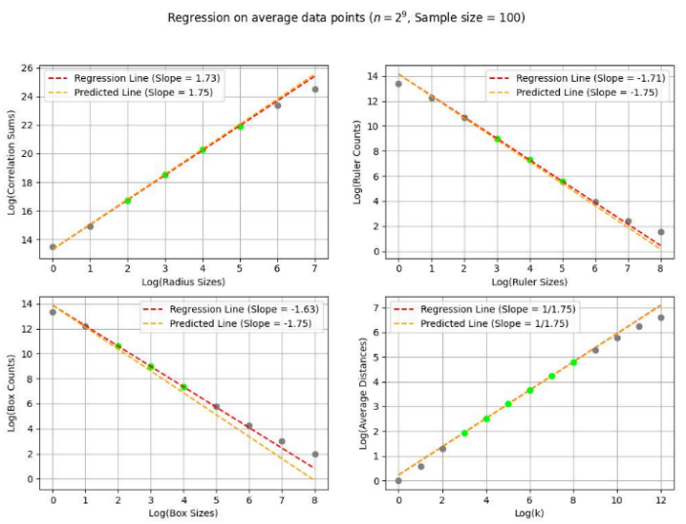1.75).

The other methods yield an estimate of 1.71 (Ruler) and 1.73 (Correlation), which fall fairly close to the theoretical fractal dimension 1.75, which is even attained by the Equipaced Polygon Method’s approximated 1.75. This is a rather surprising outcome, considering the still relatively low lattice size inspected.

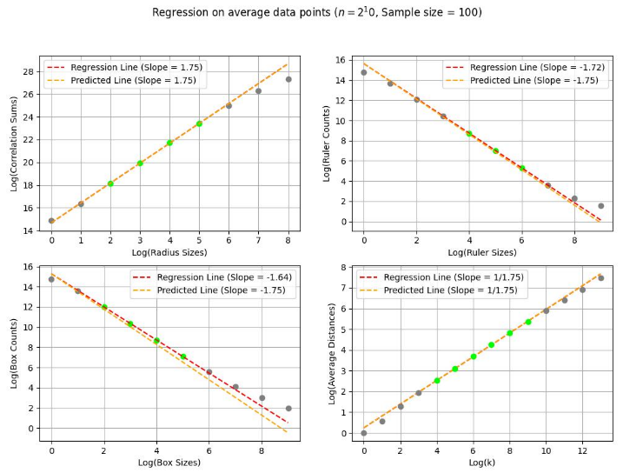For the last round of mass simulations, we considered a lattice size of 1,024, i.e. a lattice with 1,040,576 cells.

At this point, both the Correlation and Equipaced Polygon Methods manage to reach the theoretically predicted value, yielding an estimated dimension of approximately 1.75 each. The Ruler Method provides a result of approximately 1.72 (which is also close to 1.75), while the Box Counting Method continues its underperformance with a slightly improved approximately 1.64.

* 1. Initial Distribution Analysis

After the fractal analysis conducted using average measurements, we started to analyse the distribution of the 100 simulations in the case, one by one calculating the estimated fractal dimensions for each simulation.

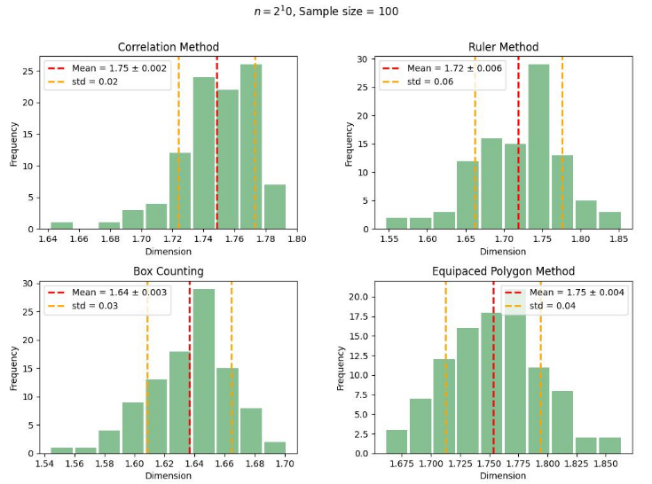The following figure shows histograms on the resulting dimensions:

As displayed, the simulationwise results also show an underperformance of the Box Counting Method compared to its counterparts. What is also worth noting is that, while both the Correlation and Equipaced Polygon Methods reach the theoretically predicted 1.75 in mean, the Correlation Method manages to do so with lower standard deviation (0.02).

We also conducted initial hypothesis tests referring to the normality of the results. In case of the Correlation Method, the Shapiro-Wilk test (Shapiro & Wilk, 1965) rejects the normality of the results with significance 0.01, while in case of the other methods, it fails to reject normality at the same level of significance. Assuming normality, the one sample -test (Student, 1908) accepts the hypothesis that the true population mean is 1.75 with significance 0.01.

1. CONCLUSION AND DISCUSSION

We have developed robust simulation to numerically confirm the theoretically predicted result. We found that the Box Counting Method, while exhibiting a growing tendency as lattice size is increasing, is consistently underperforming its counterparts, suggesting a low speed of convergence. In regard of speed of convergence, the Equipaced Polygon Method has proved to be the most efficient, approximately attaining the desired result even with a relatively low lattice size of 512. However, the Correlation Method also manages to reach this value with a lattice size of 1024 (which is still relatively low), and does so with a lower standard deviation. The Ruler Method, while attains a quite good estimate of 1.72 with lattice size 1024, exhibits a slightlu slower pace of convergence.

These findings collectively highlight the nuanced performance characteristics of each method, with the Equipaced Polygon Method showcasing remarkable efficiency, the Correlation Method demonstrating both speed and precision, and the Ruler Method providing a solid but slightly slower convergence.

Our initial statistical analysis regarding the distribution of the results of the 100 simulations revealed distinctive patterns in the estimated fractal dimensions obtained through different methods. The histograms depicting the distribution of dimensions across simulations highlighted the underperformance of the Box Counting Method compared to its counterparts.

Notably, both the Correlation and Equipaced Polygon Methods achieved a mean fractal dimension of 1.75, in line with theoretical predictions. However, the Correlation Method exhibited superior precision, evidenced by its lower standard deviation of 0.02.

Hypothesis tests regarding normality provided additional insights. The Shapiro-Wilk test rejected the normality assumption for the Correlation Method's results at a significance level of 0.01, while the results of other methods were consistent with normal distribution assumptions. Assuming normality, the one-sample -test supported the hypothesis that the true population mean is 1.75 with a significance level of 0.01.

In conclusion, the Correlation Method stands out for its accuracy and precision, achieving the theoretically predicted fractal dimension with a lower standard deviation. The Equipaced Polygon Method also performed well, while the Box Counting Method demonstrated comparatively weaker performance. These findings contribute to a nuanced understanding of the strengths and limitations of each method in fractal analysis.

REFERENCES

*Batty, M., & Longley, P. (1994). Fractal cities. London: Academic Press.*

*Decoster, G., & Mitchell, D. (1991). The efficacy of the correlation dimension technique in detecting determinism in small samples. Journal of Statistical Computation and Simulation, 39(4), 221-229. Retrieved from https://doi.org/10.1080/00949659108811357*

*Gastner, M. T., Oborny, B., Zimmermann, D. K., & Pruessner, G. (2009). Transition from Connected to Fragmented Vegetation across an Environmental Gradient: Scaling Laws in Ecotone Geometry. The American Naturalist, 174(1). Retrieved from https://www.journals.uchicago.edu/doi/10.1086/599292*

*Juhász, R., & Oborny, B. (2020). Percolation theory suggests some general features in range margins across environmental gradients. Ecological Complexity, 42, 100814. Retrieved from https://doi.org/10.1016/j.ecocom.2020.100814*

*Keller, J., Crownover, R. M., & Chen, R. Y. (1987). Characteristics of Natural Scenes Related to the Fractal Dimension. IEEE Transactions on Pattern Analysis and Machine Intelligence, PAMI-9(5), 621-627. Retrieved from https://ieeexplore.ieee.org/abstract/document/4767956*

*Kovács, B., Kássa, K., & Najeed, M. (2023). Project Laboratory I The Fractal Structure of Treelines in High Mountain. GitHub repository. Retrieved from https://github.com/kristofkassa/project_lab_treeline*

*Mertens, S. (2022). Exact site-percolation probability on the square lattice. Journal of Physics A: Mathematical and Theoretical, Volume 55, Number 33. doi:10.1088/1751-8121/ac4195*

*Oborny, B. (2018). Scaling Laws in the Fine-Scale Structure of Range Margins. Mathematics 6(12), 315. Retrieved from https://doi.org/10.3390/math6120315*

*Shapiro, S., & Wilk, M. (1965). An analysis of variance test for normality (complete samples). Biometrika, 593.*

*Student. (1908). The Probable Error of a Mean. Biometrika, 1-25.*

*Theiler, J. (1990). Estimating fractal dimension. Journal of the Optical Society of America, 7(6), 1055-1073. Retrieved from https://opg.optica.org/josaa/abstract.cfm?URI=josaa-7-6-1055*