|  |
| --- |
| an **Online course registration and exam management system**  **for**  “Academy of the handsome men and beautiful woman (BEA) “  web application  BTI7302 - Project 2 – 2019  *Advisor: Prof. Dr. Olivier Biberstein*  *Author: Kristina Shiryagina*  *Author: Kristina Shiryagina*  *Version and date: 01, 30.09.19* |
| **Bern University of Applied Sciences**  Department  Division |

Contents

Vision and scope 3

Introduction 3

Problem Statement 3

Project background 4

Stakeholder Description 4

List of Risks 5

Assumptions and Constraints 5

Vision of Solution 5

Vision Statement 5

Scope 5

Summary of System Feature 5

List of features will not be developed 5

Analysis 1 6

Domain model 7

User stories 2 8

Design 1 10

Class diagram 2 10

Implementation 11

Software Architecture: 11

Testing 13

Conclusion 13

Summary 13

Interpretation 13

Outlook 13

Glossary 13

Bibliography 13

Version control 14

Protocol 15

# Vision and scope

## Introduction

This document describes the Vision and Scope of a new smart and flexible an **Online Academy course registration and exam management system** forAcademy of beauty( BEA ). This part of the document will cover the problem and vision statement including project background, stakeholders, candidate risks, assumptions and constraints, and project scope.

## Problem Statement

BEA is an online academy of beauty. For this academy is needed to develop:

* **Online course registration system.**
* **Exam management system**.

Current user management system doesn't have the needed flexibility and is not modern enough. The capabilities are limited.

Online course registration system and exam management system are effective, reduce time and cost in courses and exam management process.

1. **Online course reservation system**. The task is to develop a new participant course registration system. The new system will allow the participants to register for courses. Instructors will be able to access the system to sign up to make an exam as well as record grades.

*There are 4 modules of this system:*

* *Login for Participant: Using this module participant login to the system using his/her*

*Unique username and password*

* *Participant Registration: In this module, the participant registers his/her details in the system. The details are stored in the participant's table in the database.*
* *Form for Registration: In this module, the participant can apply for the course by giving the details about the candidate and selecting the quota for the registration.*
* ***Enquiry about course:*** *In this module, the student can enquiry about the various courses in all the colleges.*

1. **Exam management system**. To create an Exam registration software that will meet the needs of the applicant and help them in registering for the exam, enquiry about the registered subject, modification in database and cancellation for the registered project.

There are 4 modules of this system.

* **Exam registration**. The user can select the course for the exam. The user can ask for information about courses, modification in database.
* **Form for Registration**. The user can apply for the exam by giving the details about the candidate and selecting a course for the registration.
* **Exam cancellation**. The user can cancel their name which is registered to the exam.

**//remove db( not wie?** Sonst was)

* **Modification of the data in the database**. In this module, the user can modify the data's like Phone number, address, etc.

## Project background

## Stakeholder Description

Similar to other technology applications, the success of online-learning is dependent on the extent to which it satisfies the needs and addresses the concerns of its stakeholders.

The list of stakeholders

* Participant: use the system to register for the course or exam, view information.
* Instructors: they could give ideas on the solution for the system’s development and improvement.
* Administrator: manage the system after it is built.
* Education Institutions
* Content Providers
* Development team: include all software engineers, business analysts, system analysts, system designers, implementers, testers, QA, and project management. They are tasked to build the system.
* Employers

### List of Risks

### Assumptions and Constraints

## Vision of Solution

### Vision Statement

The main goal is to develop a new **Online Academy course registration and exam management system**. The new system will allow participants to register for courses, add or drop the registered courses, register for an exam, see the final points.

The instructor will use the system too.

### Scope

To be noticed on the scope of the system that this system is an **Online Academy course registration and exam management system.** It is not an academy management system which is much larger the system we try to build. It is only part of the academy management system. We have to pay attention to building applications supporting: Participant will be able to enrol and manage their courses, to make a reservation for a final exam.

### Summary of System Feature

* User can log in.
* A participant can register for a course.
* A Participant car register for a final exam.
* A participant can choose a date for a final exam.
* An Administrator can manage participant’s information.
* An administrator can manage a course’s information.
* An Instructor can set final points to the participant.

### List of features will not be developed

* // todo
* //todo

Et ut aut isti repuditis qui ium nonsecturia quis incientiae laborem elliquis et quatur, sitiur aut od moluptatur aut ea conseque peri sim erro essequisit remporia dem et landi dest, cone poris quunt volecab ipidero quatur ad quibusamus.

# 

# Analysis 1

Et ut aut isti repuditis qui ium nonsecturia quis incientiae laborem elliquis et quatur, sitiur aut od moluptatur aut ea conseque peri sim erro essequisit remporia dem et landi dest, cone poris quunt volecab ipidero quatur ad quibusamus.

## Domain model

This document describes the domain model of the Beautiful Academy BEA. It introduces the most important entities and the associations among them. It also introduces the respective multiplicities.

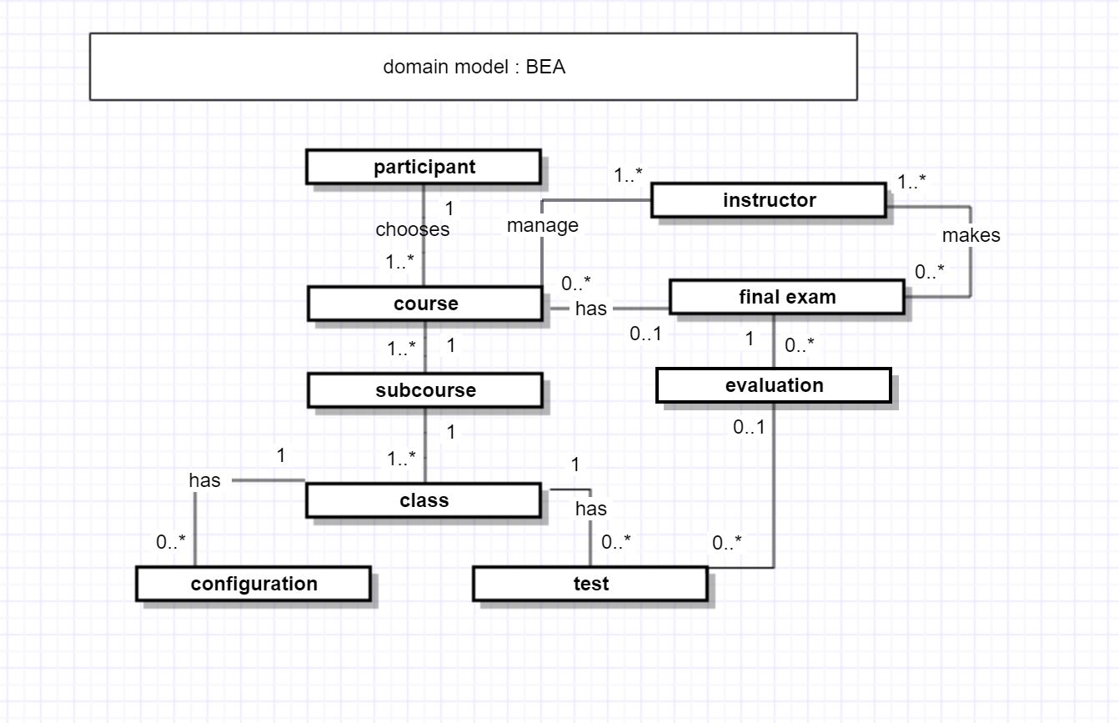

## User stories 2

1. As a user, I want to be able to login into the system with my credential (username, password).

Success: The user is logged in and can use the functionality of the system.

Failure: An error message is displayed: “Wrong username or password, please try again!”.

1. As a Participant, I want to choose and subscribe to the course.

Success:

Failure:

1. As a Participant, I want to see the information about the courses.

Success:

Failure:

1. As a Participant, I want to see the marks of the final exam and total.

Success:

Failure:

1. As a Participant, I want to select an exam (there are different data on an exam).

Success: A participant has selected exam, the database is changed.

Failure: An error message is displayed “This date is already reserved, please take another date for your final exam".

1. As a Participant, I want to be able to cancel the exam registration.

Success: A message “You have successfully deleted your exam registration”

Failure: An error message "The period of availability of deleting registration is expired, please take a contact to the administration".

1. As a Participant, I want to see my page with my personal information and my result and the courses I've done.

Success: The participant can see his page with all the information it has.

Failure: We are sorry, this page is on reconstruction, you can access it after 12 hours.

1. As a Participant, I want to receive certification.

Success: The participant will receive a certification.

Failure:

1. As an Instructor, I want to see a list of participants with courses that they have to choose and the corresponding date of a final exam.

Success: An Instructor can see the list with all the data he needs for an exam.

Failure:

1. As a System Administrator, I can change the information on a course .

Success: An Administrator can manage the data of courses, participants, exams.

Failure:

**** future user stories

1. As a Participant, I want to see the results of each test I do.

Success:

Failure:

# Design 1

## Class diagram 2

# 

# Implementation

## Software Architecture:

Et ut aut isti repuditis qui ium nonsecturia quis incientiae laborem elliquis et quatur, sitiur aut od moluptatur aut ea conseque peri sim erro essequisit remporia dem et landi dest, cone poris quunt volecab ipidero quatur ad quibusamus.



Illustration 1: Et ut aut isti repuditis qui ium

Et ut aut isti repuditis qui ium nonsecturia quis incientiae laborem elliquis et quatur, sitiur aut od moluptatur aut ea conseque peri sim erro essequisit remporia dem et landi dest, cone poris quunt volecab ipidero quatur ad quibusamus.

Et ut aut isti repuditis qui ium nonsecturia quis incientiae laborem elliquis et quatur, sitiur aut od moluptatur aut ea conseque peri sim erro essequisit remporia dem et landi dest, cone poris quunt volecab ipidero quatur ad quibusamus, et exerionem eostis peror sedipis aut int la peris eatibusam is aut autem imporum soluptatium coritas perepratem doluptas sitatur atium, ilitat velenihictem eaquas molor serit doloratiis abo.

|  |  |  |  |
| --- | --- | --- | --- |
| **Head of table** |  |  |  |
| w | x | y | z |
| 1 | 1000 | 12.5 % | 12.5 % |
| 2 | 1000 | 12.5 % | 12.5 % |
| 3 | 1000 | 12.5 % | 12.5 % |

Table 1: Et ut aut isti repuditis qui ium

Et ut aut isti repuditis qui ium nonsecturia quis incientiae laborem elliquis et quatur, sitiur aut od moluptatur aut ea conseque peri sim erro essequisit remporia dem et landi dest, cone poris quunt volecab ipidero quatur ad quibusamus.

# Testing

Illustration 1: Et ut aut isti repuditis qui ium 3

# Conclusion

// In the conclusion of the project, you first summarize the most important results of your project in an understandable way. The main thing here is to filter out the essential content from the previous chapters and get to the point in a compact, clear and concise way.

## Summary

// Summary of the main results of your thesis

## Interpretation

//Interpretation of my results

//. In the theoretical part of your project, you should research and present the current state of research in detail in order to draw the right conclusions from the conclusion of your project. Even if your question could not be answered satisfactorily, you should present it honestly. Check what you could and could not achieve, what you would do differently in retrospect and which methods have proven to be useful.

## Outlook

//Outlook of my project and future research recommendations

# Glossary

**Auinweon**

Et ut aut isti repuditis qui ium 7

**Batnwpe**

Et ut aut isti repuditis qui ium 9

**Cowoll**

Et ut aut isti repuditis qui ium 11

# Bibliography

**Literary Entry**

*Author’s name, Author’s first name, book title, publisher, place, edition, year* 7

**Literary Entry**

*Author’s name, Author’s first name, book title, publisher, place, edition, year* 9

**Literary Entry**

*Author’s name, Author’s first name, book title, publisher, place, edition, year* 11

# Version control

|  |  |  |  |
| --- | --- | --- | --- |
| **Version** | **Date** | **Description** | **Author** |
| 0.1 | 30.09.2019 |  | Kristina Shiryagina |
| 0.2 | 13.03.2013 | Et ut aut isti | Anna Meier |
| 1.0 | 21.05.2013 | Et ut aut isti | Peter Muster |

# Protocol

**Frequency:** (weekly)

**Meeting length:** (35-45 minutes)

Agenda

* **Demo and Discuss Deliverables (Demo)**
* **Planning next Goals (Plan)**
* **Lessons learned (Lessons)**
* **Date, time, location of the next meeting (next meeting)**

**09.10.19**

**Demo**

**Plan**

Next goals are:

1. Introduction of a Vision make clear. Write about an application I want to build. I have to write a Vision that can make a good picture about the functionality of this application.
2. Change the problem statement:

* Join 2 Systems in 1 . Rename system in functions. And write that these functions just a part of this system we want to build.
* Write concrete user stories to these functions, group the stories according the function.

1. Analyze domain model, put attributes to each conceptual class, make description for each association. Rebuild domain model according of new clear representation of necessary functions of the system.
2. Sequence diagram of first function we want to implement (probably log in)
3. Try to make class-diagram.
4. Implement of log in function.
5. Write a protocol in the main doc.

**Lessons learned**

To documentation play decisive role in Software Engineering Project. The first analyzing phase have to be done well to make a good start for design and implementation of the IT Product.

**Next Meeting**

16.10.19, 14:30