The data I chose was for sales of cellular phones. I started with a basic view of the sales data in the database I chose. I broke down my research into 3 questions and my hypothesis.

Hypothesis:

Research Question 1: Are the rating means different?

Research Question 2: Is the rating mean in Samsung greater than the mean in Apple?

Research Question 3: Is the rating mean in Samsung less than the mean in Apple?

Null Hypothesis: There is no difference in the rating means of other phone brands and Apple.

Alternative Hypothesis: Apple has a higher mean for ratings than other phone brands.

I wanted to show that the Apple brand is, on average, higher rated than any

other mobile phone brand even with the cost generally being substantially

higher for Apple.

What I originally wanted to see was how cellular phones were rated in relation to cost. Of the 17 brands found in the data, Apple was highest rated even though it was the highest priced as well. Google Pixel was the second highest rated. I was surprised to find that Samsung was the 10th highest rated. I was even more surprised that there were 7 brands I’d never heard of that made up the rest of the top 10. Motorola, Nokia, LG, and HTC I was not surprised to see with lower ratings.

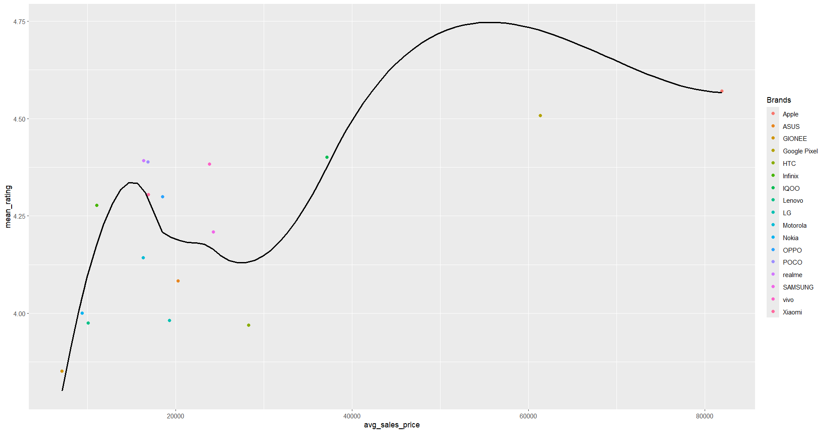

Average selling price vs average rating

The next two charts break down both stats into separate charts. The first one shows the average rating per brand and the second shows the average selling price per brand. I noted that the two have very interesting curves. That helped me with some conclusions. The first conclusion is that people are more likely to choose a cellular phone based on reviews as opposed to pricing. The second is that the major brands aren’t always the first choice for people. The 3rd highest rated phone was one I’ve never even heard of.

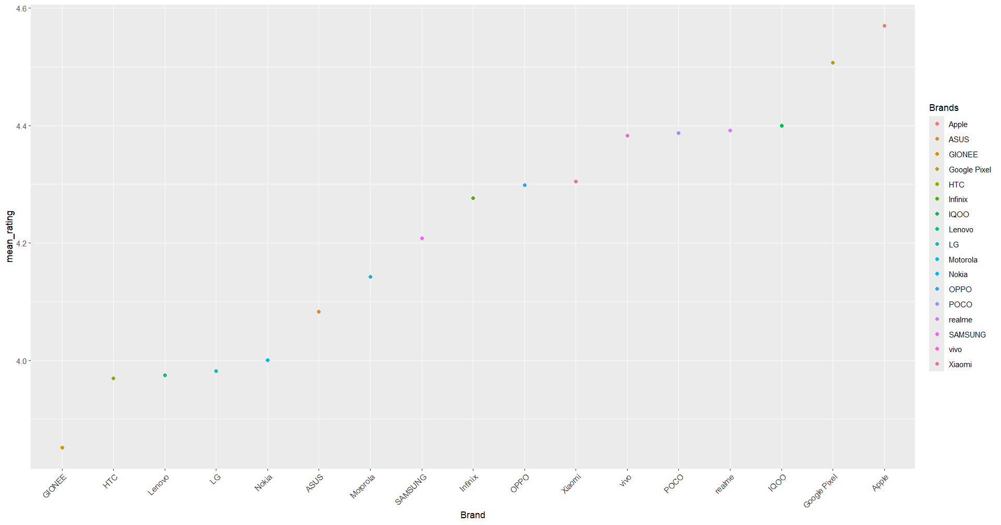

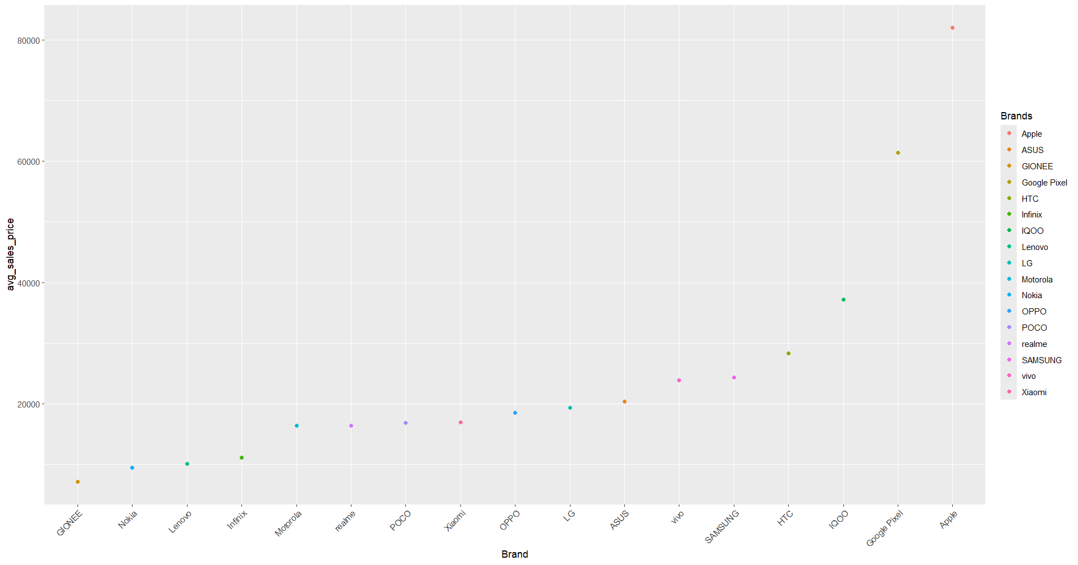

As for sale prices, Apple had the highest average sale price with Gionee having the lowest. Looking at selling prices vs the original pricing, the data was pretty hard to determine looking at the next chart. The chart was pretty congested. I didn’t dig further into this as the selling prices were not really so different from the original prices.

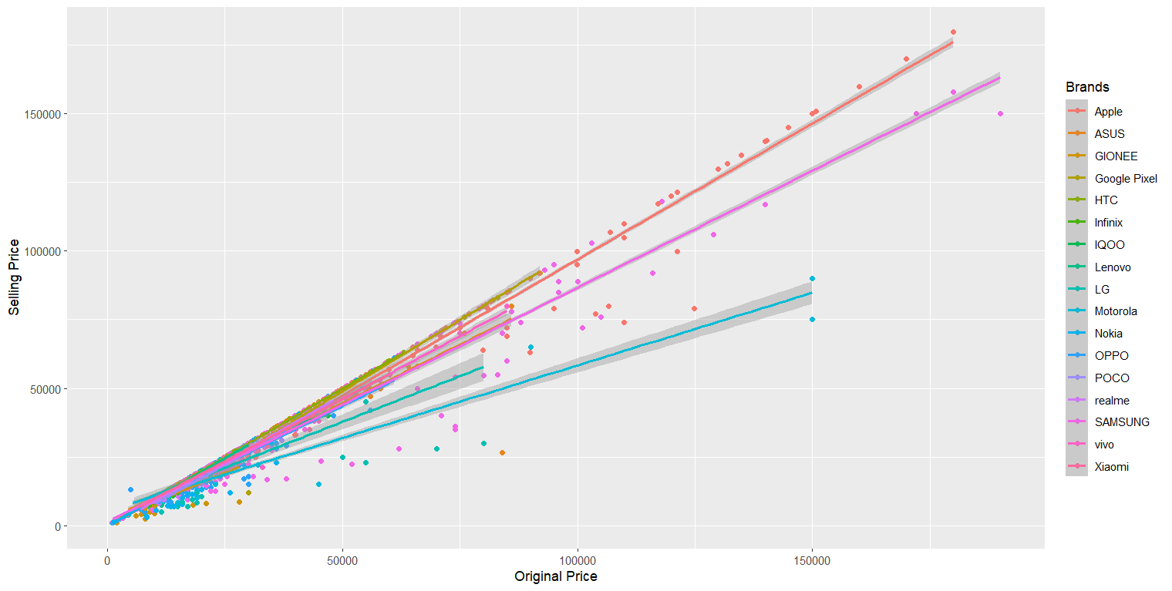

Samsung has the most models available at 210. Apple has only 25. IQ00 has by far the least models with only 1.

