Statistical Report for the EXAMPLE trial

Kristy Robledo

Last compiled on 30 March, 2023

**Table of contents**

## List of figures

## List of tables

# Formatting in Rmarkdown

check out the cheatsheets under help>cheatsheets

# Baseline

Check out [this presentation](http://www.danieldsjoberg.com/gtsummary-weill-cornell-presentation), or one of my previous sessions about gtsummary and its fantastic functions.

**Table** **:** Baseline characteristics by treatment

| **Characteristic** | **Overall**, N = 1971 | **MTA**, N = 100 | **CT**, N = 97 |
| --- | --- | --- | --- |
| Age at randomisation in years, Mean (SD) | 60 (11) | 60 (11) | 60 (12) |
| sex.f, n (%) |  |  |  |
| Male | 68 (35) | 40 (40) | 28 (29) |
| Female | 129 (65) | 60 (60) | 69 (71) |
| tt_Lnum, Median (Minimum-Maximum) | 3 (0-15) | 3 (1-13) | 3 (0-15) |
| pathway.f, n (%) |  |  |  |
| MAP Kinase | 24 (12) | 13 (13) | 11 (11) |
| HR | 84 (43) | 41 (41) | 43 (44) |
| PI3K/AKT/mTOR | 89 (45) | 46 (46) | 43 (44) |
| 1Mean (SD); n (%); Median (Minimum-Maximum) | | | |

# Cox regression analysis

Method: cox regression for the effect of treatment.

We plan to adjust for

* list1
* list2

**Table** **:** COx regression analysis for PFS

| **Characteristic** | **HR** **(95% CI)**1 | **p-value** |
| --- | --- | --- |
| bras.f |  |  |
| MTA | — |  |
| CT | 1.18 (0.87 to 1.61) | 0.28 |
| agerand | 0.99 (0.98 to 1.01) | 0.27 |
| 1HR = Hazard Ratio, CI = Confidence Interval | | |

# Kaplan-Meier curves

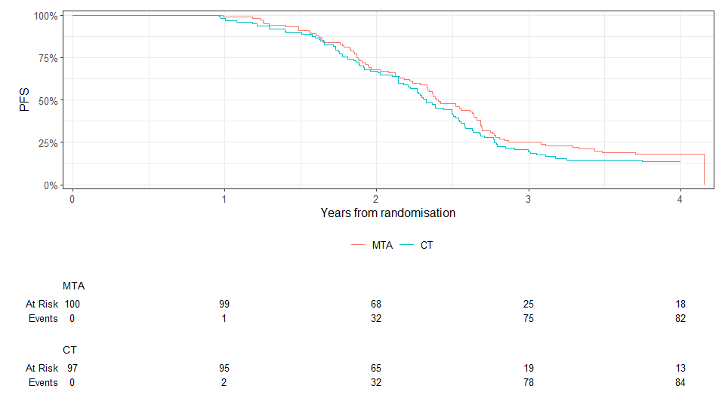

**Figure** **:** PFS by treatment

## Survival at time t (or find time for probability p eg. median survival)

**Table** **:** Survival table

| **Characteristic** | **365 days** | **730 days** |
| --- | --- | --- |
| bras.f |  |  |
| MTA | 99% (97% to 100%) | 68% (59% to 78%) |
| CT | 98% (95% to 100%) | 67% (58% to 77%) |

# Crossreferencing

Take a look at Table for baseline and Table for the regression.

# Inline reporting

There are a total of 197 participants enrolled in this trial. The average age is 60.0936011. Obviously you would also want to round this number….

Or we can use gtsummary helper “inline_text” function if you have saved the table. For example, the mean age is 60 (11) years.

# AE tables

* look to gtreg package and tbl_reg. Presentation and [examples here](https://shannonpileggi.github.io/gtreg/)

# Reproducibility receipt

Analyses and summaries produced in this report were carried out using the R statistical environment, version 4.1.3. The report itself was produced using an Rmarkdown workflow, located here: C:/Users/krobledo/OneDrive - The University of Sydney (Staff)/2. TEACHING/CodingConundrums/stats_report.Rmd`. The following table lists the non-base R packages used in analyzing and building this report.

R packages used in analyses and reporting

| package | version | date |
| --- | --- | --- |
| dplyr | 1.0.10 | 2022-09-01 |
| flextable | 0.8.3 | 2022-11-06 |
| forcats | 0.5.2 | 2022-08-19 |
| ggplot2 | 3.4.0 | 2022-11-04 |
| ggsurvfit | 0.2.1 | 2022-12-06 |
| gtsummary | 1.7.0 | 2023-01-13 |
| ipcwswitch | 1.0.4 | 2021-02-17 |
| officedown | 0.3.0 | 2023-01-06 |
| officer | 0.5.2 | 2023-01-27 |
| purrr | 1.0.1 | 2023-01-10 |
| readr | 2.1.3 | 2022-10-01 |
| sessioninfo | 1.2.2 | 2021-12-06 |
| stringr | 1.5.0 | 2022-12-02 |
| survival | 3.5.0 | 2023-01-09 |
| tibble | 3.1.8 | 2022-07-22 |
| tidyr | 1.2.1 | 2022-09-08 |
| tidyverse | 1.3.2 | 2022-07-18 |