Example report

Kristy Robledo

27/02/2020

## R Markdown

This is an R Markdown document. Markdown is a simple formatting syntax for authoring HTML, PDF, and MS Word documents. For more details on using R Markdown see <http://rmarkdown.rstudio.com>. [link](http://rmarkdown.rstudio.com)

* write
* lists
* of things

1. number
2. your
3. lists

**bold**

*italics*

When you click the **Knit** button a document will be generated that includes both content as well as the output of any embedded R code chunks within the document. You can embed an R code chunk like this.

This is table one by treatment

|  |  |  |
| --- | --- | --- |
|  | Placebo | Testosterone |
| Total participants randomised | 503 | 504 |
| • Total participants that received at least one dose of treatment | 503 | 504 |
| • Participants who died before 2 years | 2 (0.4%) | 2 (0.4%) |
| • Participants permanently discontinued treatment prior to 2 years | 131 (26.0%) | 116 (23.0%) |
| Participants with data for primary endpoint analysis at 2 years* | 413 (82.1%) | 443 (87.9%) |
| Total participants treated beyond 2 years | 59 (11.7%) | 67 (13.3%) |

## Create a figure

## Observations: 150  
## Variables: 5  
## $ Sepal.Length <dbl> 5.1, 4.9, 4.7, 4.6, 5.0, 5.4, 4.6, 5.0, 4.4, 4.9, 5.4,...  
## $ Sepal.Width <dbl> 3.5, 3.0, 3.2, 3.1, 3.6, 3.9, 3.4, 3.4, 2.9, 3.1, 3.7,...  
## $ Petal.Length <dbl> 1.4, 1.4, 1.3, 1.5, 1.4, 1.7, 1.4, 1.5, 1.4, 1.5, 1.5,...  
## $ Petal.Width <dbl> 0.2, 0.2, 0.2, 0.2, 0.2, 0.4, 0.3, 0.2, 0.2, 0.1, 0.2,...  
## $ Species <fct> setosa, setosa, setosa, setosa, setosa, setosa, setosa...

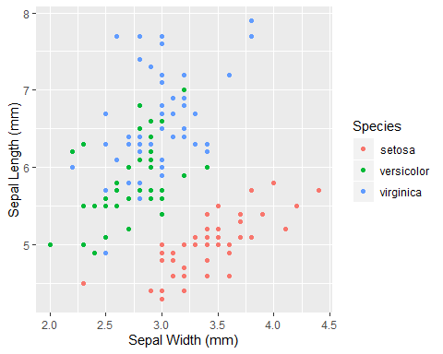

Sepal lengtth by width by species