Kaplan Meier session in CC

Kristy Robledo

2022-03-31

## Table of content

## List of figures

## List of tables

# KM plot

Summary of data:

glimpse(lung)

## Rows: 228  
## Columns: 10  
## $ inst <dbl> 3, 3, 3, 5, 1, 12, 7, 11, 1, 7, 6, 16, 11, 21, 12, 1, 22, 16~  
## $ time <dbl> 306, 455, 1010, 210, 883, 1022, 310, 361, 218, 166, 170, 654~  
## $ status <dbl> 2, 2, 1, 2, 2, 1, 2, 2, 2, 2, 2, 2, 2, 2, 2, 2, 2, 2, 2, 2, ~  
## $ age <dbl> 74, 68, 56, 57, 60, 74, 68, 71, 53, 61, 57, 68, 68, 60, 57, ~  
## $ sex <dbl> 1, 1, 1, 1, 1, 1, 2, 2, 1, 1, 1, 2, 2, 1, 1, 1, 1, 1, 2, 1, ~  
## $ ph.ecog <dbl> 1, 0, 0, 1, 0, 1, 2, 2, 1, 2, 1, 2, 1, NA, 1, 1, 1, 2, 2, 1,~  
## $ ph.karno <dbl> 90, 90, 90, 90, 100, 50, 70, 60, 70, 70, 80, 70, 90, 60, 80,~  
## $ pat.karno <dbl> 100, 90, 90, 60, 90, 80, 60, 80, 80, 70, 80, 70, 90, 70, 70,~  
## $ meal.cal <dbl> 1175, 1225, NA, 1150, NA, 513, 384, 538, 825, 271, 1025, NA,~  
## $ wt.loss <dbl> NA, 15, 15, 11, 0, 0, 10, 1, 16, 34, 27, 23, 5, 32, 60, 15, ~

table(lung$status)

##   
## 1 2   
## 63 165

KM curve:

lung %>%  
 mutate(months = time/30.4,   
 dead = case_when(  
 status==2 ~ 1,   
 TRUE ~ 0)) ->lung2  
  
m1<-survfit(Surv(months, dead) ~ sex, data=lung2)  
  
ggsurvplot(m1,   
 data=lung2,   
 legend.labs = c("Males", "Females"),   
 break.time.by = 12/2,   
 risk.table = TRUE,   
 risk.table.height= 0.2,   
 tables.theme = theme_cleantable(),   
 legend="none",   
 palette = c("red", "darkblue"),   
 conf.int = TRUE  
 )

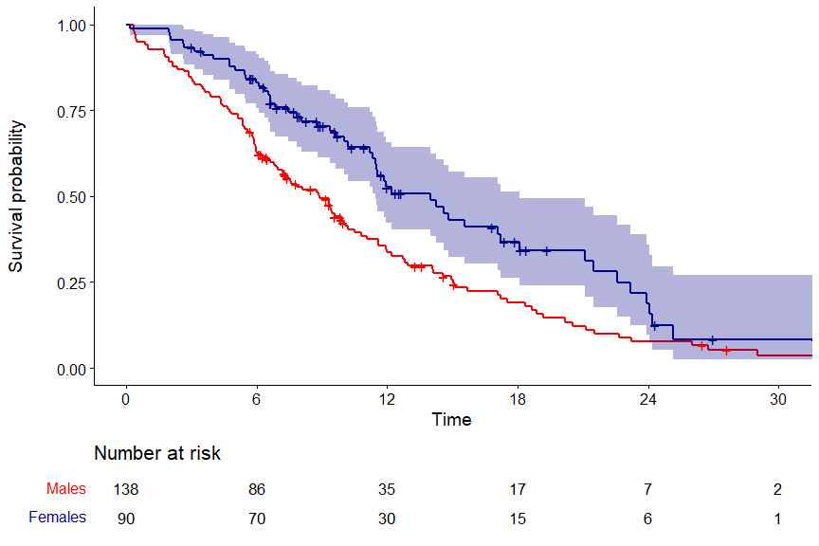

**Figure** : Kaplan Meier curve by gender

p1<-ggsurvplot(m1,   
 data=lung2,   
 legend.labs = c("Males", "Females"),   
 break.time.by = 12/2,   
 risk.table = TRUE,   
 risk.table.height= 0.2,   
 tables.theme = theme_cleantable(),   
 legend="none",   
 palette = c("red", "darkblue"))

# output plot into pdf for submission

p1<-ggsurvplot(m1,   
 data=lung2,   
 legend.labs = c("Males", "Females"),   
 break.time.by = 12/2,   
 risk.table = TRUE,   
 risk.table.height= 0.2,   
 tables.theme = theme_cleantable(),   
 legend="none",   
 palette = c("red", "darkblue")  
 )  
  
p2<-ggsurvplot(m1,   
 data=lung2,   
 legend.labs = c("Males", "Females"),   
 break.time.by = 12/2,   
 risk.table = TRUE,   
 risk.table.height= 0.2,   
 tables.theme = theme_cleantable(),   
 legend="none",   
 palette = c("red", "black")  
 )  
  
plots<-list()  
  
plots[[1]]<-p1  
plots[[2]]<-p2  
  
p<-ggarrange(plot, print=TRUE, ncol=1, risk.table.height=0.3)  
  
ggsave(plot=p, "Fig1.pdf")

# output plot into pptx for presentation

tum_graph <- rvg::dml(code = print(p1, newpage = FALSE))  
  
  
doc <- read_pptx()  
doc <- add_slide(doc, layout = "Title and Content", master = "Office Theme")  
doc <- ph_with(doc, tum_graph, location = ph_location(width = 8, height=6) )  
  
print(doc, target = "plots in pp.pptx")

# logrank test

survdiff(Surv(months, dead) ~ sex, data=lung2)

## Call:  
## survdiff(formula = Surv(months, dead) ~ sex, data = lung2)  
##   
## N Observed Expected (O-E)^2/E (O-E)^2/V  
## sex=1 138 112 91.6 4.55 10.3  
## sex=2 90 53 73.4 5.68 10.3  
##   
## Chisq= 10.3 on 1 degrees of freedom, p= 0.001

new reproducible publication ready:

tbl_survfit(m1,   
 times=c(6, 12)) %>%  
 add_p() %>%  
 add_nevent() %>%  
 add_n() %>%  
 as_flex_table() %>%  
 set_caption(caption = "Survival probabilities at 6 and 12 months")

**Table** : Survival probabilities at 6 and 12 months

| Characteristic | N | Event N | Time 6 | Time 12 | p-value1 |
| --- | --- | --- | --- | --- | --- |
| sex | 228 | 165 |  |  | 0.001 |
| 1 |  |  | 63% (55%, 72%) | 34% (26%, 43%) |  |
| 2 |  |  | 83% (76%, 91%) | 53% (42%, 66%) |  |
| 1Log-rank test | | | | | |

tbl_survfit(m1,   
 probs=c(0.5))

## Table printed with {flextable}, not {gt}. Learn why at  
## https://www.danieldsjoberg.com/gtsummary/articles/rmarkdown.html  
## To suppress this message, include `message = FALSE` in the code chunk header.

| Characteristic | 50% Percentile |
| --- | --- |
| sex |  |
| 1 | 8.9 (7.0, 10) |
| 2 | 14 (11, 18) |

# cox regression

ph<-summary(coxph(Surv(months, dead)~sex, data=lung2))  
  
HR<-round(ph$coefficients[2], digits=2)  
HRl<-round(ph$conf.int[3], digits=2)  
HRu<-round(ph$conf.int[4], digits=2)  
p<-signif(ph$waldtest[3], digits=1)  
  
stats<-glue('HR = {HR} (95% CI: {HRl}-{HRu}), p-value={p}')

# stick information on the curve

p1$plot +  
 annotate("text",   
 x=12, y= 0.9,   
 hjust=0,   
 label=stats)

