Statistical report for penguin trial

Kristy Robledo

16/12/2021

Table of Contents

# 1 Statistical report

This is a trial about penguins. **yay**

We are aiming to

* show
* lots
* of
* things
* in
* rmarkdown

## 1.1 Baseline characteristics

The baseline characteristics are in Table 1.1. Also see Figure 1.1

**Table 1.1:** Baseline characteristics of penguin types

| Characteristic | Adelie, N = 1521 | Chinstrap, N = 681 | Gentoo, N = 1241 |
| --- | --- | --- | --- |
| island |  |  |  |
| Biscoe | 44 (29%) | 0 (0%) | 124 (100%) |
| Dream | 56 (37%) | 68 (100%) | 0 (0%) |
| Torgersen | 52 (34%) | 0 (0%) | 0 (0%) |
| bill_length_mm | 38.8 (36.8, 40.8) | 49.5 (46.3, 51.1) | 47.3 (45.3, 49.5) |
| Unknown | 1 | 0 | 1 |
| bill_depth_mm | 18.40 (17.50, 19.00) | 18.45 (17.50, 19.40) | 15.00 (14.20, 15.70) |
| Unknown | 1 | 0 | 1 |
| flipper_length_mm | 190 (186, 195) | 196 (191, 201) | 216 (212, 221) |
| Unknown | 1 | 0 | 1 |
| body_mass_g | 3,700 (3,350, 4,000) | 3,700 (3,488, 3,950) | 5,000 (4,700, 5,500) |
| Unknown | 1 | 0 | 1 |
| sex |  |  |  |
| female | 73 (50%) | 34 (50%) | 58 (49%) |
| male | 73 (50%) | 34 (50%) | 61 (51%) |
| Unknown | 6 | 0 | 5 |
| year |  |  |  |
| 2007 | 50 (33%) | 26 (38%) | 34 (27%) |
| 2008 | 50 (33%) | 18 (26%) | 46 (37%) |
| 2009 | 52 (34%) | 24 (35%) | 44 (35%) |
| 1n (%); Median (IQR) | | | |

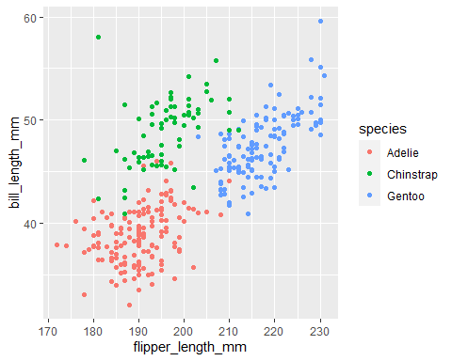

Figure 1.1: Flipper length by bill length

# 2 Resources

[Bookdown](https://bookdown.org/yihui/bookdown/)

## 2.1 Reproducibility

Analyses and summaries produced in this report were carried out using the R statistical environment, version 4,1.2. The report itself was produced using an Rmarkdown workflow, located here: D:/OneDrive - The University of Sydney (Staff)/2. TEACHING/CodingConundrums/rmarkdown_demo.Rmd`. The following table lists the non-base R packages used in analyzing and building this report.

**Table 2.1:** R packages used in analyses and reporting

| package | version | date |
| --- | --- | --- |
| dplyr | 1.0.7 | 2021-06-18 |
| flextable | 0.6.10 | 2021-11-15 |
| forcats | 0.5.1 | 2021-01-27 |
| ggplot2 | 3.3.5 | 2021-06-25 |
| gtsummary | 1.5.0 | 2021-10-16 |
| palmerpenguins | 0.1.0 | 2020-07-23 |
| purrr | 0.3.4 | 2020-04-17 |
| readr | 2.0.2 | 2021-09-27 |
| stringr | 1.4.0 | 2019-02-10 |
| tibble | 3.1.5 | 2021-09-30 |
| tidyr | 1.1.4 | 2021-09-27 |
| tidyverse | 1.3.1 | 2021-04-15 |