Statistical Report for the EXAMPLE trial

Kristy Robledo

Last compiled on 22 February, 2023

**Table of contents**

## List of figures

## List of tables

# Baseline

Here is the table one for the report.

**Table** **:** Table one by treatment

| **Characteristic** | **Overall**, N = 1971 | **MTA**, N = 100 | **CT**, N = 97 |
| --- | --- | --- | --- |
| sex.f, n (%) |  |  |  |
| Male | 68 (35) | 40 (40) | 28 (29) |
| Female | 129 (65) | 60 (60) | 69 (71) |
| Age in years, Mean (SD) | 60 (11) | 60 (11) | 60 (12) |
| pathway.f, n (%) |  |  |  |
| MAP Kinase | 24 (12) | 13 (13) | 11 (11) |
| HR | 84 (43) | 41 (41) | 43 (44) |
| PI3K/AKT/mTOR | 89 (45) | 46 (46) | 43 (44) |
| tt_Lnum, Median (Minimum-Maximum) | 3 (0-15) | 3 (1-13) | 3 (0-15) |
| 1n (%); Mean (SD); Median (Minimum-Maximum) | | | |

# Progression free survival

Please see Table for baseline.

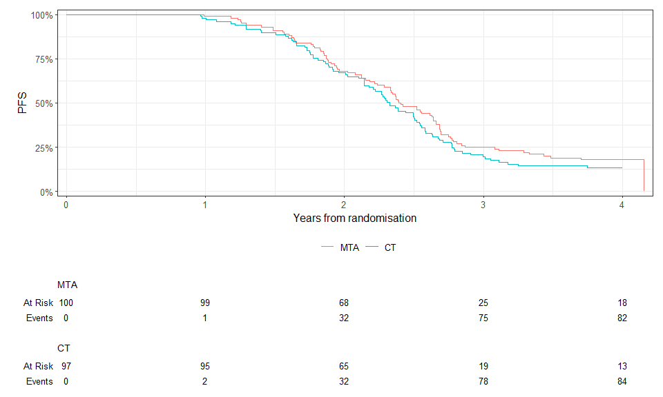

**Figure** **:** PFS by treatment

**Table** **:** Cox model for PFS

| **Characteristic** | **HR** **(95% CI)**1 | **p-value** |
| --- | --- | --- |
| bras.f |  |  |
| MTA | — |  |
| CT | 1.18 (0.87 to 1.60) | 0.28 |
| 1HR = Hazard Ratio, CI = Confidence Interval | | |

**Table** **:** Survival times table

| **Characteristic** | **365 days** | **730 days** |
| --- | --- | --- |
| bras.f |  |  |
| MTA | 99% (97% to 100%) | 68% (59% to 78%) |
| CT | 98% (95% to 100%) | 67% (58% to 77%) |

this is how to create a list

* one
* two
* three

order list

1. one
2. two
3. three

# Reproducibility receipt

Analyses and summaries produced in this report were carried out using the R statistical environment, version 4.1.3. The report itself was produced using an Rmarkdown workflow, located here: C:/Users/krobledo/OneDrive - The University of Sydney (Staff)/2. TEACHING/Talks/Introduction to Rmarkdown/Intro_Rmarkdown/example_statsreport.Rmd`. The following table lists the non-base R packages used in analyzing and building this report.

R packages used in analyses and reporting

| package | version | date |
| --- | --- | --- |
| dplyr | 1.0.10 | 2022-09-01 |
| flextable | 0.8.3 | 2022-11-06 |
| forcats | 0.5.2 | 2022-08-19 |
| ggplot2 | 3.4.0 | 2022-11-04 |
| ggsurvfit | 0.2.1 | 2022-12-06 |
| gtsummary | 1.7.0 | 2023-01-13 |
| ipcwswitch | 1.0.4 | 2021-02-17 |
| officedown | 0.3.0 | 2023-01-06 |
| officer | 0.5.2 | 2023-01-27 |
| purrr | 0.3.5 | 2022-10-06 |
| readr | 2.1.3 | 2022-10-01 |
| sessioninfo | 1.2.2 | 2021-12-06 |
| stringr | 1.4.1 | 2022-08-20 |
| survival | 3.5.0 | 2023-01-09 |
| tibble | 3.1.8 | 2022-07-22 |
| tidyr | 1.2.1 | 2022-09-08 |
| tidyverse | 1.3.2 | 2022-07-18 |