Statistical Report for the EXAMPLE trial

Dr Anurika De Silva

Last compiled on 10 February 2023

Placeholder for table of contents - remove text after inserting

## 1.1 List of figures

## 1.2 List of tables

# 2. Introduction

Normal cells become cancer cells via a succession of genomic alterations. This finding has led to the development of molecularly targeted agents that inhibit the proteins that are abnormally activated as a result of somatic genetic alterations. Theoretically, these agents are more specific to cancer cells than are cytotoxic agents that target cell replication. Some of these molecularly targeted agents have yielded previously unprecedented anti-tumour activity in specific tumour types in the presence of the matching molecular alteration. Molecularly targeted agents have followed the same clinical development process as cytotoxic agents: per tumour location and histology. Most genetic molecular alterations exist across tumour types and histologies, although incidence varies. This observation challenges the existing drug development strategies for molecularly targeted agents and raises the possibility of a shift towards histology-agnostic molecularly based treatment with these drugs.

# 3. Baseline characteristics

|  |  |  |  |
| --- | --- | --- | --- |
| **Table 1: Baseline characteristics** | | | |
|  | **CT** | **MTA** | **Total** |
|  | **N=97** | **N=100** | **N=197** |
| Sex, n (%) |  |  |  |
| Female | 69 (71.1%) | 60 (60.0%) | 129 (65.5%) |
| Male | 28 (28.9%) | 40 (40.0%) | 68 (34.5%) |
| Age (years), mean (SD) | 60.4 (12.0) | 59.8 (10.6) | 60.1 (11.3) |
| Molecular pathway altered, n (%) |  |  |  |
| Hormone receptor pathway | 43 (44.3%) | 41 (41.0%) | 84 (42.6%) |
| RAF/MEK pathway | 11 (11.3%) | 13 (13.0%) | 24 (12.2%) |
| PI3K/AKT/mTOR pathway | 43 (44.3%) | 46 (46.0%) | 89 (45.2%) |
| Previous lines of treatment, median (IQR) | 3.0 (2.0-5.0) | 3.0 (2.0-5.0) | 3.0 (2.0-5.0) |
| CT = Treatment at physician's choice group, IQR = Interquartile range, MTA = Molecularly targeted agent group, SD = Standard deviation | | | |

# 4. Results

There are a total of 197 participants enrolled in this trial. The average age is 60.1 (11.3) years.

## 4.1. Kaplan-Meier plot

Plot the Kaplan–Meier curve by treatment for progression on a landscape page.

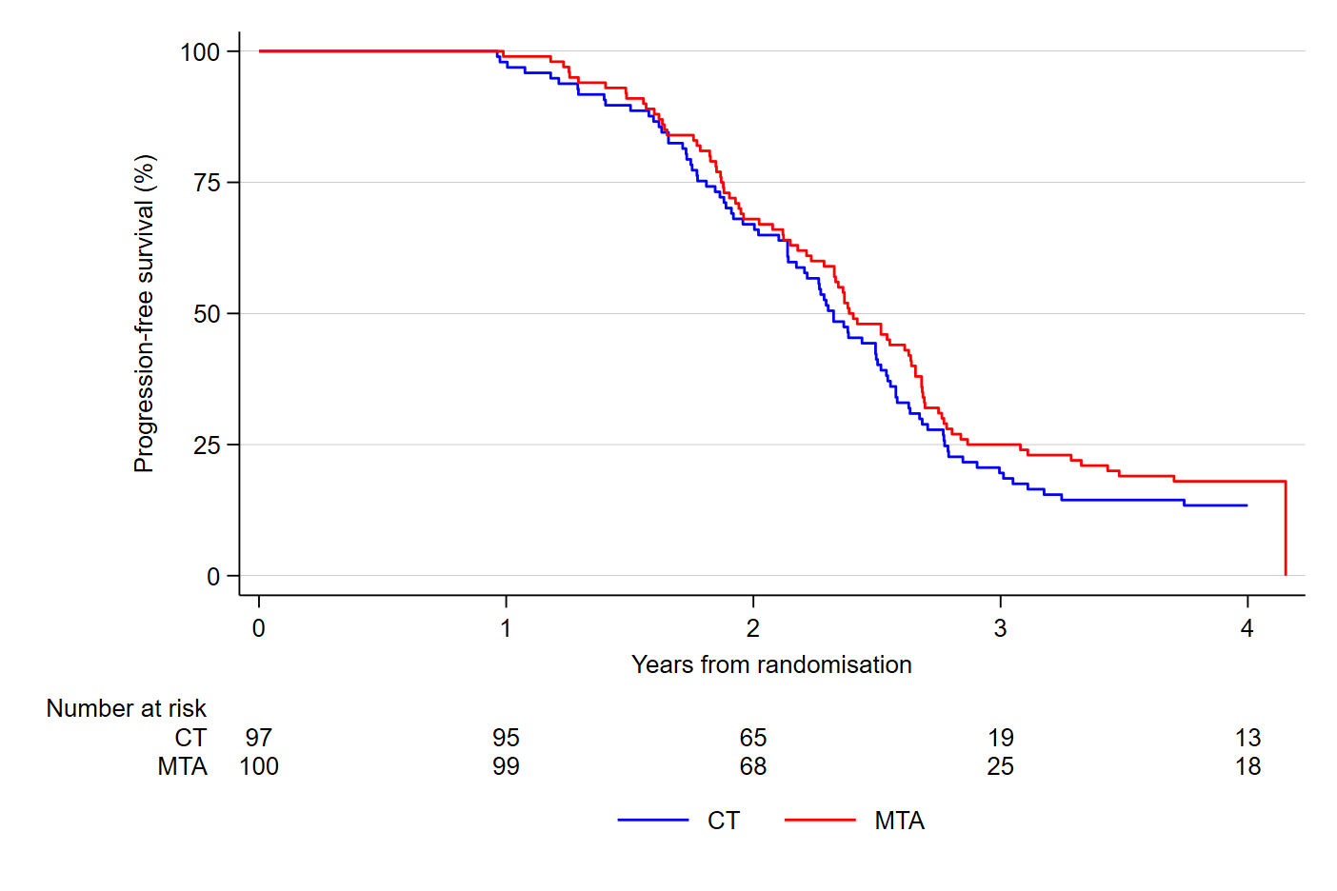  
Figure 1: Kaplan–Meier curve by treatment for progression-free survival.

## 4.2. Cox regression

|  |  |  |
| --- | --- | --- |
| **Table 2: Effect of treatment for progression-free survival** | | |
| **Characteristic** | **HR (95% CI)** | **p-value** |
| Treatment |  |  |
| Treatment at physician's choice group | Ref. |  |
| Molecularly targeted agent group | 0.85 (0.62,1.15) | 0.283 |
| HR = Hazard Ratio, CI = Confidence Interval | | |