GETTING STARTED WITH POWER BI

# Setup

1. Download files from here: <https://github.com/kristywedel/Jeopardy/>
2. Unzip the files
3. Open jeopardydatadictionary.xlsx, Code.txt and the completed Jeopardy.pbix.

# Creating the Power BI Report

1. Open a new blank Power BI file.
2. Go to Get Data > More
3. Select JSON
4. In the file picker, open JEOPARDY_QUESTIONS1.json.
5. In Power Query editor, click Close & Apply

# Create a Date Table

1. In the Modeling tab, select New Table.
2. In the formula bar, type:

*DateTable =*

*VAR MinDate = MIN(JEOPARDY_QUESTIONS1[air_date])*

*VAR MaxDate = MAX(JEOPARDY_QUESTIONS1[air_date])*

*RETURN*

*ADDCOLUMNS(*

*CALENDAR(MinDate, MaxDate),*

*"Year", YEAR([Date]),*

*"Month Name", FORMAT([Date], "mmmm"),*

*"Month Number", MONTH([Date])*

*)*

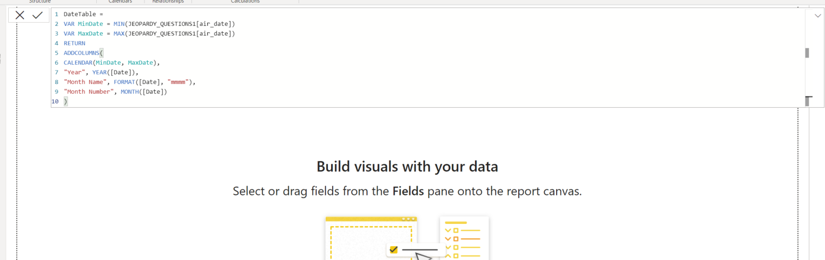

1. Press Enter or select the check mark on the left.
2. The date table is now added.

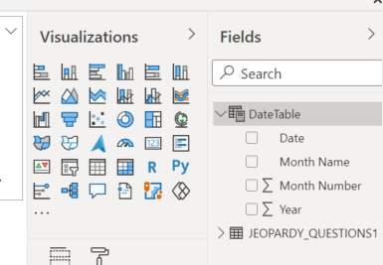

# Create the DateTable relationship

1. In the Model tab, drag the air_date field from the JEOPARDY_QUESTIONS1 table to the Date field on the DateTable table.

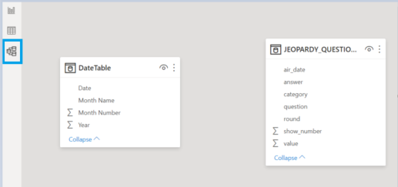

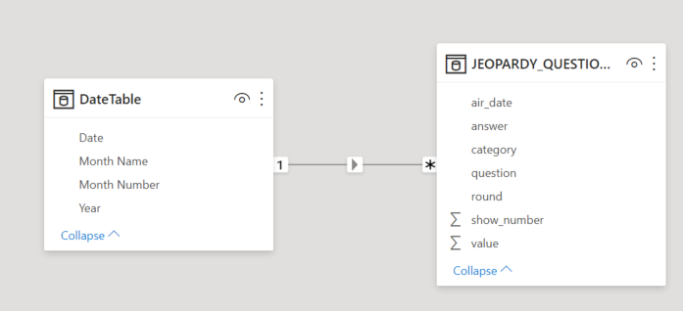

1. Go back to the Report tab.
2. In the Fields pane, click on the Date in DateTable.
3. In Column Tools, change the format to *3/14/2001.
4. Repeat this for air_date in JEOPARDY_QUESTIONS1.

# Create a Metrics table

1. On the Home tab, click Enter Data.
2. Name the table Metrics and click Load.

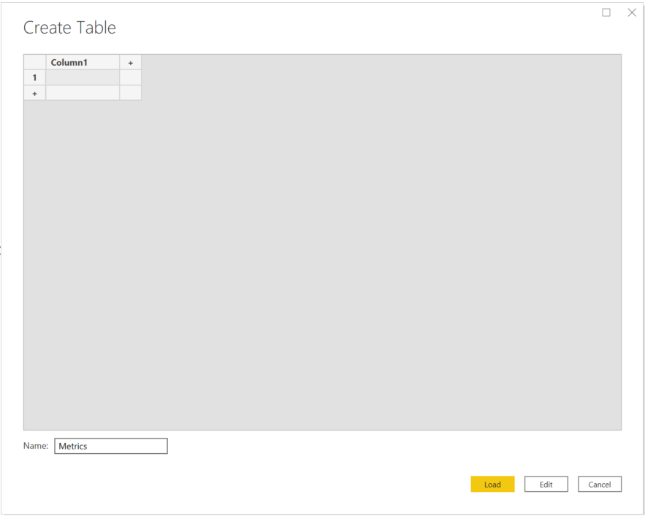

1. Right-click on the Metrics table in the Fields pane and select New Measure.
2. Copy and paste the measures below one at a time and then hit enter or select the check.

These are in the format measure_name = expression

*SumValue = Sum(JEOPARDY_QUESTIONS1[value])*

*CountCategory = COUNT(JEOPARDY_QUESTIONS1[category])*

*CountValue = COUNT(JEOPARDY_QUESTIONS1[value])*

*CountQuestion = COUNT(JEOPARDY_QUESTIONS1[question])*

1. Right-click Column1 in the Metrics table and delete it.

# Create the Data Dictionary

1. Add the data dictionary by going to Home > Enter Data
2. Copy and paste the data in jeopardydatadictionary.xlsx to the Create Table window.
3. Name the table DataDictionary and then click Load.

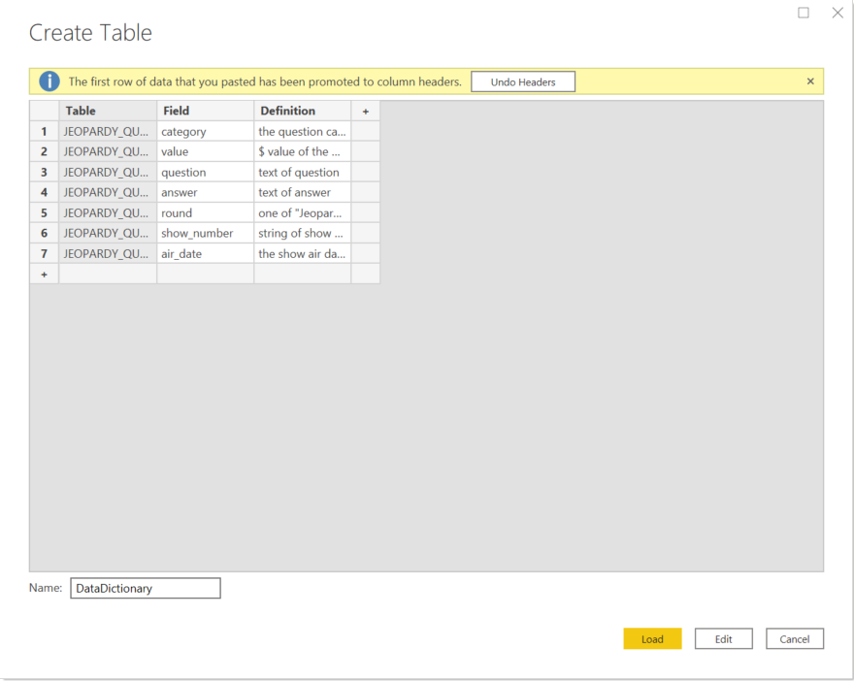

1. Optional Steps
   1. Organize the measures into folders.
      1. Go to the Model tab, select one of the metrics and change the Display Folder
   2. Create a summary table for the count of questions per day
      1. Go to Modeling > New Table and define the table as below

*SummaryTable = SUMMARIZE(JEOPARDY_QUESTIONS1,JEOPARDY_QUESTIONS1[air_date], "NumQuestions", [CountQuestion])*

* + 1. Add and additional measure to the metrics table:

*CountNumQuestions = Count(SummaryTable[NumQuestions])*

# Creating a Chart

1. To create the Overview page Top 10 Categories bar chart, select clustered column chart from the visualizations pane
2. 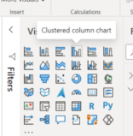
3. Then drag the field category in JEOPARDY_QUESTIONS1 to the axis and the measure CountCategory in Metrics to the Values.

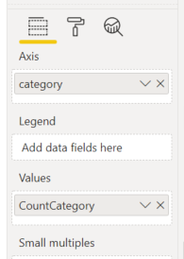 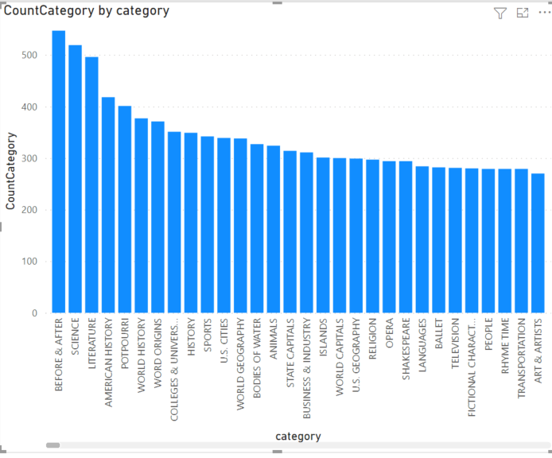

1. To limit this to the top 10, select the bar chart.
2. In the Filters pane, expand category and change the filter type to Top N.
3. Enter 10 next to Top, drag CountCategory to the ‘By value’ section and click Apply Filter.

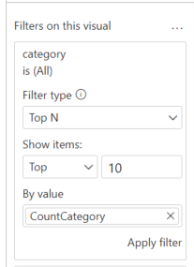

1. To adjust the color, title and other features go to the format area within the visualizations pane.

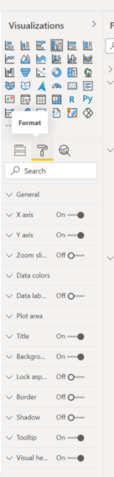

# Creating Dynamic Text

1. To create dynamic text that can be displayed in a card showing the min and max value of questions create a new measure.
2. Right-click on the Metrics table and select New Measure, use the definition below

ValueText = "The max value in the dataset is " & FORMAT(MAX(JEOPARDY_QUESTIONS1[value]), "$#,0") & " and the min is " & FORMAT(MIN(JEOPARDY_QUESTIONS1[value]), "$#,0") & "."

1. From the Visualizations pane, select card and add ValueText to the Fields section.
2. To remove the label ‘ValueText’, in the Visualizations pan click the format button (paint roller) and toggle Category label off.

# Creating a Switch to Toggle Measures

1. Go to Home > Enter Data
2. Rename the Column Measures and enter ‘SumValue’ in row 1 and ‘CountQuestion’ in row 2. These are the names of measures we want to choose from.
3. Click the Load button.
4. Right-click SwitchTable and add a new measure.
5. The definition of the measure is below:

*SelectedMeasure =*

*IF(*

*HASONEVALUE(SwitchTable[Measures]),*

*SWITCH(*

*VALUES(SwitchTable[Measures]),*

*"SumValue", [SumValue],*

*"CountQuestion", [CountQuestion]*

*),*

*[SumValue]*

*)*

1. On the report canvas, add a slicer from the Visualizations pane.
2. Add the Measures field from the Switch Table.
3. In the Visualizations pane > Format under General, change the Orientation to Horizontal.
4. In Selection controls turn Single select on (so only one measure can be chosen).
5. On the report canvas, add a line chart with Date on the axis and SelectedMeasure from the SwitchTable in Values.
6. Use the slicer to toggle the line chart.

