# Instructions

## Load Data – Load the 3 CSV Files

1. Open a new Power BI file.
2. Click the Get Data dropdown and select Text/CSV.
3. Select the colors.csv file.
4. Click load.
5. Repeat these steps to load inventories.csv and inventory_parts.csv.

## Transformations – Create a Calculated Column

1. On the Home tab, click transform data.
2. On the colors table, there is a field is_trans that indicates the lego brick is translucent. This field is either “t” if it is translucent or “f” if it is not. Power BI reads this as a character field.
3. For this demo, we want to create a field that is 1 if it’s translucent and null if it isn’t.
4. Click the Add Column tab, select Conditional Column.
5. Give the column the name ‘Translucent’.
6. In the If statement line, change column name to is_trans, value to t and output to 1.
7. In the else portion, type null.

Bonus:

1. Create a new column based on the rgb column on the colors table that could be used to color charts.
2. Highlight the rgb column, right click and select duplicate.
3. Click on the transform tab, while the new duplicate column is selected.
4. Click the Format drop-down and select Prefix.
5. Add a ‘#’

1. Close and Apply in Power Query Editor.

## Data Model

1. On the Home tab, click the model view on the left side of the screen.

1. Change the cross filter to both on each of the relationships. Right-click the arrow and select properties.

1. This will allow separate objects to filter in either direction on the report pane.
2. Click back to the report pane.

## Creating Measures - DAX

1. On the report pane, in the visualizations section, click the table icon to add a table to the canvas.
2. Expand the colors table and click the check box next to name to add it to the table.
3. Expand inventory_parts and add color_id to the table.
4. Click the down arrow to change the column to display the count of color id’s.
5. Graphical user interface, application

   Description automatically generated
6. Click the down arrow again the show the value as the % of grand total. This shows the % of all blocks are a specific color. This is an implicit measure. Power BI is creating a measure in the background in order to calculate the count and % of grand total. In order to further customize the calculation or to use additional features, it’s generally better to create explicit measures with DAX.
7. To create a measures table to organize the measures we create, go to Model > New Table.
8. Rename the table Metrics.
9. In Table Tools, click New Measure.
10. In the formula bar, type NumInventory = COUNT(inventories[inventory_id])
11. This is using the language DAX (Data Expression)
12. Also create the measures:
13. AverageParts equals the average of inventories[num_parts]
14. NumParts equals the sum of inventories[num_parts]
15. AverageColors equals the average of inventory_parts[color_id]
16. NumYears equals the distinct number of years in the dataset (HINT: use the function DISTINCTCOUNT).

Bonus:

1. Create the explicit measure of % color we had the implicit version of.
2. %color = DIVIDE(COUNT(inventory_parts[color_id]), CALCULATE(COUNT(inventory_parts[color_id]), ALL(colors[name])))

## Designing a Report

We’ll be looking to answer a few key questions in the data.

* How have the sets changed over time?
  + Number of colors
  + Number of parts
  + On the report pane, click the line chart icon.

1. Create a chart to show year and AverageColors measure.
2. To make the trend clearer, you can add a trend line in the analysis pane.

1. Copy and paste the chart and modify the measure on the second chart to be AverageParts.

1. Add a Card visual and the measure NumYears.

Card visual

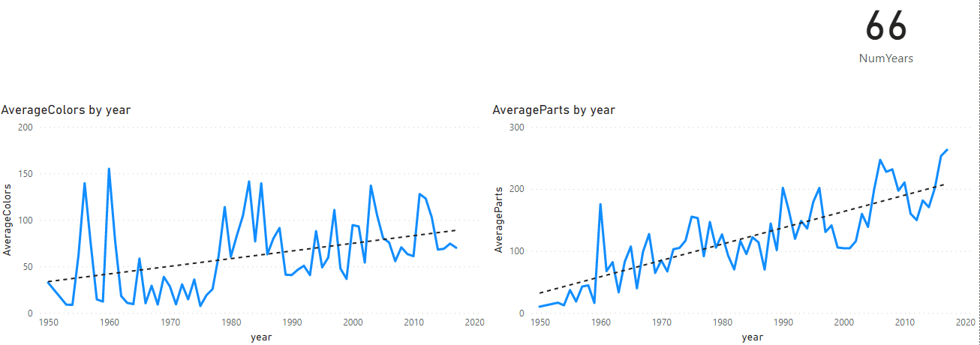

1. Click onto whitespace on the page. Drag the theme_name field to the filters pane.

## Customizing Visuals

1. Go to the view tab, select one of the other themes. In this case, the theme executive is selected. Custom themes can also be selected.

1. Click one of the line charts and go to the visualizations pane and select format visual.
2. Type Title in the search bar and scroll to the ‘Title’ section. Change the size to 18. Also, change the text to Average Number of Colors by Year.

1. With the chart selected, click on the home tab and then click the format painter button.
2. Click the other line chart to apply the title formatting.
3. Click on the second chart, and in the visualizations pane, go to format visual.
4. Search for Title and rename the title to Average Number of Parts by Year.

## Publish the workspace

1. Open the Home tab.
2. Click Publish.
3. Select a workspace.

<https://app.powerbi.com/groups/me/reports/61995258-8476-4018-a7ad-e3897f3d42e1/ReportSectionb8e7b0d95440600b0d04>

## Make a bookmark

1. Open the report at http://app.powerbi.com/
2. On the filter pane, select advanced filtering.
3. Show items that contain Star Wars.
4. Apply the filter.
5. Add a personal bookmark and name it Star Wars

1. Use the reset arrow to remove the filter. It would otherwise be remembered the next time you open the report.

## Create an alert

1. Open the report at http://app.powerbi.com/
2. To create an alert that would trigger when a new year is added to the dataset, click the KPI and select the pin icon.
3. Pin to a new dashboard.

1. Go to the dashboard.
2. Hover over the NumYears tile and select the three dots.
3. Click Manage Alers.
4. Add an alert rule.
5. Leave it at the default.
6. This will send an email when a new year is added.