About me in few words
Hi, my name is Kristina. I’m a digital marketer with 6+ years of hands-on experience driving growth through Meta Ads, Google Ads, and cross-channel strategy across different markets (US/Canada/LATAM/EU). I work end-to-end across acquisition, funnel performance, reporting systems, and operational execution, not only inside the ads manager. Experience managing complex D2C ecosystems on Shopify with seasonal budgets from ~$15K to $100K+ per month. Strong focus on ROAS/CAC discipline, forecasting/pacing, experimentation frameworks, and scalable reporting/automation.
Key Competencies
- Meta Ads (Facebook/Instagram), Google Ads (Search/Shopping/Performance Max/YouTube); Tik Tok Ads.
- Experience across Tier-1 markets (US, Canada) and international campaigns in EU and LATAM.
- E-commerce Growth (Shopify, D2C, B2C)
- Google Merchant Center & Product Feeds
- GA4, Google Tag Manager, Meta Pixel, Conversions API, attribution mindset
- Funnel Strategy & Conversion Optimization
- Reporting & Forecasting
- Growth experimentation: creative testing, structure tests, audience/offers, pacing & forecasting
- AI-Assisted Analytics & Automation
- Lead Generation & Growth Marketing
- Team Leadership & Cross-functional Collaboration

Languages:
Ukrainian - Native
English - Fluent (C1)
Spanish - B1
Chinese - Intermediate (Bachelor´s in Chinese Language & Interpretation)

Experience

A. D2C Apparel Brand (US/Canada)
Performance Marketing Manager (Contract) | Jan 2023 – Present

Manage performance marketing for a multi-store Shopify ecosystem in the US and Canada (D2C production & retail). Lead cross-channel acquisition and growth execution with ROAS focus and operational tracking.

- Meta Ads for ~18 Shopify stores Google Ads for ~10 Shopify stores
- Seasonal ad budgets ~$15K to $100K+ per month
- Acquisition + retargeting systems across Meta & Google
- Shopping/PMax segmentation, feed health, Merchant Center maintenance
- Forecasting/pacing based on seasonality and behavior
- Reporting systems: daily tracking + gap detection + action plans
Key outcomes
- Stabilized ROAS during seasonal peaks through segmentation, pacing, and structure refinement
- Reduced budget under-spend risk and improved budget utilization via forecasting methods
- Created AI-assisted reporting dashboards (Claude-based) for real-time visibility and faster decision-making
- Supported a 25% year-over-year increase in net revenue during the 2026 peak season through campaign optimization, testing frameworks, and improved budget allocation while maintaining healthy ROAS and efficiency metrics.

B. Rebirth Travel (Travel & Tourism)
CMO / Marketing Lead (Project-Based Engagement) | Jun 2025 – Nov 2025

Led the complete rebranding and market repositioning of a travel agency transitioning from a discount-focused model to a premium personalized travel brand.
- Developed and executed the overall marketing and growth strategy.
- Led the rebranding process, including positioning, messaging, visual identity, and customer communication.
- Coordinated cross-functional teams across design, content, web development, and paid media.
- Built the customer acquisition funnel from awareness through lead generation, consultation, and sales.
- Developed Meta Ads and Google Ads strategies focused on qualified lead acquisition.
- Oversaw website structure, conversion strategy, and user experience improvements.
- Established reporting processes and performance measurement frameworks.

Key outcomes:
- Successfully repositioned the brand toward higher-value customers and premium travel experiences.
- Redesigned the customer journey and lead qualification process.
- Built a full-funnel lead generation framework focused on lead quality rather than lead volume.
- Implemented audience segmentation, remarketing, and customer journey mapping strategies.
- Created scalable marketing foundations to support future growth and expansion.

C. Canny Dentists (UK, Health & Wellness)
Growth & Community Marketing Manager | Jan 2023 – Oct 2024

- Built acquisition strategy primarily via organic growth systems (community/email/social)
- Managed multi-channel presence to increase reach/retention and audience trust
- Produced weekly content, aligned messaging with audience pain points, and drove funnel depth
- Strengthened community engagement loops and growth operations consistency

D. White Pony - lead generation / fintech
Performance Marketing Specialist | Jun 2022 – Oct 2023

- LATAM company that generates leads for brokers like XM (www.xm.com), OffersFX (www.offersfx.com) and more. LATAM
- Work done: create and manage lead generation campaigns in Meta Ads.
- Type of ads: image and video ads that point to their website and Meta Lead Ads.
- Budget: $20K a month
- Strategy:
  - Constantly testing funnels (crypto, tesla), demographic & interest based audiences and creatives (delivered by the communication’s team as they are in spanish) to increase leads volume and decrease CPL (Cost Per Lead).

E. Zenith Prep Academy (Education & E-Learning)
⟟ United States
Dates: December 2021 - September 2022
Position: Marketing Assistant
Job Description: Research, analysis & assistance for the marketing department.

Please refer to my recommendation letter here.

F. Remote Helpers
⟟ Kyiv, Ukraine | Remote
Dates: January 2020 - January 2022
Position: SMM Team Lead
Job Description: Led social media marketing initiatives, including developing content and communication strategies aligned with business goals. Managed and coordinated a team of SMM specialists, overseeing content planning, execution, and performance. Contributed to campaign planning, cross-channel coordination, and improving engagement and overall social media performance.

EMAIL MARKETING CASE STUDIES

1. Dosis Diaria
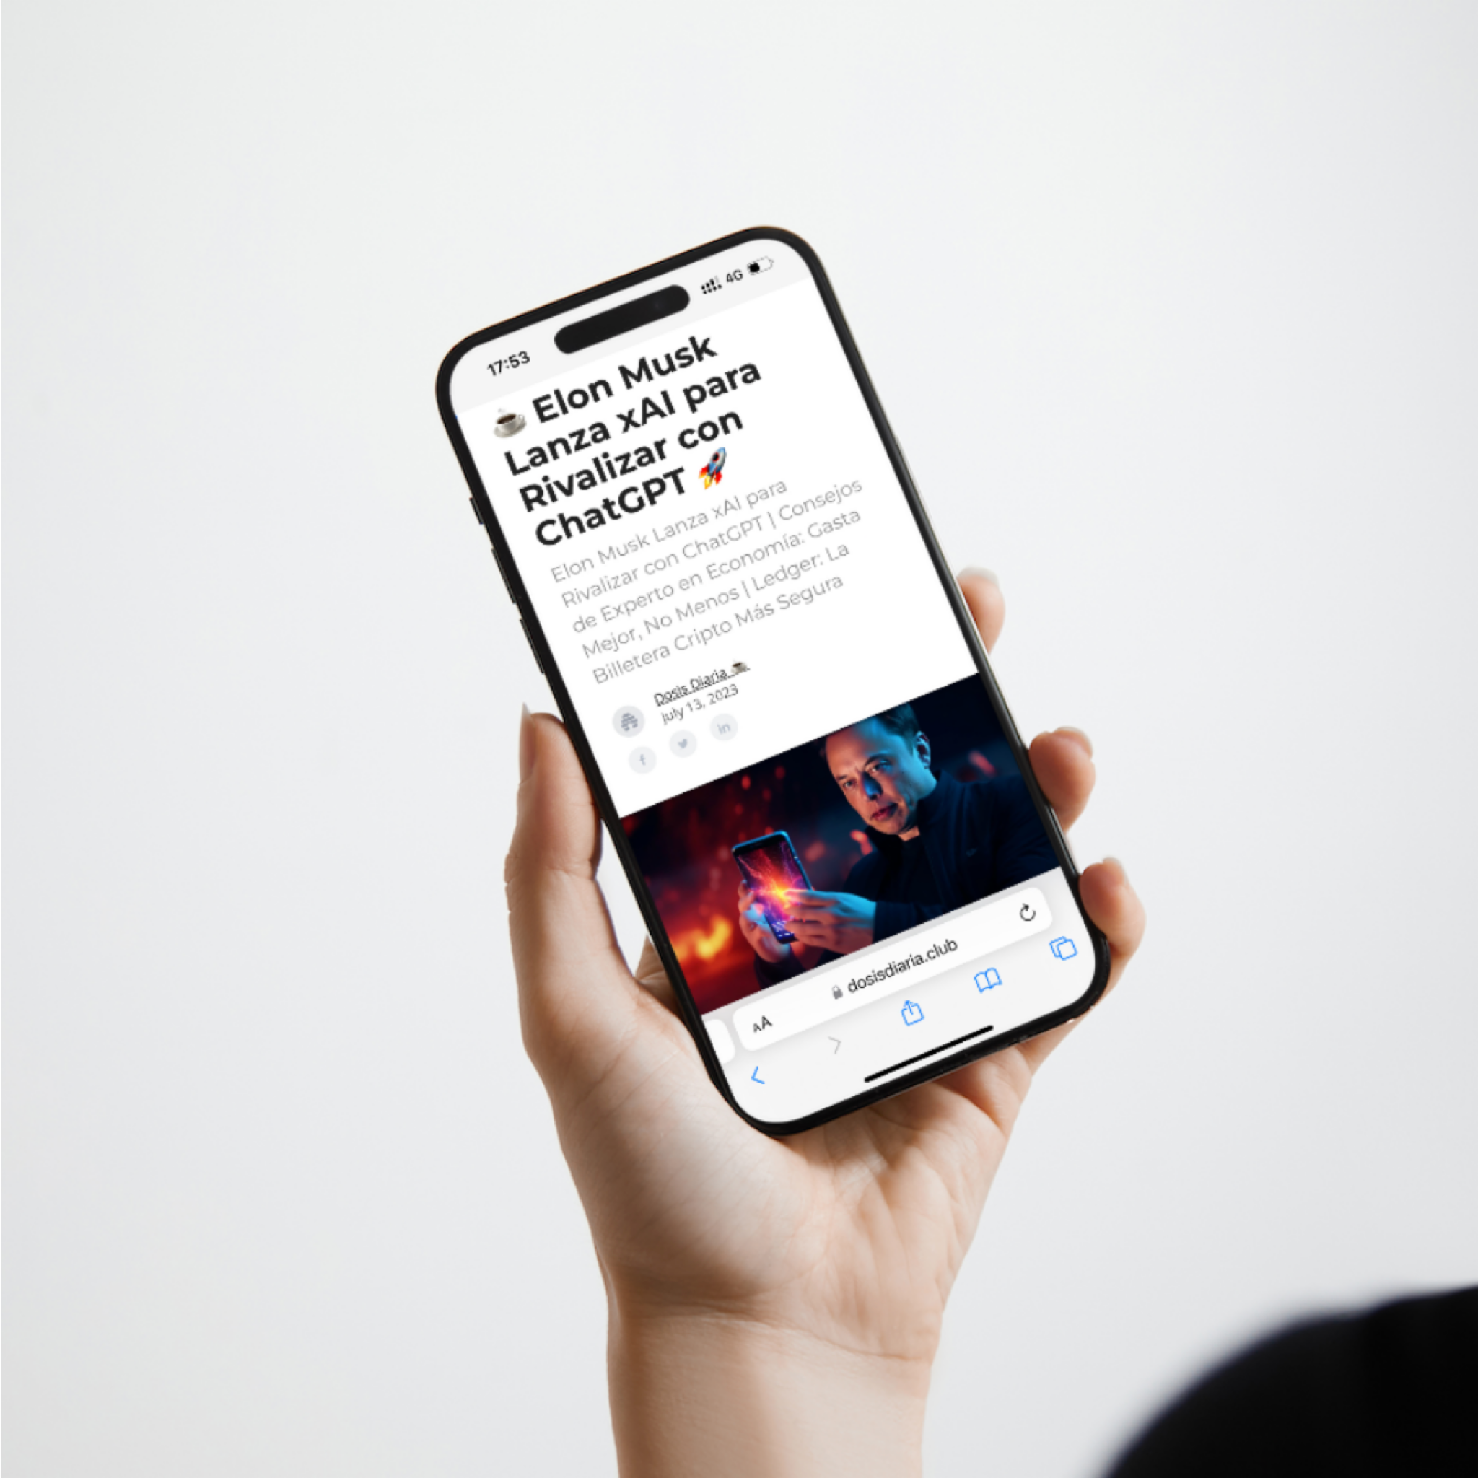
www.dosisdiaria.club

- Platform used: Beehiiv
- About: Dosis Diaria is a newsletter covering the latest news in finance, crypto and technology.
- Size: +100,000 subscribers
- Notes: In this project I only run the mailing platform and analyze the data, the content is provided to me as it’s in Spanish.
- Objectives:
  - Manage the newsletter’s publishing (the content is provided to me on a daily basis)
  - Analyze data and implement strategies to maximize open and click rates and minimize unsubscribe and spam rates.
  - Create automations within the mailing platform to help achieve these results.
  - Give feedback to the paid traffic team for them to optimize the targeting of the subscription campaigns.
- Results:
  - Growth is great, over 100,000 subscribers in less than 5 months since its launch (though this is mainly due to the paid ads team to be honest).
  - Open and click rates keep increasing due to the ongoing “cleaning” of the user base (automated by me) and finding the best performing traffic sources through a series of tests developed by the paid ads team and me.
  - Organic growth efforts though a referral program proposed by me also paid off.
- Audience segmentation:
  - In this case the audience is segmented just to measure performance and some minor automations as all users get the same emails.
  - We have one re-engagement automation segmented to users who didn’t open an email for 4 weeks, but again, the segmenting is not that sophisticated in this project as their business model doesn’t require it.

2. White Pony
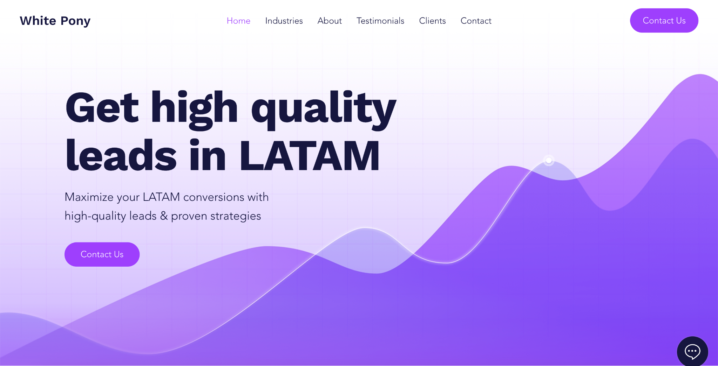
www.whitepony.io

- Platform used: Mailchimp
- About: White Pony is an affiliate in the Forex industry that generates leads of people interested in investing mostly in CFDs.
- Size: +5,000 users (in the markets I worked with)
- Notes: While the company works mostly in the LATAM market, I helped them in their English campaigns for Europe.
- Objectives:
  - Increase the conversion rate of the leads and aid in maximizing their player value.
- Results:
  - Before they sent the leads directly to the broker’s call center and that was it. Basically we created 2 flows:
    - A “welcome email” flow to introduce the users to the brokers, let them know that an agent was going to call them and what to expect from that call. This increased the contactability (when a user actually picks up the phone) on an average of 10-15% from what the brokers told us.
    - Once a lead is converted to sale, we created a flow of 5 weekly emails with tips, tricks and some success stories to increase their engagement and incentivize them to keep investing. I don’t have the exact figures on the increase of the player value but I know it worked, they even replicated this automation for their LATAM campaigns later on.
- Audience segmentation:
  - The main segmentation here was between leads and clients.
  - We also had to segment by region as different brokers operate in each one.
  - We tried gender segmentation to showcase different success stories to each group but it made no major difference so eventually we stopped this.

