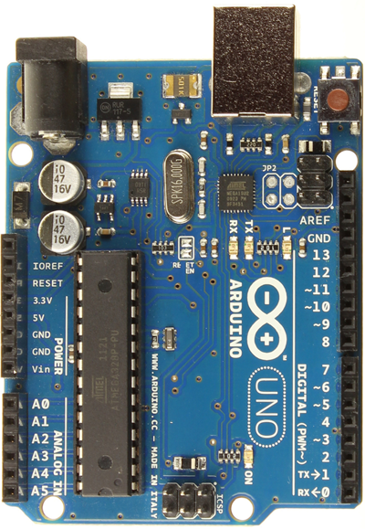
Pin Usage
Available (shared) RESET
Available (shared) 3.3V
Available (shared) 5V
Available (shared) GND
Available (shared) GND
Available (shared) Vin

Available(unconnected) A0
Available(unconnected) A1
Available(unconnected) A2
Available(unconnected) A3
SDA (UNO) A4
SCL (UNO) A5
Pin Usage
SCL SCL
SDA SDA
AREF Available(unconnected)
GND Available (shared)
13 Routed to Servo Header 3 (Leonardo)
12 Available(unconnected)
11 Routed to Servo Header 11
10 Routed to Servo Header 10
9 Routed to Servo Header 9
8 Available(unconnected)

7 Available(unconnected)
6 Routed to Servo Header 6
5 Routed to Servo Header 5
4 Available(unconnected)
3 Routed to Servo Header 3 (UNO)
2 Available(unconnected)
1 Available(unconnected)
0 Available(unconnected)

