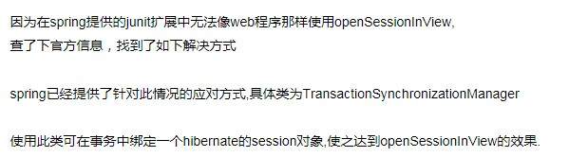

1. @RunWith(SpringJUnit4ClassRunner.class)
2. @ContextConfiguration(locations = { "classpath:applicationContext.xml" })
3. public class OpenSessionInViewTest extends AbstractTransactionalSpringContextTests {
5. @Resource(name="hibernateSessionFactory")
6. private SessionFactory sessionFactory;
8. @Before
9. public void init() {
10. Session s = sessionFactory.openSession();
11. TransactionSynchronizationManager.bindResource(sessionFactory,
12. new SessionHolder(s));
13. }
15. @Test
16. public void testQuery() {
17. SessionHolder holder = (SessionHolder)TransactionSynchronizationManager.getResource(sessionFactory);
18. Session session = holder.getSession();
19. User user= (User)session.get(User.class, "abc0003");
20. System.out.println(user.getId());
21. Set<Book> books= user.getBooks();
22. for (Book book: books) {
23. System.out.println(book.getId());
24. }
25. }
27. @After
28. public void close() {
29. SessionHolder holder = (SessionHolder)TransactionSynchronizationManager.getResource(sessionFactory);
30. SessionFactoryUtils.closeSession(holder.getSession());
31. TransactionSynchronizationManager.unbindResource(sessionFactory);
32. }
33. }