SDBP 022 — Assignment 02
Cristian Florez Ramos — N01793380
This document explains the design decisions behind the EmployeeDepartmentAssignment feature added to the EmployeeManager solution for Assignment 02, and provides evidence that the implementation builds, runs, and passes its tests.
The migration was generated and applied with the standard EF Core CLI commands, run against SQL Server LocalDB:
dotnet ef migrations add AddEmployeeDepartmentAssignment --project EmployeeManager.Infrastructure --startup-project EmployeeManager.API
dotnet ef database update --project EmployeeManager.Infrastructure --startup-project EmployeeManager.API
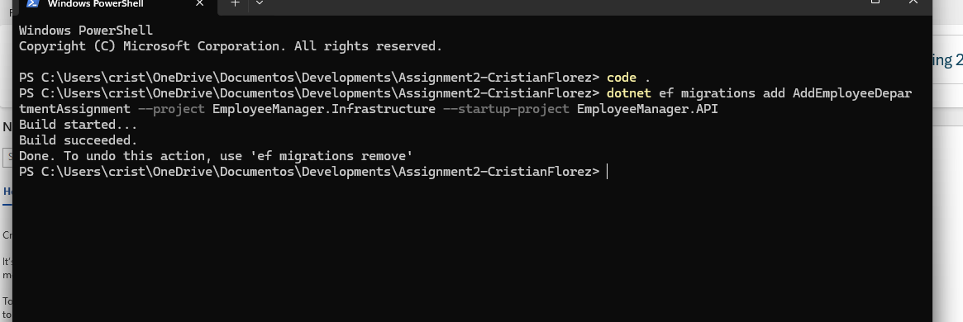
Figure 1 — Generating the migration from the terminal.
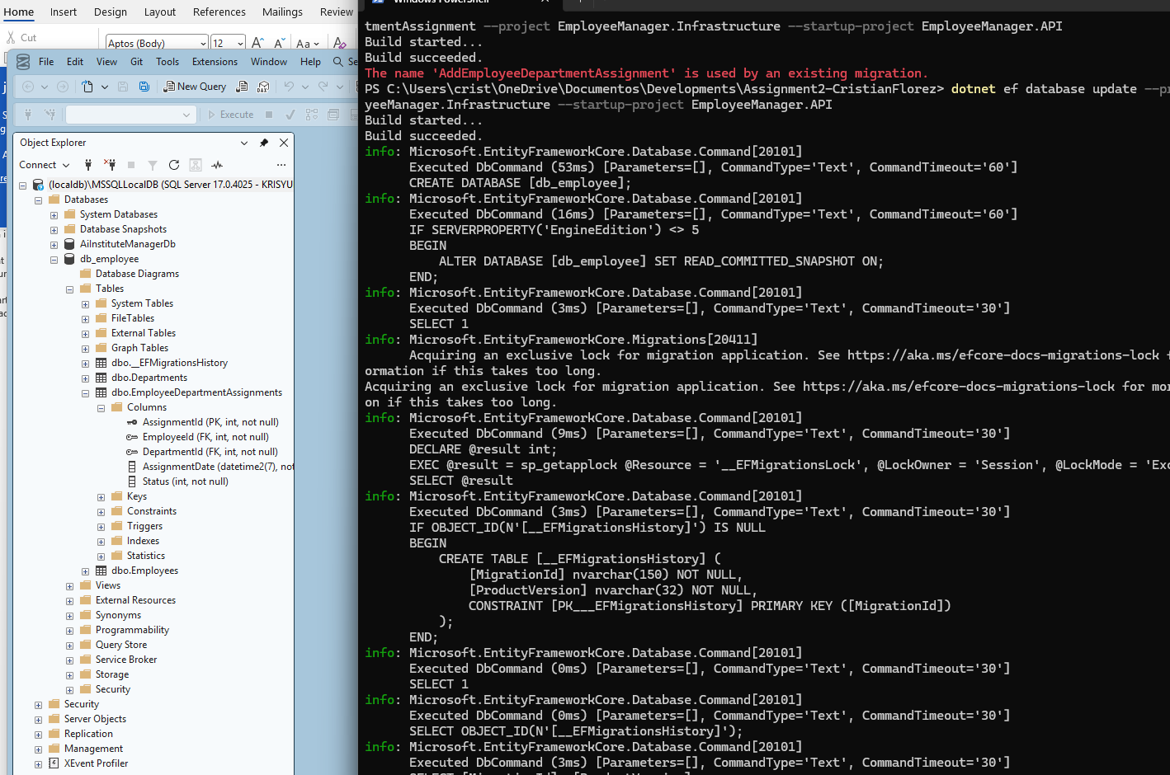
EmployeeDepartmentAssignmentController exposes the four required endpoints at the route api/assignment
POST /api/assignment — creates an assignment, returns 201 with a Location header
- GET /api/assignment/{id} — returns 200 with the assignment, or 404
- PUT /api/assignment/{id} — updates AssignmentDate and Status, returns 200, 404, 400, or 409
- DELETE /api/assignment/{id} — returns 204, or 404

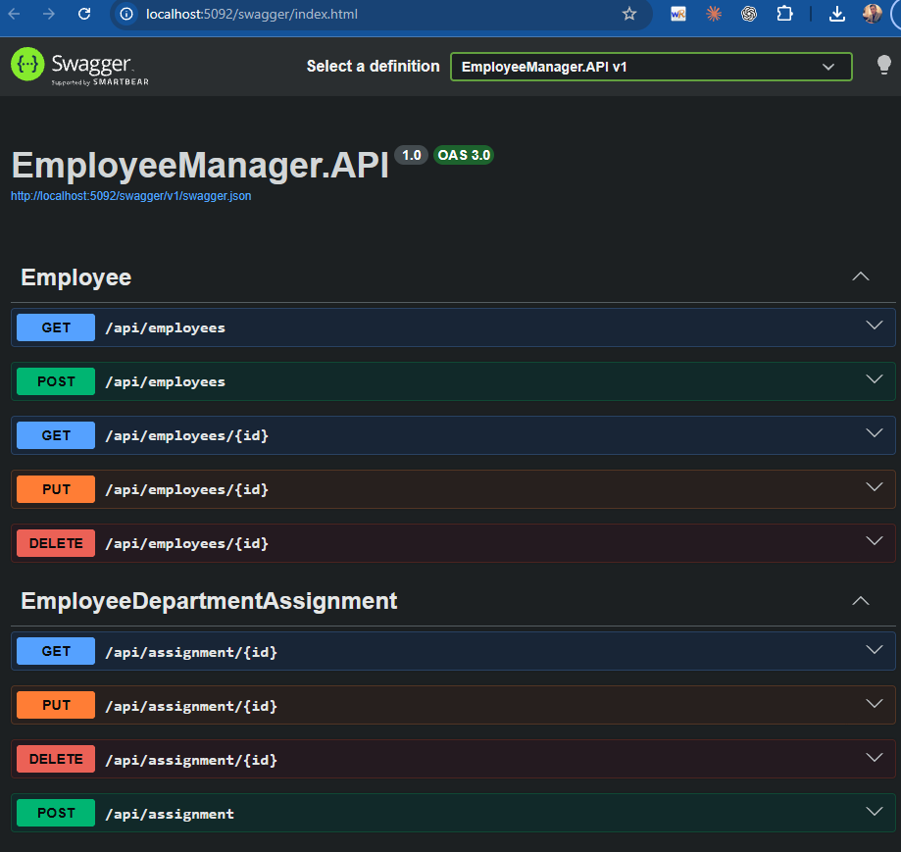

Before relying on the automated suite, the four CRUD endpoints were exercised manually through Swagger and a Postman collection covering the correct path
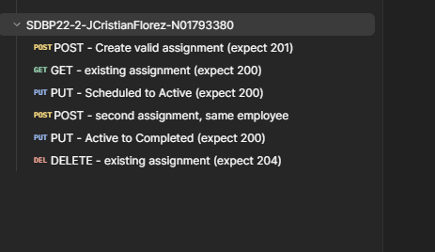

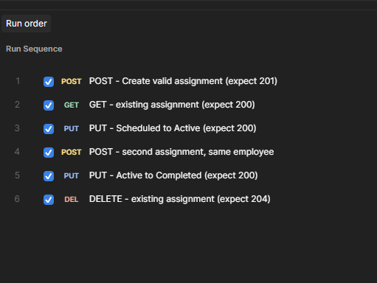

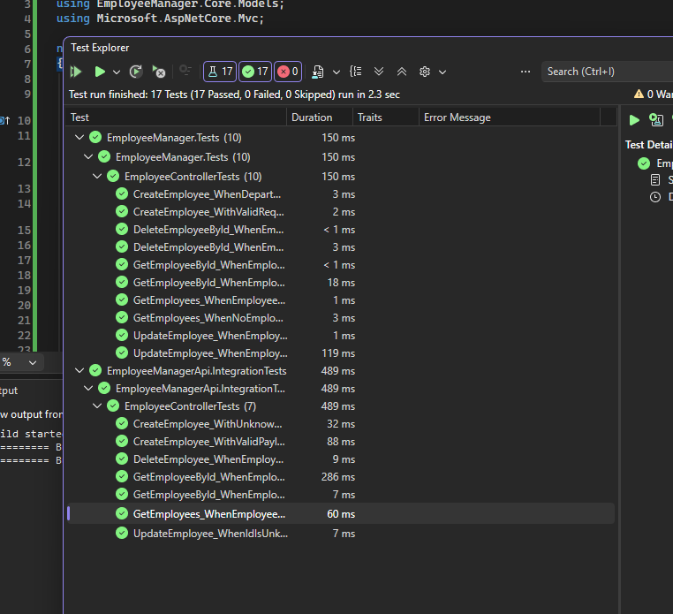
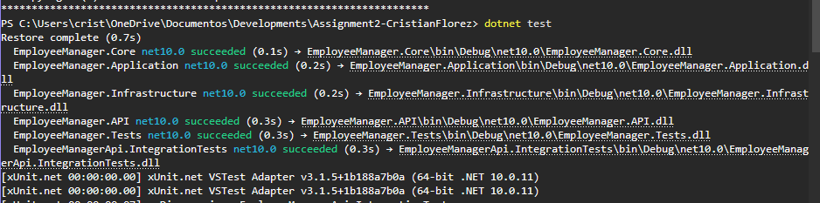
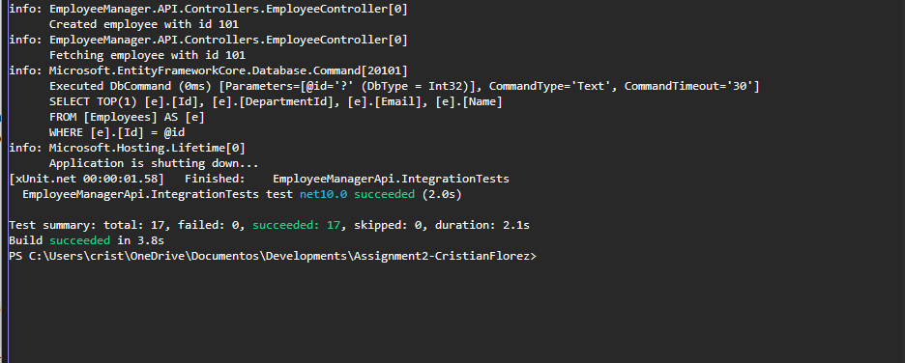

In keeping with the assignment's AI-assistant policy, this section discloses where Claude was used while completing this assignment.
Claude was used interactively, step by step, to:
- Review the starter solution's existing patterns (Employee/Department entities, AppDbContext, EmployeeController, EmployeeRepository) before proposing matching code for the new feature

