Linear algebra:
Division
Used for queries that involve the word "all" or "every".

Operation | SQL Equivalent Keyword / Clause | Purpose
Selection | WHERE | Filters rows based on a condition.
Projection | SELECT DISTINCT | Extracts specific columns (and removes duplicates).
Cartesian Product | CROSS JOIN (or FROM R, S) | Combines every row of $R$ with every row of $S$.
Union | UNION | Combines rows from both tables, removing duplicates.
Difference | EXCEPT (or MINUS in Oracle) | Returns rows in $R$ that are not present in $S$.
Intersection | INTERSECT | Returns only the rows that exist in both $R$ and $S$.
Rename | AS | Renames a table or a column.
Natural Join | NATURAL JOIN | Joins tables automatically on columns with identical names.
Theta Join | INNER JOIN ... ON | Joins tables based on an explicit conditional statement.
Aggregation | GROUP BY with aggregate functions (SUM, AVG, etc.) | Groups rows and calculates summary values.
Sort / Sorting | ORDER BY | Arranges tuples (rows) in ascending or descending order.
Left Outer Join | LEFT OUTER JOIN | Keeps all rows from the left table, padding missing right-side values with NULL.
Right Outer Join | RIGHT OUTER JOIN | Keeps all rows from the right table, padding missing left-side values with NULL.
Full Outer Join | FULL OUTER JOIN | Keeps all rows from both tables, filling in NULL values wherever a match is missing.

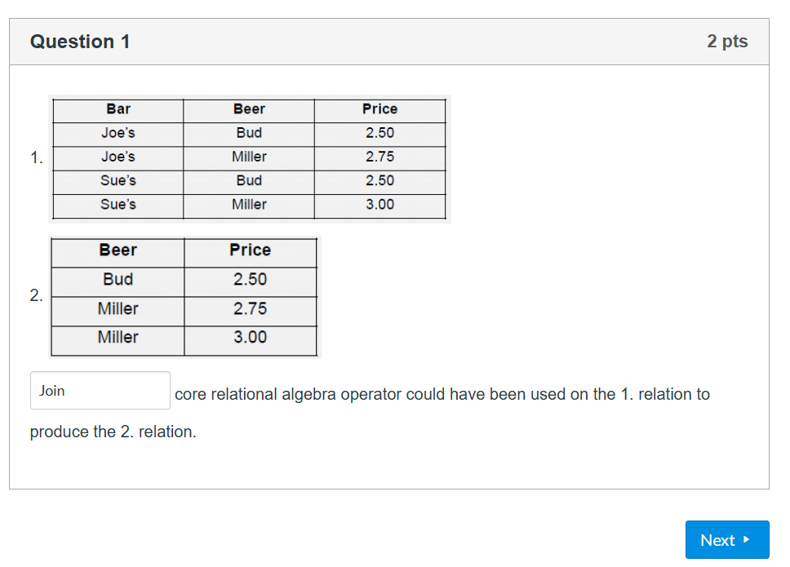
Projection

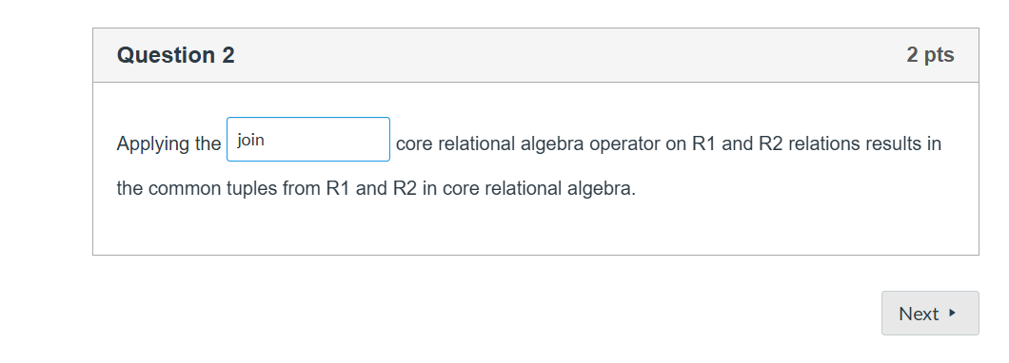
Intersection

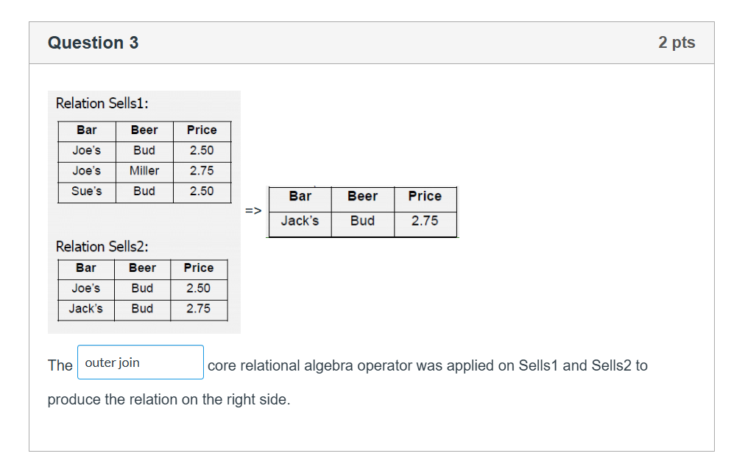
difference

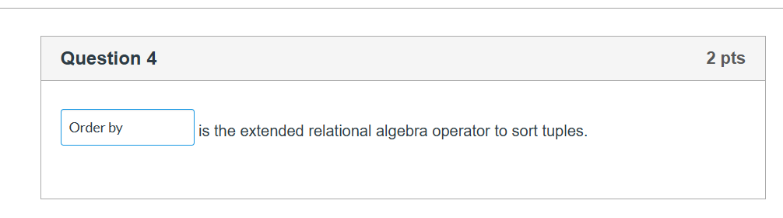
Sort
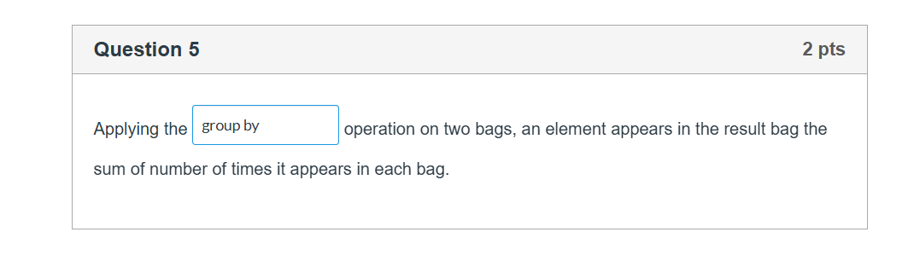
agregation
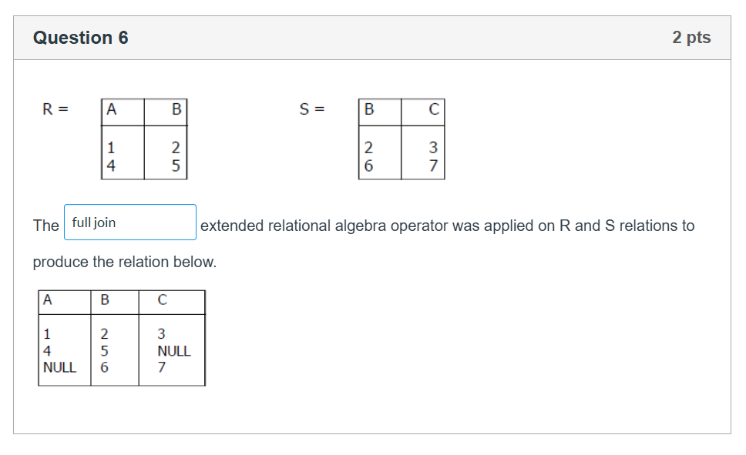
full outer join

Er diagram
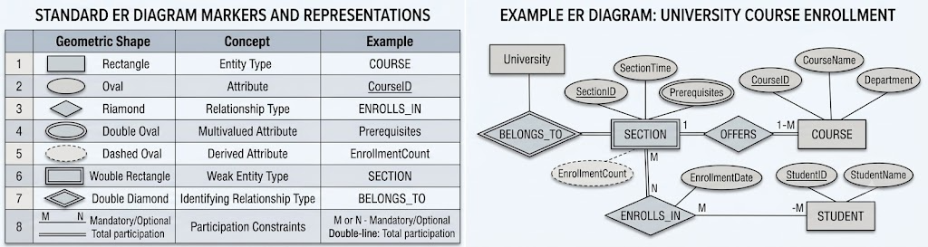
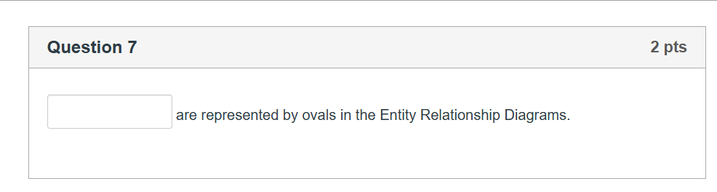
attributes
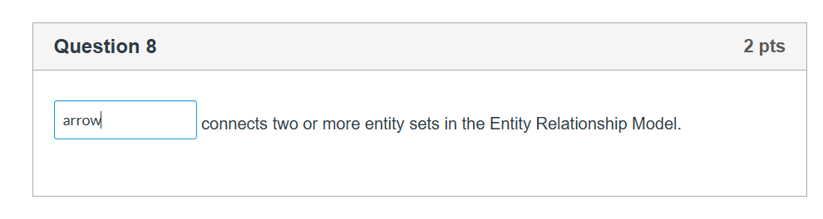
Relationships
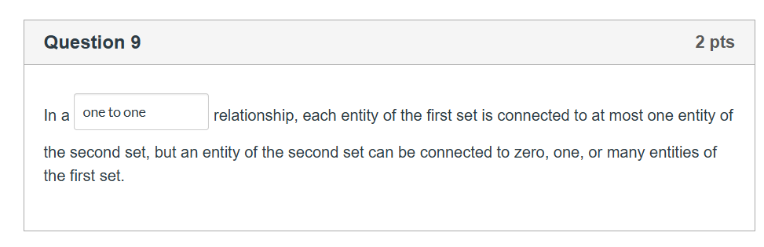
1. One-to-One (1:1)
- Rule: An entity in Set A is associated with at most one entity in Set B, and vice-versa.
- Example: Citizen $\rightarrow$ Has $\rightarrow$ Social Security Number. (One citizen has one SSN; one SSN belongs to exactly one citizen).
2. One-to-Many (1:N)
- Rule: An entity in Set A can be associated with any number (zero or more) of entities in Set B, but an entity in Set B can be associated with at most one entity in Set A.
- Example: Department $\rightarrow$ Employs $\rightarrow$ Employee. (One department can have many employees, but an employee belongs to only one department).
3. Many-to-One (N:1)
- Rule: An entity in Set A is associated with at most one entity in Set B, but an entity in Set B can be associated with any number of entities in Set A. (This matches your quiz question).
- Example: Review $\rightarrow$ Written_For $\rightarrow$ Book. (Many different reviews can be written for one specific book, but an individual review can only belong to one book).
4. Many-to-Many (M:N)
- Rule: An entity in Set A can be associated with any number of entities in Set B, and vice-versa.
- Example: Student $\rightarrow$ Enrolls_In $\rightarrow$ Course. (A student can take many courses, and a single course can contain many students).

Normal Forms:
- 1NF: Each cell holds a single atomic value; every row is uniquely identifiable
- 2NF: Remove partial dependencies—non-key columns must depend on the entire primary key
- 3NF: Remove transitive dependencies—non-key columns depend only on the primary key, not on other non-key columns
- BCNF: Every determinant must be a candidate key.

- Superkey: A set of one or more attributes (columns) that uniquely identifies a row in a table.
- Candidate Key: A minimal superkey. It is a superkey with no redundant attributes—if you remove even one column from it, it loses its ability to uniquely identify the row.
- Primary Key: The specific candidate key chosen by the database designer to uniquely identify rows in the table.
- Prime Attribute: An attribute (column) that is a member of at least one candidate key.
- Non-prime Attribute (or Non-key Attribute): An attribute that is not part of any candidate key.
- Atomic Value: A value that cannot be divided into smaller pieces (e.g., a single phone number rather than a list of three phone numbers in one cell). This is the core requirement for 1NF.

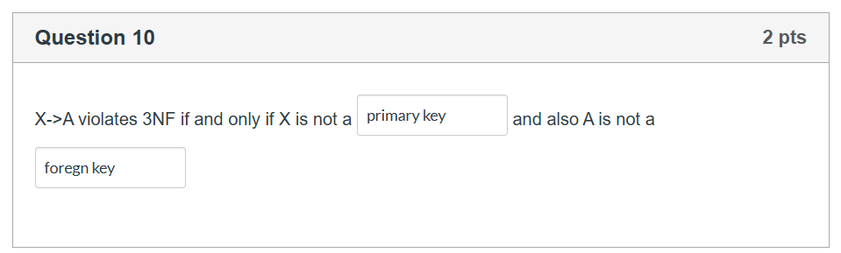
superkey, prime attribute
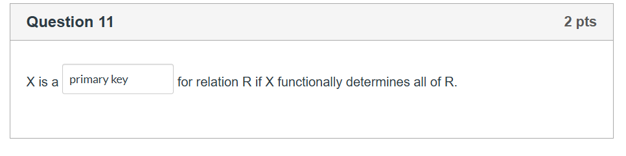
super key

DB Anomalies:
Anomaly Type | Definition | Core Cause | Concrete Example
Deletion Anomaly | A valid, unrelated fact is unintentionally lost when a tuple is deleted from the table. | Mixing two independent entities together in one row. | If student info and course details are in one table, deleting the last student enrolled in a class accidentally deletes the existence of the class itself.
Insertion Anomaly | You cannot record a valid fact because it requires unrelated data that does not exist yet. | Having a key or column constraint depend on an unrelated entity's presence. | You cannot add a brand-new course to the system because no student has enrolled in it yet, and the StudentID cannot be left blank (NULL).
Update Anomaly | Changing a single real-world fact requires editing multiple duplicate records. | Storing the same redundant information across many different rows. | If a professor's phone number is repeated in 50 student enrollment rows, changing their phone number requires updating all 50 rows perfectly, risking data corruption if one is missed.

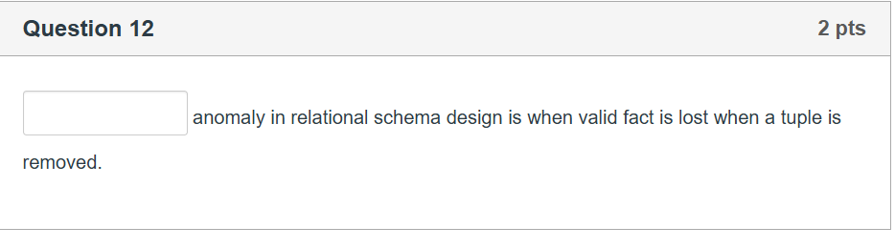
deletion

ORACLE SQL:

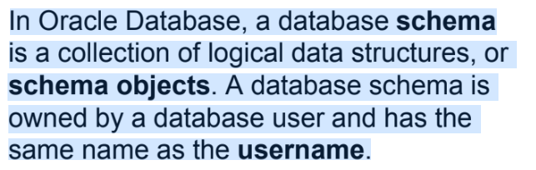

Quarry processing stages:
- parse (sql statement)
- execue (validate sql statement)
- fetch (execute optimized statement)

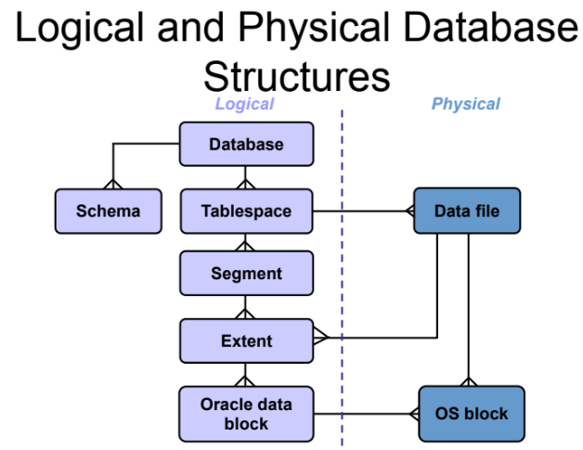
create table, modify table

Optimalization:
Index Type | When to Use | Key Use Case / Performance Benefit | Example Syntax
B-Tree Index (Default) | • High-cardinality columns (many unique values like IDs, emails, dates).  • Columns frequently used in WHERE, JOIN, or ORDER BY clauses. | Standard OLTP databases. Speeds up exact matches and range scans. | CREATE INDEX idx_emp_email ON employees(email);
Bitmap Index | • Low-cardinality columns (few unique values like gender, status, marital_status).  • Heavy read/BI environments (Data Warehousing). | Avoid on heavy OLTP/update tables due to row-locking issues. Great for combining multiple conditions in WHERE clauses. | CREATE BITMAP INDEX idx_cust_gender ON customers(gender);
Function-Based Index | • Queries that frequently apply a SQL function to a column in the WHERE clause (e.g., UPPER(), TRUNC()). | Prevents the optimizer from ignoring a standard index when a function modifies the column data. | CREATE INDEX idx_emp_upper_last ON employees(UPPER(last_name));
Composite (Concatenated) Index | • Multiple columns that are consistently queried together in the WHERE clause.  • Columns used frequently for filtering and sorting combined. | Place the most restrictive/frequently used column first in the index definition. | CREATE INDEX idx_emp_name ON employees(last_name, first_name);
Unique Index | • Columns where every values must be distinct (e.g., National ID, Passport Number). | Automatically created by Oracle when you define a PRIMARY KEY or UNIQUE constraint. Ensures data integrity. | CREATE UNIQUE INDEX idx_emp_ssn ON employees(social_security_number);
Reverse Key Index | • High-consequence sequential keys (like sequences or auto-incrementing IDs) causing index block contention ("hot spots") during massive bulk inserts. | Reverses the bytes of the index key (e.g., 1001 becomes 1001, 1002 becomes 2001) to distribute inserts evenly across the B-Tree structure. | CREATE INDEX idx_order_id_rev ON orders(order_id) REVERSE;

Partition:
Tables/indexes can be „split up into smller fragments”.
Eg.: quaries based on id. you have 2 thousand ids. u spliti t up 1-1000, 1001-2000. this way when u quarry id 200 it is only 1000 row scanned
Partition Type | When to Use | Key Use Case / Performance Benefit | Example Syntax
Range Partitioning | • Columns with continuous data ranges (typically dates or sequential IDs).  • Great for historical data lifecycle management (e.g., dropping data older than 5 years). | Queries looking for specific date ranges (e.g., "Sales from Q1") will only scan the Q1 partition and ignore the rest. | sql\nCREATE TABLE sales (\n sale_id NUMBER,\n sale_date DATE\n)\nPARTITION BY RANGE (sale_date) (\n PARTITION p_2025 VALUES LESS THAN (TO_DATE('01-JAN-2026','DD-MON-YYYY')),\n PARTITION p_2026 VALUES LESS THAN (TO_DATE('01-JAN-2027','DD-MON-YYYY'))\n);\n
List Partitioning | • Columns containing a discrete, unordered set of values (e.g., state_code, country, department). | Queries filtering by specific regions or categories only scan that specific list's segment. | sql\nCREATE TABLE customers (\n cust_id NUMBER,\n region VARCHAR2(20)\n)\nPARTITION BY LIST (region) (\n PARTITION p_north VALUES ('NORTH', 'NORTHEAST'),\n PARTITION p_south VALUES ('SOUTH', 'SOUTHEAST'),\n PARTITION p_default VALUES (DEFAULT)\n);\n
Hash Partitioning | • Columns with high-cardinality (unique values like customer_id or uuid) where you want to distribute data evenly, but range/list doesn't make sense.  • Used to avoid I/O bottlenecks. | Uses an internal Oracle hash algorithm to split data evenly across a pre-defined number of partitions. | sql\nCREATE TABLE orders (\n order_id NUMBER,\n order_total NUMBER\n)\nPARTITION BY HASH (order_id)\nPARTITIONS 4;\n
Composite Partitioning | • Massive tables that need a multi-layered organization strategy (e.g., Partition by Range first, then Sub-partition by List or Hash). | Combines the architectural benefits of two types. Highly common in enterprise data warehouses. | sql\nCREATE TABLE web_logs (\n log_date DATE,\n region VARCHAR2(10)\n)\nPARTITION BY RANGE (log_date)\nSUBPARTITION BY LIST (region) (\n PARTITION p_q1 VALUES LESS THAN (TO_DATE('01-APR-2026','DD-MON-YYYY')) (\n SUBPARTITION p_q1_us VALUES ('US'),\n SUBPARTITION p_q1_eu VALUES ('EU')\n )\n);\n
cluster:
Clustering is a database storage technique where rows from one or more tables that share common columns (called the cluster key) are physically stored together in the same data blocks on disk.
Cluster Type | When to Use | Key Use Case / Performance Benefit | Example Syntax
Index Cluster | • Tables that are frequently joined together in a parent-child relationship (e.g., orders and order_items).  • Queries that frequently fetch a parent and all its related children. | Oracle creates a "cluster index" on the cluster key. Instead of scanning two separate tables on disk, it finds both the parent and child rows in the exact same physical block. | sql\n-- 1. Create the Cluster\nCREATE CLUSTER order_cluster (order_id NUMBER);\n\n-- 2. Create the Cluster Index\nCREATE INDEX idx_ord_cluster ON CLUSTER order_cluster;\n\n-- 3. Create Tables inside the Cluster\nCREATE TABLE orders (order_id NUMBER, order_date DATE) CLUSTER order_cluster (order_id);\nCREATE TABLE order_items (order_id NUMBER, item_id NUMBER) CLUSTER order_cluster (order_id);\n
Hash Cluster | • A single table or a group of tables where rows are almost exclusively accessed via equality queries (e.g., WHERE customer_id = 105).  • The cluster key has high cardinality (many unique values). | No index is created. Oracle applies a hash function directly to the key to compute the exact physical address of the row on disk. This reduces disk I/O to a single read for exact lookups. | sql\n-- 1. Create the Hash Cluster\nCREATE CLUSTER hash_cust_cluster (cust_id NUMBER) \nSIZE 512 HASHKEYS 10000;\n\n-- 2. Create Table inside the Cluster\nCREATE TABLE customers (cust_id NUMBER, name VARCHAR2(50)) \nCLUSTER hash_cust_cluster (cust_id);\n
Sorted Hash Cluster | • Heavy OLTP environments where data is inserted, but needs to be retrieved in a specific sorted order based on a secondary column (e.g., retrieving a customer's logs sorted by timestamp). | Combines hashing with row sorting. Oracle automatically stores rows sorted by the designated columns within the hash bucket, completely bypassing the need for a costly SORT operation at runtime. | sql\nCREATE CLUSTER sorted_log_cluster (cust_id NUMBER, log_date TIMESTAMP SORT)\nHASHKEYS 5000;\n

View
Transactions:
a transaction is a logical unit of work that contains one or more SQL statements.
Command | What it Does | Data Visibility
COMMIT | Permanently saves all changes made in the current transaction to disk. | Changes become visible to all other database users.
ROLLBACK | Undoes all changes made in the current transaction, returning data to its original state. | Data looks as if the transaction never happened.
SAVEPOINT <name> | Creates a temporary marker within the transaction. | Allows you to do a partial rollback to that specific marker without losing the entire transaction.

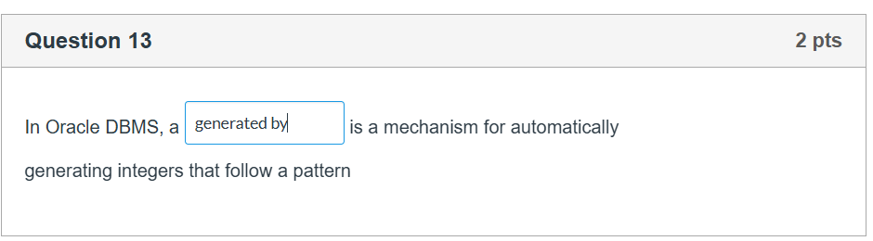

Sequence

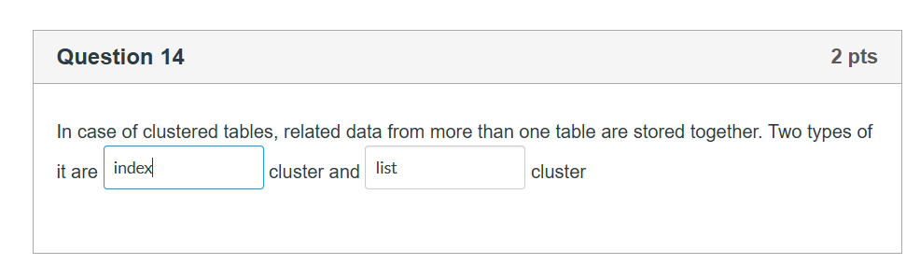
- Index Cluster: Uses a traditional B-tree index structure on the cluster key to locate the data blocks containing the related table rows.
- Hash Cluster: Uses a mathematical hash function applied to the cluster key to directly calculate the physical disk location of the rows, bypassing index lookups entirely for fast equality queries.

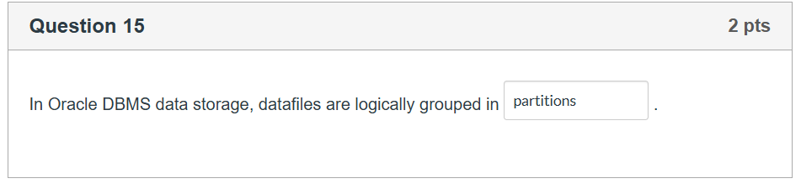
Oracle groups these physical datafiles into a logical unit called a tablespace. Inside a tablespace, database objects like tables and indexes are stored.
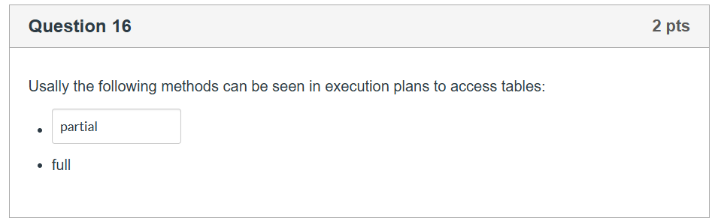
Full Table Scan (full): The database reads every single row in the table from disk to find the matching data.
Index Scan (index): The database uses an index (like a B-tree or bitmap index) to target the specific location of the requested data directly, avoiding the need to read the entire table.

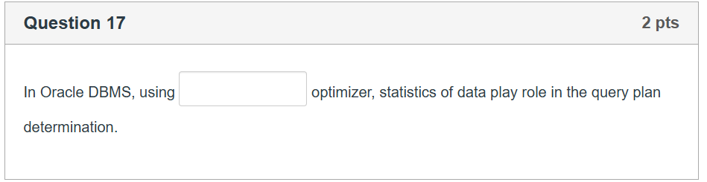
Cost-Based Optimizer (CBO): This modern approach relies heavily on object statistics (such as number of rows, block counts, and data distribution) gathered from the tables and indexes. It calculates the expected "cost" (CPU and I/O resources) of various execution paths and chooses the one with the lowest cost.

Rule-Based Optimizer (RBO): This legacy approach ignored data statistics entirely and strictly followed a fixed set of 15 ranking rules to choose an execution path.

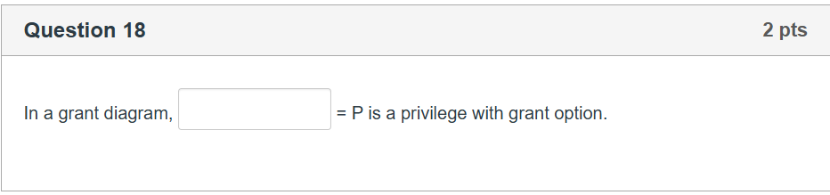
P (Standard Privilege): Represents a user who has been granted the privilege P but cannot pass it on to anyone else.
P* (Privilege with Grant Option): Represents a user who has been granted the privilege P along with the explicit authority to grant that exact privilege to other database users.

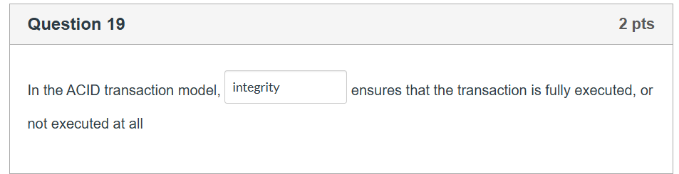
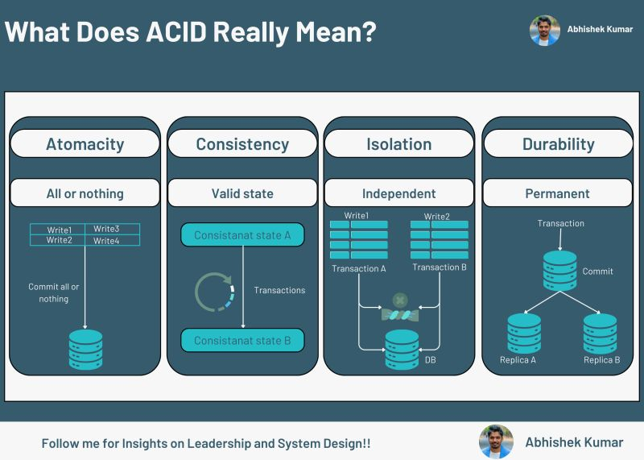

NoSql
types:
- key-value
- graph
- bigtable
- document

Mongodb:
document oriented
bson format
{
x: 3,
y: „eded”,
z: [1, 2],
d: {}
}
Sharding is MongoDB’s method for horizontal scaling. As a database grows, a single machine may no longer have enough CPU, RAM, or disk space to handle the load. Instead of buying a bigger, more expensive server (Vertical Scaling), sharding allows you to split your data across multiple smaller, cheaper servers (Horizontal Scaling). Then comes the writing consern. Unlike in sql (when you goes ofline… rollback happens) in mongo db there is few methods in case of writing.
https://www.alibabacloud.com/help/en/mongodb/use-cases/transactions-and-read-write-concern

Configuration | Description | Performance | Risk of Data Loss | Best Used For
{ w: 0 } | Unacknowledged | Maximum | Very High | IoT telemetry data, log aggregation, clickstream tracking.
{ w: 1, j: false } | Acknowledged by Primary RAM. | Fast | Low (Lost only on instant power failure) | Standard application data where slight loss is acceptable.
{ w: 1, j: true } | Acknowledged by Primary Disk Journal. | Medium | Very Low (Safe on single-node crash) | Critical single-instance data.
{ w: "majority" } | Acknowledged by majority of replica set RAM. | Slower | Extremely Low (Resistant to Primary failure) | Financial transactions, user credentials, orders.
{ w: "majority", j: true } | Acknowledged by majority of replica set Disk Journals. | Slowest | Virtually Zero | Maximum security database requirements.

creating db

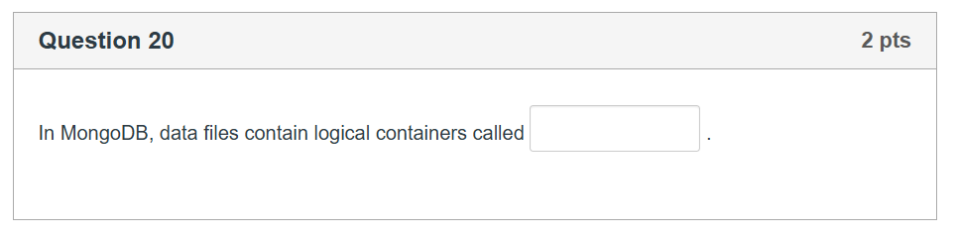
Relational Database (e.g., Oracle, MySQL) | MongoDB (NoSQL Document Store)
Database | Database
Table | Collection
Row / Tuple | Document
Column / Attribute | Field
Table Join | Embedding documents or $lookup

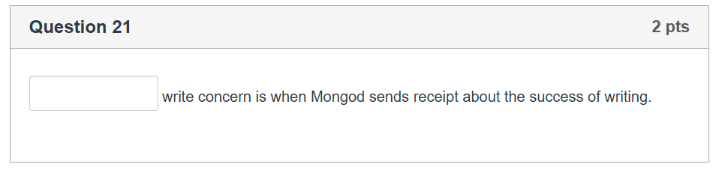
Acknowledged Write Concern (w: 1): This is the default setting. The mongod instance sends a receipt back to the client application after it receives the write operation and applies it to memory (and the journal).

Unacknowledged Write Concern (w: 0): The client application sends the write command, and MongoDB returns a status response immediately without waiting for a confirmation that the write succeeded. If an error occurs (such as a duplicate key or network issue), the application won't know.

CRUD:

// Insert a single product
db.products.insertOne({
name: "Wireless Mouse",
category: "Electronics",
price: 29.99,
stock: 150,
tags: ["accessory", "computer"],
specs: { dpi: 1600, battery: "AA" }
});

// Insert multiple products at once
db.products.insertMany([
{
name: "Mechanical Keyboard",
category: "Electronics",
price: 89.99,
stock: 45,
tags: ["gaming", "computer"]
},
{
name: "Coffee Mug",
category: "Kitchenware",
price: 14.99,
stock: 200,
tags: ["ceramic", "home"]
}
]);

// Find ALL products in the collection
db.products.find();

// Find products where the category is exactly "Electronics"
db.products.find({ category: "Electronics" });

// Find products with a price greater than ($gt) 20
db.products.find({ price: { $gt: 20 } });

// Find a single product matching a criteria (returns the first one it finds)
db.products.findOne({ name: "Coffee Mug" });

// Update ONE product: Change the price of the Wireless Mouse
db.products.updateOne(
{ name: "Wireless Mouse" }, // Filter (which document to update)
{ $set: { price: 24.99 } } // Update operator
);

// Update MULTIPLE products: Lower the stock by 5 for all Electronics
db.products.updateMany(
{ category: "Electronics" }, // Filter
{ $inc: { stock: -5 } } // Increment operator (negative lowers it)
);

// Delete ONE product: Remove the Coffee Mug
db.products.deleteOne({ name: "Coffee Mug" });

// Delete MULTIPLE products: Remove everything out of stock
db.products.deleteMany({ stock: 0 });
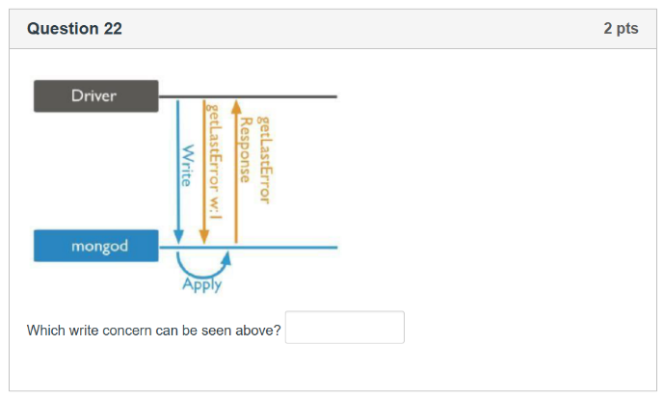
acknowledged
The diagram illustrates the step-by-step sequence of a MongoDB write operation:
- The Driver sends a Write command to the mongod database process.
- The mongod process receives it and uses Apply to commit the change to memory.
- Because the driver issue a request with w:1 (getLastError w:1), it explicitly tells the database that it is waiting for a receipt.
- MongoDB sends a getLastError Response back to the driver confirming the write succeeded.

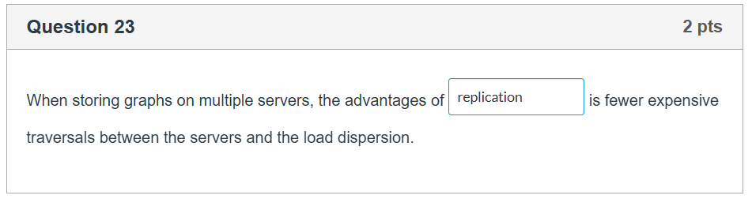
replication

Neo4J:
Neo4j uses a Property Graph model. Everything in the database boils down to four basic building blocks:
- Nodes (Entities): These represent the objects or things in your data (e.g., a specific Person, Product, or Company). They are visually represented as circles.
- Labels: These are used to categorize nodes (similar to a table name in SQL). For example, a node representing Elon Musk would have the label :Person. A node can have multiple labels.
- Relationships (Edges): These connect nodes to show how they interact (e.g., a Person WORKS_FOR a Company, or a Person IS_FRIENDS_WITH another Person). Relationships in Neo4j always have a direction (an arrow) and a specific type.
- Properties (Attributes): Both Nodes and Relationships can store key-value pairs of data. For instance, a :Person node might have properties like name: "Alice" and age: 30. A WORKS_FOR relationship might have a property like since: 2021.

Create Data
Cypher
// Create two Person nodes and a "FRIENDS_WITH" relationship between them
CREATE (a:Person {name: "Alice", age: 30})
CREATE (b:Person {name: "Bob", age: 32})
CREATE (a)-[:FRIENDS_WITH {since: 2024}]->(b)
Read / Match Data
Cypher
// Find Alice and see who all of her friends are
MATCH (p:Person {name: "Alice"})-[r:FRIENDS_WITH]->(friend:Person)
RETURN friend.name, r.since
Update Data
Cypher
// Find Bob and update his age property
MATCH (p:Person {name: "Bob"})
SET p.age = 33
Delete Data
Cypher
// Delete a node and its attached relationships
MATCH (p:Person {name: "Bob"})
DETACH DELETE p

Feature | Relational Database (SQL) | Graph Database (Neo4j)
Data Structure | Tables, Rows, Columns | Nodes, Relationships, Properties
Connections | Foreign Keys & Joint Tables | Physical, direct Pointers
Query Language | SQL | Cypher
Deep Joins Performance | Slower with every added join | Constantly fast, regardless of total data size

Redis:

in memory
1 threaded

• Nodes (Entities): These represent the objects or things in your data (e.g., a specific Person, Product, or Company). They are visually represented as circles.
• Labels: These are used to categorize nodes (similar to a table name in SQL). For example, a node representing Elon Musk would have the label :Person. A node can have multiple labels.
• Relationships (Edges): These connect nodes to show how they interact (e.g., a Person WORKS_FOR a Company, or a Person IS_FRIENDS_WITH another Person). Relationships in Neo4j always have a direction (an arrow) and a specific type.
• Properties (Attributes): Both Nodes and Relationships can store key-value pairs of data. For instance, a :Person node might have properties like name: "Alice" and age: 30. A WORKS_FOR relationship might have a property like since: 2021

Create Data
Cypher
// Create two Person nodes and a "FRIENDS_WITH" relationship between them
CREATE (a:Person {name: "Alice", age: 30})
CREATE (b:Person {name: "Bob", age: 32})
CREATE (a)-[:FRIENDS_WITH {since: 2024}]->(b)
Read / Match Data
Cypher
// Find Alice and see who all of her friends are
MATCH (p:Person {name: "Alice"})-[r:FRIENDS_WITH]->(friend:Person)
RETURN friend.name, r.since
Update Data
Cypher
// Find Bob and update his age property
MATCH (p:Person {name: "Bob"})
SET p.age = 33
Delete Data
Cypher
// Delete a node and its attached relationships
MATCH (p:Person {name: "Bob"})
DETACH DELETE p

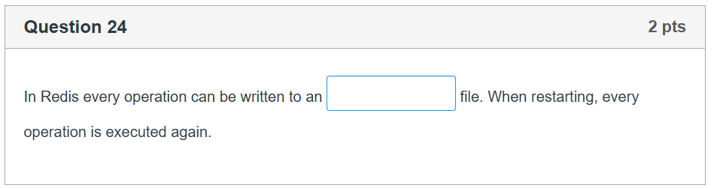
The correct term for the blank is AOF (or Append Only File).
- The Explanation: Redis is an in-memory database, meaning it keeps its data in RAM. To prevent data loss if the server crashes, it offers persistence mechanisms. The AOF (Append Only File) logs every write operation received by the server. When Redis restarts, it reads and re-executes every operation in this log file sequentially to reconstruct the original state of the dataset.

HBase:
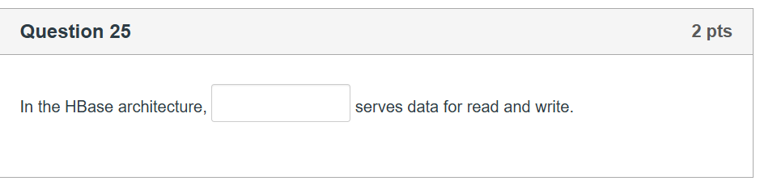
RegionServer

HMaster: The master node responsible for monitoring cluster health, managing schema changes, and coordinating administrative tasks. It does not handle user data paths.

RegionServer: The worker nodes that physically handle user data requests. A table is horizontally split into chunks called "regions," and a RegionServer serves data reads and writes for all the specific regions assigned to it by the master.

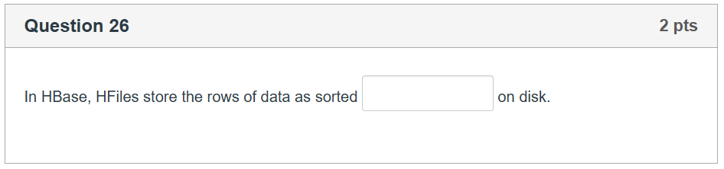
key-value pairs

XML:
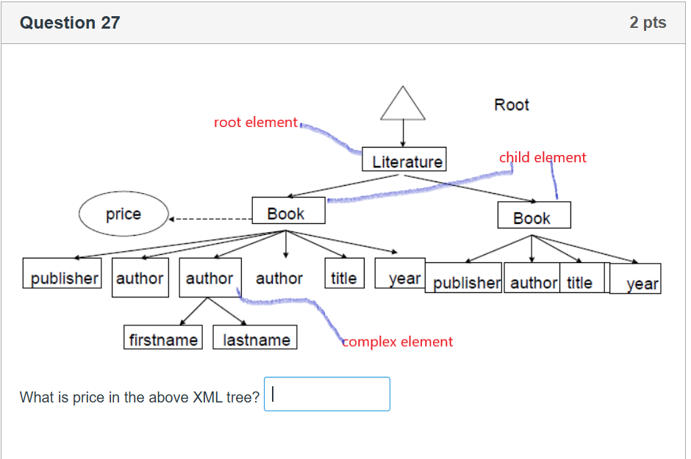
attributes

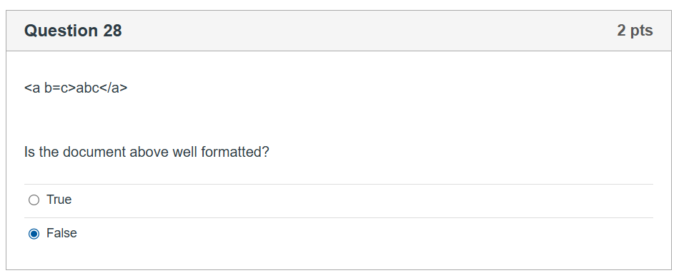
Incorrect: <a b=c>

Correct: <a b="c"> or <a b='c'>
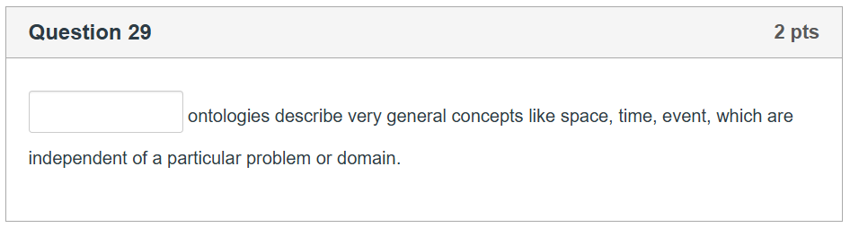
Top-level / Upper Ontologies: Describe highly generalized, domain-independent concepts (such as space, time, event, object, behavior) that apply across all human knowledge domains. Examples include SUMO (Suggested Upper Merged Ontology) and DOLCE.
Domain Ontologies: Restrict the vocabulary to a specific field or area of concern (e.g., medical terminology, automotive manufacturing engineering).
Task Ontologies: Describe a generic task or activity (e.g., diagnosing an illness, solving an optimization problem).
Application Ontologies: The most specific layer, tailored to a single localized application or system setup.

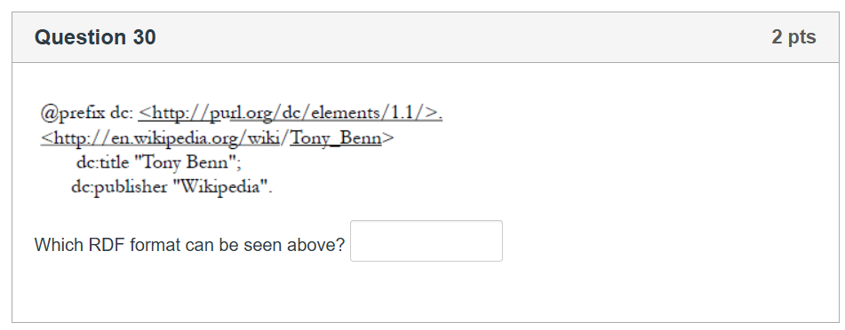
Turtle

1. N-Triples (.nt)
N-Triples is a highly simplified, line-by-line subset of the Turtle format. It completely cuts out shortcuts like @prefix declarations, relative IRIs, or shared predicate groupings.
- Key Characteristics: Every single line represents exactly one standalone semantic triple consisting of a explicit Subject Predicate Object . statement.
- Best Used For: High-volume stream processing and parsing large datasets, since parsers can read line-by-line without holding entire document prefixes in memory.
Plaintext
<http://en.wikipedia.org/wiki/Tony_Benn> <http://purl.org/dc/elements/1.1/title> "Tony Benn" .
<http://en.wikipedia.org/wiki/Tony_Benn> <http://purl.org/dc/elements/1.1/publisher> "Wikipedia" .

2. RDF/XML (.rdf or .xml)
This was the original standard specification format introduced by the W3C for writing down graph-based RDF data using an XML structure.
- Key Characteristics: It wraps resources within nested XML elements, using attributes like rdf:about to establish subjects and nested sub-elements to represent predicates.
- Best Used For: Legacy enterprise integrations already heavily built around XML validation schemas. It is notoriously difficult for humans to read and write manually compared to modern formats.
XML
<rdf:RDF xmlns:rdf="http://www.w3.org/1999/02/22-rdf-syntax-ns#"
xmlns:dc="http://purl.org/dc/elements/1.1/">
<rdf:Description rdf:about="http://en.wikipedia.org/wiki/Tony_Benn">
<dc:title>Tony Benn</dc:title>
<dc:publisher>Wikipedia</dc:publisher>
</rdf:Description>
</rdf:RDF>

3. JSON-LD (.jsonld)
JSON-LD (JavaScript Object Notation for Linked Data) maps RDF graphs directly into standard JSON syntax. It acts as a translational bridge between traditional web development and the semantic graph ecosystem.
- Key Characteristics: Uses a special "@context" block at the top of the file to map clean, nested JSON keys to formal semantic web IRIs.
- Best Used For: Web programming and SEO optimization. This format is the global standard used by Google (schema.org) to read structured metadata directly out of web page headers.
JSON
{
"@context": {
"dc": "http://purl.org/dc/elements/1.1/"
},
"@id": "http://en.wikipedia.org/wiki/Tony_Benn",
"dc:title": "Tony Benn",
"dc:publisher": "Wikipedia"
}

4. N3 / Notation3 (.n3)
Notation3 is a complex, generalized superset of the Turtle syntax.
- Key Characteristics: It visually looks almost identical to Turtle but extends beyond pure data triples by adding logical formatting rules, variables, and graph-to-graph relationships.
- Best Used For: Advanced semantic web reasoning software engines that require explicit policy logic definitions or inline mathematical rules.

