Tic tac toe Game

Basic Game:
- two human plays, the game have a window where the players can choose the position where the own character is put.
-either of them wins when his/her character is on every field of one of the row or coloumn or diagonal of the board.

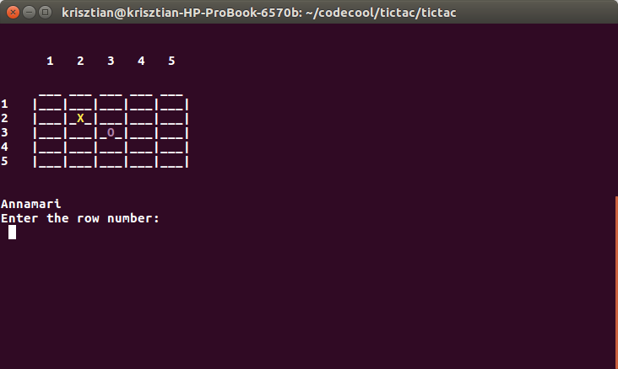

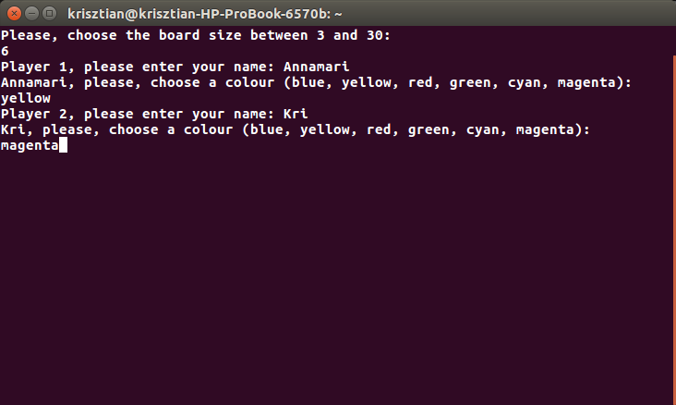

New functions:

1. Amoeba version
- if on case of 5 or bigger board size. either of them wins when his/her character is on 5 field of either of the row or coloumn or diagonal of the board.
2. Computer vs Human game mode
3. Multi-Players
-on the same computer 3 or more players can play
4. Time limit
- the players have only five sec to choose the positions
5. Character choice

