Laravel app deployment on herokun

Csinalj egy Procfile-t:
web: vendor/bin/heroku-php-apache2 public/ -ezzel a szoveggel

Kosd ossze githubon a projekttel.
Utana johetnek a env valtozok:

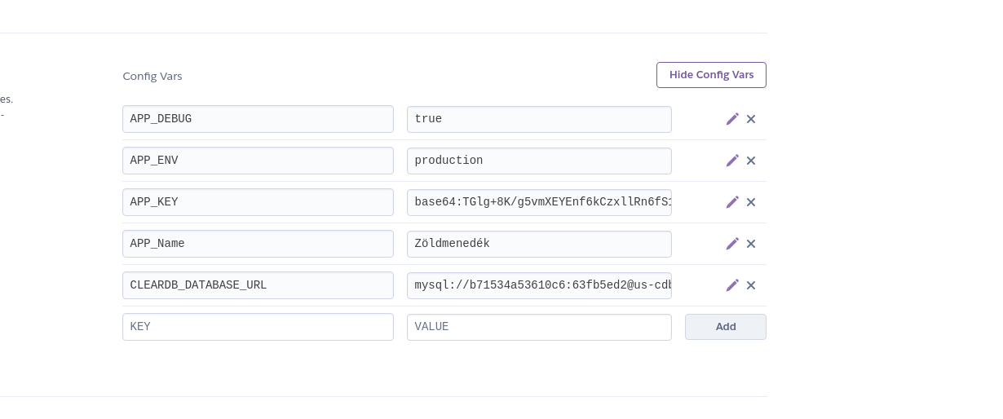
APP_KEY a .env filebol jon, laravel generalja projekt letrehozaskor.
A ClearDB url-t a Resources tabon adtam hozza mint MySQL database
Az url-t feldarabolva MySQL Workbenchel betudom importalni a DB-t a remote serverre:
https://mattstauffer.com/blog/laravel-on-heroku-using-a-mysql-database/

Igy tudsz a MySQL Workbenchben hozzacsatlakozni a Dbhez:
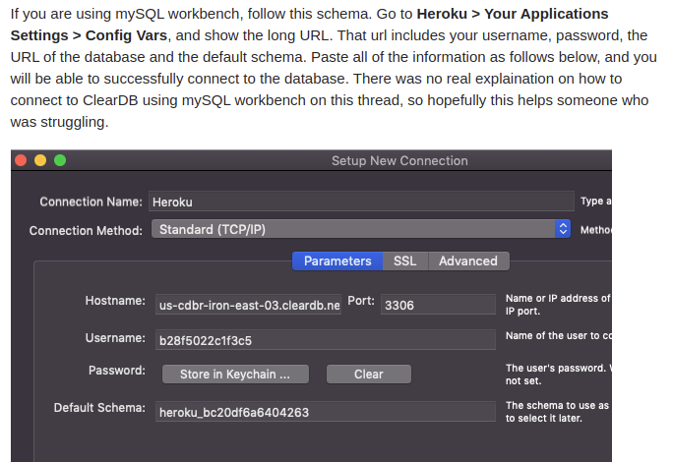
A database.php fileban modositsd a db connectiont:
// For Deployed DB Connection
$url = parse_url(getenv("CLEARDB_DATABASE_URL"));

$host = $url["host"];
$username = $url["user"];
$password = $url["pass"];
$database = substr($url["path"], 1);

//local development environment db connection
// 'mysql' => [
// 'driver' => 'mysql',
// 'url' => env('DATABASE_URL'),
// 'host' => env('DB_HOST', '127.0.0.1'),
// 'port' => env('DB_PORT', '3306'),
// 'database' => env('DB_DATABASE', 'forge'),
// 'username' => env('DB_USERNAME', 'forge'),
// 'password' => env('DB_PASSWORD', ''),
// 'unix_socket' => env('DB_SOCKET', ''),
// 'charset' => 'utf8mb4',
// 'collation' => 'utf8mb4_unicode_ci',
// 'prefix' => '',
// 'prefix_indexes' => true,
// 'strict' => true,
// 'engine' => null,
// 'options' => extension_loaded('pdo_mysql') ? array_filter([
// PDO::MYSQL_ATTR_SSL_CA => env('MYSQL_ATTR_SSL_CA'),
// ]) : [],
// ],

//cleardb db connection on heroku
'mysql' => array(
'driver' => 'mysql',
'host' => $host,
'database' => $database,
'username' => $username,
'password' => $password,
'charset' => 'utf8',
'collation' => 'utf8_unicode_ci',
'prefix' => '',
),

Ezt pushold githubra es utana mehet a deploy

