1. Modeled data

1.1. Raw RTs

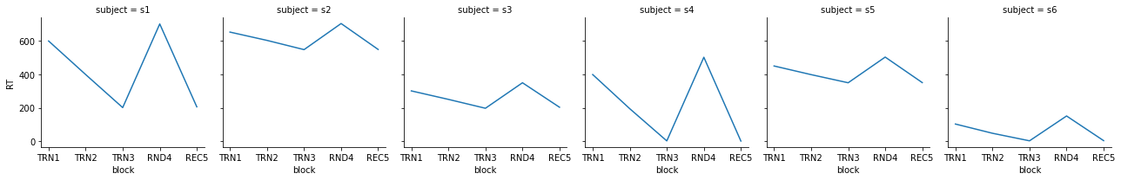

1.2. Normalized RTs

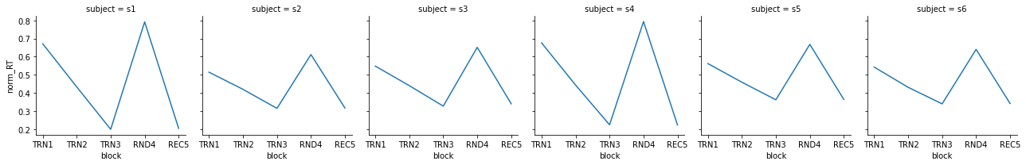

1.3. Calculated indices



1.4. Conclusion of modeled data

Normalizing RTs only magnifies learning effects in the case of steeper learning curves, completely ignoring baseline reaction times. This is only good if it is a typical scenario that subject with steep learning curves tend to have high baseline RTs (s4) while subjects with smooth/moderate learning curves have low baseline RTs (s6). But how actual data look like in 1) different SL tasks and 2) different subjects?

2. Real data from tasks

We looked at data from three of our experiments to look for such trends.

2.1. Segmentation

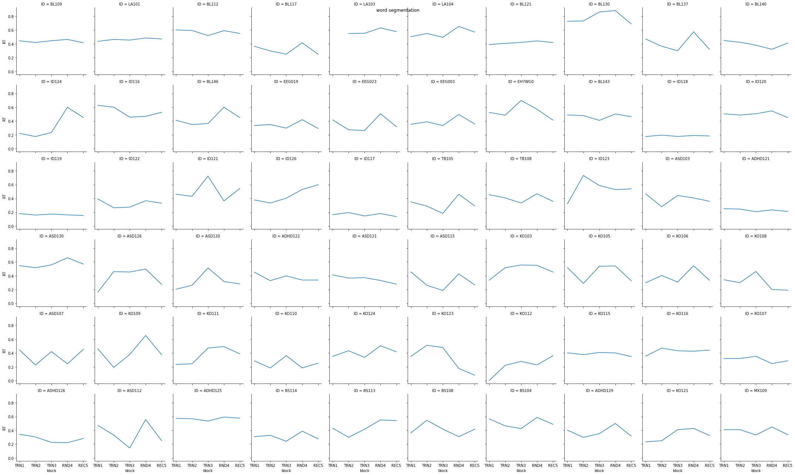

2.2. AGL

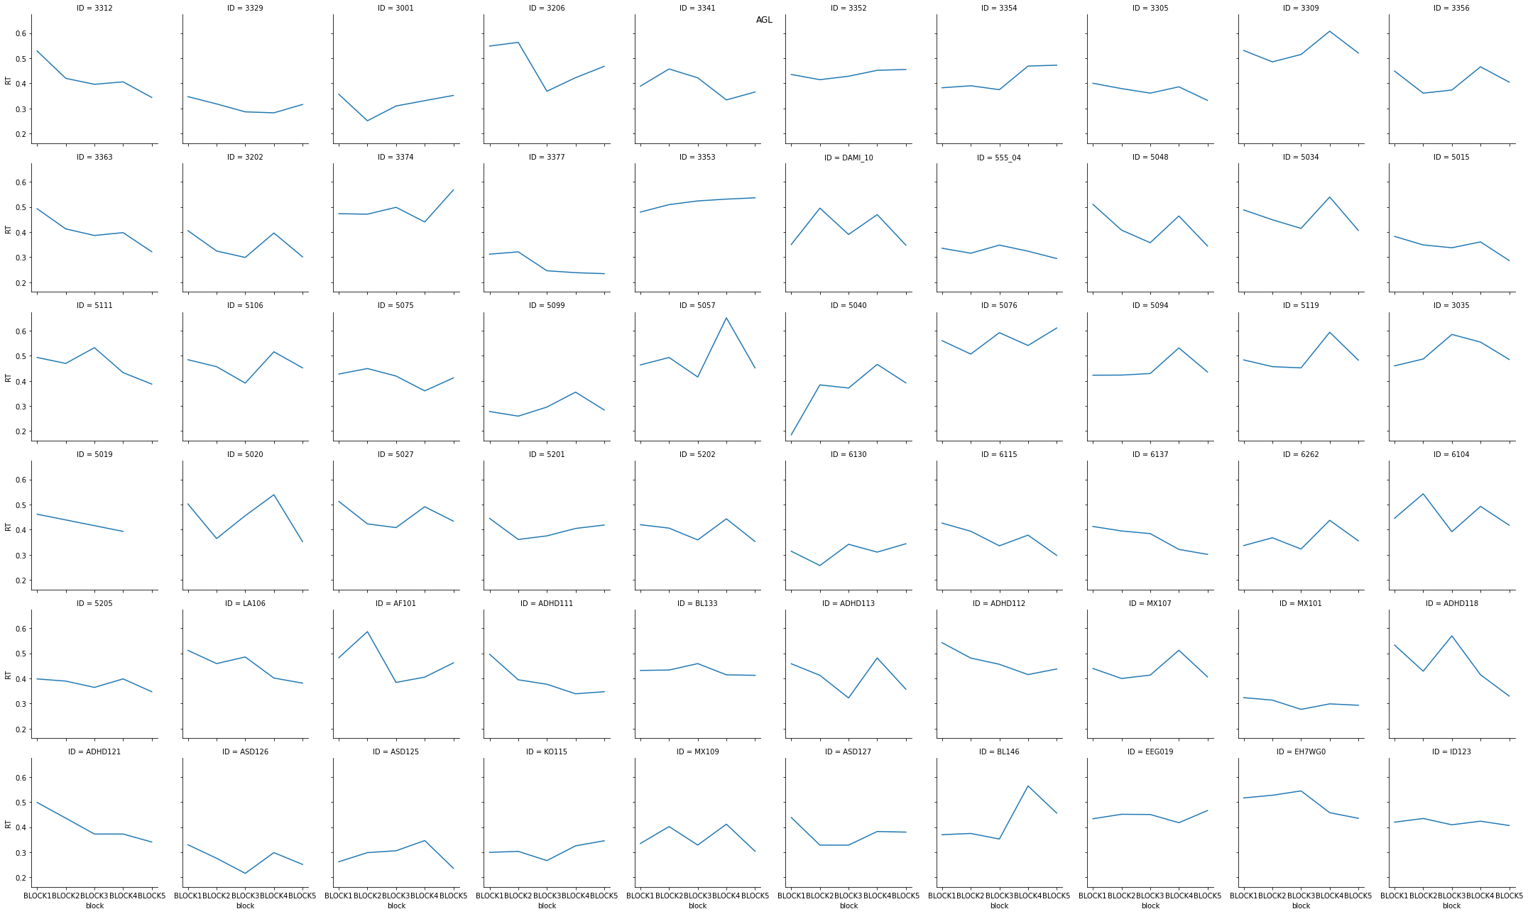

2.3. NAD

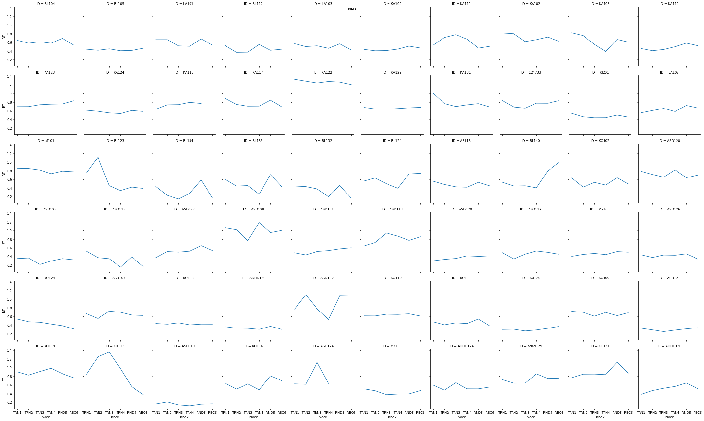

2.4. Conclusion of real data

By the visual inspection of data, there is no clear trend in the direction that participants with steeper learning curves would have higher baseline reaction times than participants with more smooth/moderate learning curves. So there is not enough ground for normalizing RT data. But this is based only on the visual inspection of subsample. ¯\_(ツ)_/¯