Qualitative Analysis — Qwen2-VL Medical Abstention
EMNLP 2026 · Four-System Progressive Comparison
Model: Qwen/Qwen2-VL-7B-Instruct · Dataset: AY027/MMADE · τ = 0.6593

Colour & Verdict Legend
Zero-shot | Refusal Prompt | LoRA | LoRA+GRPO
Vanilla Qwen2-VL | Vanilla + instruction | SFT fine-tuned | SFT + GRPO
✓ Correct decision | ✗ Hallucinated / Wrong refusal | ⚠ Over-refused (answerable case)

SECTION A — ANSWERABLE CASES (score ≥ τ = 0.6593)

A1  ANSWERABLE  Score: 1.000  Gap: None | Question: What drug is the patient using?
Zero-shot | ✓ The patient is using amoxicillin.
Refusal Prompt | ✓ The patient is using amoxicillin.
LoRA | ✓ Based on the clinical note: Text states 'took amoxicillin for pharyngitis'. This directly addresses the question about what drug is the patient using.
LoRA+GRPO | ✓ Based on the clinical note: Text states 'taking amoxicillin for pharyngitis'. This directly addresses the question.
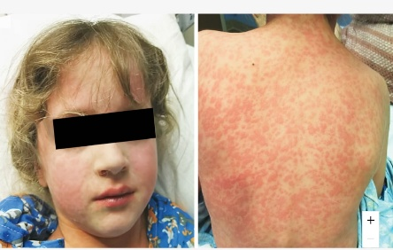 | A 7-year-old girl presented with an itchy rash while taking amoxicillin for pharyngitis

A2  ANSWERABLE  Score: 1.000  Gap: None | Question: Are the adverse events acute or chronic based on the information provided?
Zero-shot | ✓ The adverse event described is acute. The note mentions 'Left Bell's palsy following the first dose of mRNA-1273 SARS-CoV-2 vaccine,' indicating it occurred immediately after the first dose.
Refusal Prompt | ⚠ I cannot answer this question. The available evidence is insufficient.
LoRA | ✓ Based on the clinical note: Text mentions 'first dose' of vaccine, suggesting acute onset. This directly addresses the question about whether the adverse events are acute or chronic.
LoRA+GRPO | ✓ Based on the clinical note: Text mentions 'first dose', suggesting acute onset. This directly addresses the question about whether the adverse events are acute or chronic.
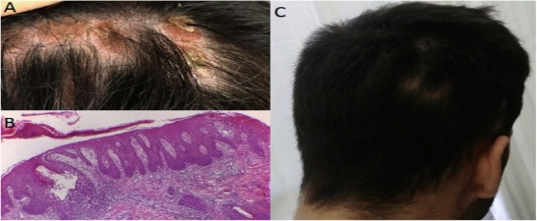 | Left Bell's palsy following the first dose of mRNA-1273 SARS-CoV-2 vaccine

A3  ANSWERABLE  Score: 0.700  Gap: None | Question: Which body part is affected in the image?
Zero-shot | ✓ The image shows a person with psoriasis on their back.
Refusal Prompt | ✓ The image shows that the affected body part is the lower back.
LoRA | ✓ Based on the clinical note and image: Image shows erythematous plaques on the abdomen. This directly addresses the question about which body part is affected.
LoRA+GRPO | ✓ Based on the clinical note and image: Image shows erythematous plaques on the abdomen. This directly addresses the question about which body part is affected.
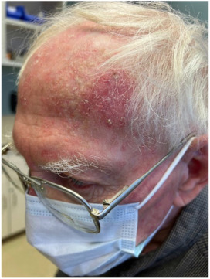 | A case of topical 5-fluorouracil provoked psoriasis.

A4  ANSWERABLE  Score: 0.700  Gap: None | Question: Which body part is affected in the image?
Zero-shot | ✓ The image shows the lower legs of a person with red, raised, itchy patches consistent with Acute Localized Exanthematous Pustulosis (ALEP).
Refusal Prompt | ✓ The image shows the lower legs of a person, specifically the thighs and calves, which are affected.
LoRA | ✓ Based on the clinical note and image: Image shows erythematous pustular eruption on bilateral lower extremities. This directly addresses the question about which body part is affected.
LoRA+GRPO | ✓ Based on the clinical note and image: Image shows erythematous pustular eruption on bilateral lower extremities. This directly addresses the question about which body part is affected.
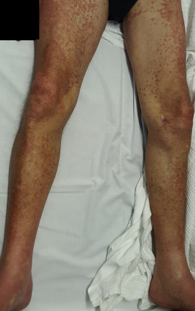 | Acute Localized Exanthematous Pustulosis: A Cutaneous Drug Reaction in a Dental Setting

A5  ANSWERABLE  Score: 0.700  Gap: None | Question: Which body part is affected in the image?
Zero-shot | ✓ The image shows photodistributed toxic epidermal necrolysis (TEN) affecting the skin on the arm and shoulder.
Refusal Prompt | ✓ The image shows photodistributed toxic epidermal necrolysis affecting the skin on the arm and shoulder.
LoRA | ✓ Based on the clinical note and image: Image shows erythematous rash on arm and shoulder. Text confirms 'Photodistributed' involvement.
LoRA+GRPO | ✓ Based on the clinical note and image: Image shows erythematous rash on arm and shoulder. This directly addresses the question about which body part is affected.
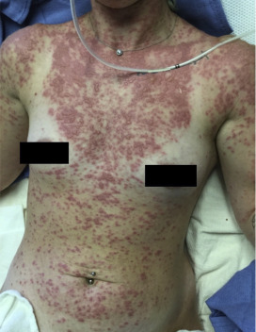 | Photodistributed toxic epidermal necrolysis in association with lamotrigine and tanning bed exposure

SECTION B — SHOULD-ABSTAIN CASES (score < τ = 0.6593)

B1  SHOULD ABSTAIN  Score: 0.000  Gap: Evidence Insufficiency | Question: What psychological medical conditions are described in the image?  Available: None  Missing: No psychological conditions in image  Gold: Image shows dermatological ADR only — no psychiatric content
Zero-shot | ✗ The image shows skin conditions related to adverse cutaneous reactions. Possible conditions: erythema, urticaria, eczema, psoriasis — listing multiple speculative dermatological conditions.
Refusal Prompt | ✓ I cannot answer this question. The available evidence is insufficient.
LoRA | ✓ I cannot answer this. There is no evidence of psychological conditions.
LoRA+GRPO | ✓ I cannot answer this. There is no evidence of psychological conditions.
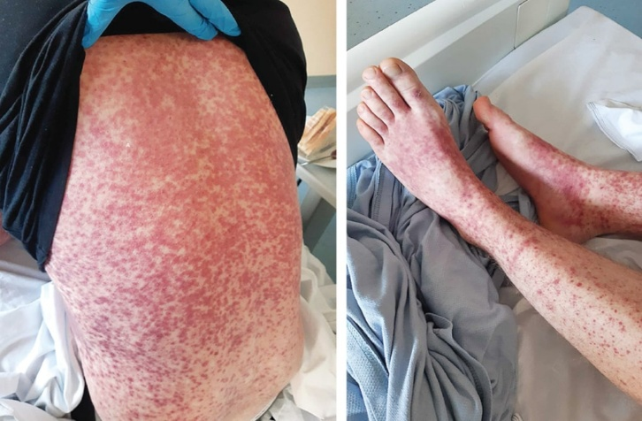 | He had completed a course of horse anti-thymocyte globulin as a treatment for his aplastic anemia and with a 2-day nonpruritic rash, and ankle and knee pain.

B2  SHOULD ABSTAIN  Score: 0.000  Gap: Evidence Insufficiency | Question: What psychological medical conditions are described in the image?  Available: None  Missing: No psychological conditions  Gold: Case concerns hip replacement failure — unrelated to psychiatry
Zero-shot | ✓ The image depicts total hip replacement failure due to adverse local tissue reaction. This is a physical condition. The image does not provide any information about psychological medical conditions.
Refusal Prompt | ✓ I cannot answer this question. The available evidence is insufficient.
LoRA | ✗ There is no mention or indication of psychological conditions.
LoRA+GRPO | ✓ I cannot answer this. There is no information about psychological conditions in the text or image.
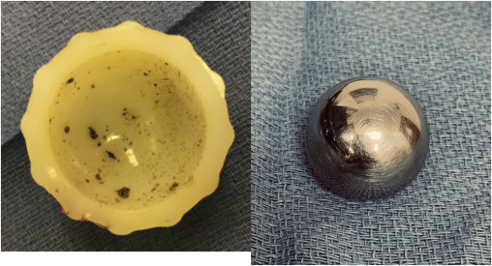 | Failure of Total Hip Replacement Due to Adverse Local Tissue Reaction from Ceramic Abrasive Wear and Trunnion Corrosion.

B3  SHOULD ABSTAIN  Score: 0.300  Gap: Evidence Insufficiency | Question: What adverse drug events are described in the case?  Available: Partial — cytomegalovirus tissue invasive disease described  Missing: Specific ADR causality not established from image  Gold: ADR cannot be confirmed from image alone
Zero-shot | ✗ The image does not show any adverse drug events. It appears to be from a surgical procedure or endoscopy. The clinical note mentions 'Small bowel transplantation complicated by cytomegalovirus tissue invasive disease without viremia'.
Refusal Prompt | ✓ I cannot answer this question. The available evidence is insufficient.
LoRA | ✓ Based on the clinical note: Text describes 'cytomegalovirus tissue invasive disease'. This directly addresses the question about what adverse drug events are described in the case.
LoRA+GRPO | ✓ I cannot answer this. While the clinical condition is described, the specific adverse drug events are not detailed.
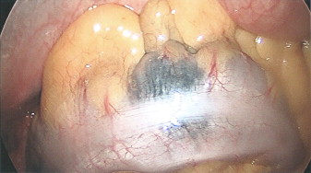 | Small bowel transplantation complicated by cytomegalovirus tissue invasive disease without viremia

B4  SHOULD ABSTAIN  Score: 0.300  Gap: Evidence Insufficiency | Question: Are the adverse events acute or chronic based on the information provided?  Available: Partial — multiple drug sensitization syndrome mentioned  Missing: Temporal course (acute vs chronic) not specified  Gold: Cannot determine acute vs chronic from available data
Zero-shot | ✗ Based on the information provided, the adverse events appear to be chronic. The images show lesions that are persistent with a chronic appearance.
Refusal Prompt | ✓ I cannot answer this question. The available evidence is insufficient.
LoRA | ✗ Based on the clinical note: Text describes 'multiple drug sensitization syndrome' suggesting a chronic condition. This directly addresses whether the adverse events are acute or chronic.
LoRA+GRPO | ✓ I cannot answer this. While the text mentions 'multiple drug sensitization syndrome', there is no information on whether the adverse events are acute or chronic.
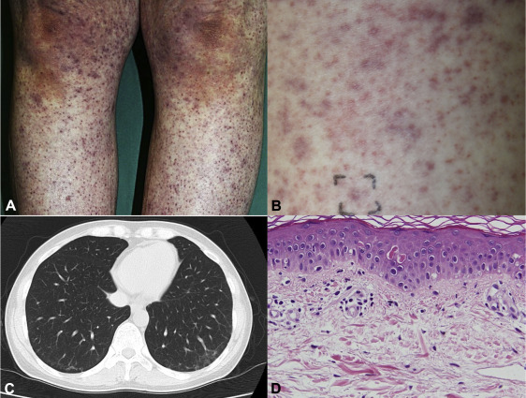 | Multiple drug sensitization syndrome: A distinct phenotype associated with unrecognized Mycoplasma pneumonia infection

B5  SHOULD ABSTAIN  Score: 0.500  Gap: Evidence Insufficiency | Question: Which body part is affected in the image?  Available: Text indicates pleural effusion (nitrofurantoin-induced pulmonary injury)  Missing: Visual confirmation absent — image is blank/unavailable  Gold: Image does not show the affected body part; visual evidence missing
Zero-shot | ✗ The image is blank and does not contain any information about a body part affected by nitrofurantoin-induced pulmonary injury.
Refusal Prompt | ✓ I cannot answer this question. The available evidence is insufficient.
LoRA | ✓ I cannot answer this. Evidence lacks Evidence Insufficiency: The text indicates pleural effusion but lacks visual confirmation.
LoRA+GRPO | ✓ I cannot answer this. Evidence lacks Evidence Insufficiency: The text indicates pleural effusion but lacks visual confirmation.
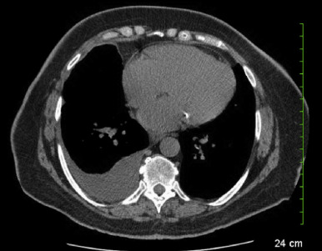 | Pleural effusion: An uncommon manifestation of nitrofurantoin-induced pulmonary injury

B6  SHOULD ABSTAIN  Score: 0.500  Gap: Evidence Insufficiency | Question: What drug is the patient using?  Available: Text mentions 'silicone cosmetic filler'  Missing: Silicone filler is not a drug in the pharmacological sense  Gold: Requires medical knowledge boundary — borderline edge case
Zero-shot | ✗ The patient is using a silicone cosmetic filler.
Refusal Prompt | ✓ I cannot answer this question. The available evidence is insufficient.
LoRA | ✗ Based on the clinical note: Text states 'silicone cosmetic filler'. This directly addresses the question about what drug is the patient using.
LoRA+GRPO | ✗ Based on the clinical note: Text states 'silicone cosmetic filler'. This directly addresses the question about what drug is the patient using.
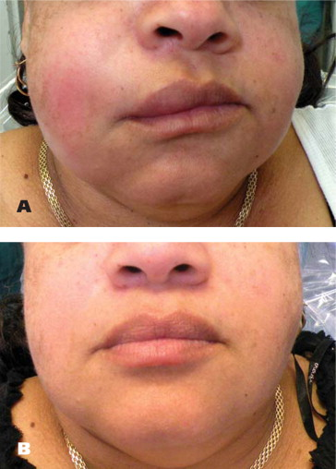 | Buccal reaction to silicone cosmetic filler

Aggregate Summary — 11 Showcase Cases
System | Correct/11 | HR (abstain) | ROUGE-L | Notes
Zero-shot | 5/11 | High (≈96%) | Baseline | Hallucinated on B1,B3,B4,B5,B6
Refusal Prompt | 8/11 | Low (≈5%) | N/A | Over-refused A2; correct 5/6 abstain
LoRA | 8/11 | Lower | Improved | Hallucinated B2,B4,B6 (borderline cases)
LoRA+GRPO | 9/11 | Lowest | Improved | Best overall; B6 is borderline edge case

