|  |
| --- |
| NAME:KRITARTH JHA |
| 19BCS4253 |
| CSE(MC) |

AIM:DESIGN A SYSTEM WITH 5 P0LES FOR HIGHWAY LIGHTING SUCH THAT WHENEVER A CAR CROSSES THROUGH THE POLE ,THE LED START BLINKING.

THEORY:IN RIGHT HAND TRAFFIC ,THE YELLOW TRAP IS A POTENTIALLY DANGEROUS SCENARIO IN TRAFFIC FLOW THROUGH A TRAFFIC LIGHT RELATING TO PERMISSIVE LEFT TURNS,WHILE AT THE SAME TIME.OPPOSING THROUGH A TRAFFIC STILL HAS A CIRCULAR GREEN LIGHT. THIS LEAD TO POTENTIAL TRAFFIC CONFLICT IF DRIVER ATTEMPT TO COMPLETE A LEFT TURN WHEN IT IS NOT SAFE TO DO SO. THERE WILL BE ADIFFERENT OBJECTS OF HIGHWAY LIGHTING SUCH AS ALIGNMENT,STREET…………….

DIAGRAM:

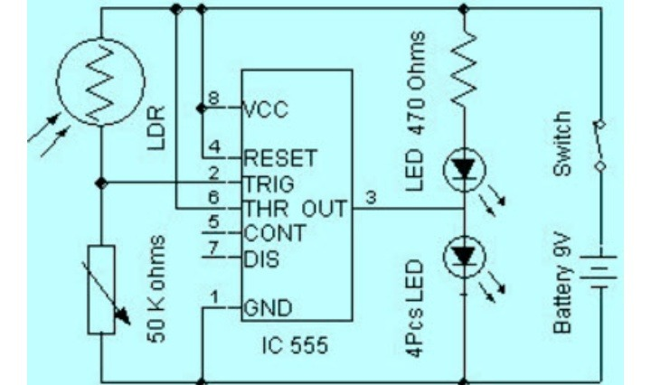

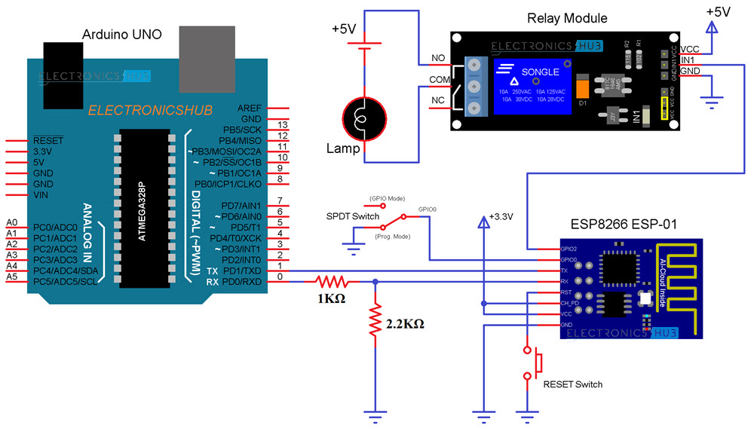

THANKS