

**Mini project -2**

**SYNOPSIS**

**ON**

“**Ecommerce Website”**

**Submitted By: Submitted To:**

Name : Kritarth Sharma Faculty Name: Mr. Akash Choudhary

Uid:181500335

Name : Priyanka Nigam

Uid:181500509

**DECLARATION**

We declare that the project report is based on our own work carried out during the course of our study under the supervision of Mr. Akash Chaudhary. We assert the statements made and conclusions drawn are an outcome of my research work. The work contained in the report is original and has been done by me under the general supervision of my supervisor. The work has not been submitted to any other Institution for any other degree/diploma/certificate in this university or any other University of India or abroad. We have followed the guidelines provided by the university in writing the synopsis. Whenever we have used materials (data, theoretical analysis, and text) from other sources, we have given due credit to them in the text of the report and giving their details in the references.

**ACKNOWLEDGEMENT**

Our sincere gratitude and thanks towards our project guide Mr. Akash Kumar Chaudhary. It was only with his backing and support that We could start the project. He provided us all sorts of help and corrected us if ever seemed to make mistakes. We have no such words to express my gratitude. We acknowledge my dearest parents for being such a nice source of encouragement and moral support that helped me tremendously in this aspect. We also declare to the best of my knowledge and belief that the Project Work has not been submitted anywhere else.

**INTRODUCTION**

Ecommerce, also known as electronic commerce or internet commerce, refers to the buying and selling of goods or services using the internet, and the transfer of money and data to execute these transactions. Ecommerce is often used to refer to the sale of physical products online, but it can also describe any kind of commercial transaction that is facilitated through the internet.

Whereas e-business refers to all aspects of operating an online business, ecommerce refers specifically to the transaction of goods and services.

The history of ecommerce begins with the first ever online sale: on the August 11, 1994 a man sold a CD by the band Sting to his friend through his website NetMarket, an American retail platform. This is the first example of a consumer purchasing a product from a business through the World Wide Web—or “ecommerce” as we commonly know it today.

Since then, ecommerce has evolved to make products easier to discover and purchase through online retailers and marketplaces. Independent freelancers, small businesses, and large corporations have all benefited from ecommerce, which enables them to sell their goods and services at a scale that was not possible with traditional offline retail.

Global retail ecommerce sales are projected to reach $27 trillion by 2020.

The main theme of the project is to build a social media website where the user can do the following things:

* Register if new user
* Login
* View various items
* Add to cart
* Purchase items

**Project Implementation:**

The project will have the following modules:

* Post module: All the functionalities related to posts will be in this module.
* Cart module: Manages operations related to cart.
* User module: Manages the users.
* Purchase module: All the functionalities related to purchase such as insert, view, delete will be in this module.

The project should provide the functionality for generating the report related to cart, users, purchase, and statistics of visitors.

Admin of the site should have control over:

* Designing and developing the website.
* Creating and updating the database
* Inserting, viewing, updating, deleting the data in the database.

**Technologies used for this project:**

Front-end: HTML,CSS, Bootstrap,React

Back-end: Mongodb,Express,Node

**USE OF THE PROJECT**

The online marketplace is a good platform for you to expand your business. We are going to explain what kind of advantages there are by sharing what we know about online selling. In brief, these are the plus points we will talk about.  
  
1. Faster buying process  
2. Store and product listing creation  
3. Cost reduction  
4. Affordable advertising and marketing  
5. Flexibility for customers  
6. No reach limitations  
7. Product and price comparison  
8. Faster response to buyer/market demands  
9. Several payment modes

**Data Flow Diagram**

Zero Level DFD- E-commerce Portal

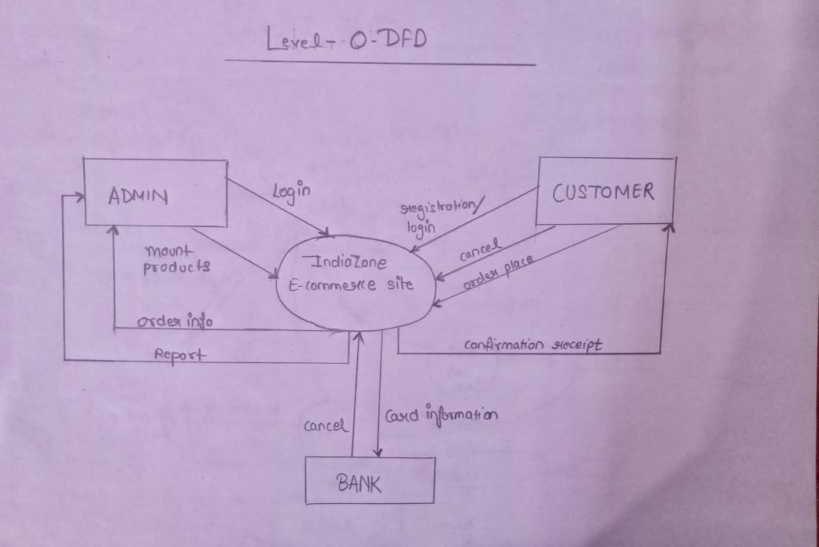

First Level DFD- E-commerce Portal

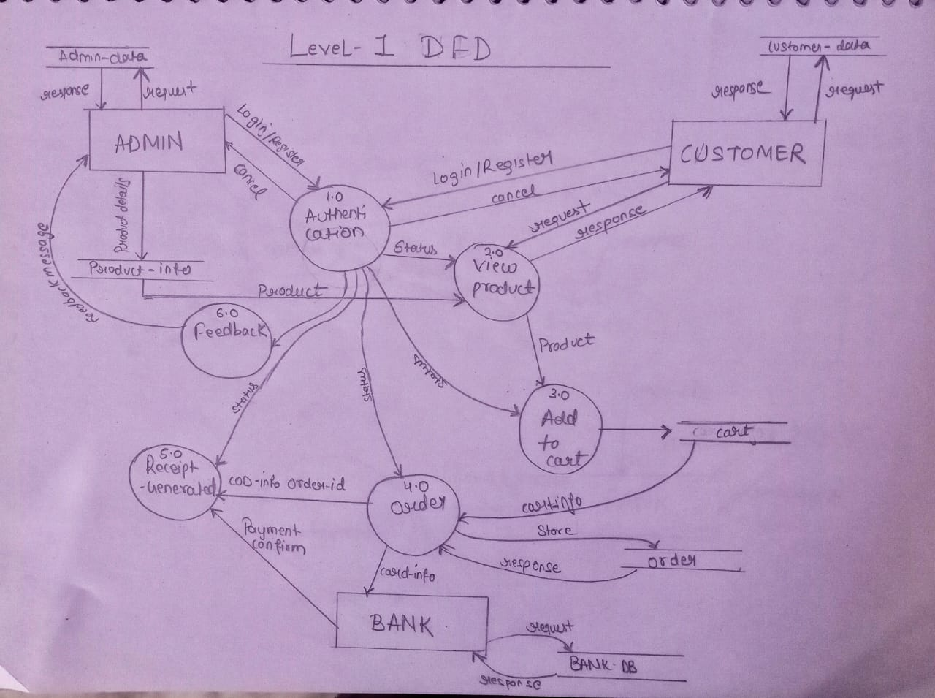

Second Level DFD- E-commerce Portal

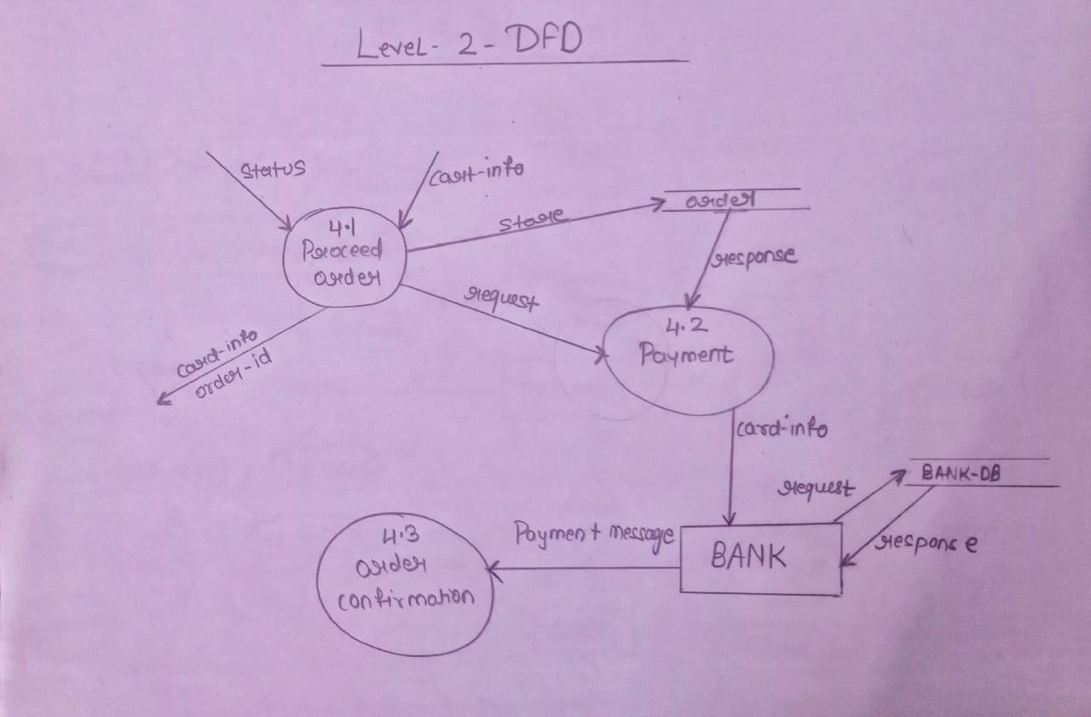

**ER-Diagram**

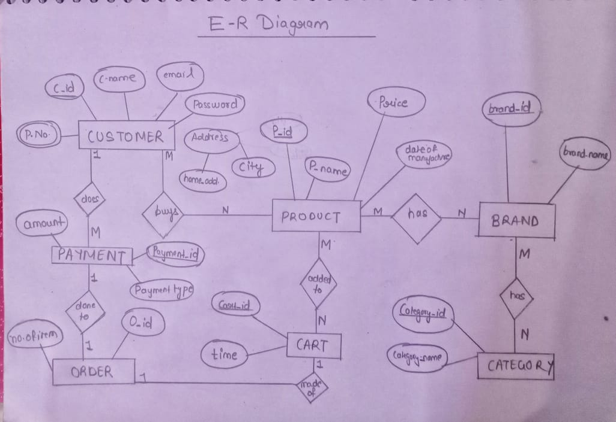

**Developer Software Specification:**

Technology Implemented : Node

Language Used : Javascript

Database : Mongodb

User Interface Design : Html,css , javascript and Bootstrap,React

Web Browser : Microsoft edge/chrome

**Developer Hardware Requirements:**

Processor : 64-bit

Operating System : Windows-10

RAM : 12-GB

**References**

* <https://alialhaddad.medium.com/build-a-e-commerce-site-using-mern-stack-step-1-introduction-80ce53888541>
* <https://www.udemy.com/course/react-node-ecommerce/>