QUORA FOR COLLEGE

(FULL STACK PROJECT – REPORT)

A Project Report submitted in partial fulfillment of the requirements for the award of the degree of

Bachelor of Technology

In

Computer Science and Engineering

Efforts By:

Kritarth Sharma (181500335)

Department of Computer Engineering and Applications



GLA University

Mathura-281406, INDIA

May, 2021

i

Department of Computer Engineering and Applications GLA University, 17 km. Stone NH#2, Mathura-Delhi Road,

Chaumuha, Mathura – 281406 U.P (India)

DECLARATION

We hereby declare that the work which is being presented in the B.Tech Project “Quora For College”, in partial fulfillment of the requirements for the award of the Bachelor of Technology in Computer Science and Engineering and submitted to the Department of Computer Engineering and Applications of GLA University, Mathura, is an authentic record of our own work .

The contents of this project report, in full or in parts, have not been submitted to any other Institute or University for the award of any degree.

ii
Department of Computer Engineering and Applications GLA University, 17 km. Stone NH#2, Mathura-Delhi Road, Chaumuha, Mathura – 281406 U.P (India)

CERTIFICATE

This is to certify that the above statements made by the candidate are correct to the best of my knowledge and belief.

_____________________

iii
ACKNOWLEDGEMENT

Presenting the ascribed project paper report in this very simple and official form, we would like to place my deep gratitude to GLA University .

He has been helping us since Day 1 in this project. He provided us with the roadmap, the basic guidelines explaining on how to work on the project. He has been conducting regular meeting to check the progress of the project and providing us with the resources related to the project. Without his help, we wouldn’t have been able to complete this project.

And at last but not the least we would like to thank our dear parents for helping us to grab this opportunity to get trained and also my colleagues who helped me find resources during this project.

Thanking You.

iv
ABSTRACT

Wikipedia is a collection of Human Knowledge whereas Quora for college is a collection of Individual Knowledge. Being on Quora for college will make you a better thinker, which will be handy in whatever else you may pursue. It's a bit like going to school, except way better.

Fortunately, many of you humans have been enlisted to provide both questions and answers as a cover, maintaining the appearance of just another innocuous website.

Just as the purpose of humanity is for the creation of the one great individual [which occurs at intervals throughout time] Quora is the quagmire from which springs ‘The Wonderful Lizard of Awes’.

Quora for college mission is to share and grow the world’s knowledge. A vast amount of the knowledge that would be valuable to many people is currently only available to a few — either locked in people’s heads, or only accessible to select groups. We want to connect the people who have knowledge to the people who need it, to bring together people with different perspectives so they can understand each other better, and to empower everyone to share their knowledge for the benefit of the rest of the world.

Quora for college is a knowledge exchange platform, which can be share by anyone who has knowledge in something. Obviously sharing knowledge is a part of wisdom. It will reach to the people who has desire to acquire knowledge.

v
 | CONTENT
Declaration |  | ii
Certificates |  | iii
Acknowledgement |  | iv
Abstract |  | v
Content |  | vi
List of Figures |  | vii
CHAPTER 1: INTRODUCTION |  | 1
1.1 | Context | 1
1.2 | Motivation | 1
1.3 | Objective | 2
1.4 | Sources | 3
CHAPTER 2: SOFTWARE REQUIREMENT ANALYSIS |  | 4
2.1 | Importance of Question | 4
2.2 | Importance of Answer | 7
2.3 | Type of Question | 8
2.4 | Quora For College As A Full stack Project | 13
CHAPTER 3: SOFTWARE DESIGN |  | 16
3.1 | Use Case Diagram | 16
3.2 | Domain Model Diagram | 17
3.3 | Data Flow Diagram | 18
 | 3.3.1 Level – 0 DFD | 18
 | 3.3.2 Level - 1 DFD | 19

vi
3.4 | Flow Chart |  | 20
CHAPTER 4: METHODOLOGY |  |  | 21
4.1 | MERN Stack |  | 21
 | 4.1.1 | MongoDB | 22
 | 4.1.2 | Express | 23
 | 4.1.3 | React | 24
 | 4.1.4 | Node Js | 25

4.2 | Software Requirement Analysis | 26
4.3 | Hardware Requirement Analysis | 27
CHAPTER 5: USER INTERFACE AND IMPLEMENTATION |  | 28
CHAPTER 6: TESTING |  | 36
6.1 | Compatibility Testing | 36
6.2 | User Testing | 36
6.3 | Unit Testing | 37
CHAPTER 7: CONCLUSION |  | 38
References |  | 39

vii
List of Figures

- Use Case Diagram

- Domain Model Diagram

- Level – 0 Dfd

- Level - 1 Dfd

- Flow Chart

- MERN Stack

- MongoDB

- Express

- React

- Node Js

- Login Screen

- Signup Option

- Login With Gmail

- Navbar Of Home Screen

- Left Sidebar Of Home Screen

- Right Sidebar Of Home Screen

- Add Question Field

- Question Added In The Feed

- Replying The Question

- Answer Added In The Feed

viii
- Date And Time When The Question And Answer Added

- Feed Up Section – I

- Feed Up Section – II

- Feed Up Section - III

ix
CHAPTER 1

INTRODUCTION

1.1 CONTEXT

This Full Stack Project “Quora for College” in the partial fulfillment of the requirements for the award of the degree of Bachelor of Technology in Computer Science and Engineering at GLA University, Mathura. This project has been completed approximately three months and has been executed in modules.

1.2 MOTIVATION

Questions are the best way to gain deeper insights and develop more innovative solutions. Children learn by asking questions. Students learn by asking questions. New recruits learn by asking questions. Innovators understand client needs by asking questions. It is the simplest and most effective way of learning. People who think that they know it all no longer ask questions – why should they? Brilliant thinkers never stop asking questions because they know that this is the best way to gain deeper insights.

The great philosophers spend their whole lives asking deep questions about the meaning of life, morality, truth and so on. We do not have to be quite so contemplative but we should nonetheless ask the deep questions about the

1
situations we face. It is the best way to get the information we need to make informed decisions and for sales people it is the single most important skill they need to succeed.

Quora for College is an engaging site that feels like duet of search engine and social media network, but its purpose is to give you the answers and allow you to answer the questions asked by others of subjects in which you’re knowledgeable. In short, Quora for college function is quite simple, you can post questions to get answers or provide answers to questions asked by others.

1.3 OBJECTIVE

The Internet is a maelstrom of information, most of it real, and much of it false. Efforts such as Wikipedia have shown that collectively, Internet users possess much knowledge on a wide range of subjects, knowledge that can be collated and curate to form valuable information repositories. In the last few years, community question-and-answer (Q&A) sites have provided a new way for users to crowd source the search for specific detailed information, much of which involves getting first-hand answers of specific questions from domain experts.

Quora for College is a question and answer site with a fully integrated social network connecting its users. In this section, we introduce Quora for College, using Stack Overflow as a basis for comparison. Quora for College is a question and answer site where users can ask and answer questions.
2
1.4 SOURCES

The sources of our project (including all the project work, documentations and

presentations) will are available at the following link:

https://github.com/kritarth2121/Quora-clone

And this is the live link of our website:

https://kritarth-quora.netlify.app/

3
CHAPTER 2

SOFTWARE REQUIREMENT ANALYSIS

2.1 IMPORTANCE OF QUESTION

People will ask questions when they gather information through sources of media like newspapers and the internet.

- Discover something new. Often, when you ask questions, whether they’re related to something within the company or not, you discover something new.

This may not automatically lead you in a new direction but it’s possible that, in the future, it will benefit you in some way.

- Put things together. Often, by asking questions that are unrelated to the topic, you will discover new ideas and perspectives you had never considered. For example, when it comes to selling a product, it might benefit you to know more about the mindset of your customer rather than just what steps you can take to increase sales.

- Remember things. Asking questions is likely to jog your memory. You might remember something that helped you in the past that you had forgotten. Or you might remember someone else who had a similar experience and how they dealt with it.

4
  - Resolve issues. You can also resolve issues by asking questions that seem to have nothing to do with the topic at hand. If two people are arguing about something, it might help to know more about them and where they’re coming from before the issue can be resolved.

  - Understand people better. Most people love to answer questions about themselves. We’re all hungry to be understood, not just because we want to get our way but because we want to feel important. So instead of talking at a person, it’s important to talk with them.

- Fixing things that are broken: Some things wear out and break over time, others are flawed from day-1. Personal and business environments are full of things, activities, interactions and processes that are broken or not operating in the way they are desired to work. Question asking skill gives us a mechanism for identifying these things, figuring out why they are broken and determining a course of action to fix them.

- Addressing risk: Humans have learned to identify trends and developed an awareness of cause-and-effect relationships in their environment. These skills not only enable us to fix things when they break but also anticipate what may happen in the future (based on past-experience and current events). Question asking skill can be applied to the anticipated future events and used to enable

5
action in the present to influence the likelihood of the event occurring and/or alter the impact if the event does occur.

- Improving performance: Individuals and organizations do not exist in isolation in the environment. There is a complex and ever-changing web of relationships that exist and as a result, the actions of one person will often have either a direct impact on others or an indirect impact by changing the environment dynamics. These interdependencies enable humans to work together to solve more complex problems but they also create a force that requires everyone to continuously improve performance to adapt to improvements by others. Problem-solving helps us understand relationships and implement the changes and improvements needed to compete and survive in a continually changing environment.

- Seizing opportunity: Question asking skill isn’t just about responding to (and fixing) the environment that exists today. It is also about innovating, creating new things and changing the environment to be more desirable. Problem-solving enables us to identify and exploit opportunities in the environment and exert (some level of) control over the future.

Question asking skill and the problem-solving process are a critical part of daily life both as individuals and organizations. Developing and refining these skills through training, practice and learning can provide the ability to solve

6
problems more effectively and over time address problems with a greater degree of complexity and difficulty.

2.2 IMPORTANCE OF ANSWER

Good teachers ask questions all the time and are effective both at getting students to think about those questions and at getting them to offer possible answers, in public. They also elicit questions from students and answer them in ways that prompt more reflection and more questions.

Questions turn one-way communication into a dialog that, at least some of the time, engages many of the students in the room. The following paragraphs give some of the benefits of asking and answering questions.
- Improving attention

Trying to answer questions, or formulating and asking questions, provides a break for students from passive attention to the lecturer speaking. It raises their level of attention and performance and this lasts for a while afterwards.
- Encouraging active learning

If students are to understand new material they need to actively engage with it in some way – just listening is unlikely to succeed. Asking and answering questions, and getting into a dialog with the teacher, is a very effective way to make sense of material.
- Checking on learning

7
It is difficult to tell if what you are saying has been understood. Asking questions can clarify whether you need to spend more time on certain topics. Student questions also reveal misunderstandings.
- Fostering reflection

It is not just the student who answers or asks a question who is thinking – most of the students in the room will be empathizing and thinking at the same time. When questioning is going on students will be having some of their own private questions answered. They will also be asking their own questions in their mind, and reflecting.
- Expanding explanations

When students ask you a question it is an opportunity to provide a more elaborate explanation than might have been possible when you were lecturing. You can go back to basics or pursue more advanced issues, as appropriate.
- Building rapport

As we saw earlier, teachers who have rapport with their students, and who interact with them, are the ones who produce the best student learning performance. Engaging in question-and-answer routines builds rapport – if handled sensitively.

2.3 TYPE OF QUESTION

There is various type of question being asked some of them are mentioned below:

- The Dichotomous Question

8
The dichotomous question is generally a "Yes/No" close-ended question and used for basic validation. In the below example, a yes or no question is used to understand if the person has ever used your online store to make a purchase. The respondents who answer "Yes" and "No" can be bunched together into groups. Then, you can ask different questions to both groups.
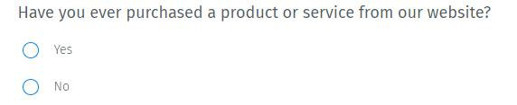

- Multiple Choice Questions

Multiple choice questions are a question type in which respondents have to select one (single select multiple choice question) or many (multi-select multiple choice question) responses from a given list of options. The multiple-choice question consists of an incomplete stem (question), right answer or answers, incorrect answers, close alternatives, and distracters. However, the questions are designed as it best matches the expected outcome. Typically, single select questions are denoted by radio buttons, and multi-select questions are denoted by check-boxes. An example of a multi-select multiple-choice question is a bank that would like to launch a new credit card and wants to understand payment merchants' usage:

9
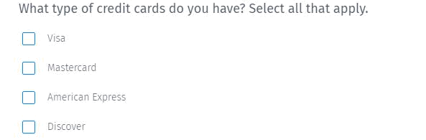

- Rank Order Scaling Question

The rank order question type allows the respondent to rank preferences in a question in the order of choice. Use this question type to understand the weight age that is offered by respondents to each option. The other type of rank order question is a drag and drop question type, where the respondent can rearrange options based on importance. An example of a rank order question is a sports goods store looking to understand from respondents their choice of sports and the order they would place them.


- Text Slider Question

10
A text slider question is a rating scale question type that uses an interactive slider in answer to select the most appropriate option. The options scale is well-defined and on the same continuum. Rating scales are used to measure the direction and intensity of attitudes. You can also use a text slider where either end of the option has an anchor.
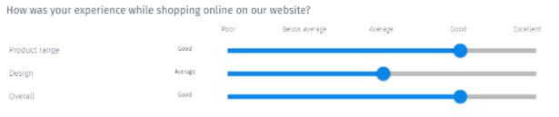

- Comment Box Open Ended Question

The comment box open-ended question is used to collect any feedback or suggestions that could be very long. They are open text format such that the respondent can answer based on their complete knowledge, feelings, and understanding. Hence, this question type is used when the organization conducting the study would like to justify a selection in a prior question or when extensive feedback is required from the respondent.


- Star Rating Question

11
The star rating question is a type of rating question that uses an odd number of stars to rank attributes or display feelings and emotions. An odd number matrix type question is used to account for a middle or neutral point in a rating survey. Higher the number of stars, higher is the agreement with a statement. This question type allows for a rating on multiple rows to be collected for one single topic. For example, if a retail brand wants to gather feedback about their brand, they can use a star rating question in the following format:
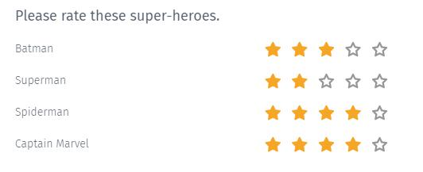

- Push to Social Questions

Push to social question type allows you to share reviews or feedback to social media sites like Facebook, Twitter, and Google +. It is used to create a positive vibe about your brand on social media. Alternatively, you can address customer satisfaction issues and negative feedback before they go out on social media.

12


- Visual Analog Question

The visual analog question is a close -ended question that can be administered in two ways - a Thumbs Up/Thumbs Down question type and an odd-point smiley question.

The thumbs up and thumbs down question is a two-point question where respondents have to indicate their feelings or opinions with either a positive or negative answer. An example of this question type is a respondent's emotion towards their experience at Starbucks.
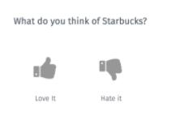

2.4 QUORA FOR COLLEGE AS A FULLSTACK PROJECT

13
We have made this web based application Quora for college using the MERN stack i.e. MongoDB , Express Js ,React js and Node JS. We have also used some part of Shell. Internet completely changes our lives. When we want any information and answers to our questions, what do you do? Just ask Google and hope there’s a direct answer? Filter search results to find the relevant answer? And when you find one, how you get to know that it’s the correct one? If find yourself in this difficult situation, which is common one. At this situation, consider looking into Quora for College. React is a declarative, efficient, and flexible JavaScript library for building user interfaces. ReactJS is an open-source, component-based front end library responsible only for the view layer of the application. It is maintained by Facebook. Bootstrap is a free and open-source tool collection for creating responsive websites and web applications. It is the most popular HTML, CSS, and JavaScript framework for developing responsive, mobile-first web sites. Node.js is an open source and cross-platform runtime environment for executing JavaScript code outside of a browser. You need to remember that NodeJS is not a framework and it’s not a programming language. Most of the people are confused and understand it’s a framework or a programming language. We often use Node.js for building back-end services like APIs like Web App or Mobile App. It’s used in production by large companies such as Paypal, Uber, Netflix, and Wallmart and so on. MongoDB, the most popular NoSQL database, is an open source document-oriented database. The term ‘NoSQL’ means ‘non-relational’. It means that

14
MongoDB isn’t based on the table-like relational database structure but provides an altogether different mechanism for storage and retrieval of data. Quora For College is an engaging site that feels like duet of search engine and social media network, but its purpose is to give you the answers and allow you to answer the questions asked by others of subjects in which you’re knowledgeable. In short, Quora for college function is quite simple, you can post questions to get answers or provide answers to questions asked by others.

15
CHAPTER 3

SOFTWARE DESIGN

3.1 USE CASE DIAGRAM
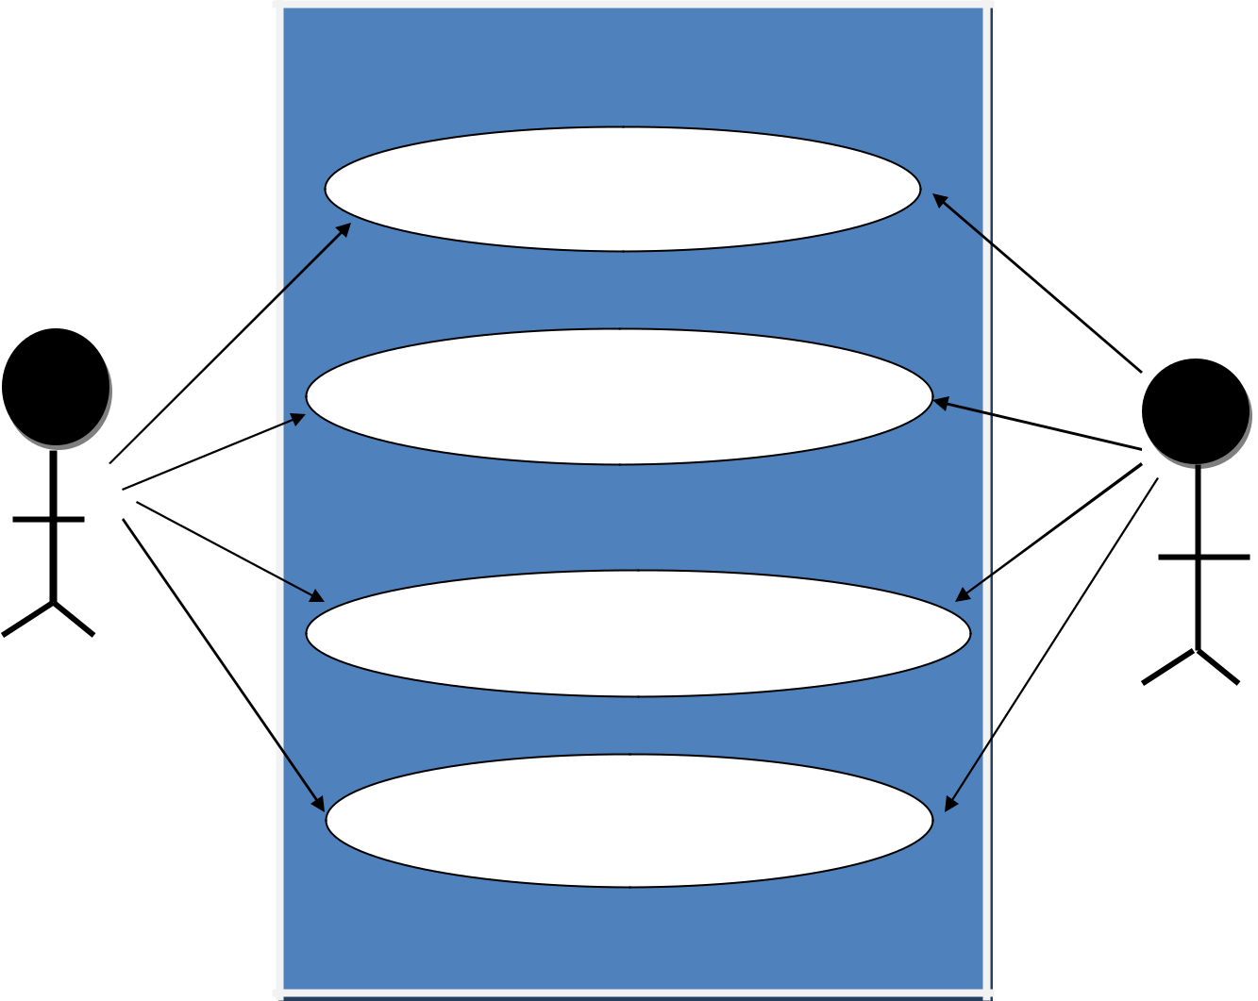

LOGIN/ SIGNUP

ADD QUESTION

REPLY TO QUESTION
USER

FEED UP

DBA

16

3.2 DOMAIN MODEL DIAGRAM
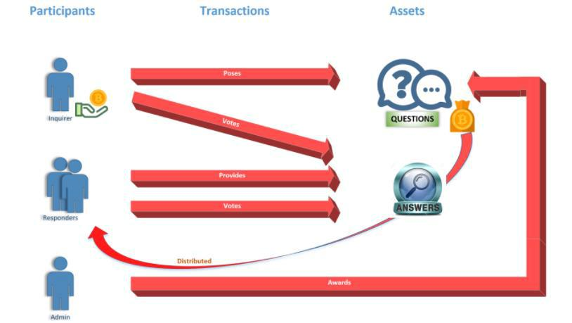

17

3.3 DATA FLOW DIAGRAM

3.3.1 Level – 0 DFD
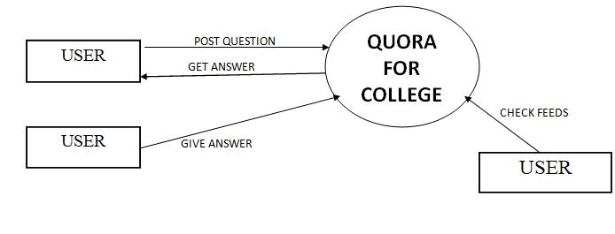

18

3.3.2 Level - 1 DFD

USER

Registered | NO | Signup
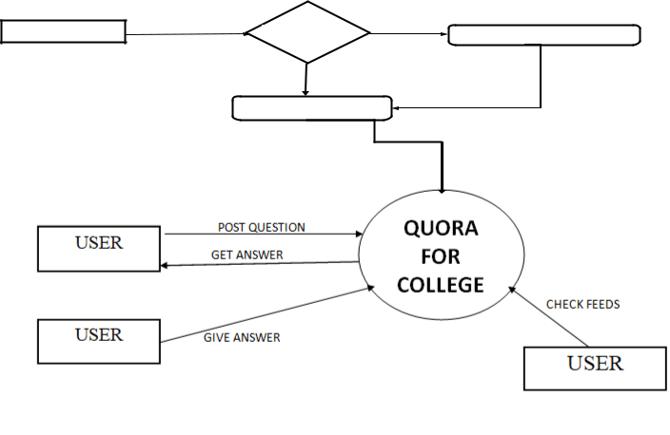

Login

19

3.4 FLOW CHART
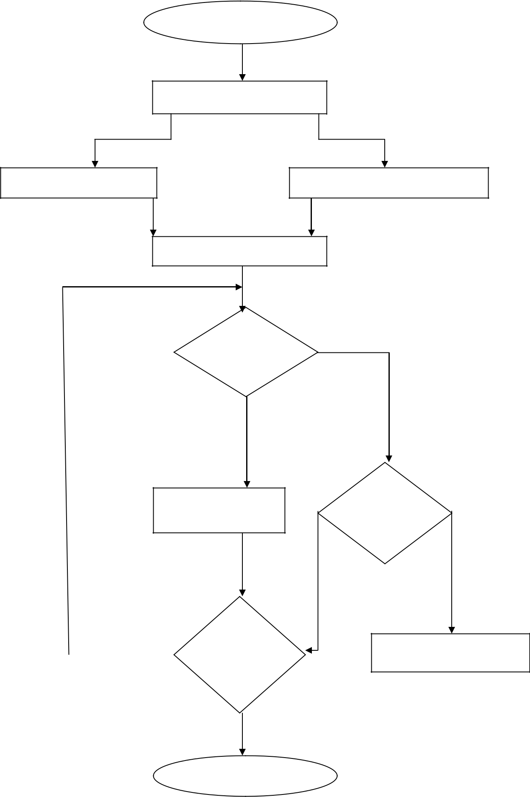
START

LOGIN

LOGIN WITH GMAIL

LOGIN WITH FACEABOOK

HOME SCREEN

ASK _{NO}
QUESTION

YES

ASK QUESTION
SCREEN

YES | WANT TO
YES | DO ANY
 | THING

NO

STOP

WANT
TO

ANSWER

YES

NO

REPLY TO QUESTION

20

CHAPTER 4

METHODOLOGY

4.1 MERN STACK

We have used MERN Stack technology for our project: MERN Stack is a JavaScript Stack that is used for easier and faster deployment of full-stack web applications. MERN Stack comprises of 4 technologies namely: MongoDB, Express, React and Node.js. It is designed to make the development process smoother and easier. Each of these 4 powerful technologies provides an end to-end framework for the developers to work in and each of these technologies play a big part in the development of web applications.


21
- MongoDB:

MongoDB is an open-source NoSQL database under the document database category, created in 2007 in the U.S by Dwight Merriman, Eliot Horowitz and Kevin Ryan. In MongoDB data is stored in a binary JSON format, commonly referred to as BSON. One entry in the database is consists of a single JSON object called a document. The database contains multiple groupings of documents called collections. JSON, or JavaScript Object Notation is a format commonly used with browsers, which makes MongoDB an excellent fit for storing data for web applications, since the same JSON data can be transported between the browser and the database without having to be converted into another format between them, as is the case with SQL. Although these conversions are made easier by ORM tools, some extra operations are nonetheless required from the software.


22
- Express:

Express.js was originally created and initially released in 2010 by TJ Holowaychuk, an open source mass-contributor and guru. In June 2014, the ownership of the Github repository for Express.js was sold by Holowaychuk to Strong Loop. Express.js is an unopinionated open source web server framework written purely in JavaScript, designed specifically to be used with Node.js. Due to its reliability and widespread use Express has become the de facto standard server software for Node.js Express in relation to Node.js can be considered analogous to what Ruby on Rails is to Ruby. Express is optimized for performance and is minimal by nature, placing only a thin layer on top of Node.js base level web features. Due to its lightweight design and standardized status, Express acts as the foundation for several other server-side JavaScript frameworks that incorporate it such as Feathers, Keystones, Kraken and Sails, which are more tailored to specific types of applications as opposed to Express, which only provides a robust implementation of more general server-side functionalities such as routing, HTTP caching and view templating.


23
- React :

React.js is a JavaScript library maintained by Facebook designed for building user interfaces for web services. React was originally created by a Facebook employee called Jordan Walke and was first used inside Facebook in 2011 when it was used in the design of the Facebook app’s newsfeed. According to Walke, the framework was inspired by and started out as a JavaScript port of XHP, an augmentation of PHP also developed at Facebook aimed at creating reusable HTML components for browser applications. XHP, however, still suffered from being forced into many roundtrips to the server during application use in regular PHP fashion [53]. React.js emerged as a solution to the problem, delivering the application components in an initial JavaScript bundle and then efficiently managing renders to the DOM, allowing for easily reusable and customizable HTML views.


24
- Node js:

Node.js is an open source platform that utilizes Google Chrome’s JavaScript runtime V8 Engine. Node.js can be characterized as being to JavaScript what the JRE is 8 to java. Node.js compiles and executes JavaScript code inside of a VM (Virtual Machine) and thereby enables JavaScript code to be run on the server side. This makes JavaScript a viable alternative to other server-side languages like PHP, ASP or Java, and most importantly enables the use of JavaScript every layer of the web stack – server, transportation format (JSON), and the client. Node.js comes with an NGINX-like base library of modules related to the most common requirements such as file management, HTTP, SSL, DNS, compression and cryptography. The basic modules are aimed at making the Node.js process into a functional web server in only a few lines of code, but Node.js is also highly customizable through the Node Package Manager, also known as “npm”, which enables Node.js users to install packages from among over 600 000 (and growing open-source blocks of code to suit their purposes.
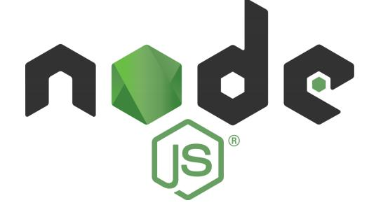

25
4.2 Software Requirement Analysis

4.2.1 Visual Studio Code:

Visual Studio Code is a free source-code editor made by Microsoft for Windows, Linux and macOS. Features include support for debugging, syntax highlighting, intelligent code completion, snippets, code refactoring, and embedded Git. Users can change the theme, keyboard shortcuts, preferences, and install extensions that add additional functionality. Microsoft has released Visual Studio Code's source code on the VSCode repository of GitHub.com, under the permissive MIT License, while the compiled binaries are freeware. In the Stack Overflow 2019 Developer Survey, Visual Studio Code was ranked the most popular developer environment tool, with 50.7% of 87,317 respondents reporting that they use it.

4.2.2 Git and Github:

Git is an open-source, version control tool created in 2005 by developers working on the Linux operating system; Github is a company founded in 2008 that makes tools which integrate with git. You do not need Github to use git, but you cannot use Github without using git. There are many other alternatives to Github, such as GitLab, BitBucket, and “host-your-own” solutions such as gogs and gittea. All of these are referred to in git-speak as “remotes”, and all are completely optional. You 10 do not need to use a remote to use git, but it will make sharing your code with others easier.

4.2.3 Web Browser:

26
A web browser (commonly referred to as a browser) is a software application for retrieving, presenting, and traversing information resources on the World Wide Web. An information resource is identified by a Uniform Resource Identifier (URI/URL) and may be a web page, image, video or other piece of content. Hyperlinks present in resources enable users easily to navigate their browsers to related resources. Although browsers are primarily intended to use the World Wide Web, they can also be used to access information provided by web servers in private networks or files in file systems.

4.3 Hardware Requirement Analysis:

- Processor: Intel CORE i3

- RAM: 4GB

- Cache Memory: 512 KB

- Monitor: 14-inch Color Monitor

- Keyboard: 108 Keys

- Mouse: Optical Mouse

- Hard Disk: 160 GB

27
CHAPTER 4

USER INTERFACE AND IMPLEMENTATION

4.1 LOGIN SCREEN
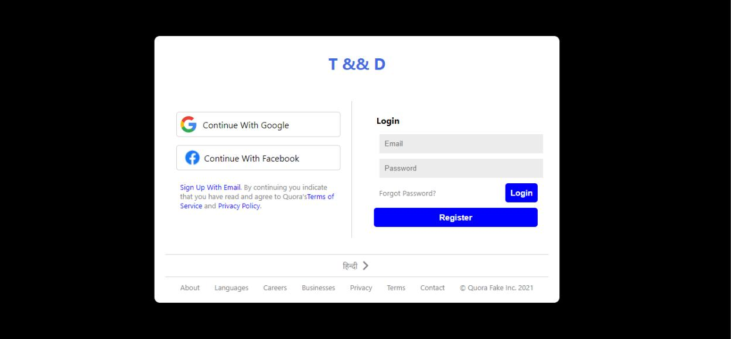

4.2 SIGNUP OPTION
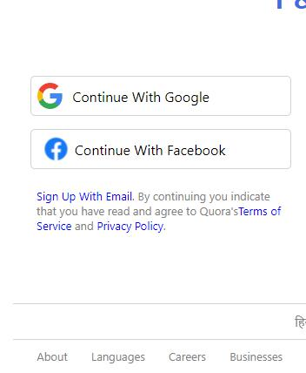

28
4.3 LOGIN WITH GMAIL
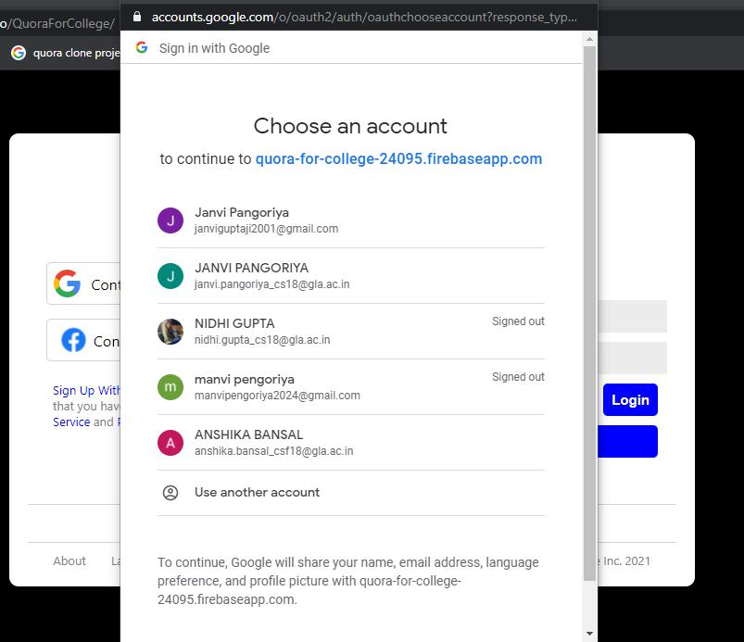

29
4.4 NAVBAR OF HOME SCREEN

4.5 LEFT SIDEBAR OF HOME SCREEN
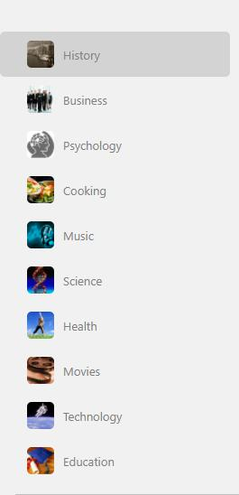

30
4.6 RIGHT SIDEBAR OF HOME SCREEN
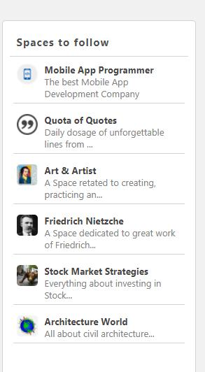

31
4.7 ADD QUESTION FIELD
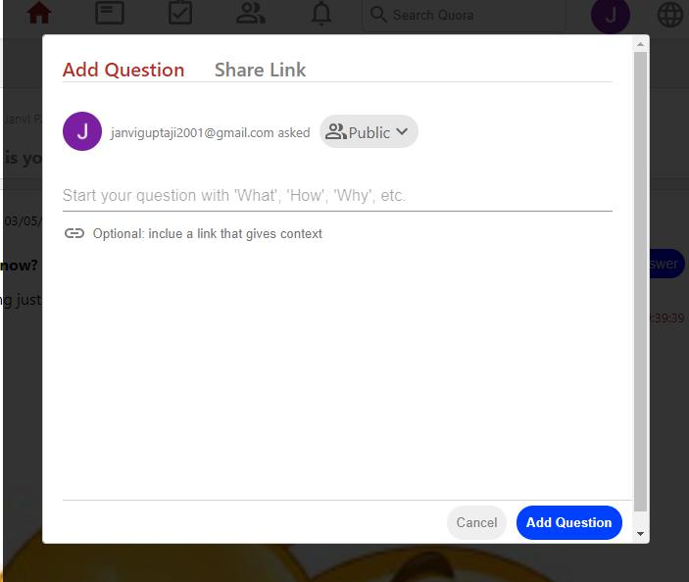

4.8 QUESTION ADDED IN THE FEED


32
4.9 REPLYING THE QUESTION
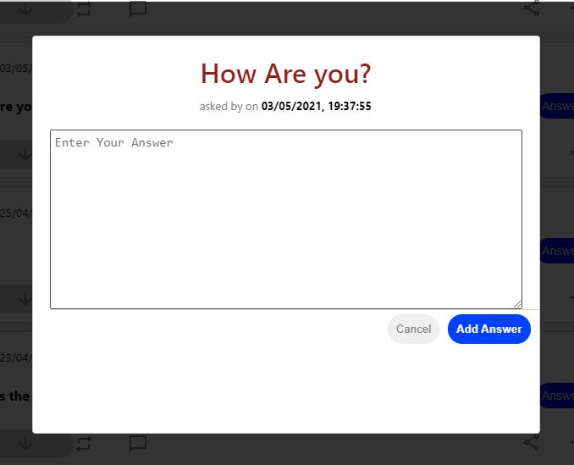

4.10 ANSWER ADDED IN THE FEED
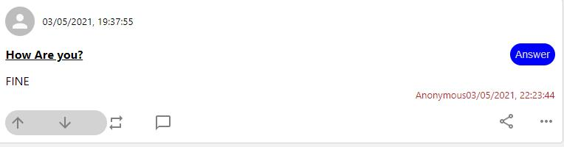

33
4.11 DATE AND TIME WHEN THE QUESTION AND ANSWER ADDED
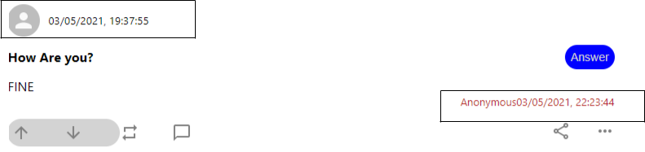

4.12 FEED UP SECTION - I
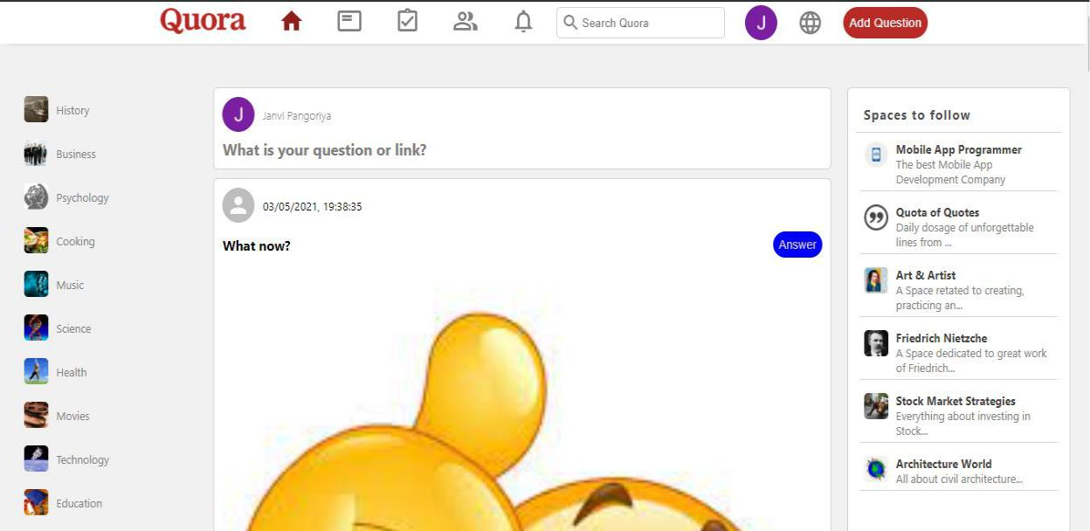

34
4.13 FEED UP SECTION - II
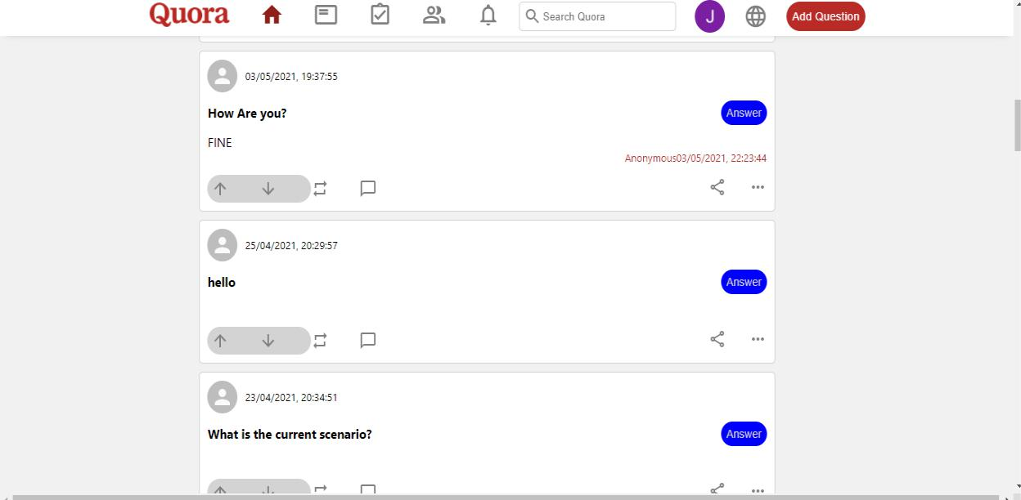

4.14 FEED UP SECTION - III
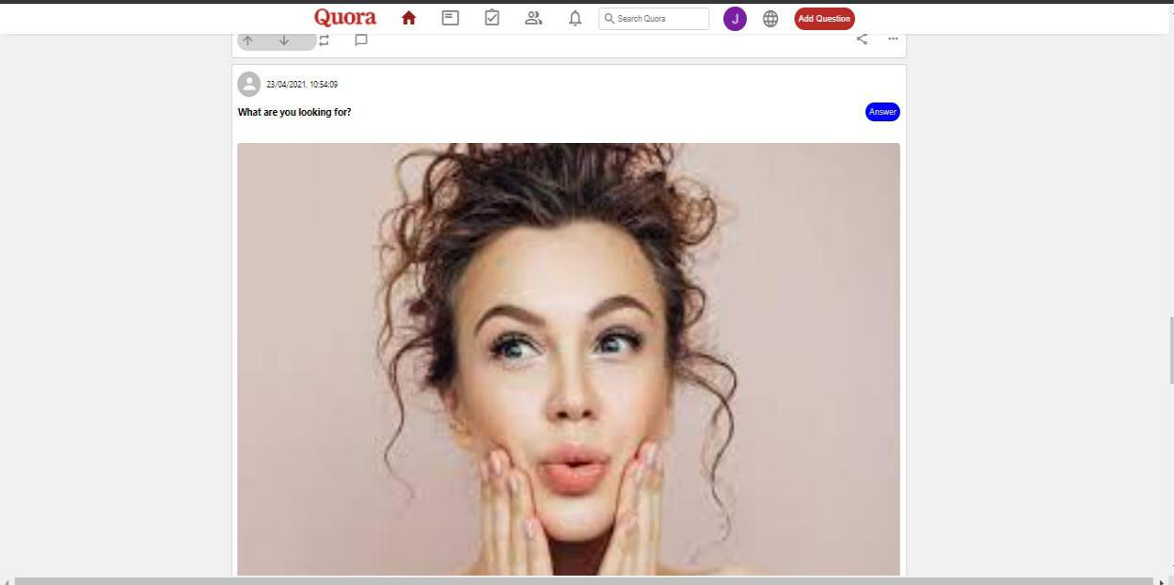

35
CHAPTER 5

TESTING

5.1 Compatibility Testing

This application was tested and used on different devices like LG G3, Google Nexus 4. The application worked fine and is stable. The application worked fine both in landscape and portrait modes and there isn't any problem with the resolution or compatibility.

5.2 User Testing

The present application was tested by my friends who are using different mobile and laptop devices and that seemed to be working fine and they were satisfied with the performance and responsiveness of the application and how the website worked.

5.3 Unit Testing

Test Case | Expected Result | Pass/ Fail
Register user Page | Should register the new user | Pass
Login page | If user is already register then user | Pass
 | should able to login with all valid
 | credentials else user should signup
 |  | 36

Add question | Should add the question in the feed | Pass
Answer Question | Should answer the pre existing | Pass
 | question
Feed up | Should show feeds | Pass
Server connection | Server should star | Pass
Database connection | Database should connect | Pass

37
CHAPTER 5

CONCLUSION

In Today’s world, gaining information has become necessity. There are various sources through which you can collect your Information. Since last decade, one new approach i.e. e-Learning is developing very swiftly. People search their questions online through web and they get their answer accordingly. Quora for college is one such example of the same.

With the help of Quora for college, you can serve people with a question and answer community where they can post unlimited questions and get it answered by others.

The purpose of Quora for College is to ask and answer questions. It is NOT simply a social media platform, and don't use it that way. You can benefit by answering and asking lots of questions. The difference between Google and Quora for College is that an actual person can explain things to you.

Quora For College is an engaging site that feels like duet of search engine and social media network, but its purpose is to give you the answers and allow you to answer the questions asked by others of subjects in which you’re knowledgeable. In short, Quora for college function is quite simple, you can post questions to get answers or provide answers to questions asked by others.

38
REFERENCES

- https://morioh.com/p/442bc4929465

- https://www.youtube.com/channel/UCuWWt9HYtUp4VTcQvBzq12Q

- https://reactjs.org/

- https://www.mongodb.com/

39

