Aim:

Design a system for a red colored magical heart pendant that blinks 60 times a minute and stops blinking and turns blue during night.

Apparatus:

Connecting Wires, Resistances, Arduino, RGB LED,LDR.

Circuit Diagram:

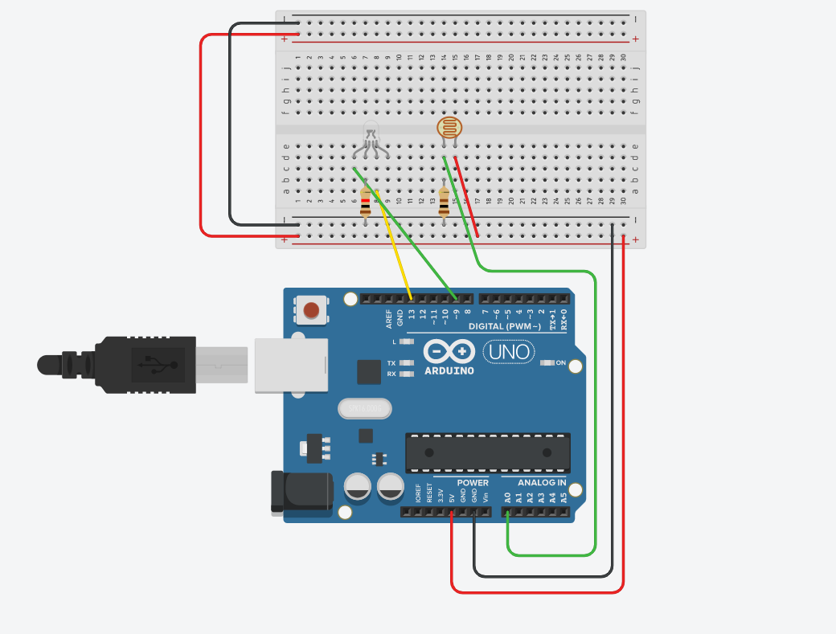


Theory :

LED is a light emmiting diode that gives light as a output. It is a semiconductor. They require very less power to get lighted and work very efficiently.

Arduino:
An Arduino UNO is a device that is equipped with digital and analog input/output slots. It has 14 Input/Output slots, 5 Analog slots and can work between 7 to 20 volts.It has 3 ground pins. It works when user inputs code into arduino.

Concept Used :

Two legs of RGB LED is inserted into the input/output pin of the arduino. The cathode leg is connected to the resistance and the resistance is connected to the ground slot of the arduino .One leg of LDR is connected to 5V and other to the analog pin.

Observation :
Blue light is observed in dark and red in lighted conditions.
Learning Outcomes:

- Learned how to make a LED blink.
- Learned how to use LDR in different brightness.

Problems :

- Connections of LED may not be connected properly.
- LED's may not be working.
- Code may be wrong
- Arduino is not working.

Troubleshooting:

- All connections should be checked properly.
- Arduino should be working.
- LED's that are in working conditions should be used.
- Right code must be used.

Precaution:

- Don't plug in an LED without a current limiting resistor.
- Don't supply more than 9V unless proper knowledge.
- Check all the connections.

