Assignment 6 – Procedures and Functions

Validation:

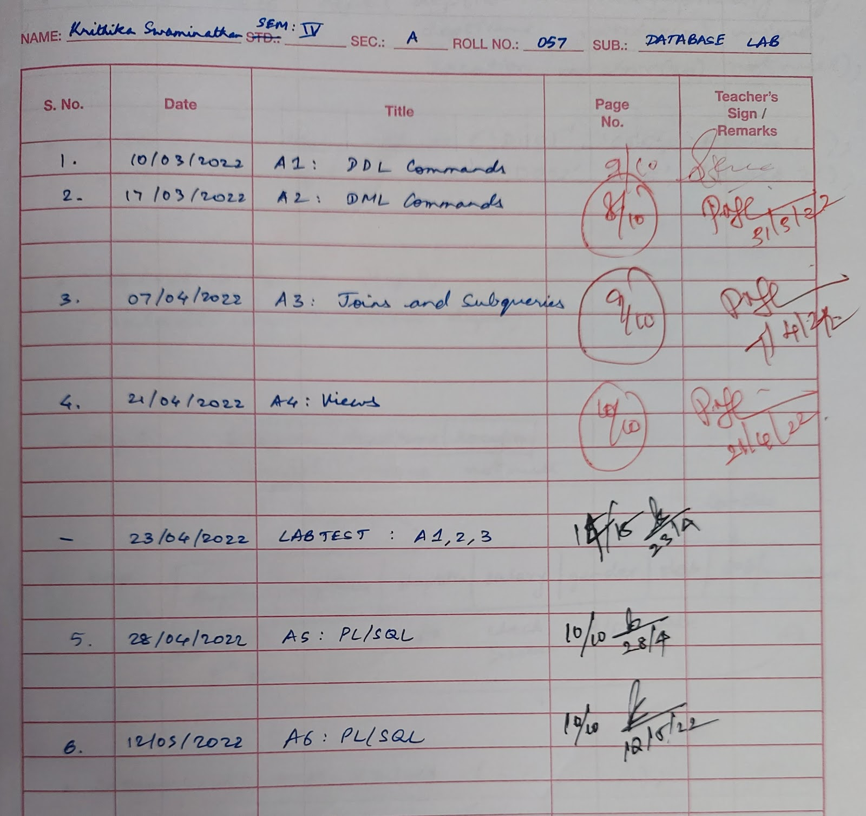

Schema diagram:

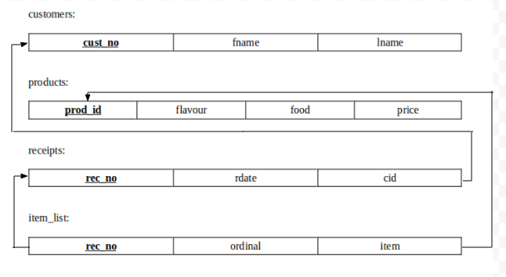

Data file:

SQL> @C:/Krithika/DBL/a4data.sql;
SQL> REM Assignment 3
SQL> REM Population of Bakery Database

SQL> drop table item_list;
Table dropped.

SQL> drop table receipts;
Table dropped.

SQL> drop table products;
Table dropped.

SQL> drop table customers;
Table dropped.

SQL>
SQL> create table customers(
2 cust_no number(2) constraint c_pk primary key,
3 lname varchar2(20),
4 fname varchar2(20)
5 );

Table created.

SQL>
SQL> insert into customers values(1, 'LOGAN', 'JULIET');
1 row created.
.
.
.
SQL> insert into customers values(21, 'JOHN', 'DAVID');
1 row created.

SQL> create table products(
2 prod_id varchar2(20) constraint prod_pk primary key,
3 flavour varchar2(20),
4 food varchar2(20),
5 price number
6 );

Table created.

SQL>
SQL> insert into products values('20-BC-C-10','Chocolate','Cake',8.95);
1 row created.
.
.
.
SQL> insert into products values('51-BLU','Blueberry','Danish',1.15);
1 row created.

SQL> create table receipts(
2 rec_no number(5) constraint rec_pk primary key,
3 rdate date,
4 cid number(2) constraint rec_fk references customers(cust_no)
5 );

Table created.

SQL>
SQL> INSERT INTO Receipts values(18129, '28-Oct-2007', 15);
1 row created.
.
.
.
SQL> INSERT INTO Receipts values(34378, '23-Oct-2007', 6);
1 row created.

SQL> create table item_list(
2 rec_no number(5) constraint it_fk1 references receipts(rec_no),
3 ordinal number(2),
4 item varchar2(20) constraint it_fk2 references products(prod_id),
5 constraint item_pk primary key(rec_no,ordinal)
6 );

Table created.

SQL>
SQL> insert into item_list values(18129, 1, '70-TU');
1 row created.
.
.
.
SQL> insert into item_list values(34378, 2, '45-VA');
1 row created.

SQL>
SQL> REM *** End of database population ***
SQL>
SQL>
SQL> REM *** Checking tables ***
SQL>
SQL> select * from customers;

CUST_NO LNAME FNAME
---------- -------------------- --------------------
1 LOGAN JULIET
2 ARZT TERRELL
3 ESPOSITA TRAVIS
4 ENGLEY SIXTA
5 DUNLOW OSVALDO
6 SLINGLAND JOSETTE
7 TOUSSAND SHARRON
8 HELING RUPERT
9 HAFFERKAMP CUC
10 DUKELOW CORETTA
11 STADICK MIGDALIA

CUST_NO LNAME FNAME
---------- -------------------- --------------------
12 MCMAHAN MELLIE
13 ARNN KIP
14 SOPKO RAYFORD
15 CALLENDAR DAVID
16 CRUZEN ARIANE
17 MESDAQ CHARLENE
18 DOMKOWSKI ALMETA
19 STENZ NATACHA
20 ZEME STEPHEN
21 JOHN DAVID

21 rows selected.

SQL> select * from products;

PROD_ID FLAVOUR FOOD PRICE
-------------------- -------------------- -------------------- ----------
20-BC-C-10 Chocolate Cake 8.95
20-BC-L-10 Lemon Cake 8.95
20-CA-7.5 Casino Cake 15.95
24-8x10 Opera Cake 15.95
25-STR-9 Strawberry Cake 11.95
26-8x10 Truffle Cake 15.95
45-CH Chocolate Eclair 3.25
45-CO Coffee Eclair 3.5
45-VA Vanilla Eclair 3.25
46-11 Napoleon Cake 13.49
90-ALM-I Almond Tart 3.75
...
...
...
PROD_ID FLAVOUR FOOD PRICE
-------------------- -------------------- -------------------- ----------
50-CHS Cheese Croissant 1.75
50-CH Chocolate Croissant 1.75
51-APR Apricot Danish 1.15
51-APP Apple Danish 1.15
51-ATW Almond Twist 1.15
51-BC Almond Bear Claw 1.95
51-BLU Blueberry Danish 1.15

40 rows selected.

SQL> select * from receipts;

REC_NO RDATE CID
---------- --------- ----------
18129 28-OCT-07 15
51991 17-OCT-07 14
83085 12-OCT-07 7
70723 28-OCT-07 20
13355 19-OCT-07 7
52761 27-OCT-07 8
99002 13-OCT-07 20
58770 22-OCT-07 18
84665 10-OCT-07 6
55944 16-OCT-07 19
42166 14-OCT-07 8
...
...
...

REC_NO RDATE CID
---------- --------- ----------
46674 29-OCT-07 15
67946 18-OCT-07 7
31233 20-OCT-07 13
15904 06-OCT-07 13
17488 20-OCT-07 6
97097 23-OCT-07 9
50512 27-OCT-07 8
11548 21-OCT-07 13
29908 14-OCT-07 13
20127 07-OCT-07 15
41963 29-OCT-07 8

REC_NO RDATE CID
---------- --------- ----------
16532 21-OCT-07 4
34378 23-OCT-07 6

200 rows selected.

SQL> select * from item_list;

REC_NO ORDINAL ITEM
---------- ---------- --------------------
18129 1 70-TU
51991 1 90-APIE-10
51991 2 90-CH-PF
51991 3 90-APP-11
51991 4 26-8x10
83085 1 25-STR-9
83085 2 24-8x10
83085 3 90-APR-PF
83085 4 51-ATW
83085 5 26-8x10
70723 1 45-CO

...
...
...

REC_NO ORDINAL ITEM
---------- ---------- --------------------
41963 2 90-CH-PF
16532 1 50-APP
16532 2 70-MAR
16532 3 70-TU
16532 4 24-8x10
34378 1 90-CHR-11
34378 2 45-VA

557 rows selected.

SQL>
SQL> REM ******************** END OF DATA FILE ************************

Script file:

SQL> @z:/a6plsql.sql;
SQL> ﻿REM Assignment 6
SQL>
SQL> REM --------------------------------------------------------------------------
> REM *** ASSIGNMENT QUESTIONS ***
SQL> REM --------------------------------------------------------------------------
> REM Consider the schema used in Assignment 3.
SQL>
SQL>
SQL> REM **_____Write a PL/SQL stored procedure for the following:_____**
SQL>
SQL> REM 1. For the given receipt number, calculate the Discount as follows:
SQL> REM For total amount > $10 and total amount < $25: Discount=5%
SQL> REM For total amount > $25 and total amount < $50: Discount=10%
SQL> REM For total amount > $50: Discount=20%
SQL> REM Calculate the amount (after the discount) and update the same in Receipts table.
SQL> REM Print the receipt as shown below:
SQL> REM ************************************************************
SQL> REM Receipt Number:13355
SQL> REM Customer Name: TOUSSAND SHARRON
SQL> REM Receipt Date :19Oct2007
SQL> REM ************************************************************
SQL> REM Sno Flavor Food Price
SQL> REM 1. Opera Cake 15.95
SQL> REM 2. Lemon Cookie 0.79
SQL> REM 3. Napoleon Cake 13.49
SQL> REM
SQL> REM Total = $ 30.23
SQL> REM Discount(10%) :$ 3.02
SQL> REM
SQL> REM Amount to be paid :$ 27.21
SQL> REM ************************************************************
SQL> REM Great Offers! Discount up to 25% on DIWALI Festival Day...
SQL> REM ************************************************************
SQL>
SQL>
SQL> create or replace procedure discount
2 (amt in products.price%type, dis out products.price%type, dispct out products.price%type, sp out products.price%type) is
3 begin
4 dis := 0;
5 dispct := 0;
6 if amt>10 and amt<25 then
7 dis := (5*amt)/100.00;
8 dispct := 5;
9 elsif amt>25 and amt<50 then
10 dis := (10*amt)/100.00;
11 dispct := 10;
12 elsif amt>50 then
13 dis := (20*amt)/100.00;
14 dispct := 20;
15 end if;
16 sp := amt - dis;
17 end;
18 /

Procedure created.

SQL>
SQL> declare
2 rid receipts.rec_no%type;
3 billdate receipts.rdate%type;
4 custfname customers.fname%type;
5 custlname customers.lname%type;
6 rtotal products.price%type;
7 d products.price%type;
8 dp products.price%type;
9 finalamt products.price%type;
10 cursor c1 is select flavour, food, price
11 from products join item_list on (prod_id = item)
12 where rec_no = rid;
13 countnum integer;
14 itemfood products.food%type;
15 itemfl products.flavour%type;
16 itemprice products.price%type;
17
18 begin
19
20 rid := &receipt;
21
22 select rdate, fname, lname, count(item), sum(price) as total
23 into billdate, custfname, custlname, countnum, rtotal
24 from receipts join item_list using (rec_no) join products on (prod_id = item) join customers on (cid = cust_no)
25 group by rec_no, rdate, fname, lname having rec_no = rid;
26
27 discount(rtotal,d,dp,finalamt);
28
29 dbms_output.put_line('->');
30 dbms_output.put_line('*************************************************');
31 dbms_output.put_line('Receipt no.: '||rid);
32 dbms_output.put_line('Customer name: '||custfname||' '||custlname);
33 dbms_output.put_line('Receipt date: '||billdate);
34 dbms_output.put_line('*************************************************');
35 dbms_output.put_line('S.No. Flavour Food Price');
36 open c1;
37 for sno in 1..countnum loop
38 fetch c1 into itemfl, itemfood, itemprice;
39 dbms_output.put_line(sno||' '||itemfl||' '||itemfood||' '||itemprice);
40 end loop;
41 close c1;
42 dbms_output.put_line('__________________________________________________');
43 dbms_output.put_line('Total = $'||rtotal);
44 dbms_output.put_line('Discount('||dp||'%): $'||d);
45 dbms_output.put_line('__________________________________________________');
46 dbms_output.put_line('Grand Total = $'||finalamt);
47 dbms_output.put_line('*************************************************');
48 dbms_output.put_line('Great Offers! Discounts up to 25% on DIWALI Day...');
49 dbms_output.put_line('*************************************************');
50
51 end;
52 /
Enter value for receipt: 13355
old 20: rid := &receipt;
new 20: rid := 13355;
->
*************************************************
Receipt no.: 13355
Customer name: SHARRON TOUSSAND
Receipt date: 19-OCT-07
*************************************************
S.No. Flavour Food Price
1 Opera Cake 15.95
2 Lemon Cookie .79
3 Napoleon Cake 13.49
__________________________________________________
Total = $30.23
Discount(10%): $3.023
__________________________________________________
Grand Total = $27.207
*************************************************
Great Offers! Discounts up to 25% on DIWALI Day...
*************************************************

PL/SQL procedure successfully completed.

SQL>
SQL>
SQL> REM Validations:
SQL>
SQL> select rdate, fname, lname, count(item) as count, sum(price) as total
2 from receipts join item_list using (rec_no) join products on (prod_id = item) join customers on (cid = cust_no)
3 group by rec_no, rdate, fname, lname having rec_no = 13355;

RDATE FNAME LNAME COUNT TOTAL
--------- -------------------- -------------------- ---------- ----------
19-OCT-07 SHARRON TOUSSAND 3 30.23

SQL>
SQL>
SQL> REM 2. Ask the user for the budget and his/her preferred food type. You recommend the best item(s) within the planned budget for the given food type.
SQL> REM The best item is determined by the maximum ordered product among many customers for the given food type.
SQL>
SQL> create or replace procedure calcount
2 (budget in products.price%type, val in products.price%type, qty out integer) is
3 begin
4 if val <= budget then
5 qty := budget/val;
6 else
7 qty := 0;
8 end if;
9 end;
10 /

Procedure created.

SQL>
SQL> declare
2 budget products.price%type;
3 val products.price%type;
4 pfood products.food%type;
5 qty integer(3);
6 pid products.prod_id%type;
7 psample products%rowtype;
8 cursor c1 is select distinct(p.prod_id), p.food, p.flavour, p.price
9 from products p join item_list i on (p.prod_id = i.item)
10 where p.price <= budget and p.food = pfood
11 group by p.prod_id, p.food, p.flavour, p.price
12 order by count(*) desc;
13 countnum integer;
14 pfl products.flavour%type;
15
16 begin
17 budget := '&budget';
18 pfood := '&food';
19
20 begin
21 select p1.prod_id, p1.price, p1.flavour into pid, val, pfl
22 from products p1 join item_list i on (p1.prod_id = i.item)
23 where p1.price <= budget and p1.food = pfood
24 group by p1.prod_id, p1.food, p1.flavour, p1.price
25 having count(*) >= all (
26 select count(*)
27 from products p2 join item_list i on p2.prod_id = i.item
28 where p2.price <= budget and p2.food = pfood
29 group by p2.prod_id, p2.food, p2.flavour, p2.price);
30 EXCEPTION
31 when no_data_found then
32 dbms_output.put_line('No recommendations found');
33 return;
34 end;
35
36 select count(count(*)) into countnum
37 from products p join item_list i on (p.prod_id = i.item)
38 where p.price <= budget and p.food = pfood
39 group by p.prod_id, p.food, p.flavour, p.price;
40
41 dbms_output.put_line('*************************************************************');
42 dbms_output.put_line('S.No. Prod_ID Food Flavour Price');
43 dbms_output.put_line('*************************************************************');
44
45 open c1;
46 for sno in 1..countnum loop
47 fetch c1 into psample;
48 dbms_output.put_line(sno||' '||psample.prod_id||' '||psample.food||' '||psample.flavour||' '||psample.price);
49 end loop;
50 close c1;
51 dbms_output.put_line('**************************************************************');
52
53 calcount(budget,val,qty);
54 dbms_output.put_line(pid||' with '||pfl||' flavour is the best item in '||pfood||' type!');
55 dbms_output.put_line('You are entitled to purchase '||qty||' '||pfood||' '||pfl||'s for the given budget!!!');
56 dbms_output.put_line('**************************************************************');
57
58 end;
59 /
Enter value for budget: 10
old 17: budget := '&budget';
new 17: budget := '10';
Enter value for food: Meringue
old 18: pfood := '&food';
new 18: pfood := 'Meringue';
*************************************************************
S.No. Prod_ID Food Flavour Price
*************************************************************
1 70-M-CH-DZ Chocolate Meringue 1.25
2 70-M-VA-SM-DZ Vanilla Meringue 1.15
**************************************************************
70-M-CH-DZ with Chocolate flavour is the best item in Meringue type!
You are entitled to purchase 8 Meringue Chocolates for the given budget!!!
**************************************************************

PL/SQL procedure successfully completed.

SQL>
SQL>
SQL> REM 3. Take a receipt number and item as arguments, and insert this information into the Item list.
SQL> REM However, if there is already a receipt with that receipt number, then keep adding 1 to the maximum ordinal number.
SQL> REM Else, before inserting into the Item list with ordinal as 1, ask the user to give the customer name who placed the order and insert this information into the Receipts.
SQL>
SQL> create or replace procedure insertitem
2 (rid in receipts.rec_no%type, ord in item_list.ordinal%type, pid in products.prod_id%type) is
3 begin
4 insert into item_list values (rid,ord,pid);
5 end;
6 /

Procedure created.

SQL>
SQL> create or replace procedure insertreceipt
2 (rid in receipts.rec_no%type, rdt in receipts.rdate%type, rcid in customers.cust_no%type) is
3 begin
4 insert into receipts values (rid,rdt,rcid);
5 end;
6 /

Procedure created.

SQL>
SQL> create or replace procedure findcust
2 (cfname in customers.fname%type, clname in customers.lname%type, foundcid out customers.cust_no%type) is
3 begin
4 begin
5 select c.cust_no into foundcid
6 from customers c
7 where c.fname = cfname and c.lname = clname;
8 EXCEPTION
9 when no_data_found then
10 dbms_output.put_line('Customer ID not found!');
11 foundcid := 0;
12 end;
13 end;
14 /

Procedure created.

SQL>
SQL> declare
2 cfname customers.fname%type;
3 clname customers.lname%type;
4 fcid customers.cust_no%type;
5 rid receipts.rec_no%type;
6 ord item_list.ordinal%type;
7 pid products.prod_id%type;
8 rdt receipts.rdate%type;
9 item_row item_list%rowtype;
10 cursor c1 is select * from item_list i
11 where i.rec_no = rid
12 order by i.ordinal desc;
13 maxord item_list.ordinal%type;
14 flag number(1) := 0;
15
16 begin
17 rid := '&receipt';
18 pid := '&product';
19 open c1;
20 fetch c1 into item_row;
21 if c1%rowcount > 0 then
22 flag := 1;
23 end if;
24 close c1;
25
26 if (flag = 1) then
27 ord := item_row.ordinal+1;
28
29 else
30 cfname := '&firstname';
31 clname := '&lastname';
32 rdt := '&date';
33 findcust(cfname,clname,fcid);
34 if (fcid = 0) then
35 dbms_output.put_line('Cannot add a new customer. Exiting...');
36 return;
37 end if;
38 insertreceipt(rid,rdt,fcid);
39 ord := 1;
40 end if;
41
42 insertitem(rid,ord,pid);
43 dbms_output.put_line('Successfully inserted record!');
44
45 EXCEPTION
46 when no_data_found then
47 dbms_output.put_line('Could not insert record!');
48 end;
49 /
Enter value for receipt: 8888
old 17: rid := '&receipt';
new 17: rid := '8888';
Enter value for product: 51-BC
old 18: pid := '&product';
new 18: pid := '51-BC';
Enter value for firstname: DAVID
old 30: cfname := '&firstname';
new 30: cfname := 'DAVID';
Enter value for lastname: JOHN
old 31: clname := '&lastname';
new 31: clname := 'JOHN';
Enter value for date: 11-OCT-07
old 32: rdt := '&date';
new 32: rdt := '11-OCT-07';
Successfully inserted record!

PL/SQL procedure successfully completed.

SQL> /
Enter value for receipt: 34378
old 17: rid := '&receipt';
new 17: rid := '34378';
Enter value for product: 51-BLU
old 18: pid := '&product';
new 18: pid := '51-BLU';
Enter value for firstname: JULIET
old 30: cfname := '&firstname';
new 30: cfname := 'JULIET';
Enter value for lastname: LOGAN
old 31: clname := '&lastname';
new 31: clname := 'LOGAN';
Enter value for date: 12-0CT-07
old 32: rdt := '&date';
new 32: rdt := '12-0CT-07';
Successfully inserted record!

PL/SQL procedure successfully completed.

SQL>
SQL> REM Validations:
SQL>
SQL> select * from item_list where rec_no = 8888;

REC_NO ORDINAL ITEM
---------- ---------- --------------------
8888 1 51-BC

SQL> select * from item_list where rec_no = 34378;

REC_NO ORDINAL ITEM
---------- ---------- --------------------
34378 1 90-CHR-11
34378 2 45-VA
34378 3 51-BLU

SQL>
SQL>
SQL> REM 4. Write a stored function to display the customer name who ordered maximum for the
SQL> given food and flavor.
SP2-0734: unknown command beginning "given food..." - rest of line ignored.
SQL>
SQL> create or replace function maxorders
2 (pid in products.prod_id%type) return varchar2 as
3 cid customers.cust_no%type;
4 max int;
5 name1 customers.fname%type;
6 name2 customers.lname%type;
7 name varchar2(40);
8
9 begin
10 select max(count(*)) into max
11 from receipts r join item_list i on (i.rec_no = r.rec_no)
12 where i.item = pid
13 group by r.cid;
14 select r.cid into cid from receipts r join item_list i on (i.rec_no = r.rec_no)
15 where i.item = pid
16 group by r.cid having count(*)=max;
17 select c1.fname, c1.lname into name1, name2 from customers c1 where c1.cust_no = cid;
18
19 name := name1||' '||name2;
20 return name;
21 EXCEPTION
22 when no_data_found then
23 dbms_output.put_line('The specified product does not exist!');
24 end maxorders;
25 /

Function created.

SQL>
SQL> declare
2 name varchar2(40);
3 pid products.prod_id%type;
4 pfood products.food%type;
5 pfl products.flavour%type;
6
7 begin
8 pfood := '&food';
9 pfl := '&flavour';
10 select p1.prod_id into pid from products p1
11 where p1.food = pfood and p1.flavour = pfl;
12 name := maxorders(pid);
13 dbms_output.put_line('Name: '||name);
14 EXCEPTION
15 when no_data_found then
16 dbms_output.put_line('The specified product does not exist!');
17 end;
18 /
Enter value for food: Danish
old 8: pfood := '&food';
new 8: pfood := 'Danish';
Enter value for flavour: Blueberry
old 9: pfl := '&flavour';
new 9: pfl := 'Blueberry';
Name: RAYFORD SOPKO

PL/SQL procedure successfully completed.

SQL>
SQL>
SQL> REM 5. Implement Question (2) using stored function to return the amount to be paid and
SQL> update the same, for the given receipt number.
2
SQL> create or replace function discountfn
2 (amt in products.price%type, dis out products.price%type, dispct out products.price%type)
3 return products.price%type is
4 sp products.price%type;
5
6 begin
7 dis := 0;
8 dispct := 0;
9 if amt>10 and amt<25 then
10 dis := (5*amt)/100.00;
11 dispct := 5;
12 elsif amt>25 and amt<50 then
13 dis := (10*amt)/100.00;
14 dispct := 10;
15 elsif amt>50 then
16 dis := (20*amt)/100.00;
17 dispct := 20;
18 end if;
19 sp := amt - dis;
20 return sp;
21 end;
22 /

Function created.

SQL>
SQL> declare
2 rid receipts.rec_no%type;
3 billdate receipts.rdate%type;
4 custfname customers.fname%type;
5 custlname customers.lname%type;
6 rtotal products.price%type;
7 d products.price%type;
8 dp products.price%type;
9 finalamt products.price%type;
10 cursor c1 is select flavour, food, price
11 from products join item_list on (prod_id = item)
12 where rec_no = rid;
13 countnum integer;
14 itemfood products.food%type;
15 itemfl products.flavour%type;
16 itemprice products.price%type;
17
18 begin
19
20 rid := '&receipt';
21
22 select rdate, fname, lname, count(item), sum(price) as total
23 into billdate, custfname, custlname, countnum, rtotal
24 from receipts join item_list using (rec_no) join products on (prod_id = item) join customers on (cid = cust_no)
25 group by rec_no, rdate, fname, lname having rec_no = rid;
26
27 finalamt := discountfn(rtotal,d,dp);
28
29 dbms_output.put_line('->');
30 dbms_output.put_line('*************************************************');
31 dbms_output.put_line('Receipt no.: '||rid);
32 dbms_output.put_line('Customer name: '||custfname||' '||custlname);
33 dbms_output.put_line('Receipt date: '||billdate);
34 dbms_output.put_line('*************************************************');
35 dbms_output.put_line('S.No. Flavour Food Price');
36 open c1;
37 for sno in 1..countnum loop
38 fetch c1 into itemfl, itemfood, itemprice;
39 dbms_output.put_line(sno||' '||itemfl||' '||itemfood||' '||itemprice);
40 end loop;
41 close c1;
42 dbms_output.put_line('__________________________________________________');
43 dbms_output.put_line('Total = $'||rtotal);
44 dbms_output.put_line('Discount('||dp||'%): $'||d);
45 dbms_output.put_line('__________________________________________________');
46 dbms_output.put_line('Grand Total = $'||finalamt);
47 dbms_output.put_line('*************************************************');
48 dbms_output.put_line('Great Offers! Discounts up to 25% on DIWALI Day...');
49 dbms_output.put_line('*************************************************');
50
51 end;
52 /
Enter value for receipt: 13355
old 20: rid := '&receipt';
new 20: rid := '13355';
->
*************************************************
Receipt no.: 13355
Customer name: SHARRON TOUSSAND
Receipt date: 19-OCT-07
*************************************************
S.No. Flavour Food Price
1 Opera Cake 15.95
2 Lemon Cookie .79
3 Napoleon Cake 13.49
__________________________________________________
Total = $30.23
Discount(10%): $3.023
__________________________________________________
Grand Total = $27.207
*************************************************
Great Offers! Discounts up to 25% on DIWALI Day...
*************************************************

PL/SQL procedure successfully completed.

SQL>
SQL>
SQL> REM *************************** END OF FILE ********************************

