SCENARIO 1: E-COMMERCE SALES DATA 24BAD061-KRITHIKA K

BAR CHART:
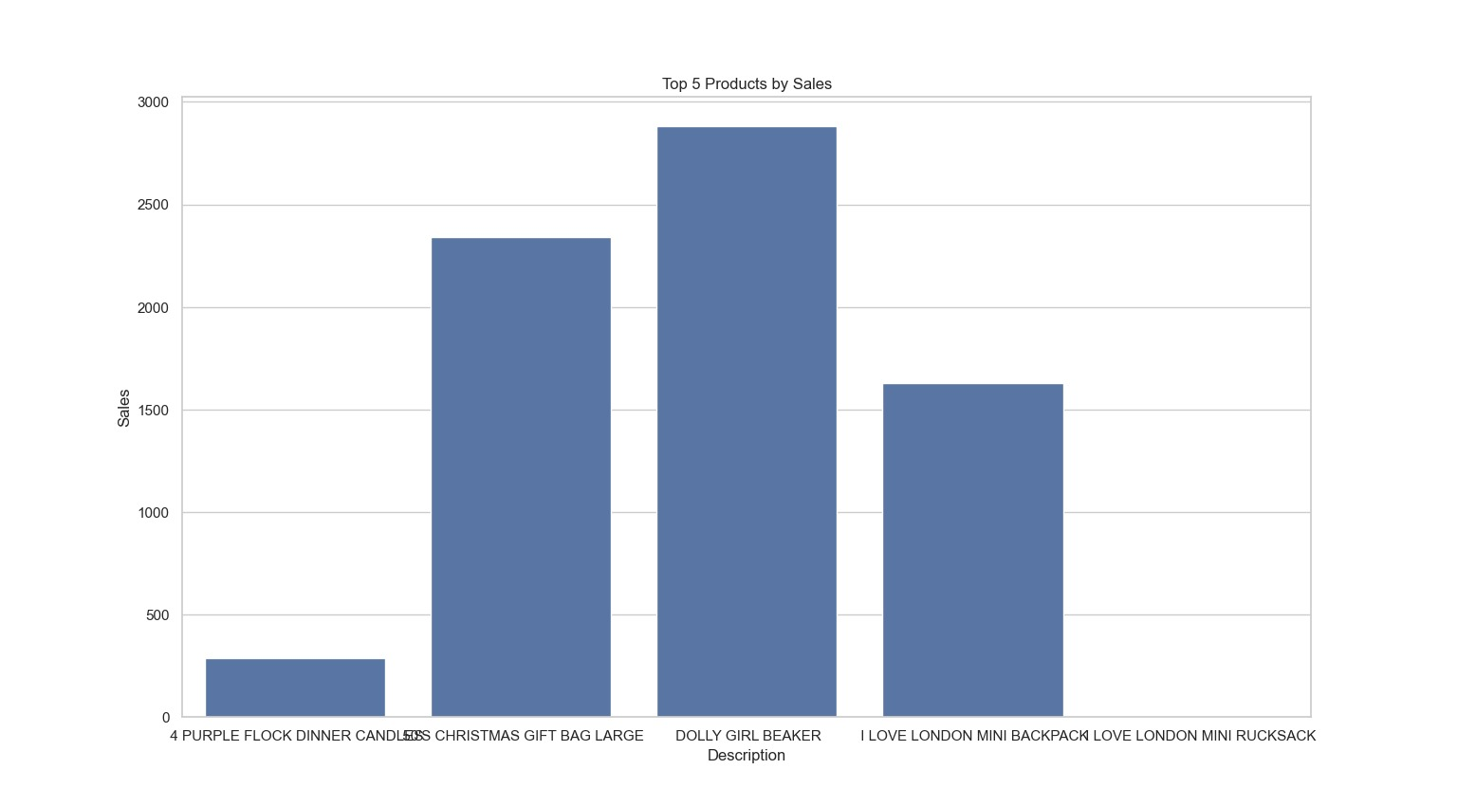

LINE CHART:
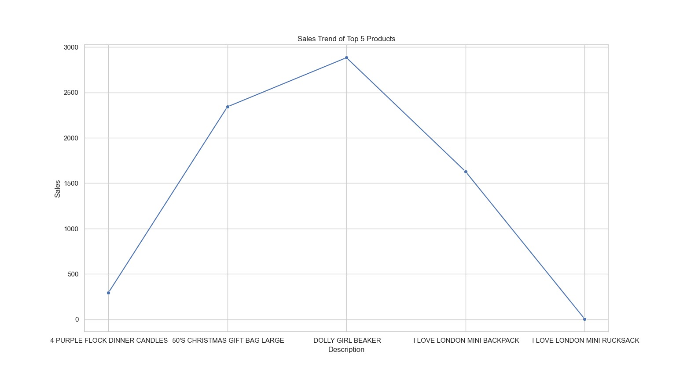

SCENARIO 2 : HOSPITAL PATIENT RECORDS 24BAD061 – KRITHIKA K
HISTOGRAM:
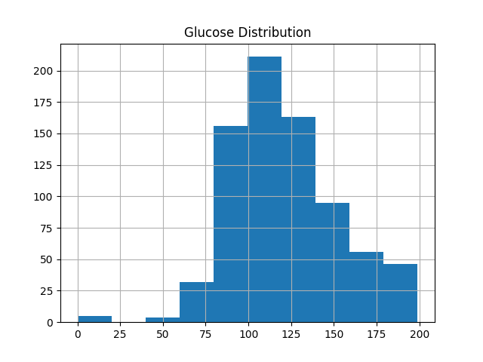
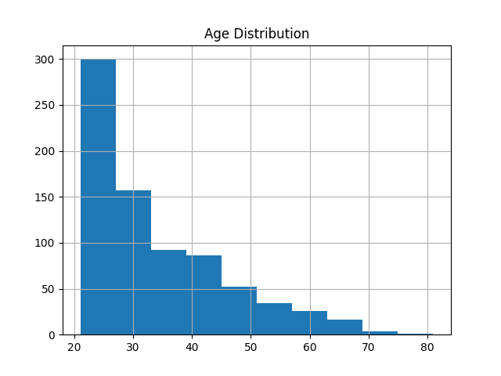

BOXPLOT:
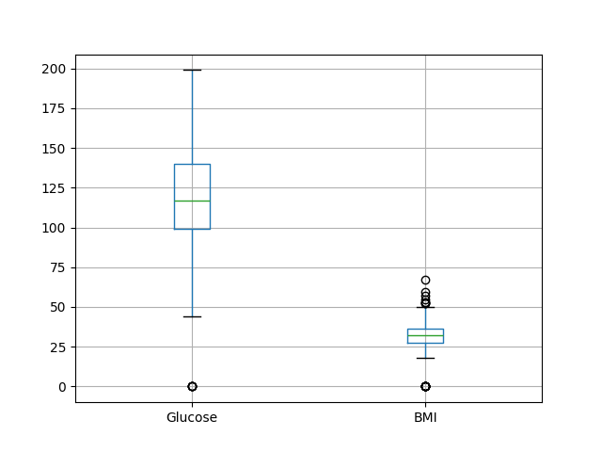

SCENARIO 3: HOUSING DATASETS 24BAD061 – KRITHIKA K
SCATTER PLOT:
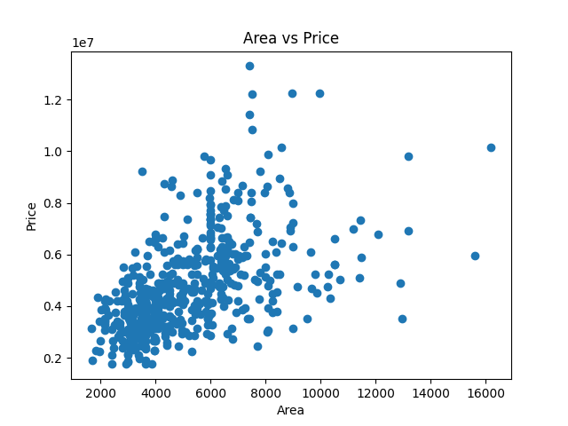

HEATMAPS:
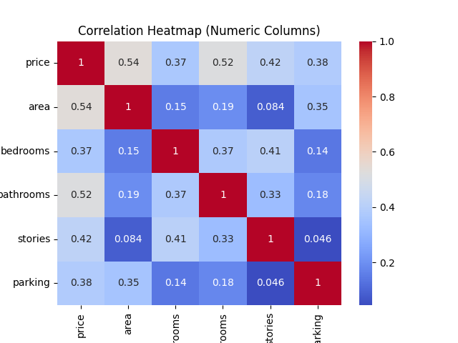

SCENARIO 4: CUSTOMER ANALYSIS 24BAD061- KRITHIKA K
BAR CHART:
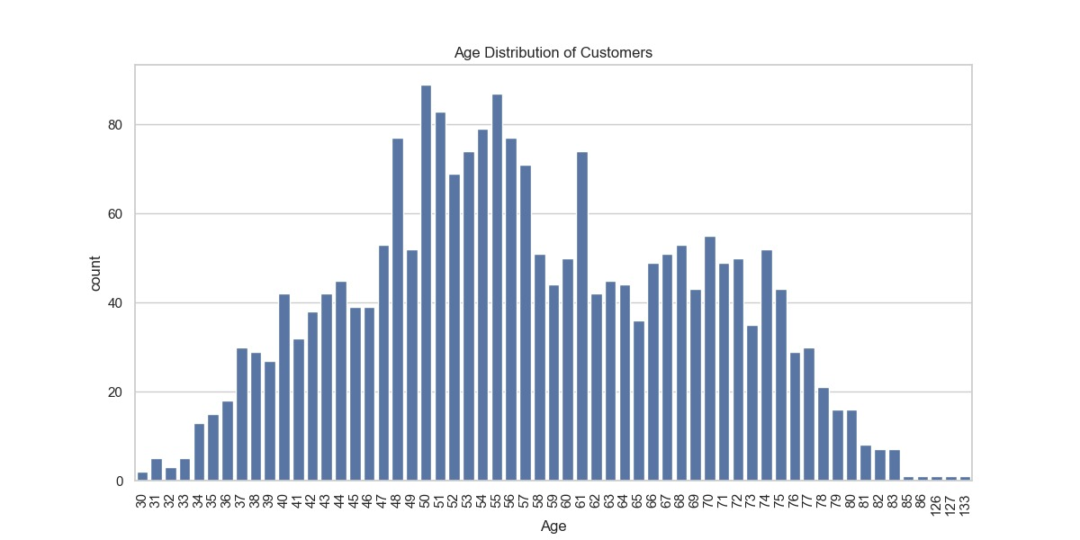

BOX PLOTS:
