RNN based LSTM,GRU based model Utilization

RNN are a class of artificial neural networks where connections between units form a directed cycle

Recurrent networks, unlike feedforward networks, have the feedback loop connected to their past decisions, ingesting their own outputs as input (like a memory). This memory (feedback) helps to learn sequences and predict subsequent values, thus being able to solve dependencies over time. For example, consider the case when the next word in a sentence is dependent on a previously occurring word or context. RNN will be an excellent choice for such scenarios. They are designed to recognize patterns in sequences of data, such as text, handwriting and so on

The RNN Model - The Recurrent Neural Network RNN remembers the analysis done upto a given point by maintaining a state

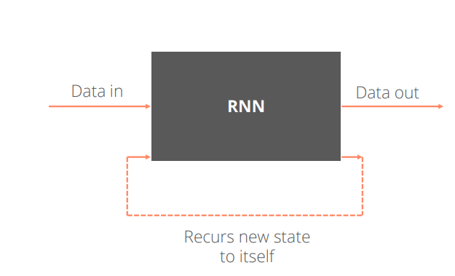

We can assume and think of state as the memory of RNN which recurs into the net with each new input

RNN: Working

The first data point flows into the network as input data, denoted as x

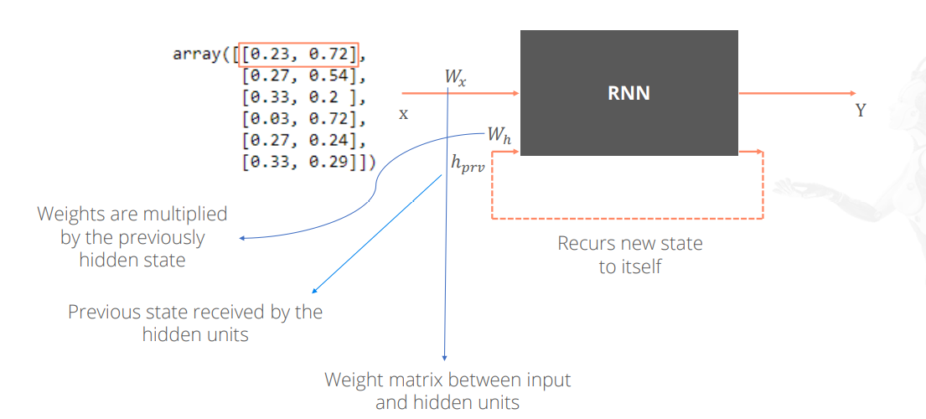

Two values are calculated in the hidden layer

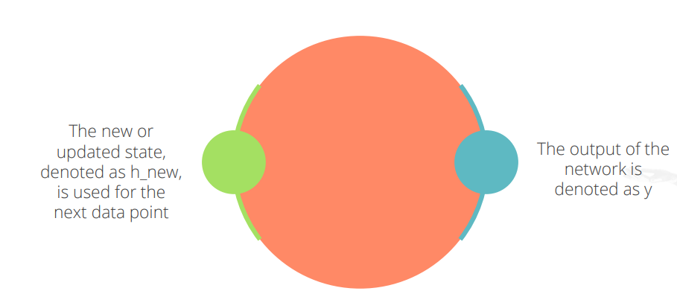

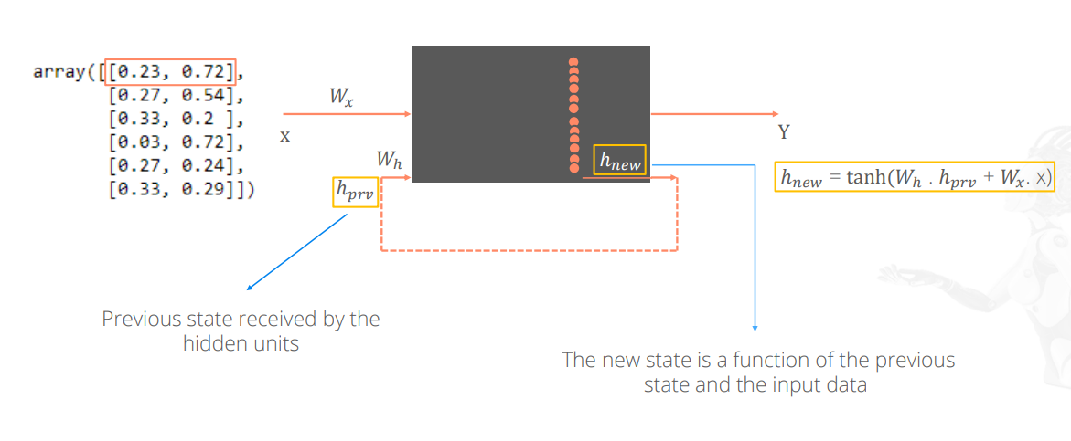

After processing the first data point, a new context is generated that represents the most recent point. Then, this context is fed back into the net with the next data point and we repeat these steps until all the data is processed

Typical RNN

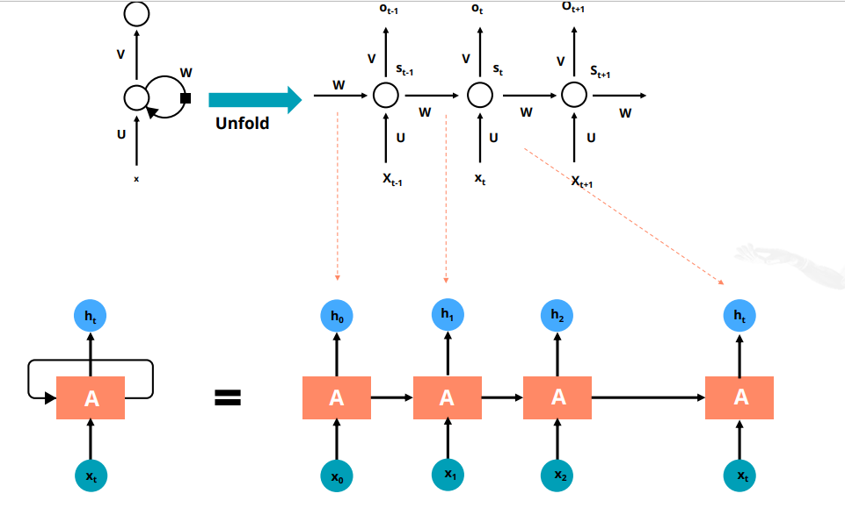

Long Short-Term Memory (LSTM)

LSTM Architecture

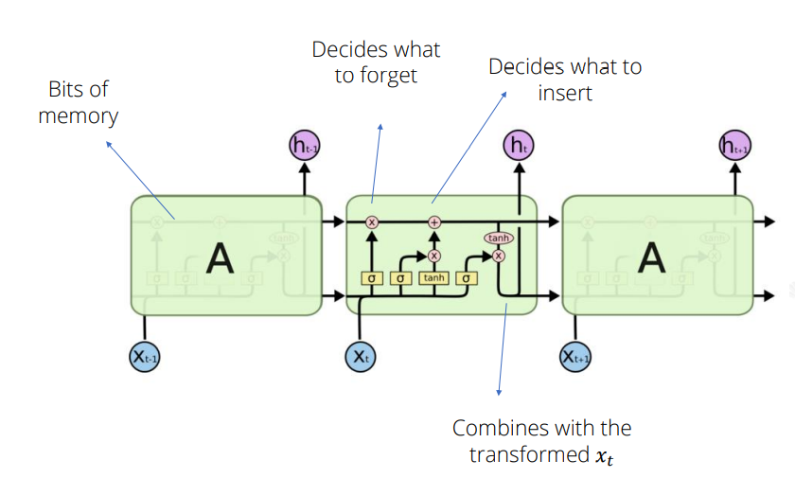

Decides which part of memory to forget. The part to be forgotten is denoted with 0

Decides what bits to insert in the next states

Decides what content to store in the next states

Decides the content of the next memory cell, which is a mixture of the not forgotten part from previous cell and insertion

Decides on what part of cell to output

Maps bits within -1 and +1 range

A peephole LSTM allows peeping into the memory

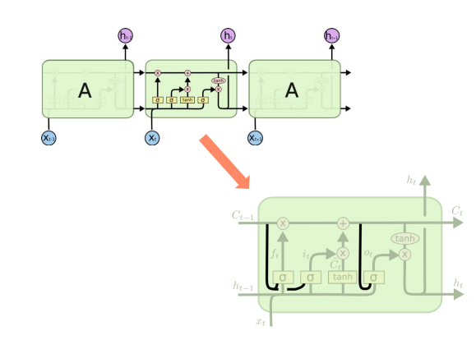

Information Flow in LSTM

Controls Forget Gate - Controls Input Gate- Updates Information- Controls Output Gate

Gated Recurrent Unit (GRU)

Performs label predictions against random data

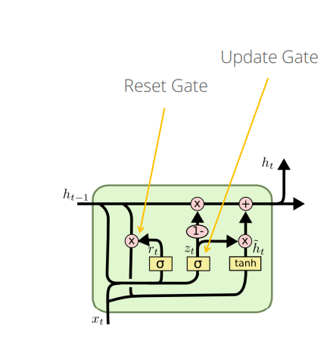

Update Gate - Determines how much of the past information (from the previous time steps) needs to be passed along to the future

Reset Gate - Determines how much of the past information needs to be forgotten

Current Memory - The current memory is computed using the reset gate to store relevant information from the past.

Current State - it holds the information for the current unit and passes it down to the network

Applications of LSTM and GRU

1. VEHICLE BEHAVIOUR PREDICTION

Object detection and behaviour prediction can be considered as two main functions of the of an autonomous vehicle

1. Target Vehicles
2. Based on Driving Rules and Environment
3. Used in Predicting Trajectory of the vehicle
4. 3D detection and tracking
5. pattern recognition
6. Data Accuracy using Car Sensors action
7. Waymo’s recent release of a rich and diverse autonomous driving dataset used to be designed and tested for Autonomous vehiclesto learn an autonomous driving policy, generating a driving actiongiven that the environment is in a certain motion state depends on speed acceleration and brake system, variableswere collected by radars, lidars, cameras, and other sensors installed on cars

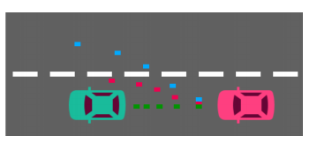

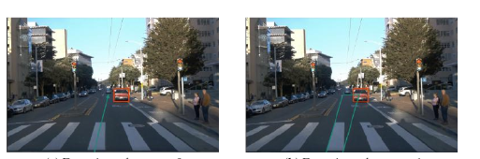

Detection Tolerance = 0 Detection Tolerance = 1

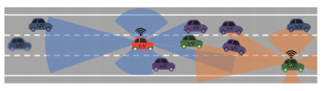

In the above figure, An illustration of the vehicle behaviour prediction problem for connected autonomous vehicles. The sensors implemented in other autonomous vehicles and infrastructure can provide more information about the SVs and reduce the object occlusion problem in ego vehicle

(GRU) [55] are the most commonly used gated RNNs.

In vehicle behaviour prediction, LSTMs are the most used deep models.

LSTM and GRU based RNN network in combination with CNN is used for simulation of self driving cars.

Also Used in Video Games simuation, video game development platform

Used in Speed Distribution Prediction of Freight Vehicles on Mountainous Freeway

Will be used in future need of intelligent systems for vehicle-to-passenger communication

Used in Mechanical Design of the cars

Traffic Control Gesture Recognition for Autonomous Vehicles –

A car driver knows how to react on the gestures of the traffic officers. Clearly, this is not the case for the autonomous vehicle, unless it has road traffic control gesture recognition functionalities

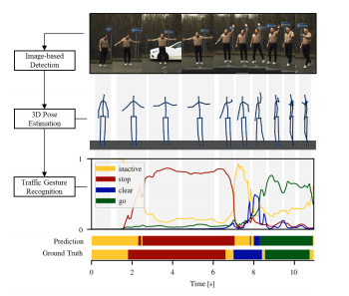

In traffic control gesture recognition, we have a sequence to sequence problem where the gesture classification happens for each input of a 3D body skeleton. This mapping is modeled with recurrent neural networks (RNNs), including attention models

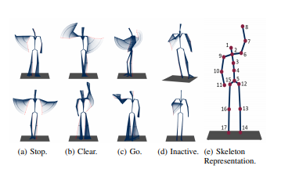

GESTURE RECOGNITION MODELS

human-vehicle interaction. Human-vehicle interaction. Autonomous vehicles need to interact with humans inside the vehicle

comprehensive understanding of the body language is important in order to react according to the human intentions. In particular, hand gestures are a common mean of interaction between the vehicle and human

CNN-GRU network model is used and trained to perform road segmentation using data captured by the front camera of a vehicle. GRU network obtains a long spatial sequence with lower computational complexity, comparing to traditional encoder-decoder architecture..