create database insurance_krithika;

use insurance_krithika;

create table insurance_krithika.person_159(

driver_id varchar(20),

name varchar(30),

adress varchar(50),

primary key(driver_id));

create table insurance_krithika.car_159(

reg_num varchar(10),

model varchar(10),

year int,

primary key(reg_num)

);

create table insurance_krithika.owns_159(

reg_num varchar(10),

driver_id varchar(20),

primary key (reg_num,driver_id),

foreign key(driver_id) references person_159(driver_id),

foreign key(reg_num) references car_159(reg_num)

);

create table insurance_krithika.accident_159(

report_num int,

accident_date date,

location varchar(20),

primary key(report_num)

);

create table insurance_krithika.participated_159(

driver_id varchar(20),

reg_num varchar(10),

report_num int,

damage_amount int,

primary key(driver_id,reg_num,report_num),

foreign key(reg_num) references car_159(reg_num),

foreign key(driver_id) references person_159(driver_id),

foreign key(report_num) references accident_159(report_num)

);

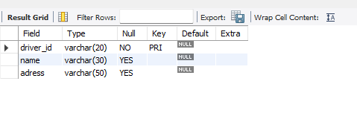desc person_159;

Desc

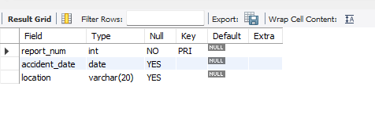

desc participated_159;

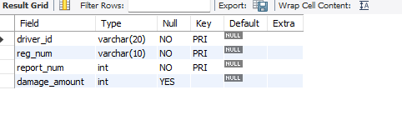

Desc car_159;

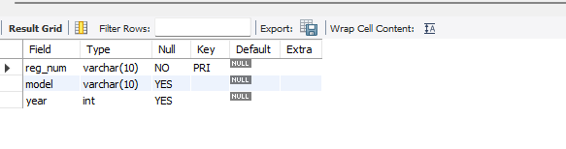

desc owns_159;

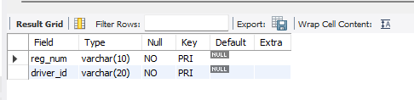

insert into person_159 values("A01","Richard", "Srinivas nagar");

insert into person_159 values("A02","Pradeep", "Rajaji nagar");

insert into person_159 values("A03","Smith","Ashok nagar");

insert into person_159 values("A04","Venu","N R Colony");

insert into person_159 values("A05","John","Hanumanth nagar");

select * from person_159;

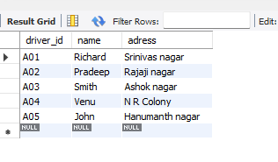

insert into car_159 values("KA052250","Indica","1990");

insert into car_159 values("KA031181","Lancer","1957");

insert into car_159 values("KA095477","Toyota","1998");

insert into car_159 values("KA053408","Honda","2008");

insert into car_159 values("KA041702","Audi","2005");

select * from car_159;

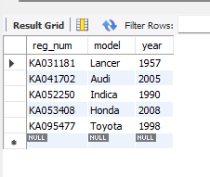

insert into owns_159 values("KA052250","A01");

insert into owns_159 values("KA031181","A02");

insert into owns_159 values("KA095477","A03");

insert into owns_159 values("KA053408","A04");

insert into owns_159 values("KA041702","A05");

select * from owns_159;

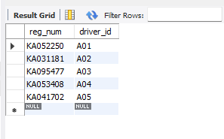

insert into accident_159 values(11,'2003-01-01',"Mysore");

insert into accident_159 values(12,'2004-02-02',"South end Circle");

insert into accident_159 values(13,'2003-01-21',"Bull temple Road");

insert into accident_159 values(14,'2008-02-17',"Mysore Road");

insert into accident_159 values(15,'2004-03-05',"Kanakpura Road");

select * from accident_159;

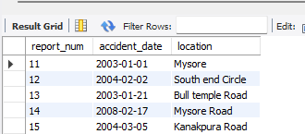

insert into participated_159 values("A01","KA052250",11,10000);

insert into participated_159 values("A02","KA053408",12,50000);

insert into participated_159 values("A03","KA095477",13,25000);

insert into participated_159 values("A04","KA031181",14,3000);

insert into participated_159 values("A05","KA041702",15,5000);

select * from participated_159;

update participated_159

set damage_amount=25000

where reg_num="KA053408" and report_num=12;

select count(distinct driver_id) CNT

from participated_159 a, accident_159 b

where a.report_num=b.report_num and b.accident_date like '2008%';

insert into accident_159 values(16,'2008-03-08',"Domlur");

select * from accident_159;

select accident_date,location from accident_159;

select driver_id from participated_159

where damage_amount>=25000;

select * from participated_159

order by damage_amount desc;

select avg(damage_amount) as Average_Damage

from participated_159;

delete from insurance_krithika.participated_159

where damage_amount<(

select avg_damage

from(

select avg(damage_amount)as avg_damage

from insurance_krithika.participated_159)

as avg_table);

select * from insurance_krithika.participated_159;

select name from person_159 a, participated_159 b

where a.driver_id=b.driver_id and dasmage_amount>(select avg(damage_amount) from participated_159);

select max(damage_amount) from participated_159;