create database Employee_Database;

use Employee_Database;

create table dept(

no varchar(20) ,

dname varchar(20),

dloc varchar(20) ,

primary key(no)

);

create table employee(

empno int,

ename varchar(20),

mgr_no int,

hiredate varchar(20),

sal float,

no varchar(20),

primary key(empno,no),

foreign key(no) references dept(no));

create table incentives(

empno int,

date date,

amt float,

primary key(empno,date),

foreign key(empno) references employee(empno));

create table project(

pno int ,

ploc varchar(20),

pname varchar(20),

primary key(pno)

);

create table Assingnedto(

empno int,

pno int,

job_role text,

primary key(empno,pno),

foreign key(empno) references employee(empno),

foreign key(pno) references project(pno)

);

insert into dept values(1,"cse","pj");

insert into dept values(2,"ise","pj");

insert into dept values(3,"csds","pg");

insert into dept values(4,"ece","pg");

insert into dept values(5,"aiml","pj");

insert into employee values(101,"akash",100,"12/01/1999",100000,1);

insert into employee values(201,"sakshi",200,"17/01/2020",50000,2);

insert into employee values(301,"gagan",100,"01/09/2004",30000,3);

insert into employee values(401,"swasthi",101,"03/08/2000",10000,4);

insert into employee values(501,"sneha",101,"29/2/2008",90000,5);

insert into incentives values(101,'2004-03-12',50000);

insert into incentives values(201,'2006-03-11',25000);

insert into incentives values(301,'2019-04-11',15000);

insert into incentives values(401,'2019-03-05',5000);

insert into incentives values(501,'2019-05-07',45000);

insert into project values(10,"bng","chatbot");

insert into project values(50,"bombay","blockchain");

insert into project values(30,"chennai","stocks");

insert into project values(80,"mysore","android app");

insert into project values(40,"bng","face detectetion");

insert into Assingnedto values(101,10,"devops");

insert into Assingnedto values(201,40,"sde");

insert into Assingnedto values(301,50,"manager");

insert into Assingnedto values(401,30,"jpa");

insert into Assingnedto values(501,80,"pa");

select * from dept;

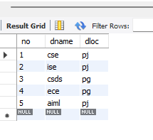

select * from employee;

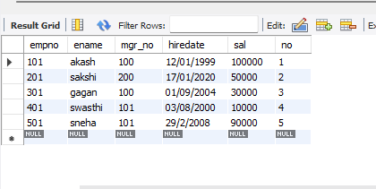

select * from incentives;

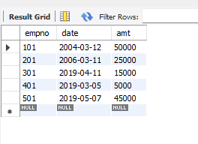

select * from project;

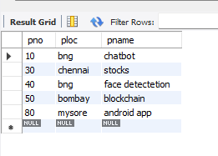

select * from Assingnedto;

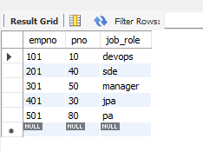

select ename from employee

where mgr_no=(select max(mgr_no) from employee);

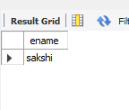

select ename from employee

where sal>(select avg(sal) from employee

);



select ename from employee

where sal=(select max(sal) from employee

where sal<(select max(sal) from employee

));

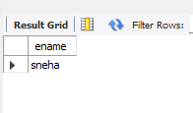

select * from employee

where empno=(select empno from incentives

where amt=(select max(amt) from incentives

where amt<(select max(amt) from incentives)));

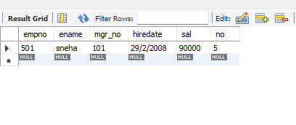

select ename from employee

where mgr_no=empno

