**SUPPLIERS**

1. **Using Scheme diagram, Create tables by properly specifying the primary**

create database Suppliers;

use Suppliers;

create table Supplier(

sid int primary key,

sname varchar(20),

city varchar(20)

);

create table Parts(

pid int primary key,

pname varchar(20),

colour varchar(20)

);

create table Catalog(

sid int,

pid int,

cost int,

foreign key(sid) references Supplier(sid),

foreign key(pid) references Parts(pid)

);

1. **Insert appropriate records in each table.**

insert into Supplier values(1001,'Acme Widget','Bangalore');

insert into Supplier values(1002,'Relaince','Mumbai');

insert into Supplier values(1003,'Croma','Mumbai');

insert into Supplier values(1004,'SleepWell','Delhi');

insert into Supplier values(1005,'Johns','Mysore');

insert into Supplier values(1006,'Williams','Mumbai');

insert into Parts values(2001,'Pen','Red');

insert into Parts values(2002,'Pen','Blue');

insert into Parts values(2003,'Pen','Black');

insert into Parts values(2004,'Mobile','Black');

insert into Parts values(2005,'Mobile','White');

insert into Parts values(2006,'Mobile','Red');

insert into Parts values(2007,'Matress','White');

insert into Parts values(2008,'Matress','Red');

insert into Catalog values(1001,2001,10);

insert into Catalog values(1001,2002,15);

insert into Catalog values(1001,2003,10);

insert into Catalog values(1001,2004,90);

insert into Catalog values(1001,2005,100);

insert into Catalog values(1001,2006,100);

insert into Catalog values(1001,2008,150);

insert into Catalog values(1001,2007,150);

insert into Catalog values(1002,2004,100);

insert into Catalog values(1002,2005,90);

insert into Catalog values(1002,2006,150);

insert into Catalog values(1003,2004,150);

insert into Catalog values(1003,2005,100);

insert into Catalog values(1003,2006,170);

insert into Catalog values(1004,2004,150);

insert into Catalog values(1004,2007,150);

insert into Catalog values(1004,2008,250);

insert into Catalog values(1005,2007,150);

insert into Catalog values(1005,2008,250);

insert into Catalog values(1006,2008,100);

1. **Find the pnames of parts for which there is some supplier.**

select distinct p.pname

from Parts p, Catalog c

where p.pid =c.pid;

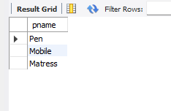

1. **Find the snames of suppliers who supply every part.**

select distinct s.sname

from Catalog c , Supplier s where c.sid = s.sid and

NOT EXISTS(select p.pid from Parts p

where NOT EXISTS(select c1.sid from Catalog c1

where c1.sid=c.sid and c1.pid =c.pid));

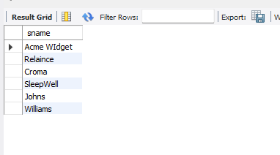

1. **Find the snames of suppliers who supply every red part.**

select distinct s.sname

from Catalog c , Supplier s where c.sid = s.sid and

NOT EXISTS(select p.pid from Parts p

where p.colour='Red' and NOT EXISTS(select c1.sid from Catalog c1

where c1.sid=c.sid and c1.pid =c.pid and p.colour='Red'));

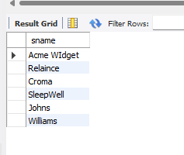

1. **Find the pnames of parts supplied by Acme Widget Suppliers and by no**

**one else.**

select p.pname

from Parts p, Catalog c, Supplier s

where p.pid=c.pid and c.sid=s.sid and s.sname="Acme Widget"

and NOT EXISTS (select * from Catalog c1, Supplier s1

where p.pid=c1.pid and c1.sid=s1.sid and

s1.sname != "Acme Widget");

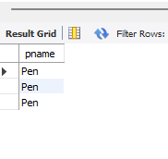

1. **Find the sids of suppliers who charge more for some part than the average**

**cost of that part (averaged over all the suppliers who supply that part).**

select distinct c.sid from Catalog C

where C.cost>(select avg(cost)

from Catalog c1

where c1.pid=c.pid);

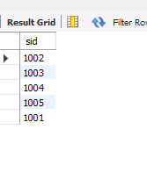

1. **For each part, find the sname of the supplier who charges the most for**

**that part.**

select P.pid, S.sname

from Parts P, Supplier S, Catalog C

where C.pid = P.pid and

C.sid = S.sid and

C.cost = (select max(C1.cost)

from Catalog C1

where C1.pid = P.pid);

