Week 1 – 0:

--Coding-C-Language Features-Optional.

ROLL NO.:240801170

Name: krithik srinivasan v

Q1) This is a simple challenge to help you practice printing to stdout. We're starting out by printing the most famous computing phrase of all time! In the editor below, use either printf or cout to print the string Hello, World! to stdout. Input Format You do not need to read any input in this challenge. Output Format Print Hello, World! to stdout. Sample Output Hello, World! Answer:(penalty regime: 0 %)

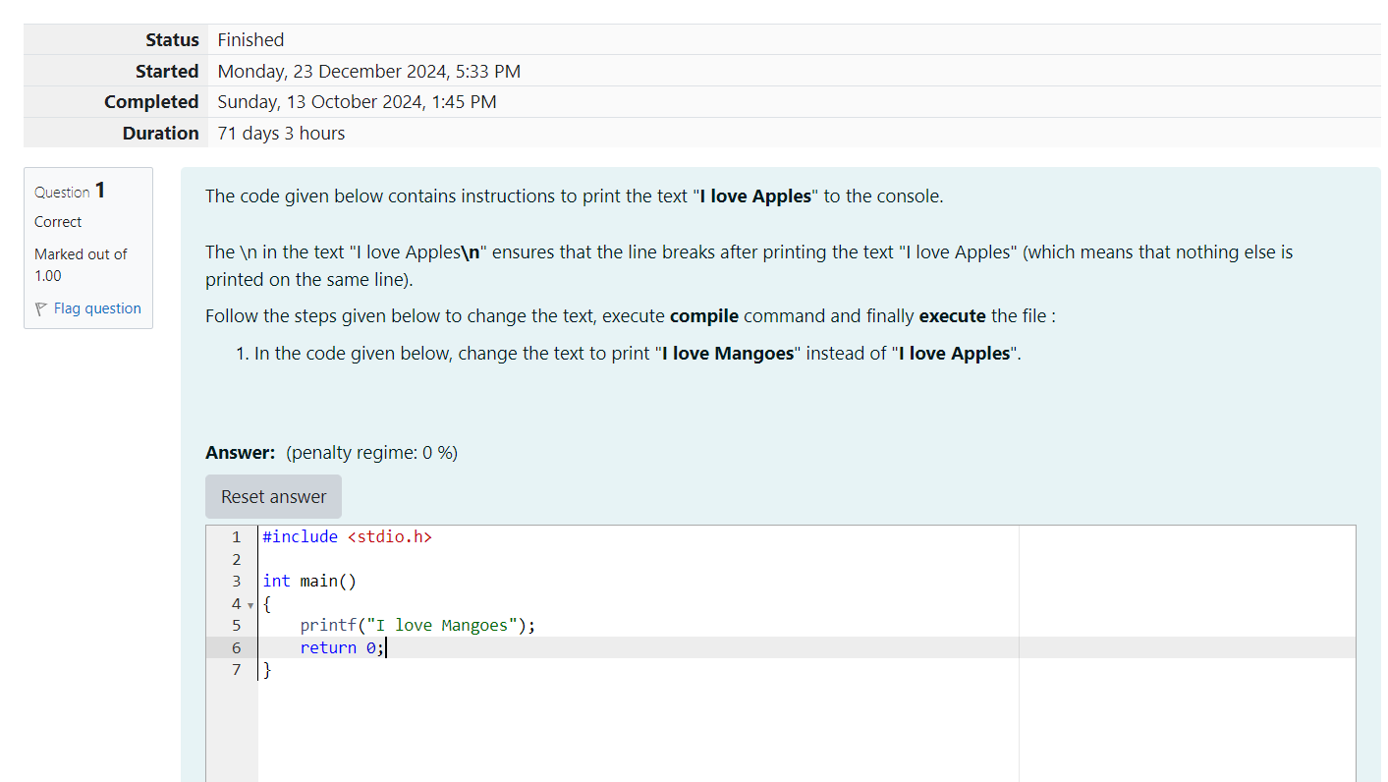

OUTPUT:

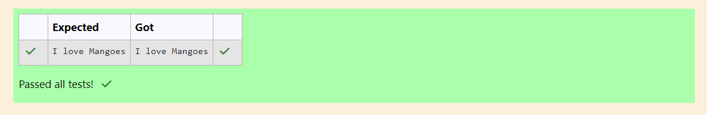

Q2)This challenge will help you to learn how to take a character, a string and a sentence as input in C. To take a single character ch as input, you can use scanf("%c", &ch); and printf("%c", ch) writes a character specified by the argument char to stdout: char ch; scanf("%c", &ch); printf("%c", ch); This piece of code prints the character ch. Task You have to print the character, ch.

Input Format Take a character, ch as input.

Output Format Print the character, ch.

Answer:(penalty regime: 0 %)

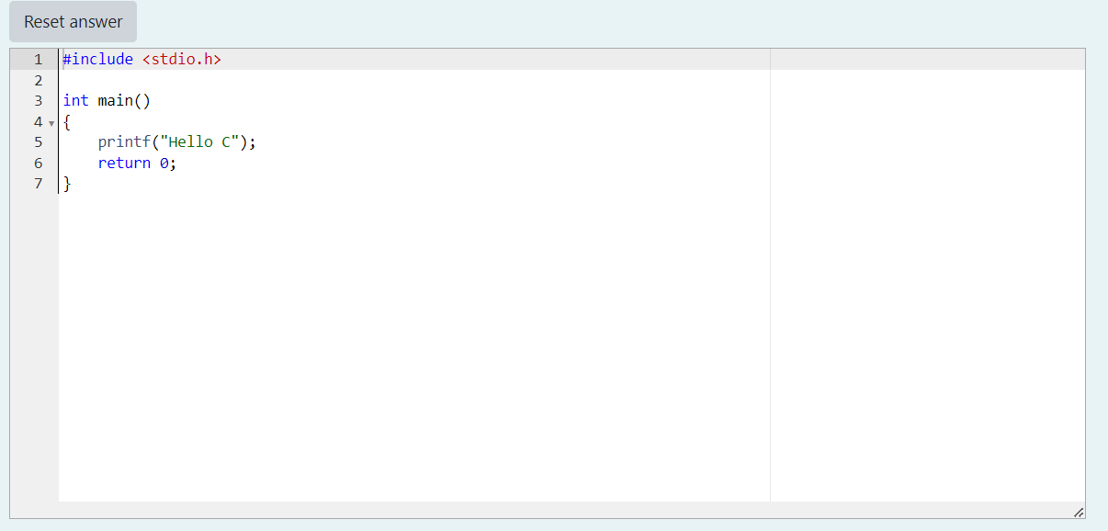

OUTPUT:

