Week 8:

ROLL NO.:240801170

Name: KRITHIK SRINIVASAN V

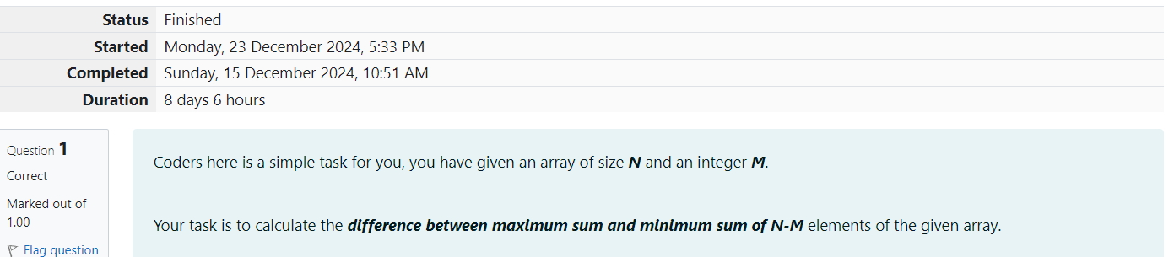

Q1) Coders here is a simple task for you, you have given an array of size N and an integer M.

Your task is to calculate the difference between maximum sum and minimum sum of N-M

elements of the given array.

Constraints:

1<=t<=10

1<=n<=1000

1<=a[i]<=1000

Input Format:

First line contains an integer T denoting the number of testcases.

First line of every testcase contains two integer N and M.

Next line contains N space separated integers denoting the elements of array

Output:

For every test case print your answer in new line

Sample Input

1

5 1

1 2 3 4 5

Sample Output

4

Explanation

M is 1 and N is 5 so you have to calculate maximum and minimum sum using (5-1 =) 4

elements.

Maximum sum using the 4 elements would be (2+3+4+5=)14.

Minimum sum using the 4 elements would be (1+2+3+4=)10.

Difference will be 14-10=4.

Code:

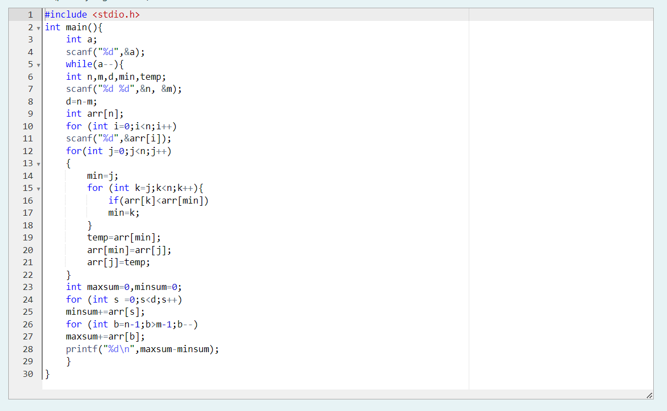

OUTPUT:

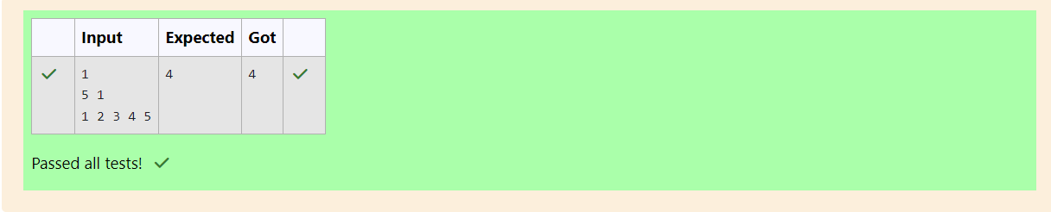

Q2) A new deadly virus has infected large population of a planet. A brilliant scientist has

discovered a new strain of virus which can cure this disease. Vaccine produced from this

virus has various strength depending on midichlorians count. A person is cured only if

midichlorians count in vaccine batch is more than midichlorians count of person. A doctor

receives a new set of report which contains midichlorians count of each infected patient,

Practo stores all vaccine doctor has and their midichlorians count. You need to determine

if doctor can save all patients with the vaccines he has. The number of vaccines and

patients are equal.

Input Format

First line contains the number of vaccines - N. Second line contains N integers, which are

strength of vaccines. Third line contains N integers, which are midichlorians count of

patients.

Output Format

Print a single line containing 'Yes' or 'No'.

Input Constraint

1 < N < 10

Strength of vaccines and midichlorians count of patients fit in integer.

Sample Input

5

123 146 454 542 456

100 328 248 689 200

Sample Output

No

Coding:

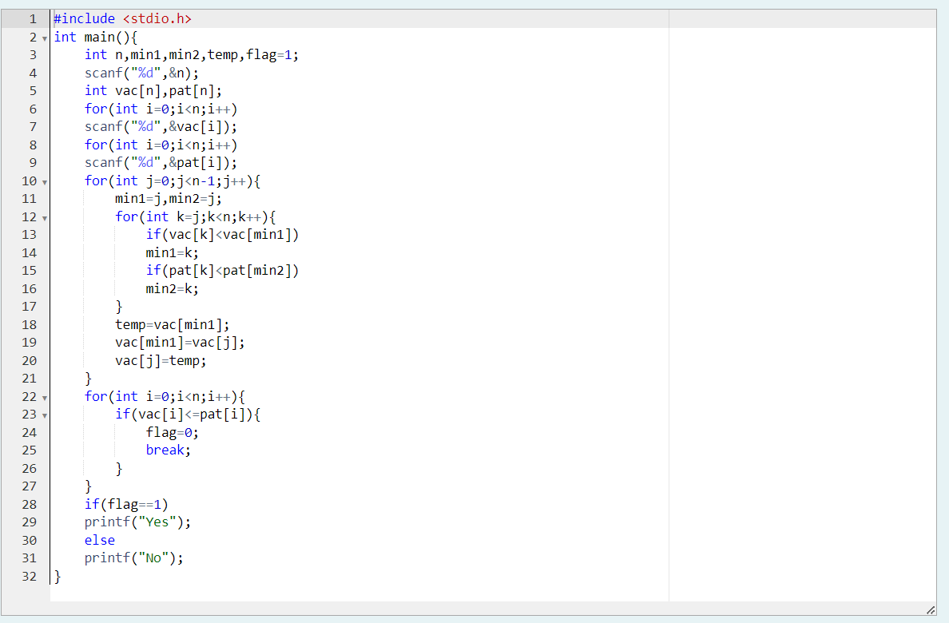

OUTPUT:

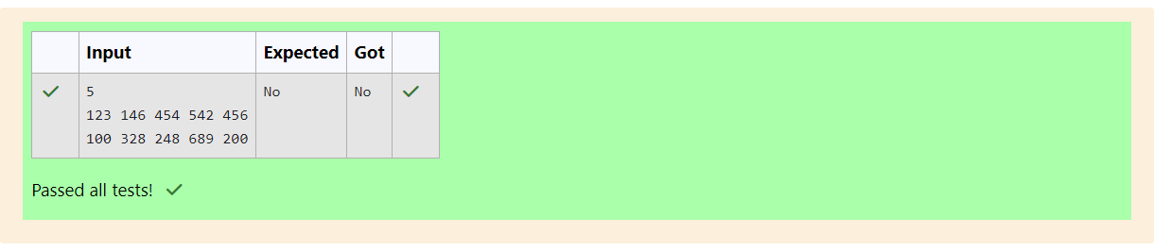

Q3) You are given an array of n integer numbers a1, a2, . . . , an. Calculate the number of pair

of indices (i, j) such that 1 ≤ i < j ≤ n and ai xor aj = 0.

Input format

- First line: n denoting the number of array elements

- Second line: n space separated integers a1, a2, . . . , an.

Output format

Output the required number of pairs.

Constraints

1 ≤ n ≤ 106

1 ≤ ai ≤ 109

Sample Input

5

1 3 1 4 3

Sample Output

2

Explanation

The 2 pair of indices are (1, 3) and (2,5).

Code:

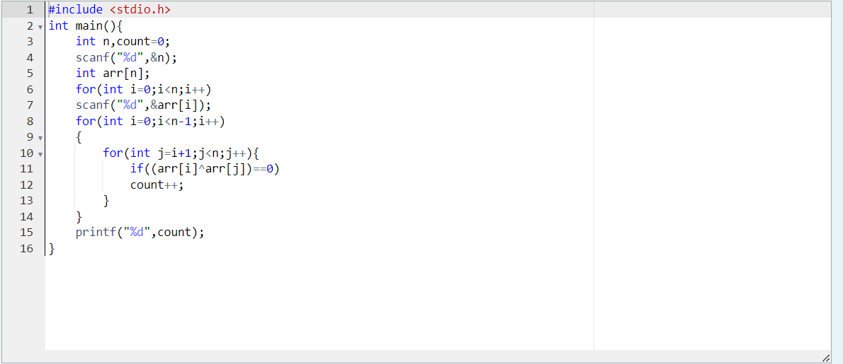

OUTPUT:

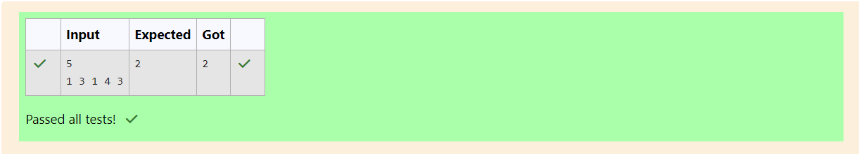

Q4) You are given an array A of non-negative integers of size m. Your task is to sort the array

in nondecreasing order and print out the original indices of the new sorted array.

Example:

A={4,5,3,7,1}

After sorting the new array becomes A={1,3,4,5,7}.

The required output should be "4 2 0 1 3"

Input Format:

The first line of input consists of the size of the array

The next line consists of the array of size m

Output Format:

Output consists of a single line of integers

Constraints:

1<=m<=106

0<=A[i]<=106

NOTE: The indexing of the array starts with 0.

Sample Input

5

4 5 3 7 1

Sample Output

4 2 0 1 3

Code:

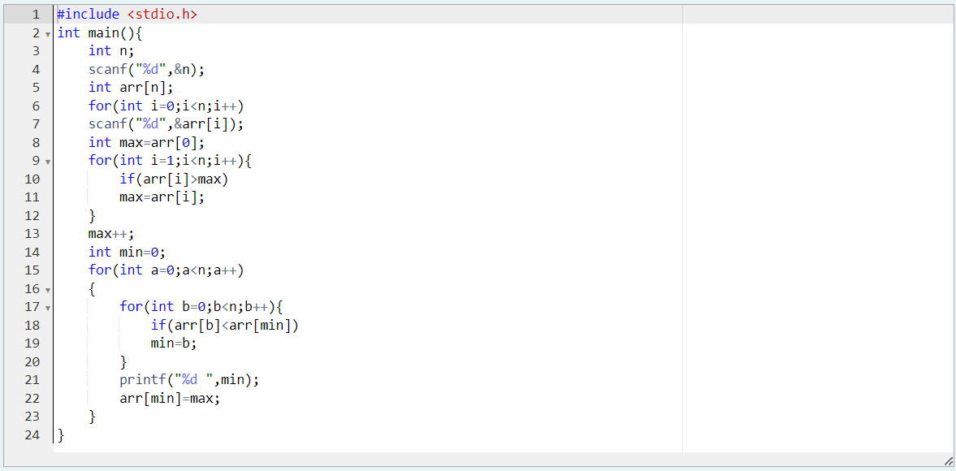

OUTPUT:  
