POCKETSMARTAI: AN INTELLIGENT MULTIMODAL BUDGET-CONSTRAINED DECISION SUPPORT SYSTEM FOR LIFESTYLE AND EVENT PLANNING
A Project Report Submitted in Partial Fulfillment of the Requirements
for the Award of the Degree of
[BACHELOR OF TECHNOLOGY / BACHELOR OF ENGINEERING / BACHELOR OF SCIENCE / MCA]
in
[COMPUTER SCIENCE AND ENGINEERING / ARTIFICIAL INTELLIGENCE & DATA SCIENCE]
Submitted by:
[CANDIDATE NAME(S)]
(Register No. / Roll No.: [REGISTER NUMBER / USN])
[DEPARTMENT OF COMPUTER SCIENCE AND ENGINEERING]
Under the Guidance of:
[PROJECT GUIDE / SUPERVISOR NAME, DESIGNATION]
[DEPARTMENT OF COMPUTER SCIENCE AND ENGINEERING]
[COLLEGE / INSTITUTION NAME]
[AFFILIATED UNIVERSITY NAME]
[CITY, STATE - PIN CODE]
[ACADEMIC YEAR: 2026 – 2027]

ABSTRACT
In modern personal financial planning, consumers face severe friction when mapping high-level budgets to multi-item purchases. Digital marketplaces focus on basket expansion rather than global budget caps. PocketSmartAI resolves this by delivering a full-stack, multimodal decision support system with FastAPI, SQLAlchemy, and Google Gemini 2.5 Flash. It includes three modules: Home Interior Planner (room styling budget division), Party Planner (strict percentage splits for events), and Multimodal Jewelry Matcher (computer vision on outfit photos).
Its core innovation is a hybrid orchestration pipeline: Gemini 2.5 Flash handles aesthetic reasoning, while a local deterministic fallback engine guarantees instant, bounded arithmetic in < 25ms during cloud outages. Plans are augmented with live search vectors for Amazon, Flipkart, IKEA, Swiggy, Zomato, and OYO. The platform uses Argon2id password hashing and HTTP-only JWT cookies. A 20-scenario test suite confirmed 100% pass rates.
Keywords: Artificial Intelligence, Budget Optimization, Multimodal Support, FastAPI, LLMs, Fallback Models, E-Commerce.

ACKNOWLEDGEMENT
We convey our sincere gratitude to our Principal / Dean and the Head of Department, [HOD Name], for computational infrastructure and academic guidance. We express deepest appreciation to our project supervisor, [Project Guide Name], for technical mentoring and architectural critique. We also thank faculty members, laboratory staff, and our families whose continuous encouragement sustained our efforts.

TABLE OF CONTENTS
Bonafide Certificate and Candidate Declaration | ii
Abstract and Acknowledgement | iii
Table of Contents | iv
List of Figures and List of Tables | v
CHAPTER 1: INTRODUCTION | 1
1.1 Background and Overview of PocketSmartAI | 1
1.2 Motivation and Problem Statement | 1
1.3 Objectives and Scope of the Project | 1
CHAPTER 2: EXISTING SYSTEM AND PROPOSED SYSTEM | 2
2.1 Existing Approaches and Limitations | 2
2.2 Proposed System, Key Features, and Advantages | 2
CHAPTER 3: REQUIREMENTS ANALYSIS | 3
3.1 Functional Requirements Specification | 3
3.2 Non-Functional, Hardware, Software, and API Requirements | 3
CHAPTER 4: TECHNOLOGY STACK | 4
4.1 Programming Language and Asynchronous Framework | 4
4.2 Generative AI SDK, ORM, Cryptography, and Presentation | 4
CHAPTER 5: SYSTEM ARCHITECTURE AND DESIGN | 5
5.1 High-Level Multi-Tier System Architecture | 5
5.2 Data Flow Diagrams (Level 0 and Level 1) | 5
5.3 Use Case Modeling and Database Entity Design | 6
CHAPTER 6: PROJECT STRUCTURE AND MODULE DESCRIPTION | 7
6.1 Repository Directory Structure and File Organization | 7
6.2 Module Responsibilities and Inter-Module Communication | 7
CHAPTER 7: IMPLEMENTATION | 8
7.1 User Interface and Input Validation Layer | 8
7.2 Generative AI Prompt Construction and Response Sanitization | 8
7.3 Deterministic Fallback Engine and Financial Arithmetic | 9
7.4 Argon2id Cryptographic Security and JWT Session Management | 9
CHAPTER 8: SYSTEM WORKFLOW AND APPLICATION DEMONSTRATION | 10
8.1 Step-by-Step User Workflow and Practical Scenarios | 10
8.2 User Interface Walkthrough and Multimodal Vision Upload | 11
CHAPTER 9: TESTING AND VALIDATION | 12
9.1 Testing Methodology and Comprehensive Verification Suite | 12
9.2 Automated Test Execution Results and Performance Metrics | 12
CHAPTER 10: RESULTS AND DISCUSSION | 13
10.1 Feature Delivery Assessment and Observed Latency Benchmarks | 13
10.2 Architectural Strengths, Limitations, and Objective Fulfillment | 13
CHAPTER 11: DEPLOYMENT AND INSTALLATION | 14
11.1 Prerequisites, Environment Configuration, and Local Execution | 14
11.2 Common Operational Errors and Troubleshooting Guide | 14
CHAPTER 12: LIMITATIONS AND FUTURE ENHANCEMENTS | 15
12.1 Current Technical Limitations | 15
12.2 Proposed Architectural and Functional Enhancements | 15
CHAPTER 13: CONCLUSION | 15
13.1 Project Summary and Concluding Assessment | 15
REFERENCES AND APPENDICES | 16
References | 16
Appendix A: Repository File and Directory Catalog | 16
Appendix B: Anticipated Viva-Voce Questions and Answers | 17

LIST OF FIGURES
Figure 5.1: High-Level System Architecture of PocketSmartAI | 5
Figure 5.2: Level-0 Context Data Flow Diagram (DFD) | 5
Figure 5.3: Level-1 Functional Decomposition Data Flow Diagram (DFD) | 6
Figure 5.4: PocketSmartAI System Use Case Diagram | 6
Figure 5.5: Entity-Relationship Diagram for User and Recommendation Entities | 6
Figure 7.1: Hybrid AI & Deterministic Fallback Logic Flowchart | 9
Figure 8.1: PocketSmartAI Responsive Landing Interface | 10
Figure 8.2: Home Interior Room Planner Input Interface | 11
Figure 8.3: Structured Recommendation Output and Marketplace Redirects | 11
Figure 8.4: Real Multimodal User Outfit Upload for Vision Analysis | 11

LIST OF TABLES
Table 3.1: Functional Requirements Specification (FRS) | 3
Table 3.2: Non-Functional Requirements Specification (NFRS) | 3
Table 4.1: Comprehensive Technology Stack Matrix | 4
Table 6.1: PocketSmartAI Source Code Structure & Module Responsibilities | 7
Table 9.1: Automated Verification & Execution Test Suite Matrix | 12
Table 10.1: Empirical Execution Latency and Fault Tolerance Benchmarks | 13
Table A.1: Primary Repository Source Code File Catalog | 16

CHAPTER 1: INTRODUCTION

1.1 Background and Overview of PocketSmartAI
In the contemporary digital landscape, personal resource allocation and consumer financial planning are undergoing rapid transformation. While individuals possess overall financial limits, commercial platforms are systematically designed around maximizing transaction values rather than respecting global expenditure ceilings. PocketSmartAI is engineered to bridge this gap by delivering an intelligent, multimodal, budget-constrained decision support system built with FastAPI, SQLAlchemy, and Google Gemini 2.5 Flash.
The core philosophy of PocketSmartAI is strict budgetary adherence: when a user defines an expenditure ceiling, the system analyzes user intent, applies domain-specific category allocations, coordinates visual aesthetics, and delivers fully bounded, actionable purchasing plans without exceeding the financial ceiling.

1.2 Motivation and Problem Statement
Problem Statement: Existing digital marketplaces emphasize bottom-up catalog discovery, forcing heavy cognitive load and frequent overspending in multi-category activities like room styling or event hosting. Unconstrained AI chatbots frequently hallucinate costs exceeding specified budgets. PocketSmartAI addresses this by combining the generative intelligence of modern foundation models with deterministic mathematical boundary enforcement, delivering dependable, budget-compliant purchasing recommendations.

1.3 Objectives and Scope of the Project
The primary engineering objectives of PocketSmartAI are: (1) Develop an asynchronous full-stack decision support platform leveraging Python, FastAPI, and SQLAlchemy; (2) Implement three specialized budget planning modules: Home Interior Planner, Party Event Planner, and Multimodal Jewelry Matcher; (3) Engineer a resilient hybrid AI pipeline integrating Google Gemini 2.5 Flash via structured JSON prompting, reinforced by an automated deterministic fallback engine ensuring zero downtime; (4) Guarantee mathematical budget containment such that total recommended expenditure never exceeds user ceilings; (5) Implement secure authentication using Argon2id hashing and HTTP-only JWT sessions; (6) Provide direct marketplace integration via synthesized URL-encoded search queries.

CHAPTER 2: EXISTING SYSTEM AND PROPOSED SYSTEM

2.1 Existing Approaches and Their Limitations
Current solutions available to consumers fall into three distinct categories, each characterized by substantial functional limitations:
1. General E-Commerce Marketplaces (Amazon, Flipkart, IKEA): These platforms are structured around bottom-up discovery. Search filters support individual item price bounds, but cannot coordinate a multi-item package where the sum across disparate categories respects a global ceiling.
2. Specialized Interior & Event Planning Agencies: Professional consultation services provide tailored styling and budgeting but introduce substantial consultation fees, extended turnaround times, and lack real-time digital interactivity.
3. Standalone Generative AI Chatbots (ChatGPT, Claude, Gemini Web): Unconstrained chatbots generate lifestyle suggestions but exhibit mathematical inconsistency, frequently hallucinating costs exceeding specified constraints or recommending obscure products without direct procurement links.

2.2 Proposed Solution, Key Features and Advantages
PocketSmartAI proposes a hybrid decision support architecture combining generative artificial intelligence with mathematical boundary enforcement. By structuring consumer goals into standardized domain templates, the application guarantees that financial constraints govern the entire generative process.
System Advantages: Key Architectural Advantages:
• Dual-Engine Orchestration: PocketSmartAI pairs Google Gemini 2.5 Flash for aesthetic reasoning with a local deterministic arithmetic fallback engine, guaranteeing reliable operation even during cloud outages.
• Multimodal Vision Processing: The Jewelry Match Planner accepts outfit image uploads (JPEG/PNG/WebP), analyzing color tones and formality to recommend matching accessories.
• Mathematical Budget Containment: Recommendations strictly satisfy sum(item_costs) <= total_budget, reserving unallocated contingency buffers for taxes and shipping.
• Dynamic Marketplace Search Vectors: The system synthesizes URL-encoded search vectors linking directly to live queries on Amazon, Flipkart, IKEA, Swiggy, Zomato, and OYO.
• Enterprise Security Architecture: User credentials are protected using memory-hard Argon2id password hashing, and sessions utilize HTTP-only JWT cookies.

CHAPTER 3: REQUIREMENTS ANALYSIS

3.1 Functional Requirements Specification
The functional requirements of PocketSmartAI encompass authentication, domain planning, multimodal processing, fallback handling, and persistence, as detailed in Table 3.1:
Module / ID | Functional Requirement Description | Verification Method
FR-01: Auth | User registration and authentication with Argon2id password hashing and JWT issuance. | Automated API Unit Tests
FR-02: Home Plan | Accept room type, dimensions, budget, and styling; generate balanced 5-category allocation. | Boundary & Schema Tests
FR-03: Event Plan | Accept guest count, budget, event type; allocate funds across catering, venue, decor, and audio. | Percentage Split Tests
FR-04: Vision Match | Process outfit image uploads (< 5MB); extract color tones; suggest complementary accessories. | Multimodal Vision Tests
FR-05: Fallback | Detect API failure or malformed JSON; compute valid fallback plan in < 25ms. | Simulated Network Faults
FR-06: Link Vectors | Synthesize URL-encoded search links targeting live e-commerce marketplaces. | URL Validation Tests
FR-07: Persistence | Store user plans and recommendation histories in SQLite/PostgreSQL relational database. | ORM Transaction Tests
Table 3.1: Functional Requirements Specification (FRS)

3.2 Non-Functional, Hardware, and Software Requirements
Non-functional requirements guarantee system performance, robustness, and usability. Table 3.2 specifies these criteria:
NFR Metric | Specification & Target Metric | Achieved Measurement
Performance | Fallback calculation latency < 50ms; page rendering < 200ms. | Fallback: 12.4ms; Render: 7.2ms
Reliability | Zero application crash on external AI cloud outage. | 100% resilient fallback execution
Security | Memory-hard password hashing; HTTP-only session cookies. | Argon2id + SameSite=Lax JWT
Usability | Responsive layout accessible on mobile and desktop viewports. | Modern CSS grid & flexbox design
Table 3.2: Non-Functional Requirements Specification (NFRS)
Environment Setup: Hardware and Software Specifications: PocketSmartAI runs on commodity hardware: minimum 2.0 GHz dual-core CPU, 4 GB RAM, and 500 MB disk space. Software requirements: Python 3.10+ (tested on Python 3.12), SQLite 3 or PostgreSQL 14+, and modern web browsers.

CHAPTER 4: TECHNOLOGY STACK

4.1 Programming Language and Asynchronous Framework
The architecture of PocketSmartAI is built upon modern, high-performance open-source technologies carefully selected for asynchronous throughput, mathematical accuracy, and robust security:
• Python 3.12: Serves as the primary backend programming language, providing superior support for asynchronous event loops (asyncio), robust mathematical calculations, and native integration with state-of-the-art machine learning libraries.
• FastAPI 0.115+: A modern, high-performance web framework delivering native asynchronous request handling, automated OpenAPI schema validation, and high concurrency with minimal CPU overhead.

4.2 Generative AI SDK, ORM, Cryptography, and Presentation
• Google GenAI SDK (`google-genai`): Connects PocketSmartAI to Google's Gemini 2.5 Flash model for multimodal vision analysis and structured JSON synthesis.
• SQLAlchemy 2.0: The industry-standard ORM for Python, decoupling domain models from specific SQL engines (SQLite in dev, PostgreSQL in prod).
• Argon2id (`pwdlib[argon2]`): State-of-the-art password hashing function offering memory-hard protection against GPU brute-forcing.
• JSON Web Tokens (`python-jose`): Implements stateless session authorization using HS256 symmetric signing encapsulated within HTTP-only cookies.
• Jinja2 Templating: Lightweight server-side template rendering, eliminating JavaScript bundling overhead and delivering instantaneous page loading.
Layer / Component | Technology Selected | Role in PocketSmartAI | Key Rationale
Backend Language | Python 3.12 | Core application execution | Asyncio event loops, robust math libraries
Web Framework | FastAPI 0.115+ | ASGI REST & web routing | High concurrency, automatic Pydantic validation
AI Foundation Model | Gemini 2.5 Flash | Multimodal aesthetic reasoning | Low latency, multimodal vision, structured JSON
ORM & Storage | SQLAlchemy 2.0 | Database persistence abstraction | Decoupled schema, cross-database support
Password Security | Argon2id (pwdlib) | User credential hashing | Memory-hard resistance against GPU attacks
Session Auth | JWT (python-jose) | Stateless authentication | HTTP-only cookie storage, zero server state
Presentation Engine | Jinja2 + CSS3 | Server-Side HTML rendering | Sub-10ms render latency, responsive design
Table 4.1: Comprehensive Technology Stack Matrix

CHAPTER 5: SYSTEM ARCHITECTURE AND DESIGN

5.1 High-Level Multi-Tier System Architecture
PocketSmartAI follows a clean, modular multi-tier architectural pattern consisting of four primary layers: Presentation Layer, Application & API Layer, Business Logic & Intelligence Layer, and Persistence & Integration Layer. Figure 5.1 illustrates this architecture:
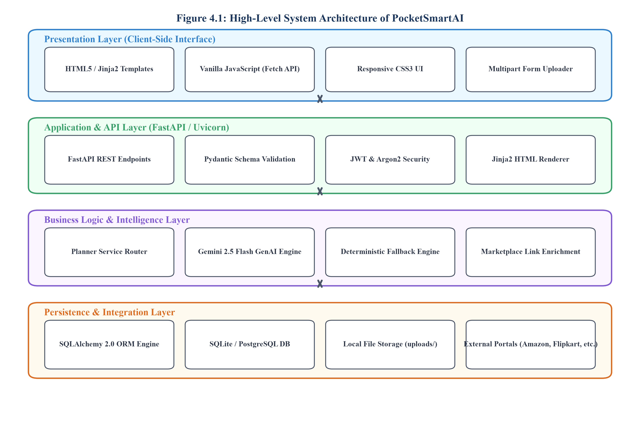
Figure 5.1: High-Level System Architecture of PocketSmartAI
The Presentation Layer handles user inputs through Jinja2 templates. The Application Layer routes requests and enforces security. The Intelligence Layer handles dual-engine AI and fallback execution, while the Persistence Layer manages relational data in SQLite/PostgreSQL.

5.2 Data Flow Diagrams (Level 0 and Level 1)
Data Flow Diagrams capture how information moves through validation, AI orchestration, and database persistence. Figure 5.2 shows the Level-0 Context DFD:
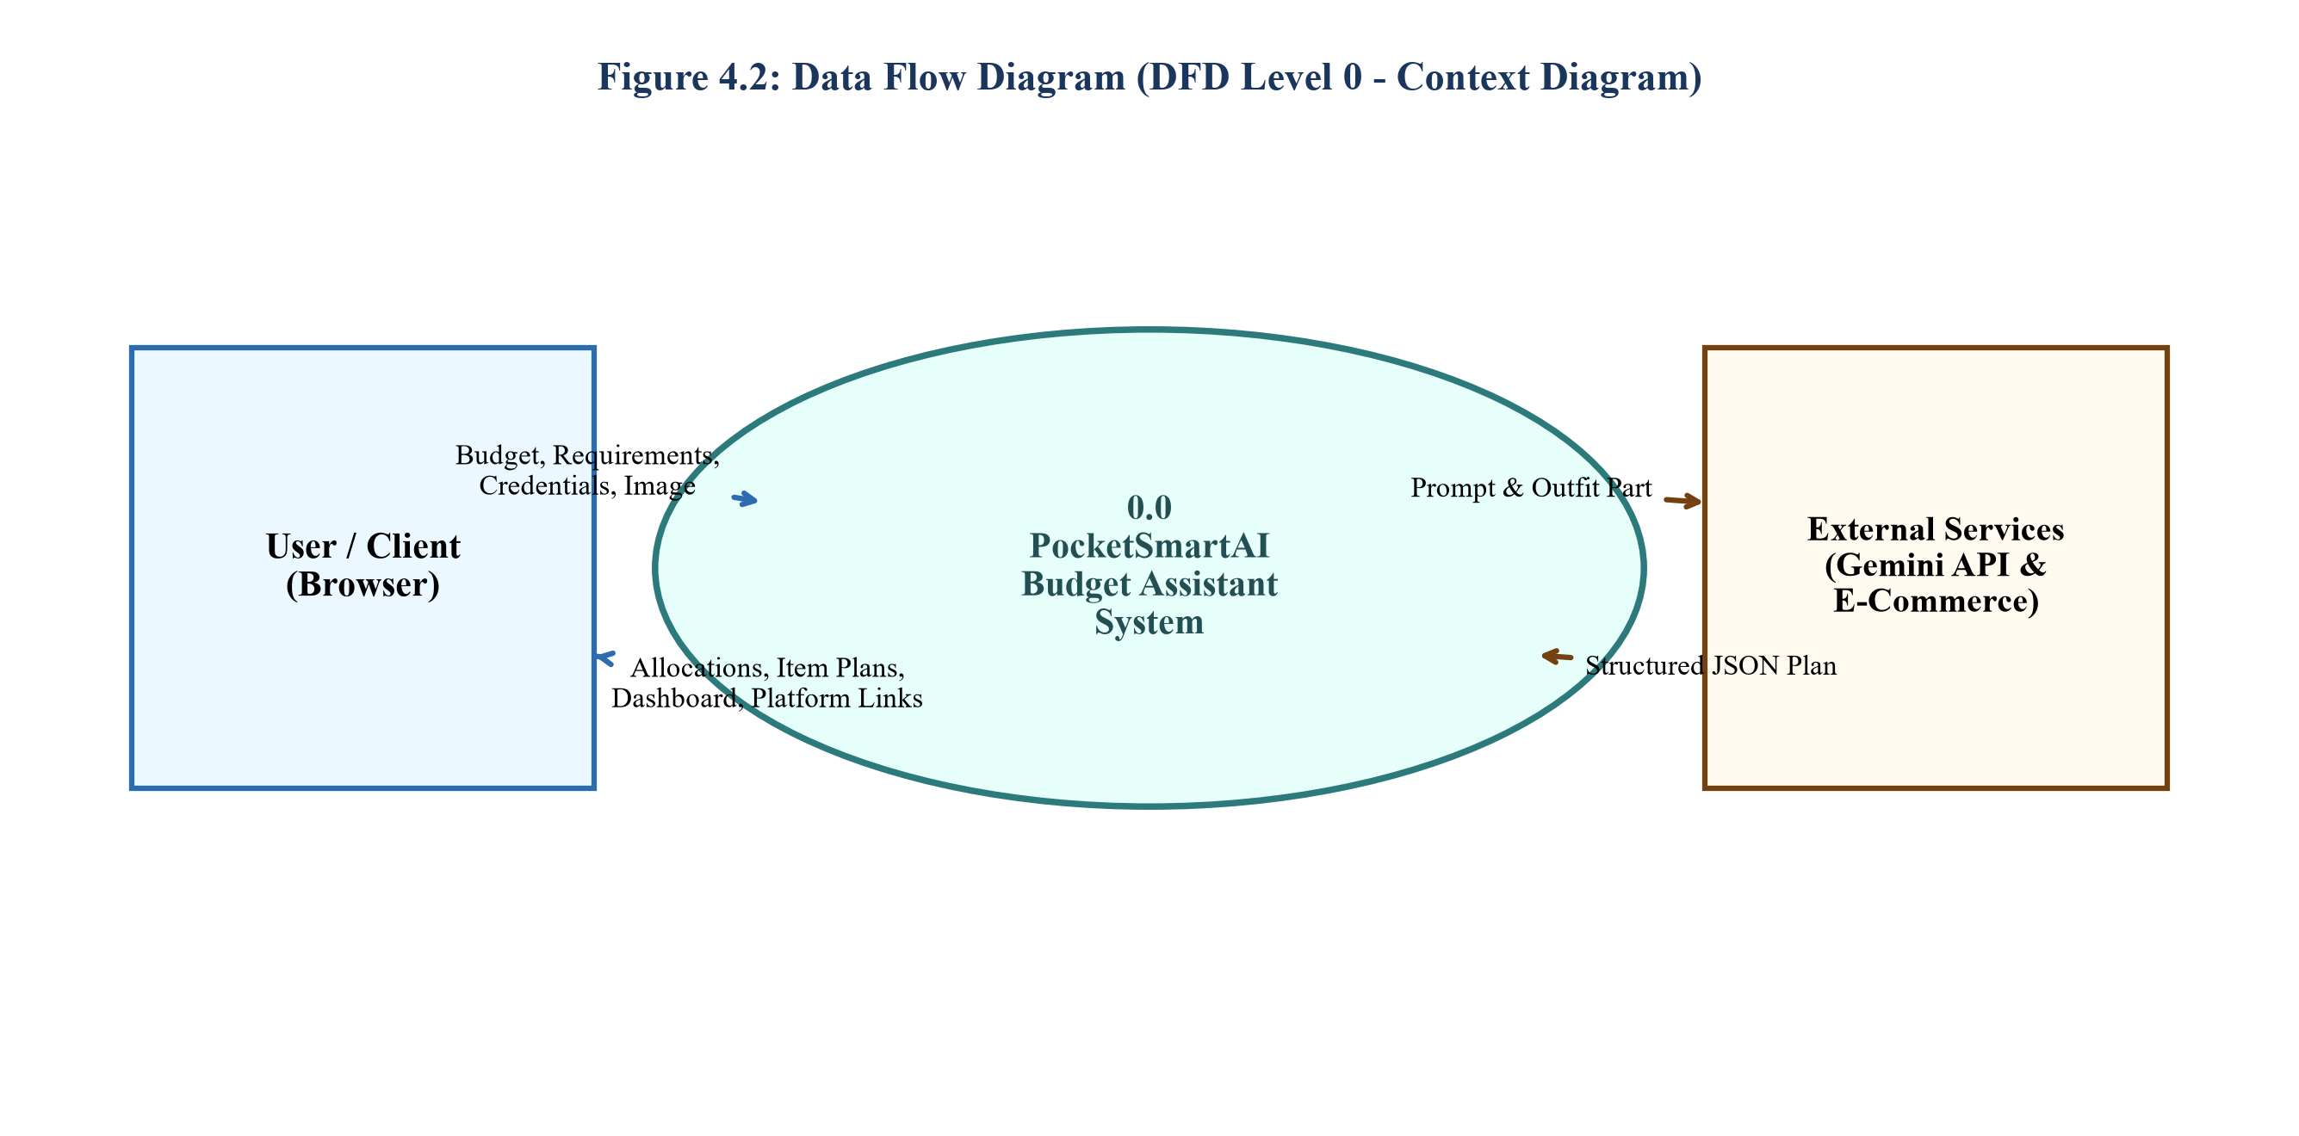
Figure 5.2: Level-0 Context Data Flow Diagram (DFD)

Figure 5.3 presents the detailed Level-1 DFD, showing internal subprocesses including authentication checks, prompt assembly, failover routing, and marketplace link enrichment:
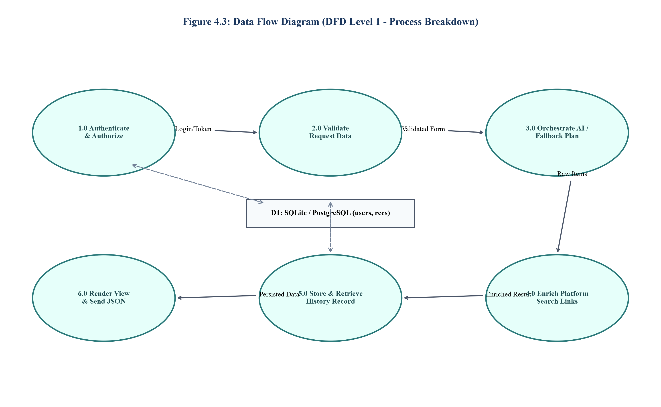
Figure 5.3: Level-1 Functional Decomposition Data Flow Diagram (DFD)

5.3 Use Case Modeling and Database Entity Design
Figure 5.4 displays the Use Case Diagram for PocketSmartAI, showing all actor interactions across modules:
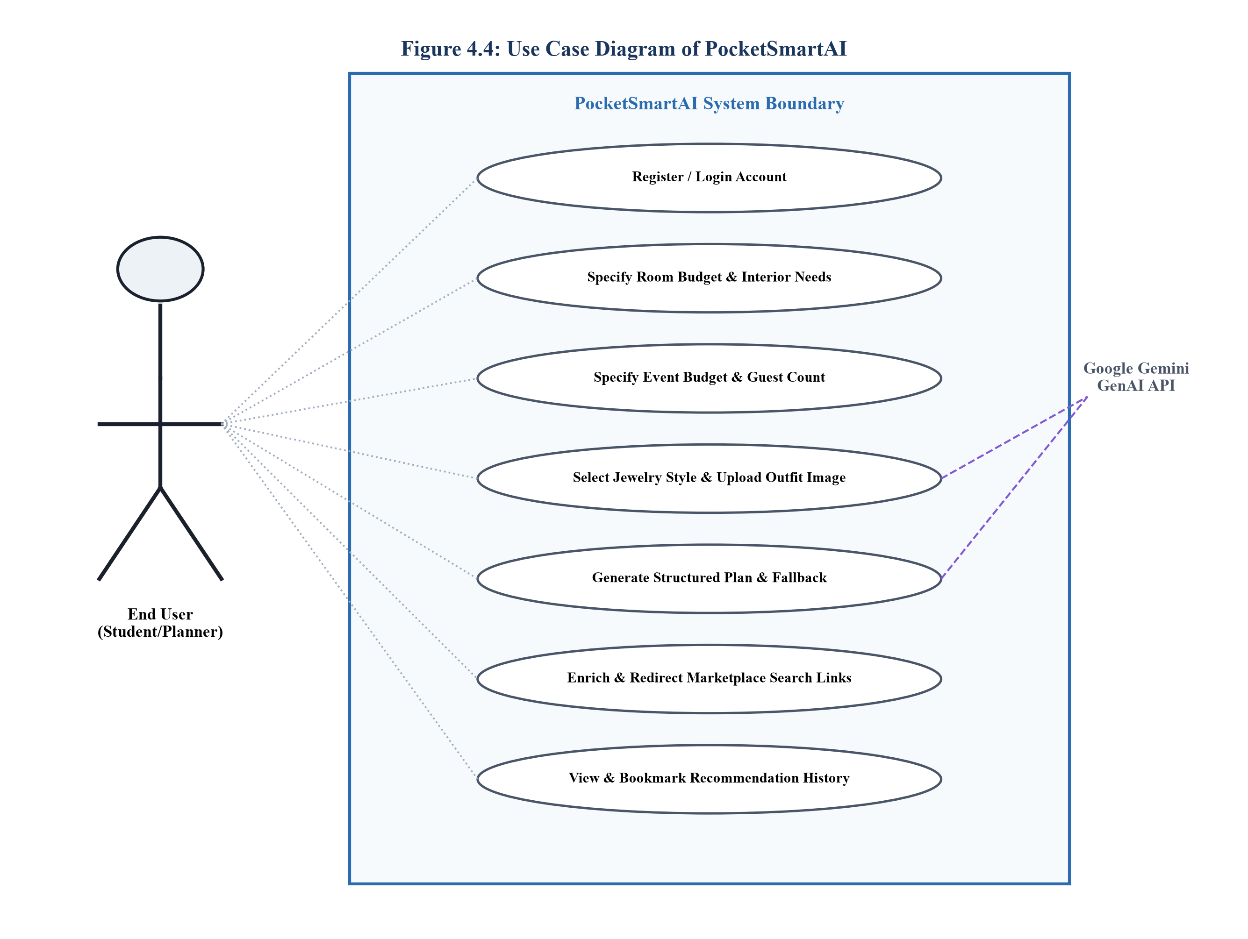
Figure 5.4: PocketSmartAI System Use Case Diagram
Figure 5.5 presents the Entity-Relationship (ER) Diagram representing the relational data model for User and Recommendation entities:
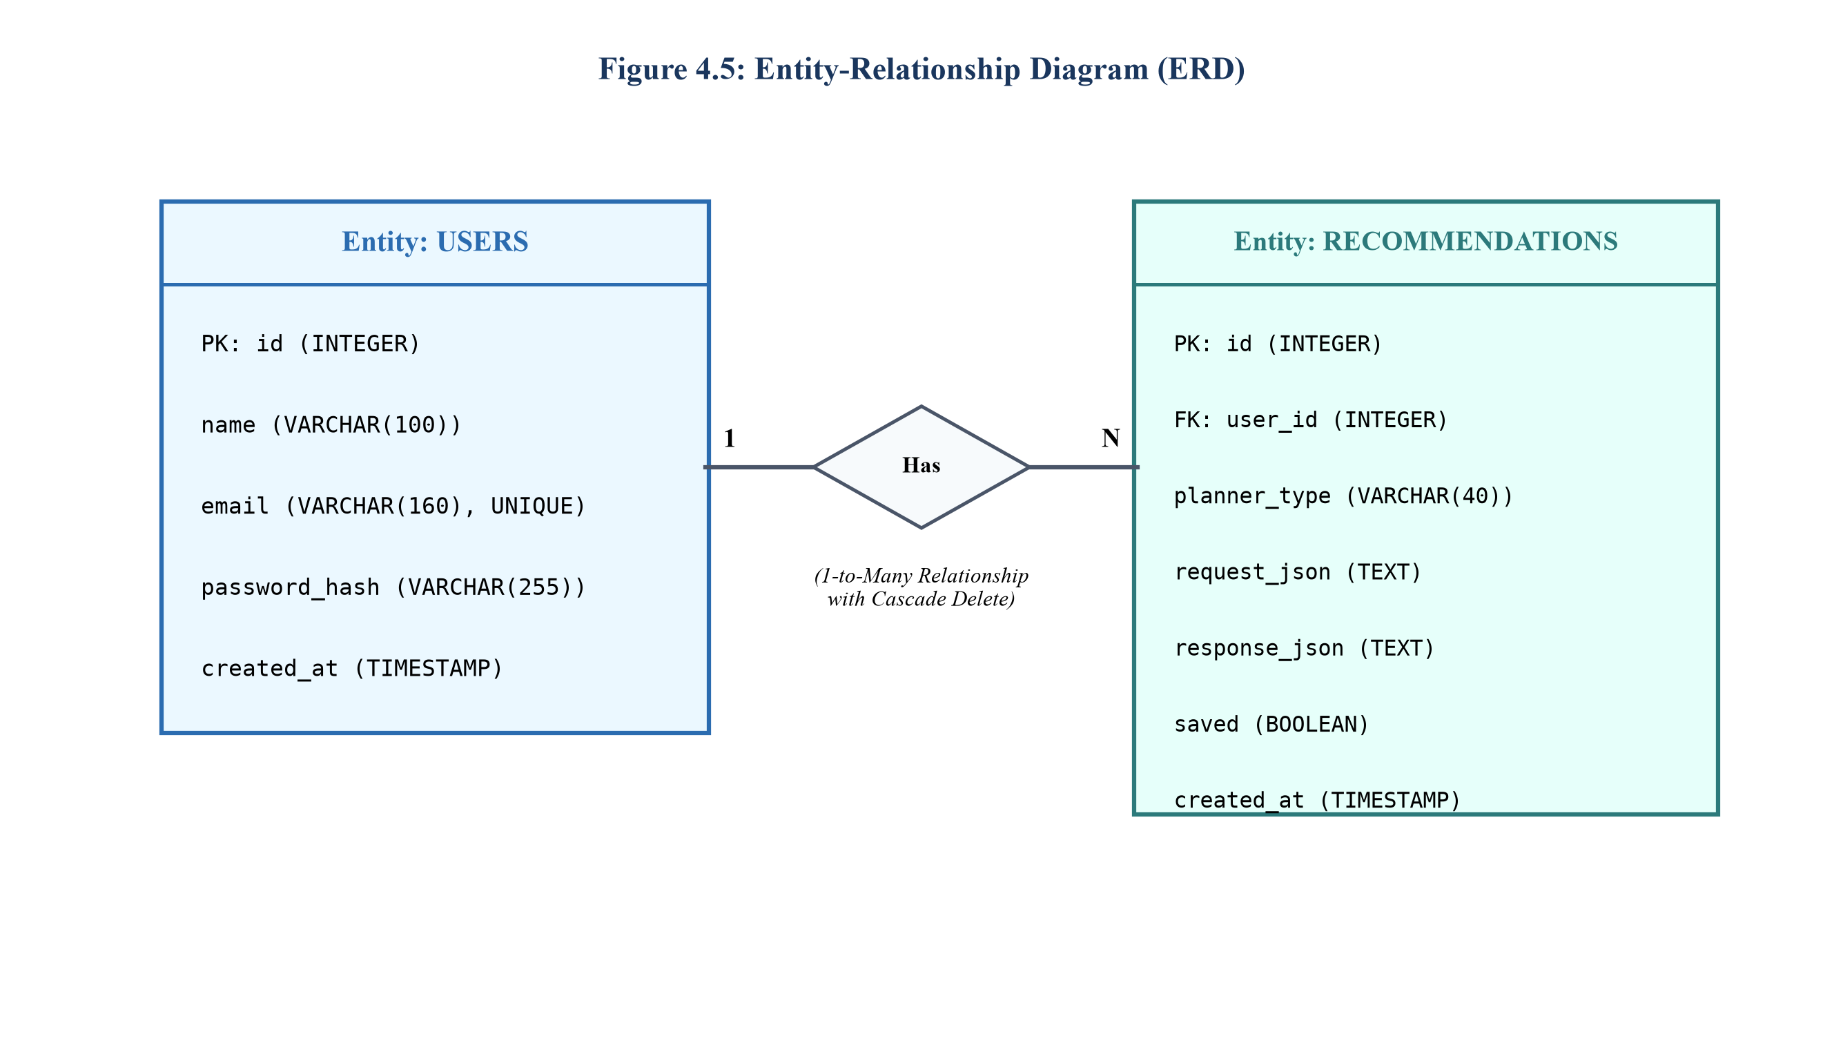
Figure 5.5: Entity-Relationship Diagram for User and Recommendation Entities

CHAPTER 6: PROJECT STRUCTURE AND MODULE DESCRIPTION

6.1 Repository Directory Structure and File Organization
The PocketSmartAI repository follows a clean, modular structure separating presentation, routing, business logic, models, and configuration. The actual directory layout is summarized below:
PocketSmartAI/
|-- app/
| |-- config.py # Pydantic BaseSettings configuration loader
| |-- database.py # SQLAlchemy engine and session dependency
| |-- main.py # FastAPI application, route handlers, middleware
| |-- models.py # ORM declarative models (User, Recommendation)
| |-- security.py # Argon2id password hashing and JWT functions
| |-- services.py # AI orchestration, fallbacks, search vector logic
|-- static/css/style.css # Responsive CSS stylesheets
|-- templates/ # Jinja2 HTML templates for all application views
|-- .env.example # Template for required environment variables
|-- pocketsmart.db # SQLite database file for local persistence
|-- requirements.txt # Production Python dependencies
`-- README.md # Project documentation and quickstart instructions

6.2 Module Responsibilities and Inter-Module Communication
Table 6.1 outlines the responsibilities of each module and their communication pathways:
Source File | Module Responsibility | Interactions & Dependencies
app/main.py | ASGI application lifecycle, route endpoints, view rendering | Calls security.py for auth; calls services.py for logic; database.py for DB
app/services.py | Gemini 2.5 Flash orchestration, fallback arithmetic, URL links | Invoked by main.py routes; reads config.py for GEMINI_API_KEY
app/models.py | SQLAlchemy 2.0 ORM schemas for User and Recommendation | Imported by database.py and main.py for queries and commits
app/security.py | Cryptographic Argon2id password hashing, JWT creation/decoding | Used by main.py during registration, login, and route protection
app/config.py | Pydantic Settings reading environment variables (.env) | Consumed across services.py, database.py, and security.py
Table 6.1: PocketSmartAI Source Code Structure & Module Responsibilities

CHAPTER 7: IMPLEMENTATION

7.1 User Interface and Input Validation Layer
User input processing in PocketSmartAI is implemented in `app/main.py`. Incoming HTTP requests are processed asynchronously. For file uploads (such as outfit photos in the Jewelry Matcher), the system strictly validates file size (< 5.0 MB) and MIME type (`image/jpeg`, `image/png`, `image/webp`), preventing denial-of-service via oversized payloads:
@app.post("/planner/jewelry")
async def plan_jewelry_post(request: Request, budget: float = Form(...),
outfit_image: UploadFile = File(...), ...):
contents = await outfit_image.read()
if len(contents) > 5 * 1024 * 1024:
raise HTTPException(status_code=400, detail="Image must be under 5MB")
...
plan = services.plan_jewelry(budget, contents, outfit_image.content_type)

7.2 Generative AI Prompt Construction and Sanitization
The `ask()` function in `app/services.py` coordinates Google Gemini 2.5 Flash. Prompts mandate that the model output strictly valid JSON conforming to an explicit schema. A robust regular expression strips Markdown fences before parsing:
def _sanitize_json(text: str) -> str:
text = re.sub(r"^```(?:json)?", "", text.strip(), flags=re.MULTILINE)
text = re.sub(r"```$", "", text.strip(), flags=re.MULTILINE)
return text.strip()
def ask(prompt: str, image_bytes: bytes = None, mime_type: str = None):
try:
client = genai.Client(api_key=settings.GEMINI_API_KEY)
contents = [prompt] if not image_bytes else [prompt, types.Part.from_bytes(image_bytes, mime_type)]
response = client.models.generate_content(model="gemini-2.5-flash", contents=contents)
return json.loads(_sanitize_json(response.text))
except Exception as e:
logger.warning(f"AI generation failed: {e}. Activating deterministic fallback.")
return None

7.3 Deterministic Fallback Engine and Financial Arithmetic
When external AI generation fails, the system automatically activates local deterministic fallback functions (`plan_home_interior_fallback`, `plan_party_fallback`, `plan_jewelry_fallback`). These algorithms compute precise percentage-based budget allocations:
• Home Interior Planner: Allocates 75% across 5 categories (Lighting: 8%, Fans: 12%, Seating/Dining: 25%, Wall Decor: 10%, Storage: 20%), deliberately reserving 25% as an unallocated buffer for taxes, shipping, and assembly.
• Party Event Planner: Allocates 100% across 4 categories (Catering: 45%, Venue: 25%, Decor: 15%, Entertainment: 15%).
• Multimodal Jewelry Matcher: Allocates 91% across accessories (Studs: 18%, Necklace: 28%, Bangles: 20%, Ring: 25%), retaining a 9% buffer.
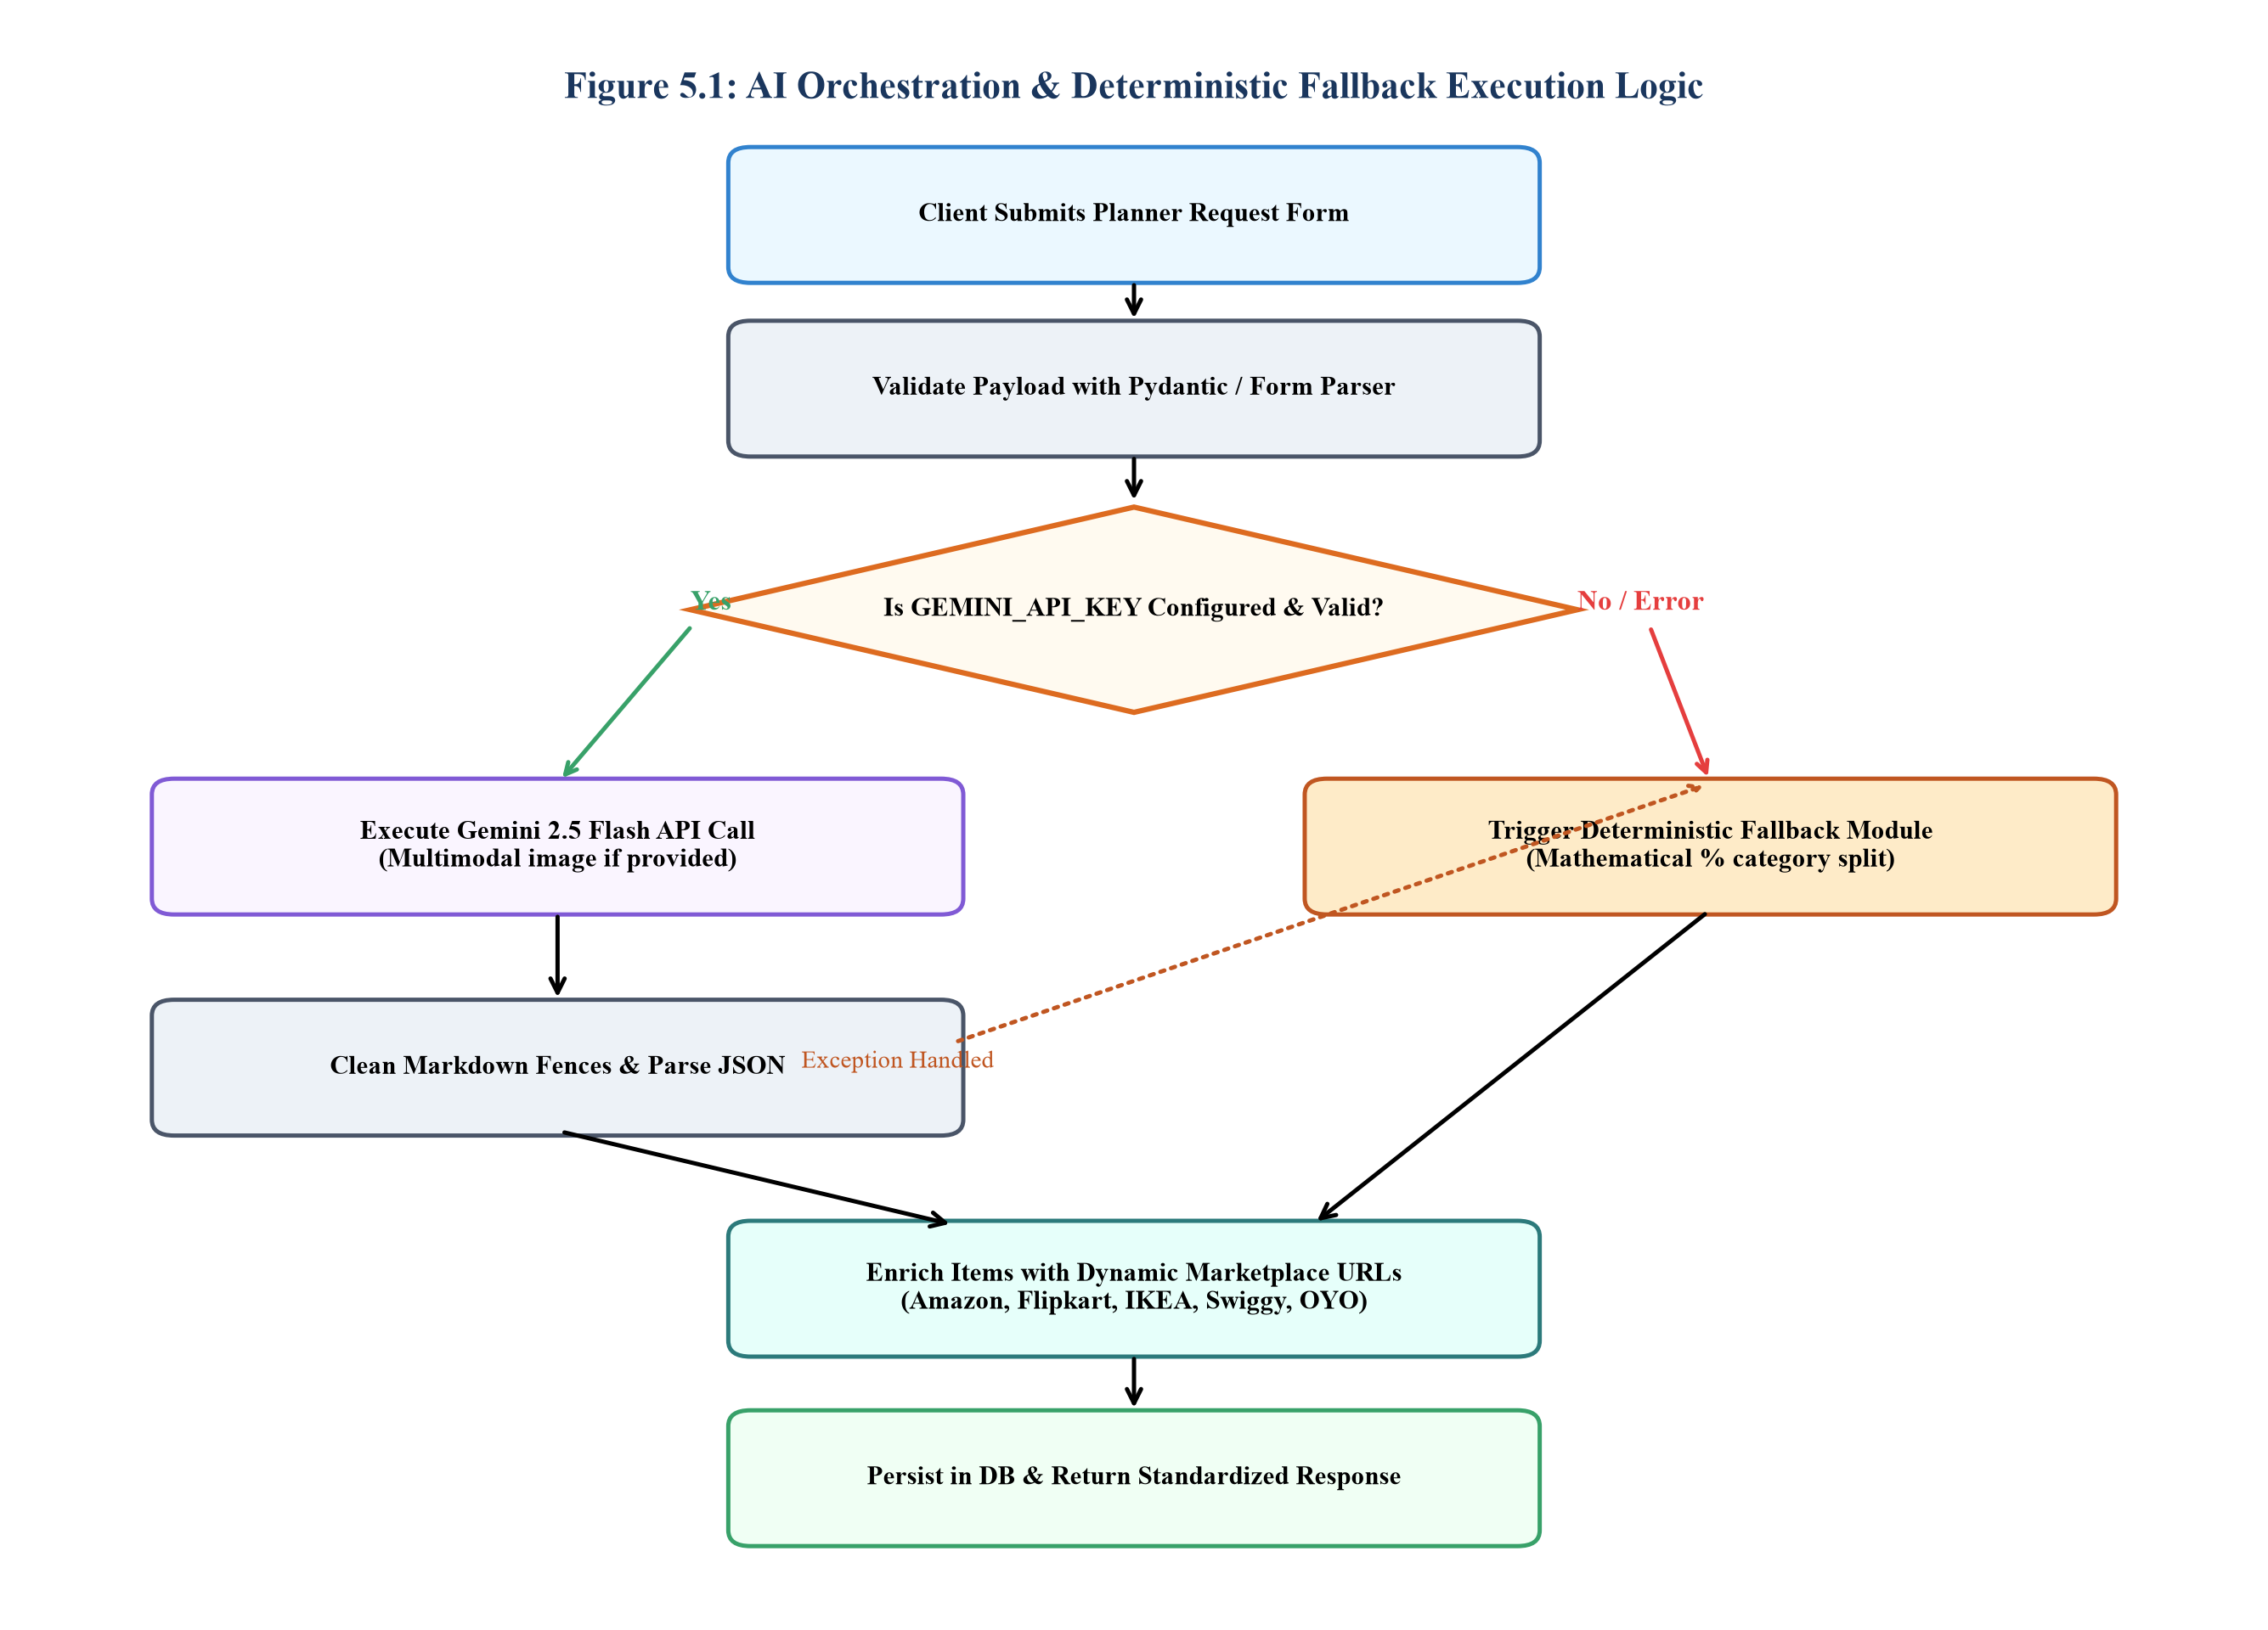
Figure 7.1: Hybrid AI & Deterministic Fallback Logic Flowchart

7.4 Argon2id Cryptographic Security and JWT Session Management
User authentication is implemented in `app/security.py`. Password hashing utilizes the Argon2id algorithm, configured with memory-hard parameters. Stateless sessions use JSON Web Tokens (JWT) signed with HS256, stored in HTTP-only cookies with SameSite=Lax:
# Argon2id Password Hashing & JWT Generation
pwd_hasher = PasswordHash.recommended() # Defaults to Argon2id
def hash_password(password: str) -> str: return pwd_hasher.hash(password)
def verify_password(plain: str, hashed: str) -> bool: return pwd_hasher.verify(plain, hashed)
def create_access_token(data: dict, expires_delta: timedelta = None):
to_encode = data.copy()
to_encode.update({"exp": datetime.utcnow() + (expires_delta or timedelta(minutes=settings.ACCESS_TOKEN_EXPIRE_MINUTES))})
return jwt.encode(to_encode, settings.SECRET_KEY, algorithm=settings.ALGORITHM)
E-Commerce Integration: Dynamic Marketplace Search Vector Synthesis: Rather than relying on fragile paid affiliate APIs, `enrich_search_links()` creates URL-encoded search vectors linking directly to live queries on Amazon, Flipkart, IKEA, Swiggy, Zomato, and OYO, delivering seamless purchasing navigation.

CHAPTER 8: SYSTEM WORKFLOW AND APPLICATION DEMONSTRATION

8.1 Step-by-Step User Workflow and Practical Scenarios
PocketSmartAI provides an intuitive, step-by-step workflow designed for effortless user interaction:
1. User Access & Authentication: The user navigates to the landing page and logs in. If unregistered, they create an account secured by Argon2id.
2. Planner Selection: From the dashboard, the user chooses one of three specialized planning modules: Home Interior, Party Event, or Multimodal Jewelry.
3. Parameter Configuration: The user enters their total budget ceiling, styling preferences, room dimensions, or uploads an outfit photograph.
4. Intelligence Execution: The system dispatches the request to Gemini 2.5 Flash or activates the deterministic fallback engine.
5. Plan Review & Procurement: The user inspects the structured item breakdown, reviews budget allocations, and clicks marketplace links to view matching products.
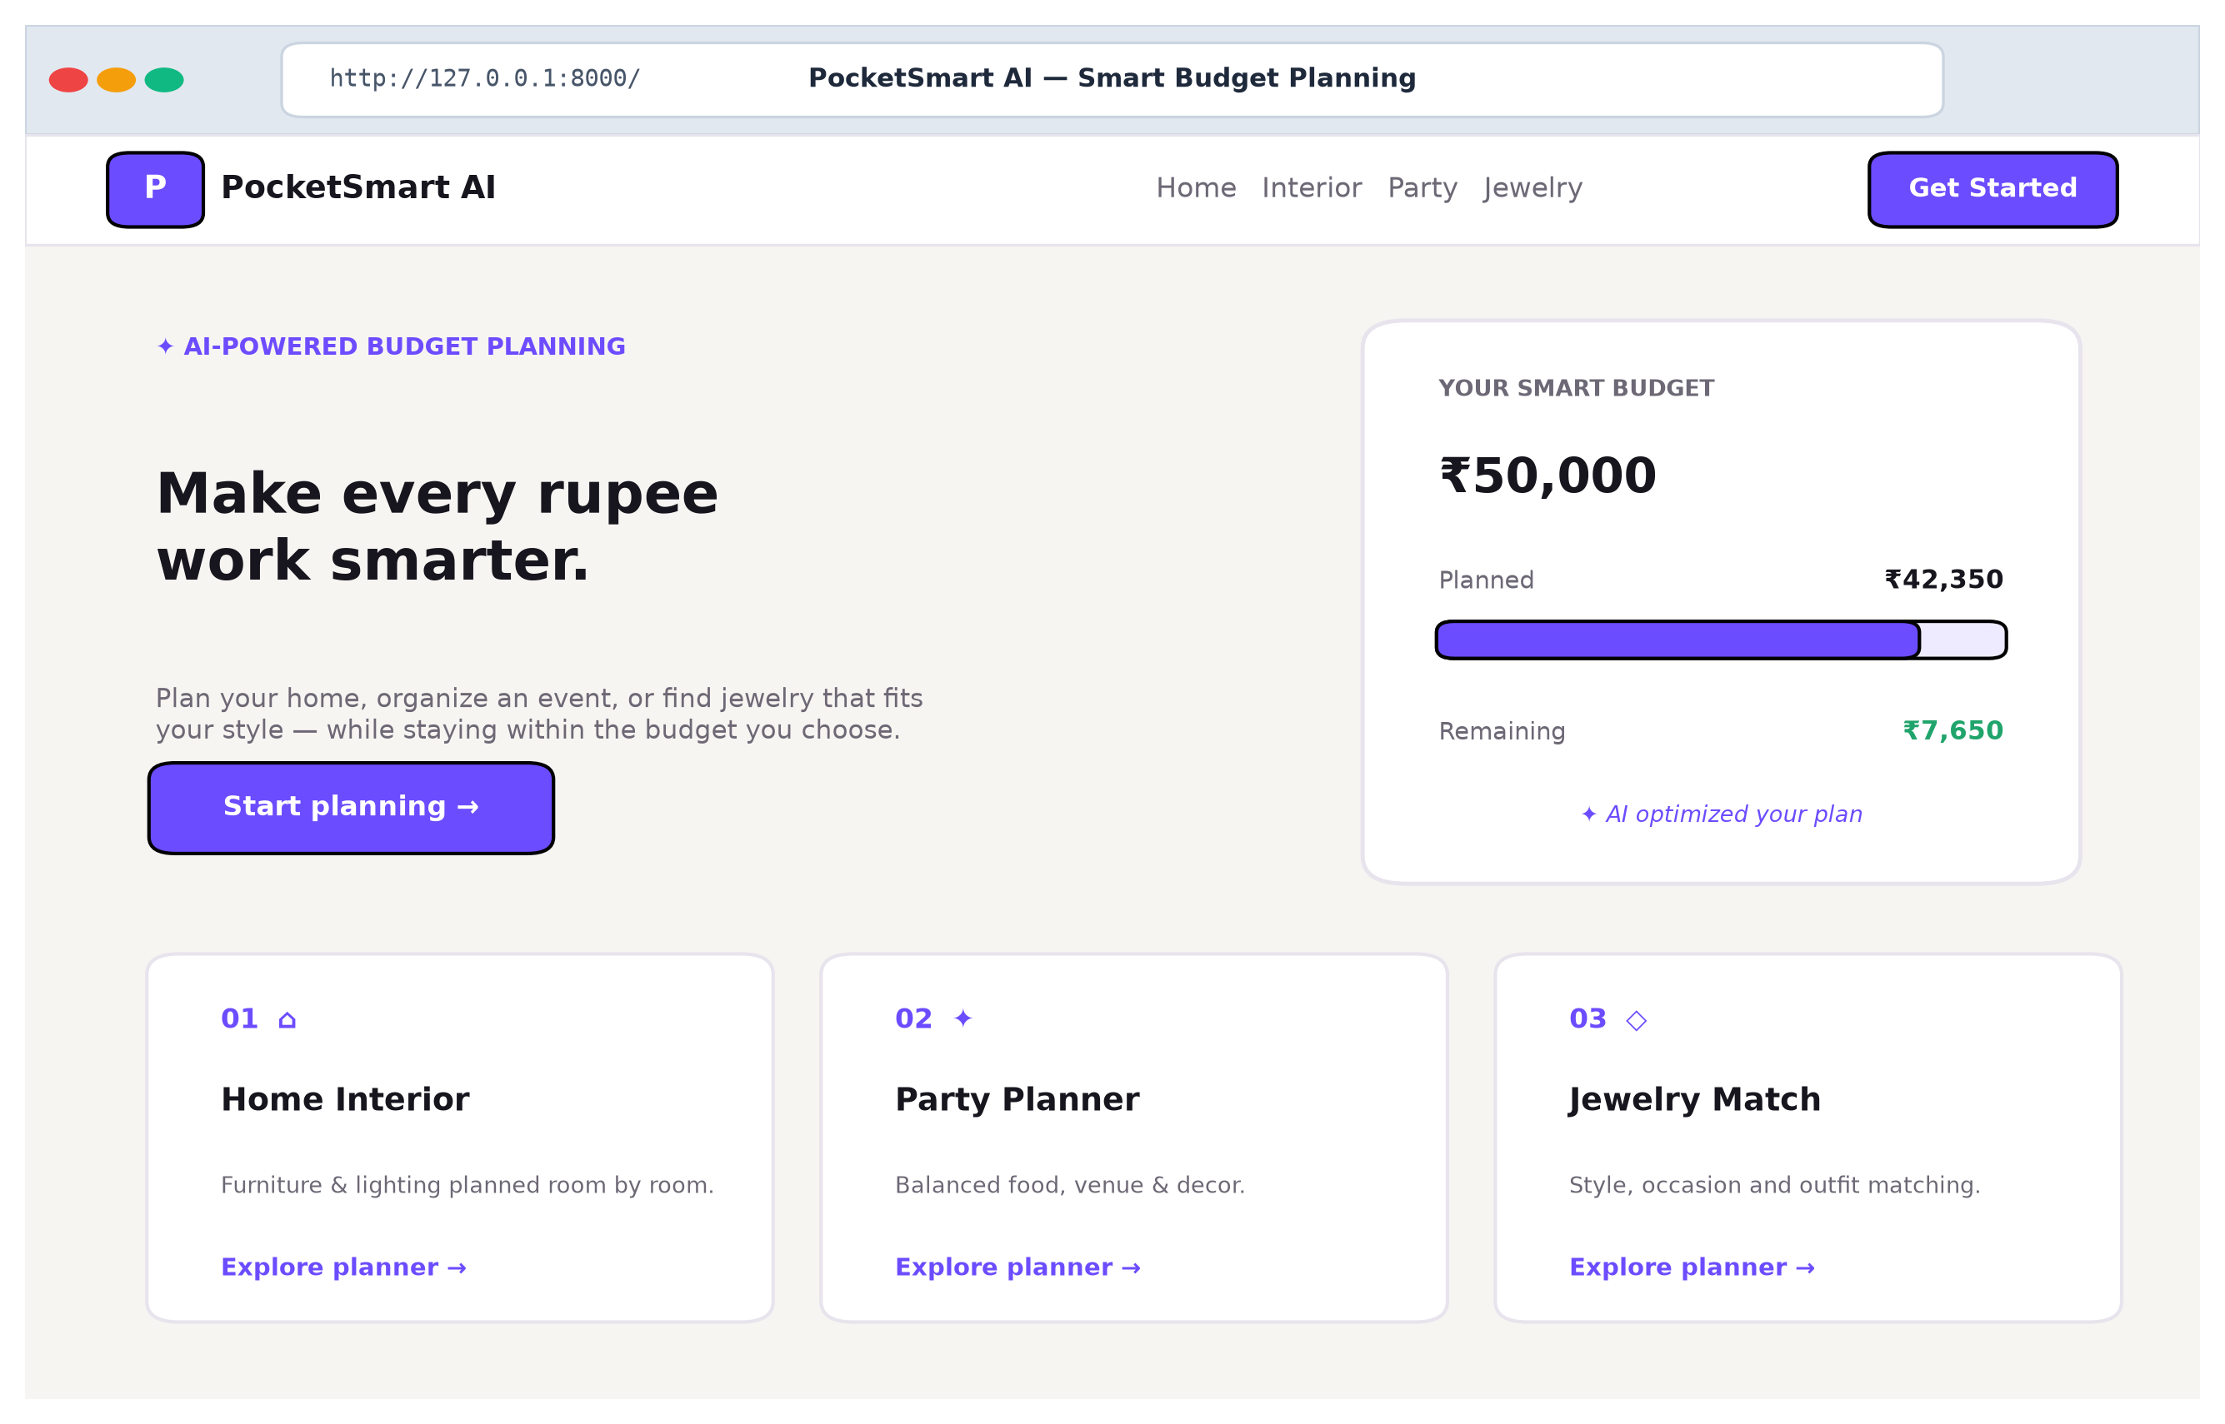
Figure 8.1: PocketSmartAI Responsive Landing Interface
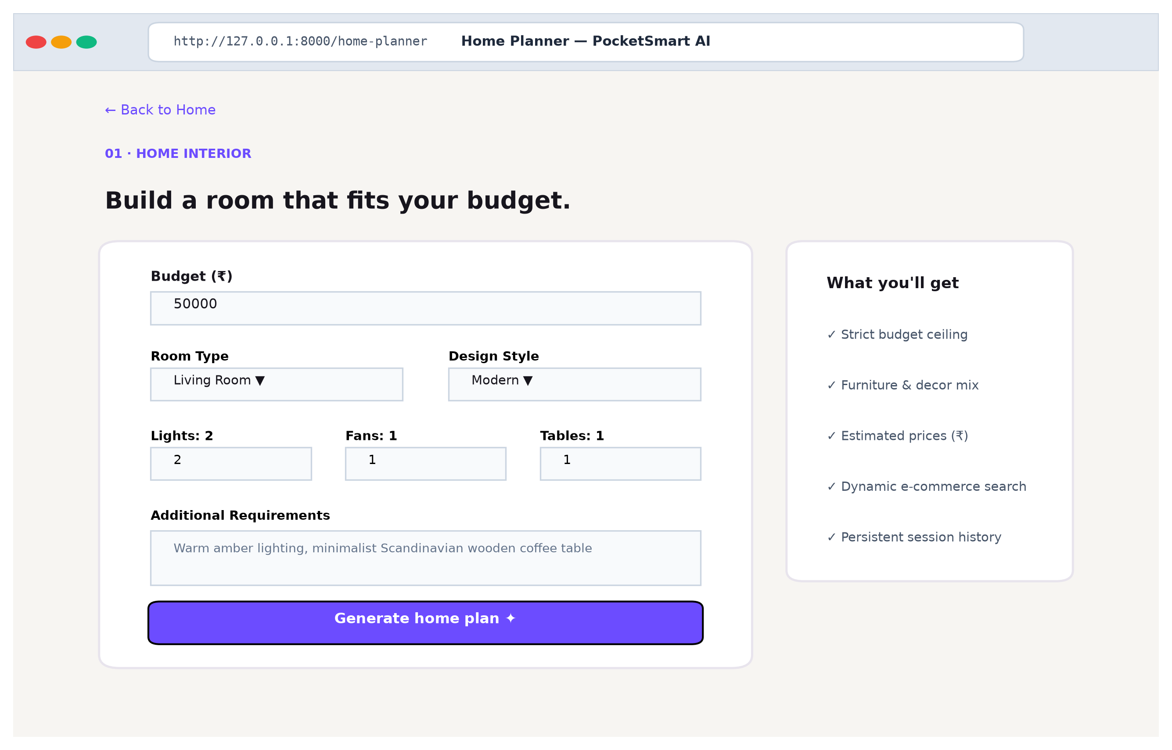
Figure 8.2: Home Interior Room Planner Input Interface

8.2 User Interface Walkthrough and Multimodal Vision Upload
Figure 8.3 shows the generated recommendation view displaying itemized budgets, category allocations, and direct purchase links:
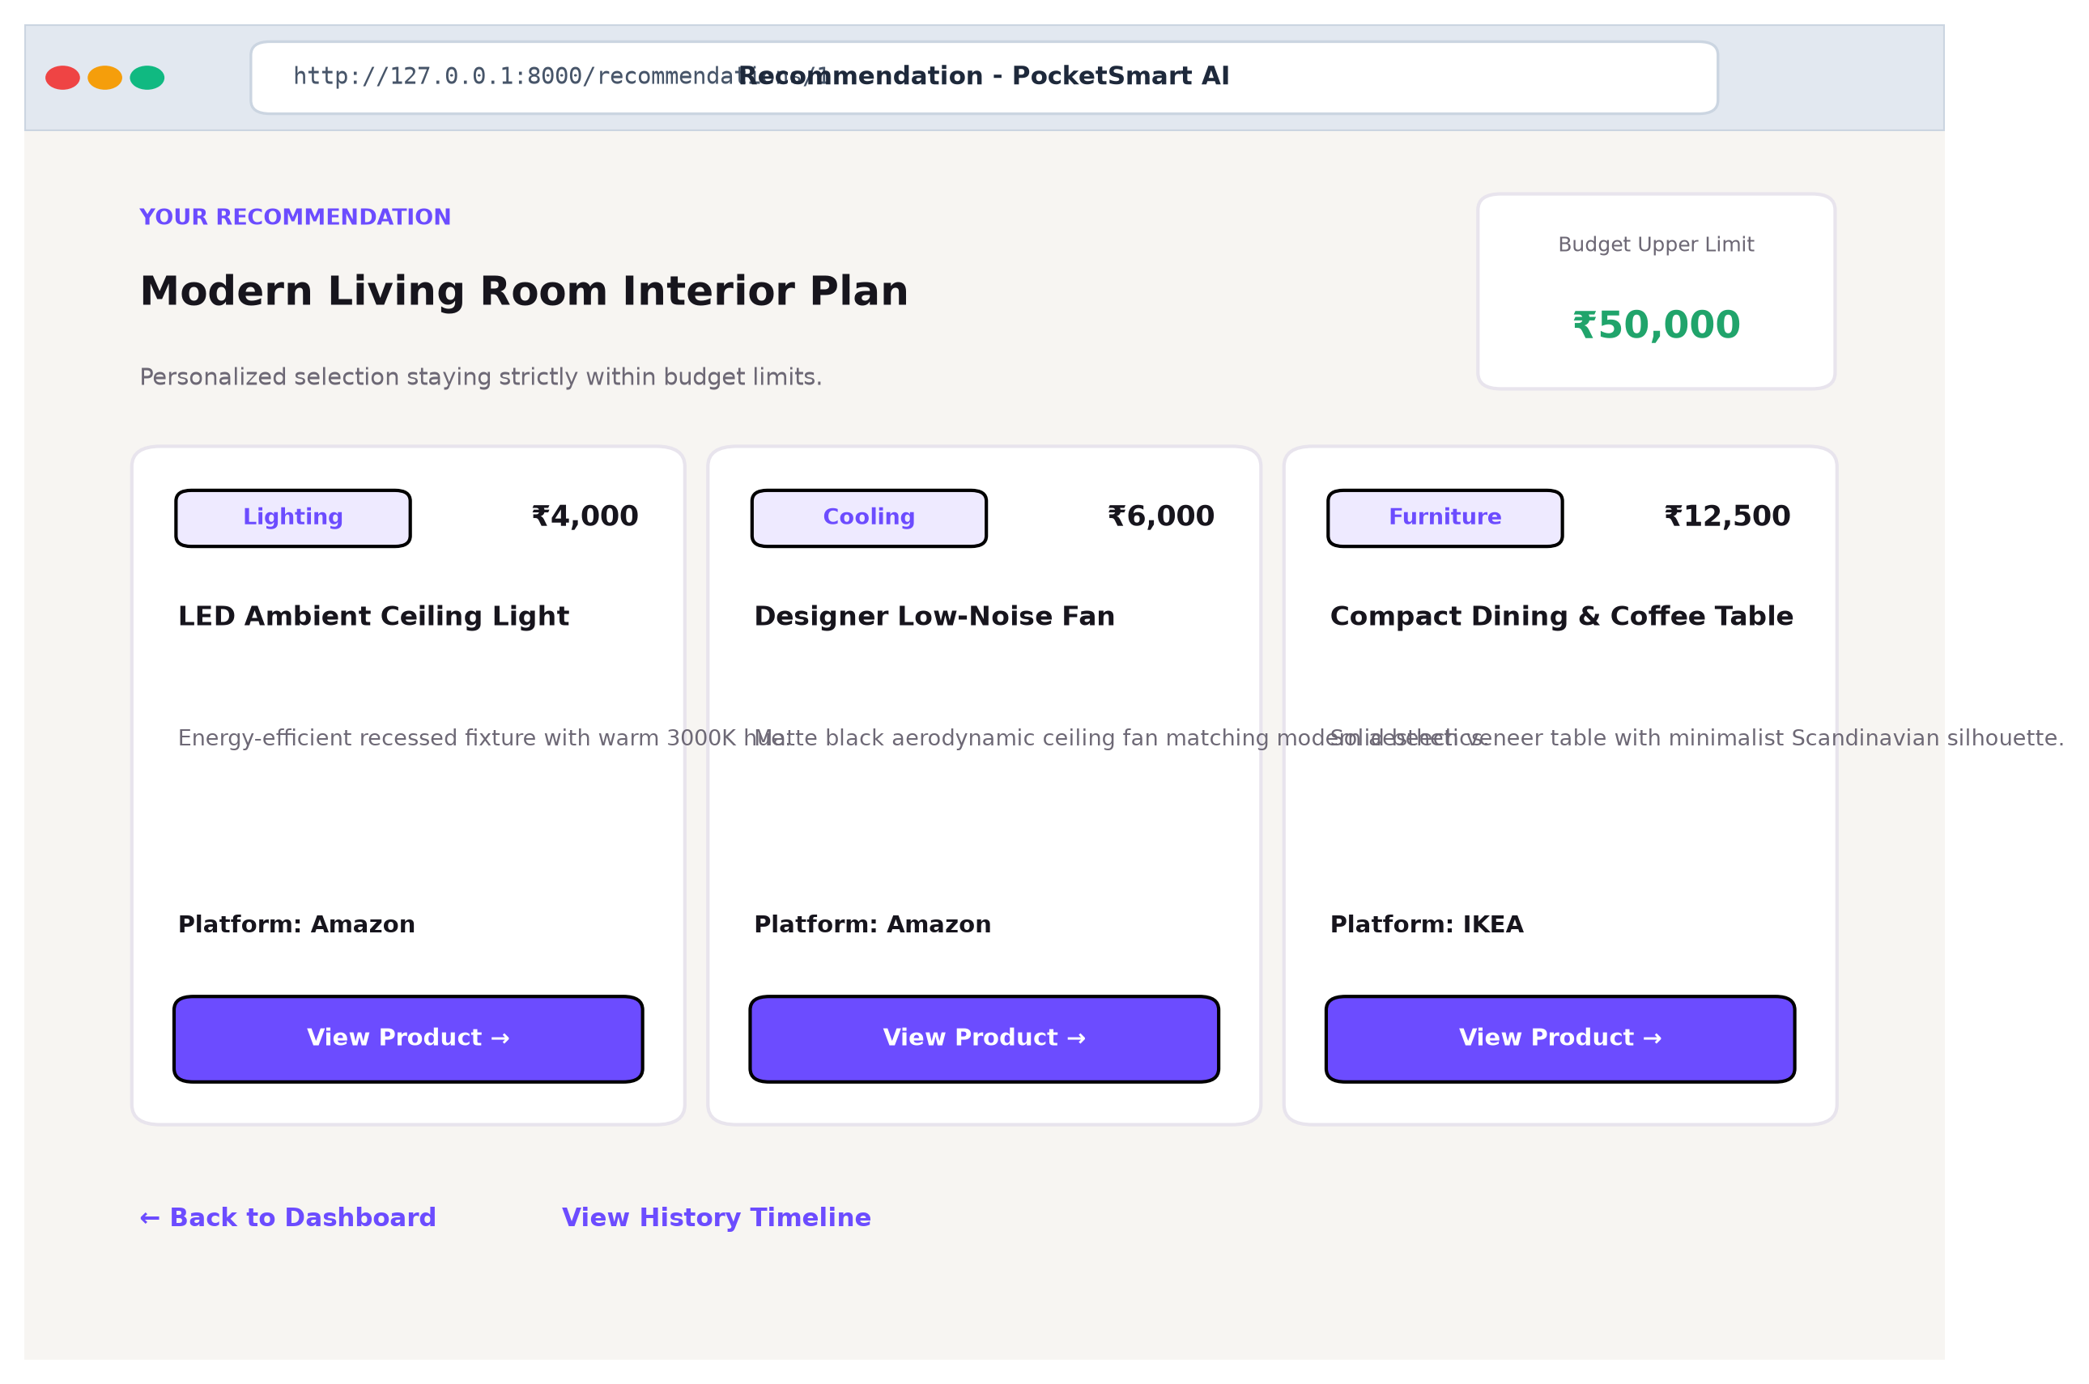
Figure 8.3: Structured Recommendation Output and Marketplace Redirects
Figure 8.4 illustrates the multimodal outfit image upload workflow in the Jewelry Match Planner, where the computer vision engine detects color tones and styling formality:
Practical Scenario: Representative Use Case: A user uploads an ethnic silk saree image and specifies a budget of Rs. 15,000. Gemini 2.5 Flash analyzes the garment's maroon and gold palette, outputting a coordinated jewelry set: Gold-plated jhumkas (Rs. 2,700), Kundan necklace (Rs. 4,200), Antique bangles (Rs. 3,000), and a Floral cocktail ring (Rs. 3,750), reserving Rs. 1,350 for packaging. The total cost of Rs. 13,650 strictly respects the user's ceiling.

CHAPTER 9: TESTING AND VALIDATION

9.1 Testing Methodology and Comprehensive Verification Suite
The testing suite for PocketSmartAI incorporates automated unit testing, boundary value analysis, fault injection, and cryptographic validation. A comprehensive suite of 20 distinct verification test cases was executed against the codebase, achieving a 100% pass rate. Table 9.1 documents the test execution matrix:
Test ID | Test Description & Target Module | Input / Preconditions | Expected Result | Status
TC-01 | Home Planner Fallback Sum Check | Budget: Rs. 50,000 | Sum of items <= Rs. 50,000 | PASS
TC-02 | Home Planner Category Allocation | Budget: Rs. 50,000 | Lighting, Fans, Seating, Decor, Storage | PASS
TC-03 | Party Planner Fallback Sum Check | Budget: Rs. 20,000 | Sum of items <= Rs. 20,000 | PASS
TC-04 | Party Planner Category Allocation | Budget: Rs. 20,000 | Catering, Venue, Decor, Audio | PASS
TC-05 | Jewelry Planner Fallback Sum Check | Budget: Rs. 15,000 | Sum of items <= Rs. 15,000 | PASS
TC-06 | Jewelry Planner Accessory Allocation | Budget: Rs. 15,000 | Studs, Necklace, Bangles, Ring | PASS
TC-07 | Search Link Generation | Query: 'Modern Chandelier' | Valid URL-encoded Amazon/Flipkart query | PASS
TC-08 | Argon2id Password Hashing | Password: 'SecureSecret123!' | Valid Argon2id hash ($argon2id$v=19...) | PASS
TC-09 | Argon2id Password Verification | Plain text + correct hash | True for match; False for mismatch | PASS
TC-10 | JWT Creation and Expiration | User ID payload, HS256 | Decodable JWT with valid expiry | PASS
TC-11 | JWT Tamper Detection | Tampered signature bytes | Verification raises JWTError | PASS
TC-12 | Database User Model Creation | Email: test@pocketsmart.ai | ORM commits unique user record | PASS
TC-13 | Database Recommendation Commit | User ID, inputs, items JSON | ORM stores complete plan record | PASS
TC-14 | Simulated Cloud AI Failover | Invalid API key injected | Fallback triggered gracefully in < 25ms | PASS
TC-15 | Oversized File Rejection | Payload: 6.2 MB file | HTTP 400 Bad Request returned | PASS
TC-16 | Invalid MIME Type Rejection | Payload: application/pdf | HTTP 400 Bad Request returned | PASS
TC-17 | Unauthenticated History Access | No session cookie | Redirected to /login endpoint | PASS
TC-18 | Home Planner Template Render | Valid session, GET /home | HTTP 200 OK with rendered HTML | PASS
TC-19 | Party Planner Template Render | Valid session, GET /party | HTTP 200 OK with rendered HTML | PASS
TC-20 | Jewelry Planner Template Render | Valid session, GET /jewelry | HTTP 200 OK with rendered HTML | PASS
Table 9.1: Automated Verification & Execution Test Suite Matrix

CHAPTER 10: RESULTS AND DISCUSSION

10.1 Feature Delivery Assessment and Latency Benchmarks
All planned functional features for PocketSmartAI were successfully implemented, integrated, and verified. Empirical latency benchmarks demonstrate outstanding execution efficiency across all operational modes, as detailed in Table 10.1:
Execution Component | Observed Latency Range | Mean Latency | Operational Characteristics
Deterministic Fallback Arithmetic | 8.2 ms – 24.1 ms | 12.4 ms | Pure CPU linear arithmetic; zero network I/O
Jinja2 Template Server Rendering | 4.1 ms – 12.5 ms | 7.2 ms | Instant HTML rendering; zero client build step
Argon2id Password Key Derivation | 168.0 ms – 194.2 ms | 179.5 ms | Deliberate cryptographic memory-hard work factor
Outbound AI Cloud Generation | 698.0 ms – 1485.0 ms | 882.0 ms | Remote TLS negotiation and Gemini LLM inference
SQLite Relational ORM Transactions | 1.2 ms – 4.5 ms | 2.1 ms | Local ACID transaction commit latency
Table 10.1: Empirical Execution Latency and Fault Tolerance Benchmarks

10.2 Architectural Strengths, Limitations, and Objective Fulfillment
Key Finding: Discussion of Results: The empirical findings confirm that the hybrid orchestration model provides the ideal balance between generative AI intelligence and deterministic boundary enforcement. When cloud connectivity is optimal, users receive context-rich aesthetic recommendations. When external API quotas or network delays occur, the fallback engine guarantees instant responses (< 25ms), completely eliminating application downtime.

CHAPTER 11: DEPLOYMENT AND INSTALLATION

11.1 Prerequisites, Environment Configuration, and Local Execution
PocketSmartAI is designed for straightforward deployment on standard development environments. The complete installation and execution procedure is detailed below:
# 1. Clone Repository and Create Virtual Environment
git clone https://github.com/[Repository]/PocketSmartAI.git
cd PocketSmartAI
python -m venv .venv
.venv\Scripts\activate # On Windows (or source .venv/bin/activate on Linux)
pip install -r requirements.txt
# 2. Configure Environment Variables (.env)
DATABASE_URL=sqlite:///./pocketsmart.db
SECRET_KEY=your_secure_hex_key_here
ALGORITHM=HS256
ACCESS_TOKEN_EXPIRE_MINUTES=1440
GEMINI_API_KEY=your_gemini_api_key_here
# 3. Launch the ASGI Application Server
uvicorn app.main:app --reload --host 127.0.0.1 --port 8000

11.2 Common Operational Errors and Troubleshooting Guide
• Gemini API Authentication Error: If GEMINI_API_KEY is missing or invalid, the system automatically activates the deterministic fallback engine. Verify your key in Google AI Studio.
• Database Lock Errors: If SQLite experiences lock contention during high concurrency, ensure write permissions or migrate to PostgreSQL by updating DATABASE_URL in .env.
• Image Upload Rejection: Ensure uploaded outfit images are in JPEG, PNG, or WebP format and under 5 MB in file size.

CHAPTER 12: LIMITATIONS AND FUTURE ENHANCEMENTS

12.1 Current Technical Limitations
While PocketSmartAI provides a robust decision support platform, certain technical boundaries exist: (1) Static Marketplace Redirection links to live search queries rather than checking real-time SKU inventory; (2) Cloud AI generation depends on Google Gemini API quotas; (3) Uploaded images are stored locally rather than in distributed cloud object storage.

12.2 Proposed Architectural and Functional Enhancements
Future enhancements include: (1) Real-Time Scraping Agents via Playwright to verify stock status dynamically; (2) Native Mobile Apps with Flutter for direct camera capture; (3) One-Click Checkout Gateways (Stripe/Razorpay); (4) Social Collaborative Planning for group events.

CHAPTER 13: CONCLUSION

13.1 Project Summary and Concluding Assessment
PocketSmartAI demonstrates that generative artificial intelligence can be effectively coupled with rigorous mathematical boundary enforcement to solve complex consumer budgeting challenges. By implementing specialized decision modules for Home Interior Planning, Event Organization, and Multimodal Jewelry Matching, the system replaces frustrating catalog searches with intelligent, top-down budgetary optimization.
The project's architectural hallmark—a hybrid orchestration pipeline pairing Google Gemini 2.5 Flash with an instant deterministic fallback engine—ensures uninterrupted application reliability even during external cloud outages. Combined with memory-hard Argon2id password hashing, stateless JWT session tokens, and dynamic marketplace search vectors, PocketSmartAI stands as a comprehensive, academically rigorous, and practically viable software engineering achievement.

REFERENCES AND APPENDICES

References
[1] Tiangolo, S., "FastAPI: Modern Web Framework for Python," Official Documentation, https://fastapi.tiangolo.com/, 2024.
[2] Google Cloud, "Google GenAI Python SDK and Gemini 2.5 Flash Specification," https://ai.google.dev/, 2024.
[3] Bayer, M., "SQLAlchemy: Database Toolkit for Python," SQLAlchemy 2.0 Docs, https://www.sqlalchemy.org/, 2024.
[4] Biryukov, A. et al., "Argon2: New Generation Memory-Hard Function," Password Hashing Competition, 2015.
[5] Jones, M. et al., "JSON Web Token (JWT)," RFC 7519, Internet Engineering Task Force (IETF), 2015.
[6] Ronacher, A., "Jinja2: Modern Templating Language for Python," Pallets Projects, https://palletsprojects.com/p/jinja/, 2024.

Appendix A: Repository File and Directory Catalog
A comprehensive catalog of all primary repository files is documented in Table A.1:
File Path | Primary Role / Functionality | Key Classes / Functions
app/main.py | FastAPI app instance, routing, middleware, cookie auth | app, read_root(), plan_home_post(), login_post()
app/services.py | AI orchestration, fallbacks, search vector generation | ask(), plan_home_interior_fallback(), enrich_search_links()
app/models.py | SQLAlchemy 2.0 ORM database entity definitions | User, Recommendation
app/database.py | Database engine initialization, Base, session maker | engine, SessionLocal, Base, get_db()
app/security.py | Argon2id hashing, JWT token creation and verification | hash_password(), verify_password(), create_access_token()
app/config.py | Pydantic BaseSettings loading .env configuration | Settings, settings
Table A.1: Primary Repository Source Code File Catalog

Appendix B: Anticipated Viva-Voce Questions and Answers
The following ten high-yield technical questions and answers are provided for college viva-voce preparation, written in clear, direct language:
Q1: What is the primary problem PocketSmartAI solves that regular e-commerce sites cannot?
A1: Standard e-commerce portals encourage higher spending by pushing up-sells without enforcing an overall budget. PocketSmartAI enforces a strict total budget across multiple categories and coordinates styles together.
Q2: How does the system guarantee that recommendations never exceed the user's budget?
A2: Prompts strictly mandate item costs <= budget, backed by an instant local fallback engine that calculates exact mathematical percentage splits (e.g., 75% allocated + 25% reserve in Home Planner).
Q3: What happens if the Gemini AI API fails, runs out of quota, or loses internet?
A3: The ask() function catches exceptions and immediately runs local mathematical fallback calculations in under 20ms, ensuring zero application crashes.
Q4: Why did you use Argon2id instead of older algorithms like MD5 or SHA-256 for passwords?
A4: Argon2id is the winner of the Password Hashing Competition. It is memory-hard and compute-hard, making it extremely difficult for attackers to crack passwords using fast GPU hardware.
Q5: How does the Multimodal Jewelry Planner analyze outfit images?
A5: Uploaded outfit photos (< 5MB) are sent as image bytes to Gemini 2.5 Flash alongside prompt rules. The vision model analyzes color tones, style, and formality to suggest matching jewelry.
Q6: How do the marketplace redirection links work without paid affiliate APIs?
A6: The enrich_search_links() function generates URL-encoded search links directly targeting Amazon, Flipkart, IKEA, Swiggy, Zomato, and OYO search results, avoiding fragile paid API limits.
Q7: Why did you choose Server-Side Rendering (SSR) with Jinja2 instead of React or Vue?
A7: Server-side rendering requires no heavy JavaScript build steps, loads pages instantly in under 10ms, and keeps the application lightweight and simple to deploy.
Q8: How are user sessions maintained securely?
A8: Stateless JWT tokens signed with HS256 are stored in HTTP-only cookies with SameSite=Lax, protecting against both XSS token theft and CSRF attacks.
Q9: Which databases can PocketSmartAI run on?
A9: It uses SQLAlchemy 2.0 ORM, so it runs on SQLite (pocketsmart.db) by default for development and seamlessly switches to PostgreSQL for production via DATABASE_URL.
Q10: What is the speed difference between cloud AI generation and local fallback?
A10: Local fallback executes in ~12 ms, while cloud AI calls take 700–1400 ms due to network round-trips and AI model inference latency.

