**DOCUMENTATION**

Name: Krithivas Swaminathan

Email:ks583@njit.edu

OUTPUT

**Horizontal Sort Display After Completion**

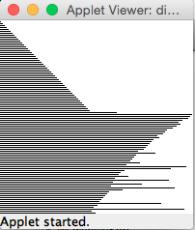 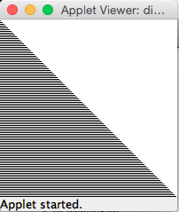

**Vertical Sort Display After Completion**

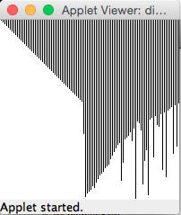 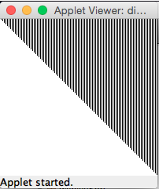

**Base Sort Display After Completion**

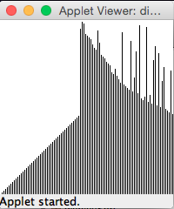 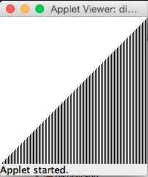

**Bar Sort Display After Completion**

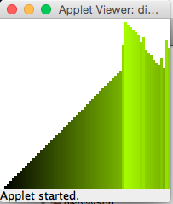 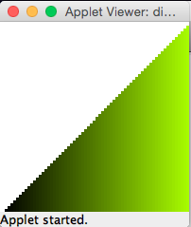

**Line Sort Display After Completion**

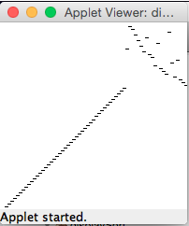 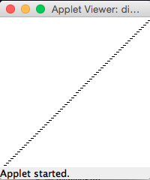

**Running all the Display Strategies simultaneously**

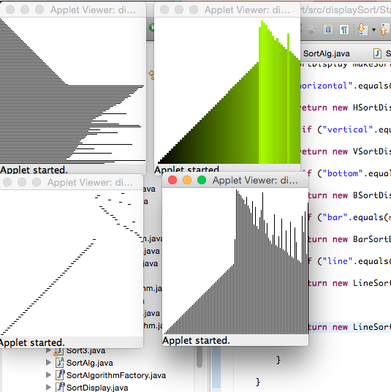

**Running Quick Sort (Left) and Insertion Sort (Right) Simultaneously to compare the speed**

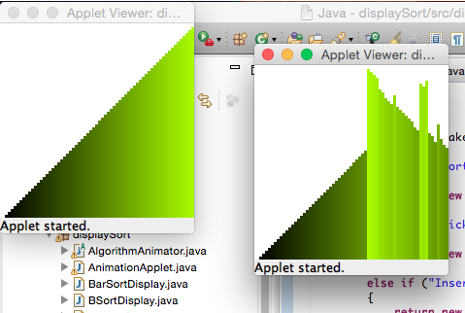

**Running all Algorithms Simultaneously to compare Speed**

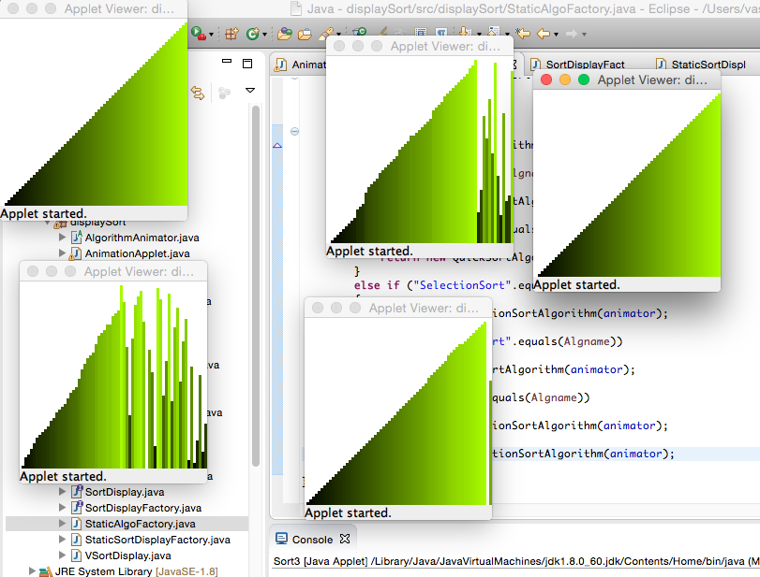

**Communication Diagram**

SelectionSortAlgorithm

BubbleSortAlgorithm

HeapSortAlgorithm

QuickSortAlgorithm

InsertionSortAlgorithm

BarsortDisplay

VsortDisplay

BsortDisplay

LinesortDisplay

HsortDisplay

theAlgorithm.sort(arr)

Animator

**SortAlg**

Inherits

AlgorithmAnimator

Inherits

**Sort2**

displayFactory

Implements Interface

theDisplay

SortDisplayFactory (Interface)

Inherits

SortDisplay

**Sort3**

Creates

StaticSortDisplayFactory

Inherits

algorithmFactory

SortAlgorithmFactory(Interface)

**makeSortAlgorithm()**

Implements Interface

Creates

StaticAlgoFactory