**Documentation**

Name: Krithivas Swaminathan

Email: krithivas@gmail.com

**Digital Clock (Alarm & Roman Numerals)**

**Screenshots**

**Captured at 8:15 AM –**

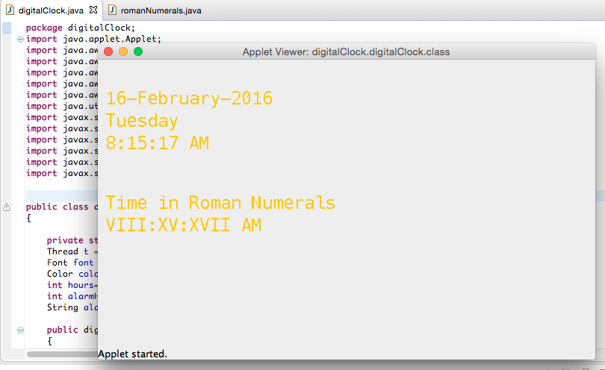

**Captured at 9:49 AM-**

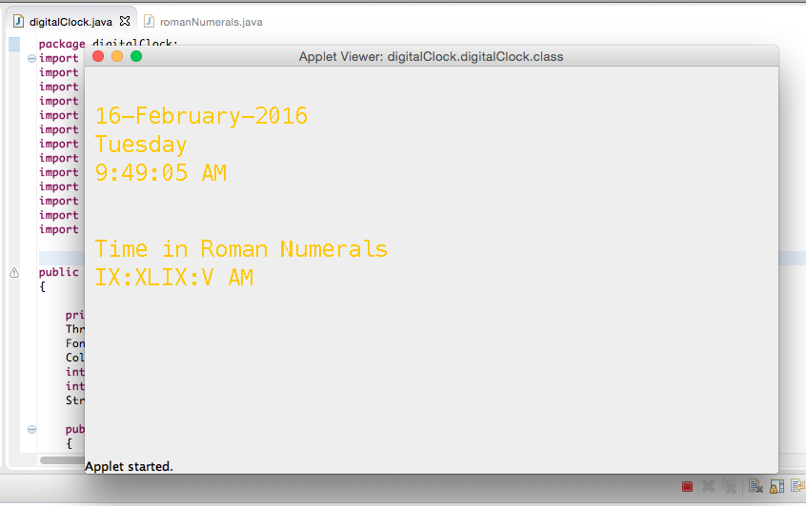

**Alarm Function**

**Setting Alarm at 8:25 AM**

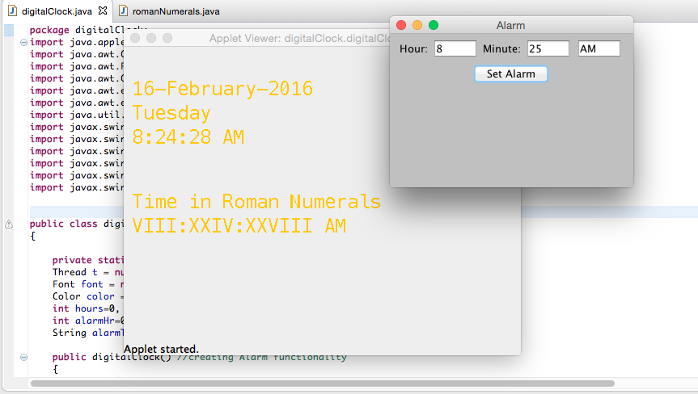

**Wake Up Call at 8.25 AM**

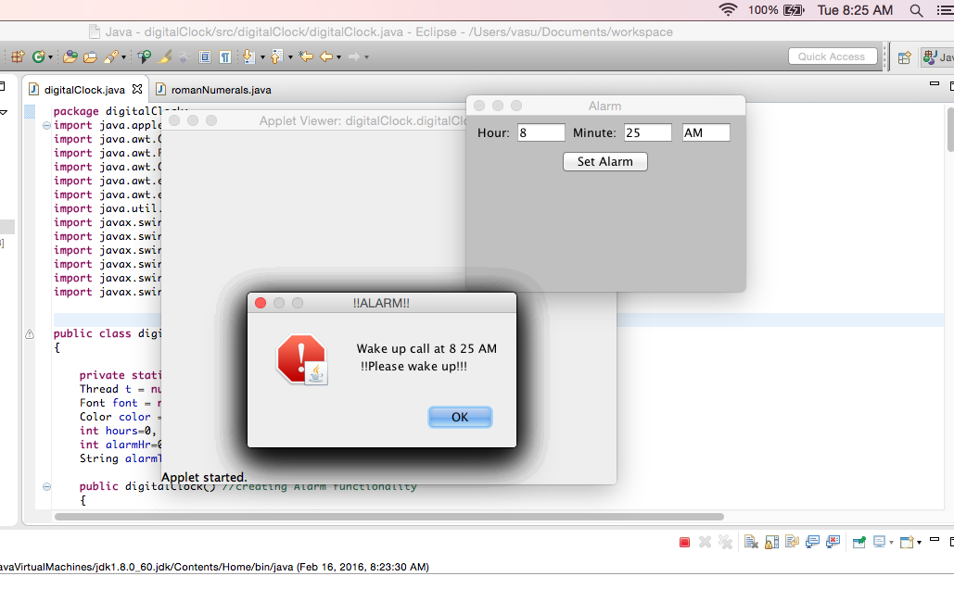

**Exception Handling – Alarm**

**Entering String inputs in the Hour and Minute Text Fields displays “Wrong Inputs” error box.**

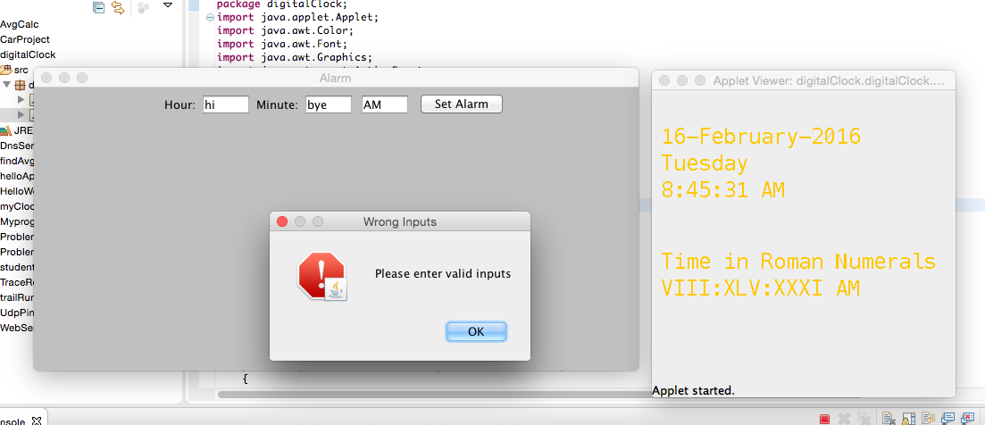

**Entering inputs in the Hour and Minute Text Field greater than 12 and 59 displays the “Invalid Input” error box with the below error message.**

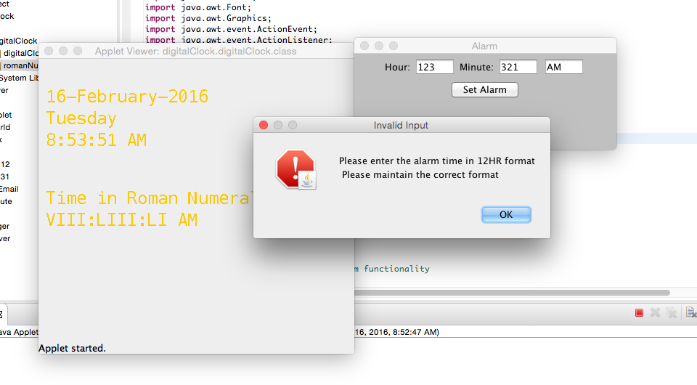

**(Digital Clock with Alarm)**

**Use Case: -** Set Alarm

**Level: -** User Goal

**Primary Actor**: - Person who needs an alarm

**Purpose: -**  To provide a user alarm at a given input time.

**Overview: -** User enters the Hours and Minutes inputs and clicks on Set Alarm button. Alarm gets set up. User gets a wakeup call at the alarm time.

**Pre-conditions:**

Hour, minute and AM/PM accepted as inputs.

Hour & Minute field must not be String inputs.

Hour and Minute field must not exceed 12 and 59 respectively.

**Type: - Expanded Essential**

**Basic Flow or Ideal Flow**

|  |  |  |
| --- | --- | --- |
| **S.no** | **Actor Actions** | **System Responses** |
| 1. | User enters the Hour, Minute and AM/PM fields. | Typed inputs displays in the respective fields. |
| 2 | User clicks on “Set Alarm” button. | The application accepts inputs. |
| 3. | User gets alerted. | The application generates a wakeup call. |

**Alternate Flow: -**

1. **User enters String inputs in the hour or minute fields.**

**(example: Types ‘abcd’ in the hour feild)**

* “Wrong Input” error box is displayed on the screen.

1. **User enters a value greater than 12 in the hour field.**

* **“**Invalid Input” error box stating error message “Please enter input the alarm time in 12HR format” is displayed on the screen.

1. **User enters a value greater than 59 in the minute field.**

* **“**Invalid Input” error box stating error message “Please enter input the alarm time in 12HR format” is displayed on the screen.

**Functionality:**

Time and date

Day of week

Month

Year

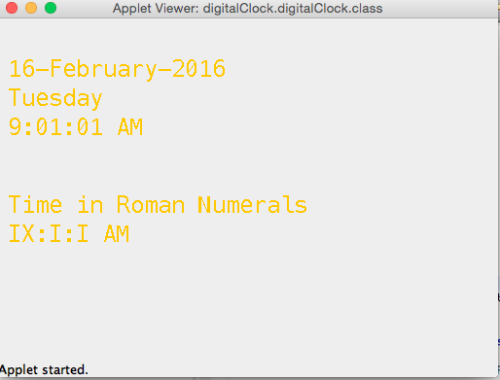

**Extra Functionality:**

Alarm function

Time in roman numerals

Chimes on the quarter hour. Implemented in code with cuckooClock.java