**Documentation**

**Name: Krithivas Swaminathan**

**Krithivas@gmail.com**

**Output ScreenShots**

Basic Calculator

ADDITION MULTIPLICATION

24+36 displays 60 24852*123 displays

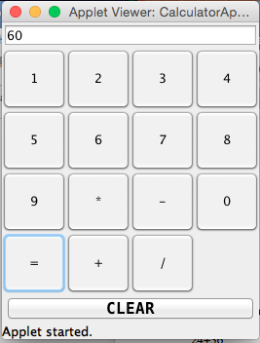 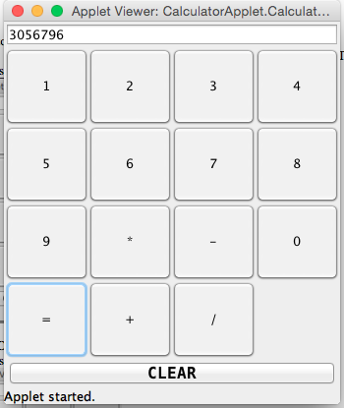

SUBTRACTION DIVISION

47-13 Displays 34 65197/956 displays

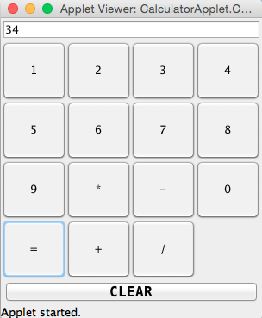 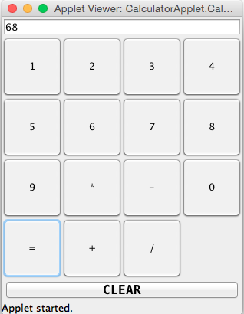

CLEAR Button

Clears the Contents of the Textbox

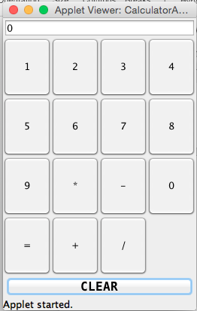

**Sequence Diagram for Clicking the Clear Button**

Clearall()

repaint()

setText = “”

Action Performed (Clear)

Button Click

Button Handler

TextFeild

Vector –Clicked Buttons

Clear Button

Calculator GUI