**Documentation**

**Name: Krithivas Swaminathan**

**Email: Krithivas@gmail.com**

**SCREENSHOTS**

**Click on File to SAVE**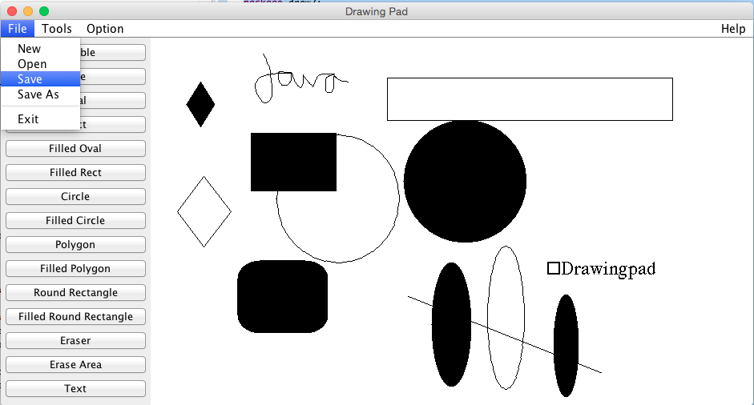

**SAVE AS DIALOG BOX.**

**Save file as Drawing1**

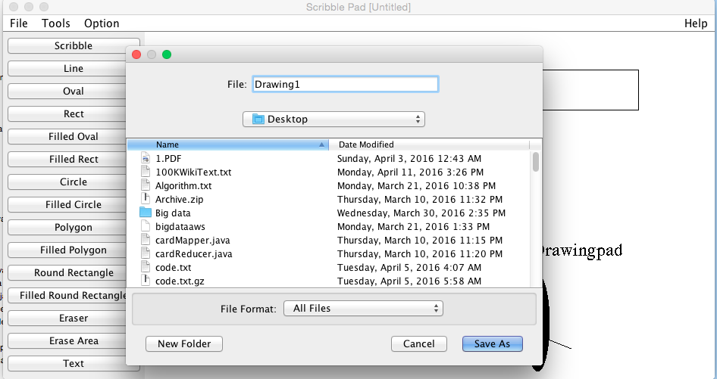

**File 🡪 open**

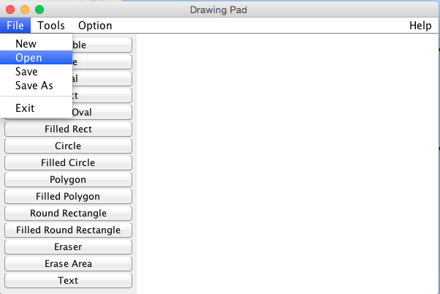

**Select Drawing1 and click on open**

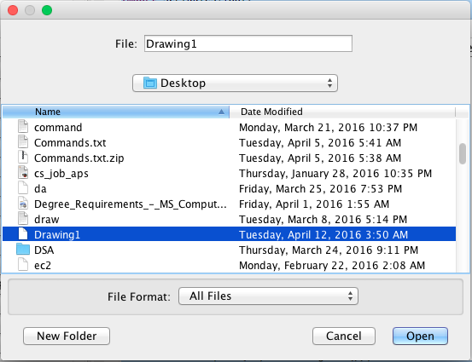

**Drawing1 is opened**

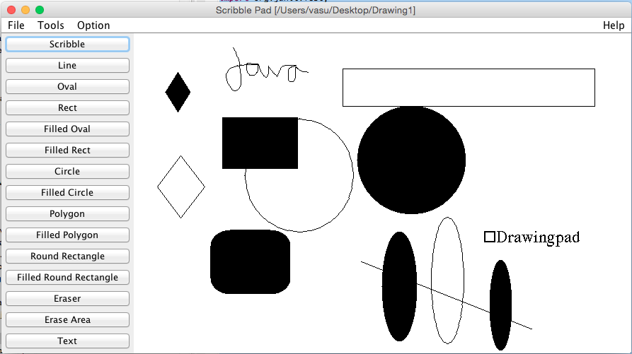

**OPTION 🡪 COLOR**

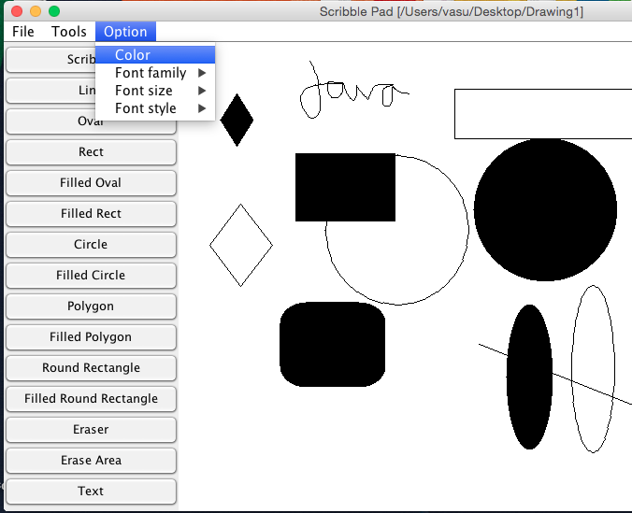

**OPENS COLOR DIALOG BOX**

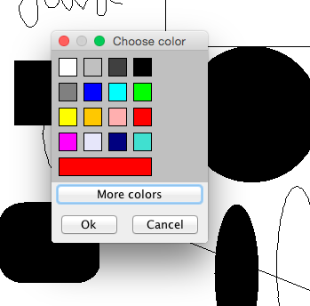

**OPTION 🡪 FONT FAMILY**

**Displays all the font we can use**

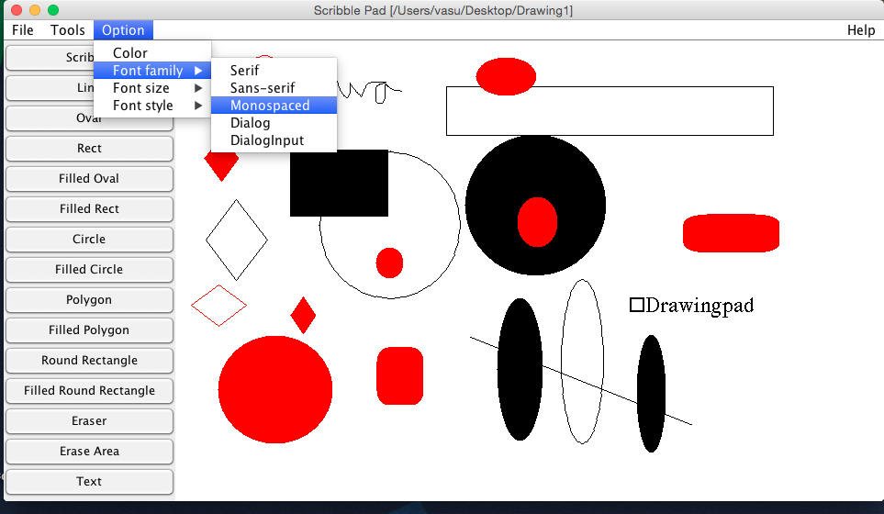

**OPTION🡪 FONT SIZE**

**To use the variety of font sizes**

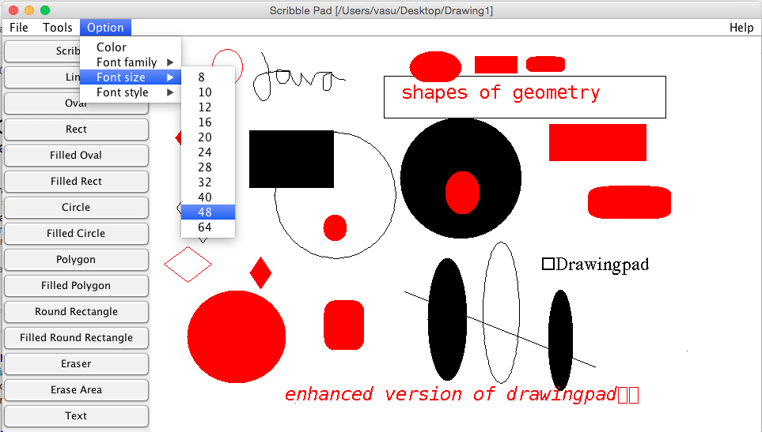

**OPTION🡪 FONT STYLE**

**For different styles**

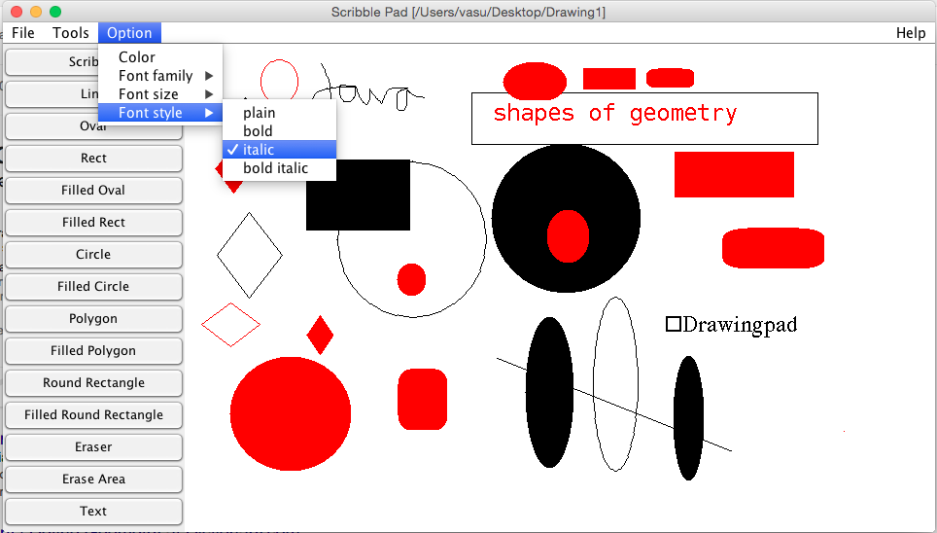

**Using the ERASER TOOL (Erase with Mouse)**

**AFTER ERASE**

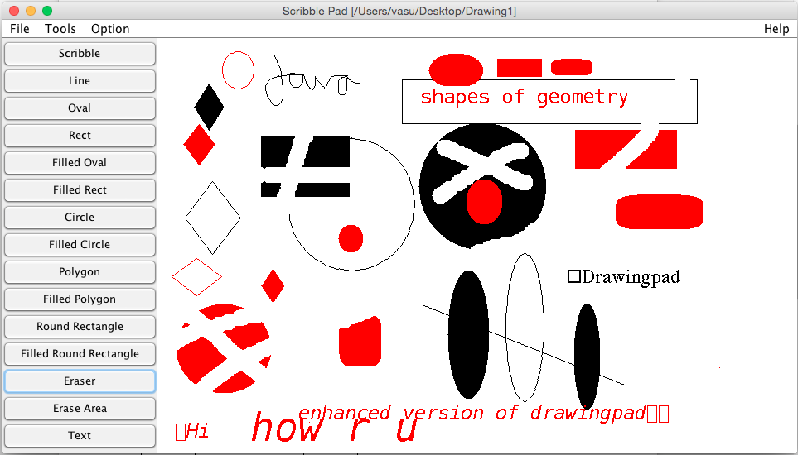

**SELECT ERASE AREA BUTTON (before Erase Area)**

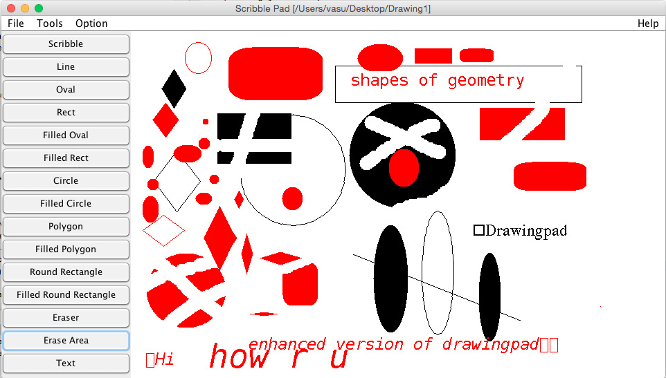

**After Erase Area**

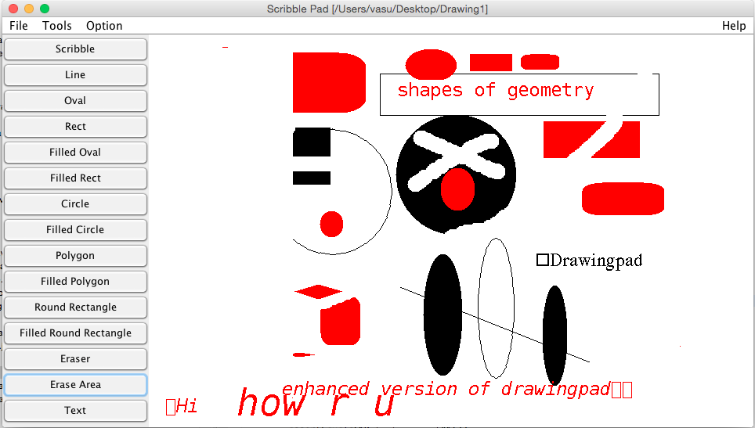

**Shows the Various Shapes (Fill and No- Fill) implemented**

