**Documentation**

**Name: Krithivas Swaminathan**

**Email:krithivas@gmail.com**

Screenshots

**Initial text file in Desktop: draw.txt**

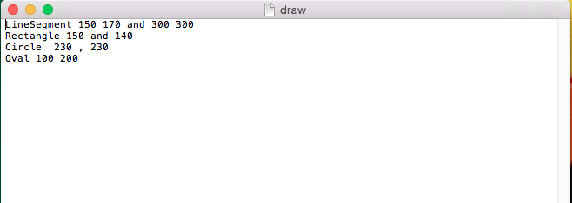

**JFrame displaying all the shapes along with the string representation of inputs**

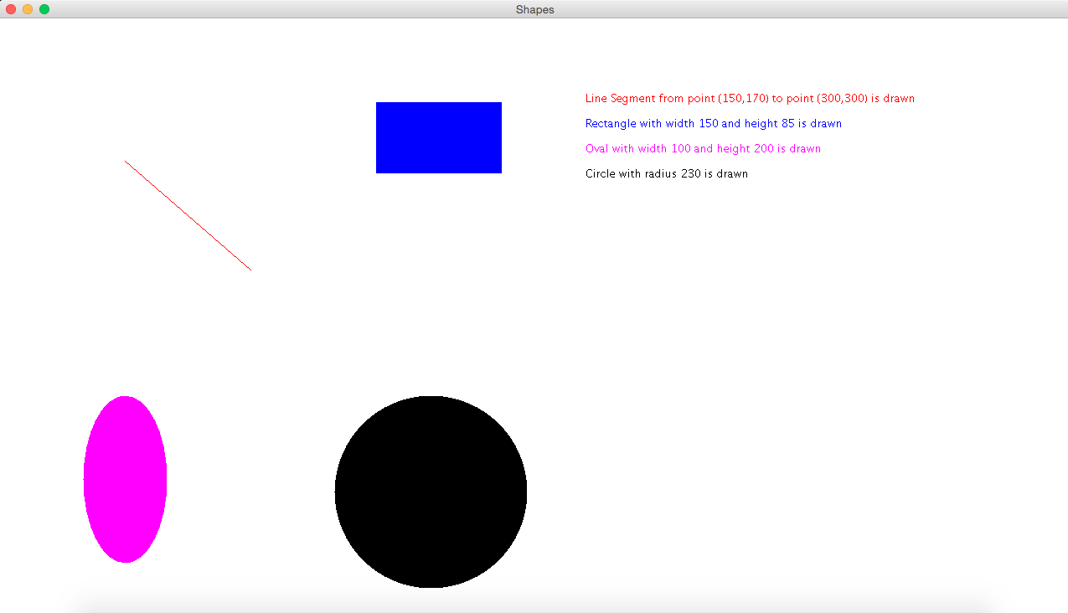

**Adding more inputs in the Text file: draw.txt**

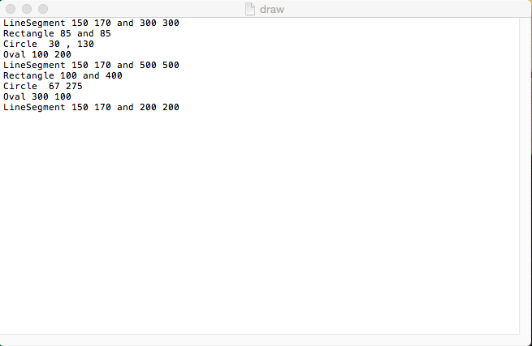

**Final output of all the shapes**

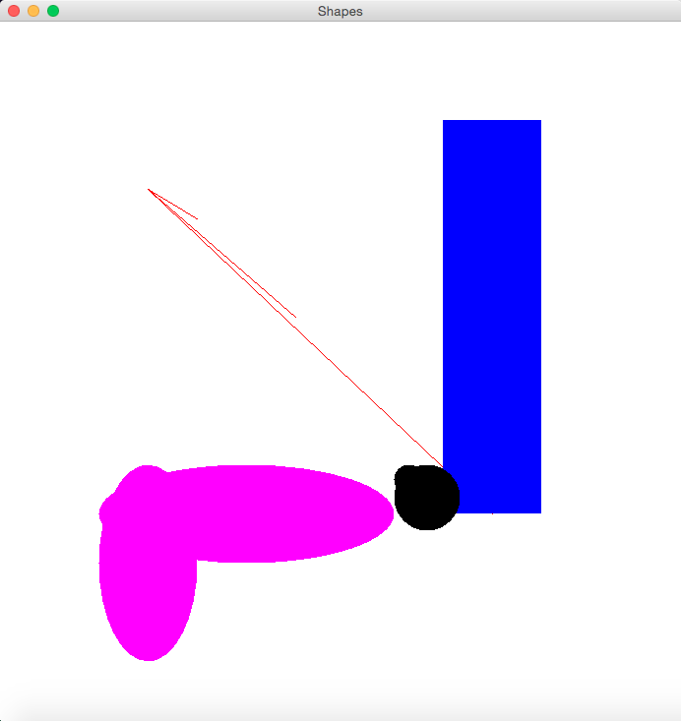

Console Output of the String representation

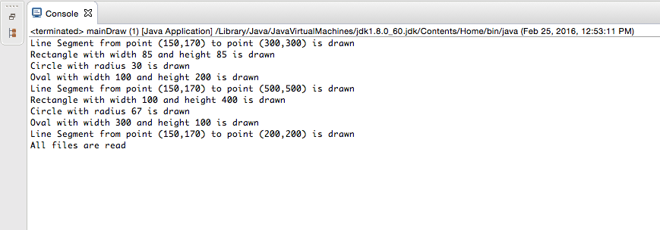

**Expanded Essential Use Case for Exercise 5 b (**Polymorphic Shapes**)**

**Use Case: -** Create Polymorphic Shapes

**Level: -** User Goal

**Primary Actor**: - User who wants to display polymorphic shapes

**Purpose: -**  Develop an application that creates variety of shapes reading inputs from a text file.

**Overview: -**  User enters the Shape and the attributes of the shapes (in pixels) into the text file. The application reads the text file and displays the shapes and the string representation of it.

**Pre-conditions:** The shape name and the attributes of the shapes must be separated by an empty space while entering into the text file.

**Type: - Expanded Essential**

**Basic Flow or Ideal Flow**

|  |  |  |
| --- | --- | --- |
| **S.no** | **Actor Actions** | **System Responses** |
| **1.** | The user enters the shape attributes into the text file and saves it. | The file accepts inputs and is saved. |
| **2.** | User runs the application. | Application displays the polymorphic shapes and the string representation of it |

**Alternate Flow: -**

1. **User enters wrong input in the text file**

**(example: Types words and invalid entries in place of pixels/integers)**

* Error message stating “Input Mismatch Exception” is displayed.

General Score Ex. 5.1 Score

|  |  |  |  |
| --- | --- | --- | --- |
| A | 2 | D | 3 |
| B | 1 | E | 2 |
| C | 3 | F | 6 |
| Total |  |  |  |